Round 8 — your four reads, fixed the same hour
Six files in chat, all committed. Suites green. Each of your notes, in order:

1. Calendar — drops from the top now
It slides down from under its own button, where it belongs, instead of surfacing under the chip bar and fighting the tier buttons for the same pixels. Same tab, same animation, opposite edge.
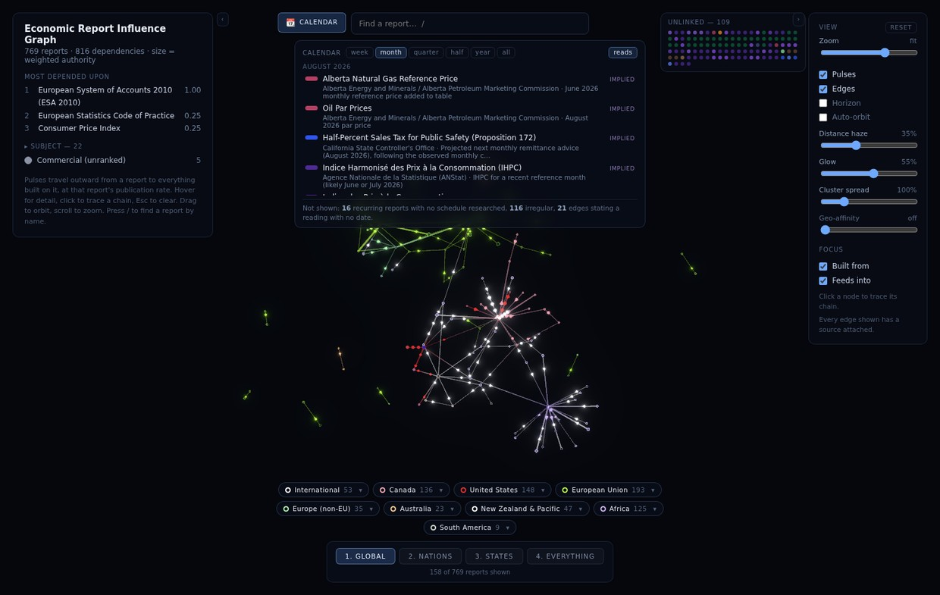

2. The stuck flyout — two bugs, both dead
The ▾ was a hit target a few pixels wide: a near-miss landed on the chip label, toggled the whole family, and left the flyout exactly where it was — which is why it felt possessed. It’s a real button now (six times the target), clicking anywhere else on the screen closes the flyout, and so does Escape. Nothing on this UI should ever need surgical aim again — if anything else feels like that, it’s a bug, tell me.

3. Pulses — boosted, and the answer is "free"
Pulses are 1.5× bigger (4.8–10.5 units, was 3.2–7.0). Cost to the processor: effectively zero — it’s the same number of meshes drawing a few more pixels each; pulse count and speed are untouched. If they still read small at your zoom levels, say a number and I’ll turn it again — this dial is cheap.

4. The built-from view — you were right, and it was my regression
My honest read: the trace view collapsed when the rims went bold, and I did that. "Dimmed" nodes still wore visible rings — the rim adds brightness at the silhouette even at 15% opacity — so a trace left you looking at a wall of ghost-rings with the chain lost among them. The old project measurement said "dimming has nothing left to take away"; that was true of the flat spheres it was measured on and stopped being true the day rims got weight. Three changes, together: the dim went genuinely dark (out-of-focus rims drop to 7%, fills to 9%, glow nearly off); the lit chain got heavier (traced edges more than double their opacity); and the one that matters most — traced edges now draw straight through the nodes. While a chain is selected, its lines ignore depth, so the thread stays visible even where it runs behind or between fat spheres at close zoom — which was exactly your "lost by the size and proximity of the nodes." The moment you clear the selection, lines depth-sort normally again.
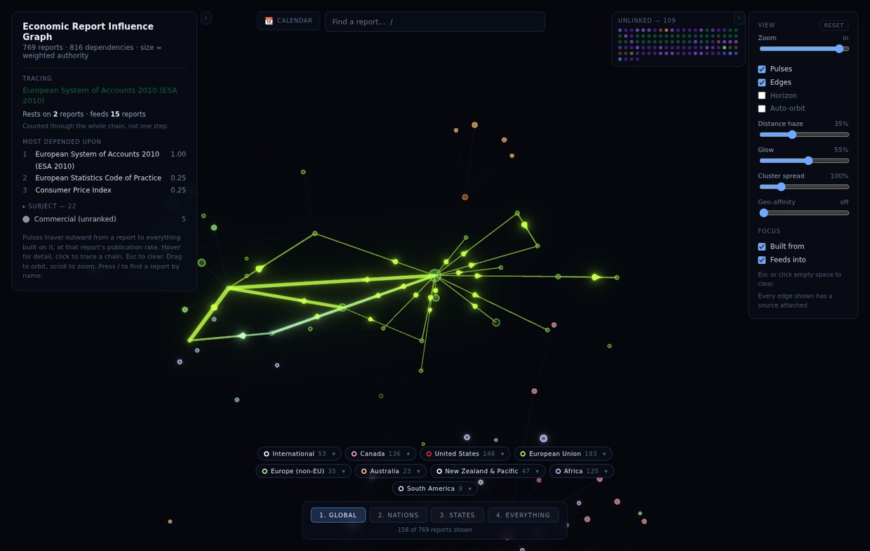
ESA 2010 traced, after: the graph falls away, the chain blazes, the trunk reads as a trunk, and every line survives the crowd.

5. Still queued
Relations dotted + shelf-pull · Blueprint mode · perf HUD · bundle split · calendar export · share links · doc-drift session · Africa. "Carry on" resumes the queue.
Q21 — Verdict on these four, and any numbers to turn (pulse size, dim depth, trace-line weight) — your answer:

