Round 10 — the chrome, the frame, and the border crossings
Eight files in chat plus the updated handoff — all committed to your folder. All suites green. Everything from your list is in; two boxes at the end.

1. The containers, both moods
Dark mode got the machined look: every box is now a gradient surface with a 1px top bevel, a bottom seam, a deep drop shadow and a faint blue field glow — instrument panel, not bubble. The title wears a serif with a blue-violet gradient ink and a soft depth shadow. And the whole page sits in the crisp frame you specced: a glassy 1px line at the very edge, #0066CC frosting inward over about 38 pixels, fading into whichever background is behind it.
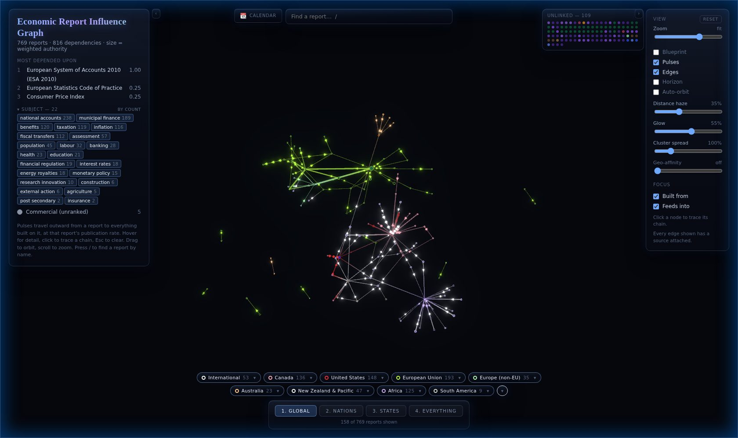
Flip Blueprint and the same boxes go glass: white-glass gradients, warm paper shadows, dark inks for every label — the expandable menus, the search, the calendar, the chips, the tier bar and the Unlinked tray all match the lighter look now. The Unlinked tray also gets its occasional ripple: a sheen sweeps across about once every nine seconds, just enough motion to say "I'm here". One system underneath: every panel colour lives in a theme file as a variable with a dark value and a paper value, so the next surface we add is themed by construction.
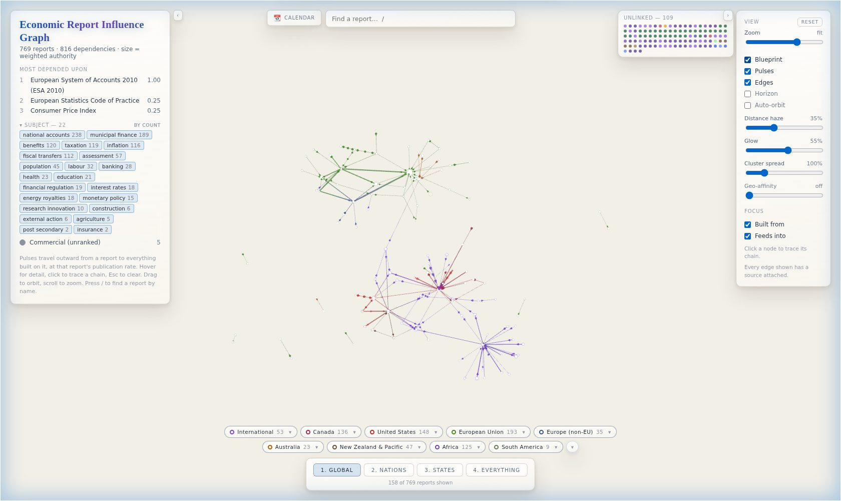

2. Border crossings stand out
An edge whose two ends belong to different regions — Canada resting on a US number, the UK on an EU one — is now a marked special case: 1.6× wider, brighter, and its pulses blink instead of gliding steadily. Here is Canada + United States isolated: the ordinary pink Canadian lines, and the bold red crossings — the NYMEX oil price feeding Alberta's royalty formula among them, which is exactly the kind of arrangement this exists to surface.
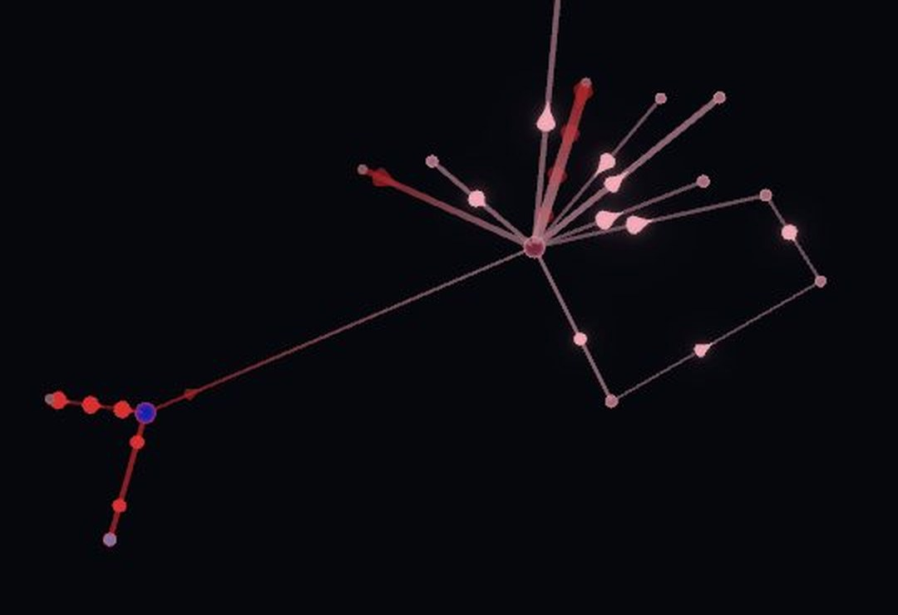
One definitional call I made, flagged for your veto: edges touching the international bodies (IMF, OECD, UN…) do NOT count as border crossings — they consume everyone's numbers, so flagging them would turn the special case into wallpaper. A crossing means one country's number resting on another country's. If you want the international edges marked too, say so in the box — it is a one-line change.

3. Handoff
HANDOFF-2026-08-12.md is updated with all of round 10: the chrome system and its rules, the cross-border definition, and the same queue for the next agent. The blink can't show in a screenshot — worth thirty seconds live: isolate Canada + United States and watch the red edges.
Q23 — Verdict on the chrome: glass strength, shadows, dark-mode glow, title, frame intensity — anything to tune — your answer:

Q24 — Border crossings: keep international bodies excluded, or mark them too? And is the blink rate right (1.3s)? — your answer:

