Round 9 — Blueprint mode, the last crumbs, and the handoff
Seven files in chat plus a handoff document — all committed to your folder. All suites green. Per your call, this closes the UI: what remains goes to the next agent, and the handoff is their briefing.

1. Blueprint mode — the toggle is first in the View panel
Flip "Blueprint" and the lights come on. Paper background, every node a pale disc, and the whole picture drawn in each family's dark ink — the same one-ink-per-family system as the dark theme, printed instead of glowing. Solid reports read as white discs, one-off instruments as open rings, trunks keep their weight, pulses ride as dark drops. Glow and haze sit the mode out (bloom is additive light, and paper does not emit); their sliders keep their values for when you switch back. Nothing moves when you flip it — the layout is seeded exactly where it was.
It took three tries to make the paper honest, and the reasons are written into the code: the renderer's physical lighting quietly divides light by π (first cut rendered concrete-grey discs), and semi-transparent lines over the page background pass through a conversion that blew the "dim" lines out brighter than the paper. Both are measured, fixed, and recorded in the handoff so nobody pays for them twice.
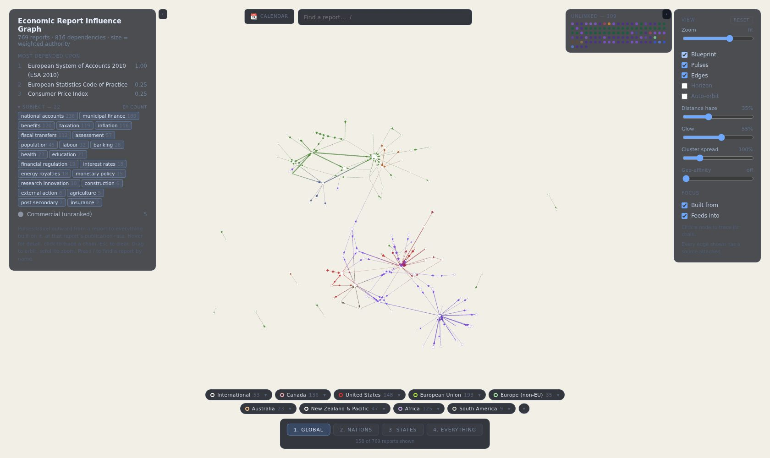
And a trace in blueprint — ESA 2010's chain inked over the pencil ghosts of everything else. This is the same trace that blazes on the dark theme, restated as a drawing:
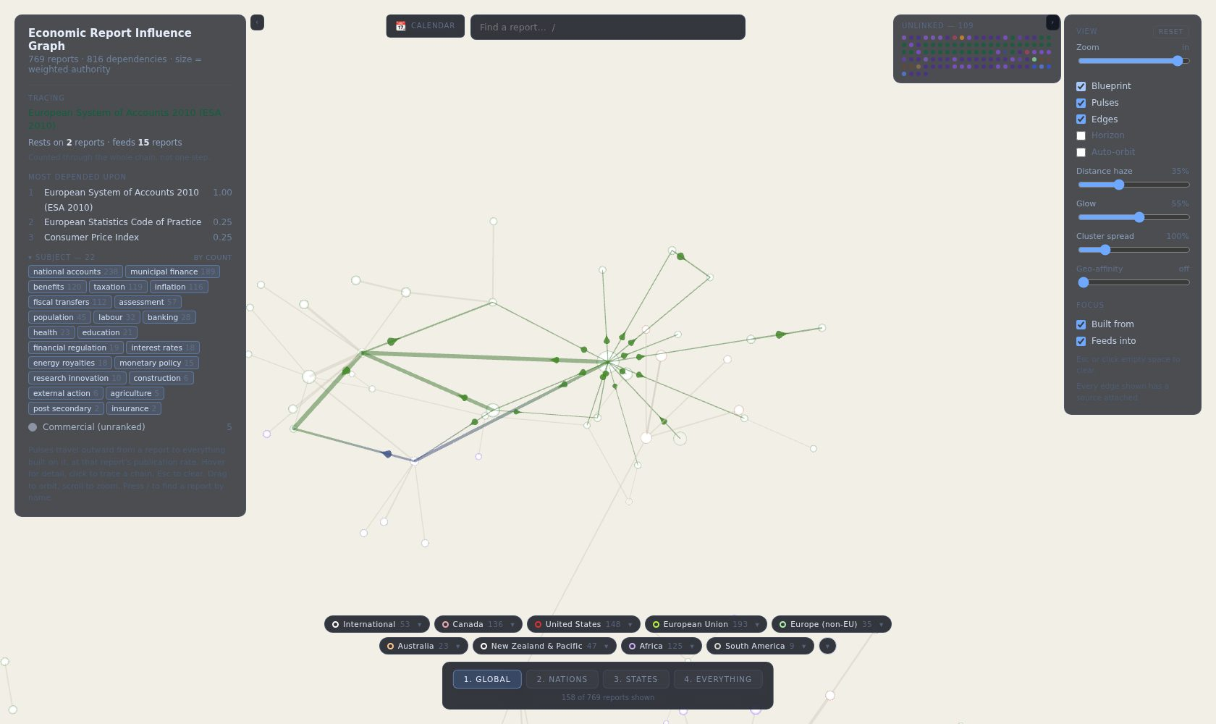

2. The other crumbs
The region tray minimizes. A small ▾ pill at the end of the chip row folds the whole tray into one "Regions" pill; if a filter is active the pill says so ("Regions · 2 on"), so state never hides with its controls. Click it to bring the chips back.
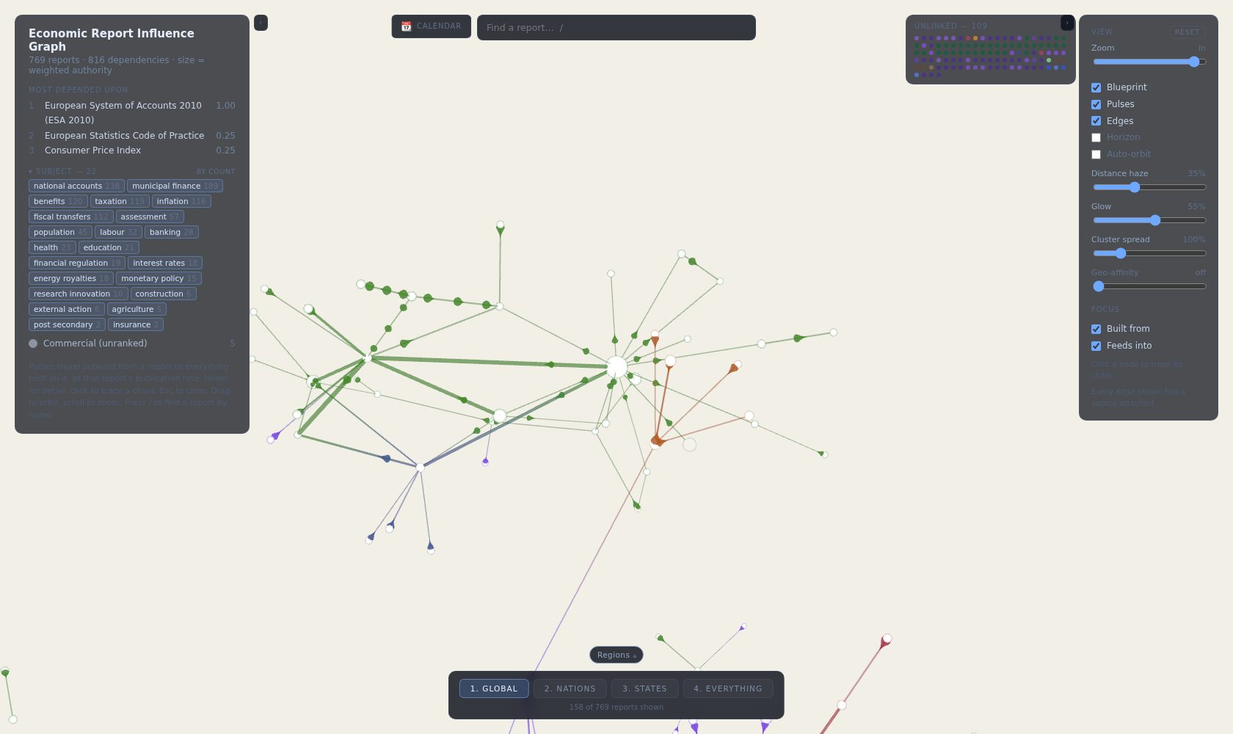
Subjects open by default. The left panel shows all 22 subject chips on load now — they were only ever hidden to protect a sidebar that could not scroll, and it scrolls. The header still collapses them.

3. The handoff
HANDOFF-2026-08-12.md sits at the repo root: the whole day round by round, the visual system as shipped, nine invariants with the measured failure behind each, how the review loop with you works, and the queue in priority order — relations drawn dotted, the perf HUD, the bundle split, calendar export, share links, the doc-drift session, then Africa starting with Nigeria's monthly CPI. The next agent reads that plus the code review and starts working; nothing lives only in my head.
Q21 — Blueprint verdict at your settings: paper tone, ink strength, dim strength — anything to tune — your answer:

Q22 — Anything the handoff should say that it does not — your answer:

