Round 7 — the chip bar. Your one-click filter is real.
Four files in chat (App, filter, InfluenceGraph, test-logic — all committed to your folder). All suites green, now 44 checks. This is the interaction half of the redesign; the visual half shipped in round 6.

1. What changed
The sidebar legend tree is gone. In its place: one row of family chips above the tier buttons, each wearing its family’s ink — the same colour its rims and edges wear in the scene, so the chips ARE the legend. The left panel now just informs: stats, most-depended-upon, the tracing block, Subject, Commercial. Nothing left to overflow.
Your click model, everywhere. From everything-on, clicking Canada shows you Canada — one click, camera re-frames, done. More clicks build combos. Clicking the last selected chip returns to everything. The ▾ on each chip opens its level flyout: "Canada’s municipal level" is chip-chevron plus one tick. And the Subject chips speak the same language now — your "select each of the 22 one at a time" complaint is dead too.
The spheres recolour. Narrow the filter to exactly one family and the fills switch to loud spread colours per level — red, green, blue, magenta — with the flyout doubling as the legend for exactly what each colour means. Rims keep the family ink throughout, so identity never blinks. Widen back out and the family palette returns. This was your Q8 ask ("if I pick Canada I want to see distinct colored levels"), and it only exists while one family is isolated — the one situation where loud level colours can’t collide with anything.

2. Proof, from the running app
The chip row at rest, then: ONE click on Canada — isolated, re-framed, recolour legend open.
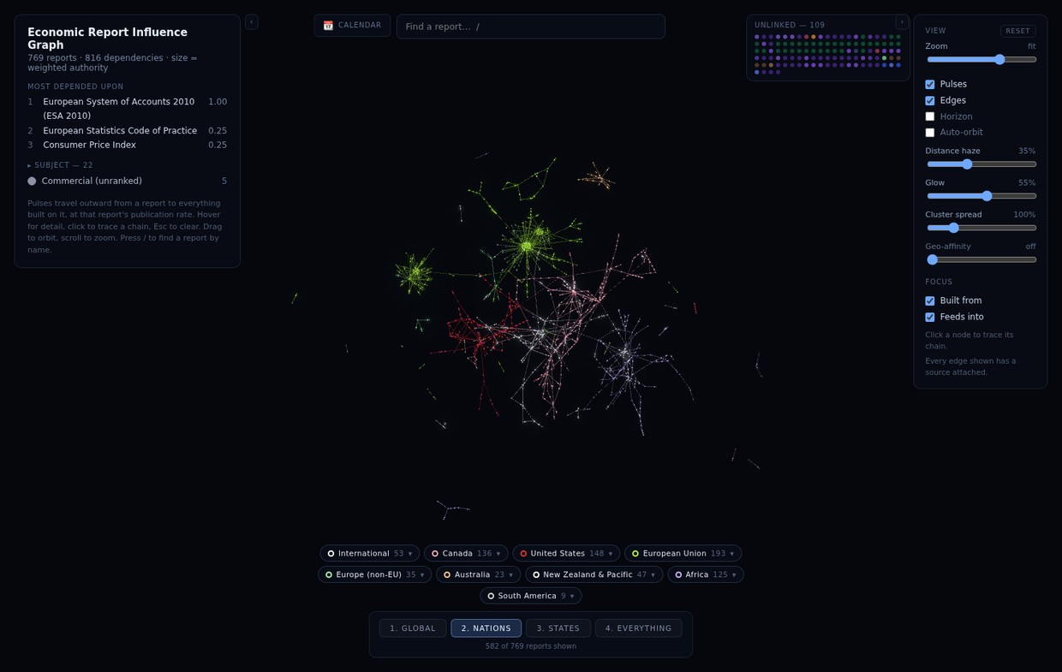
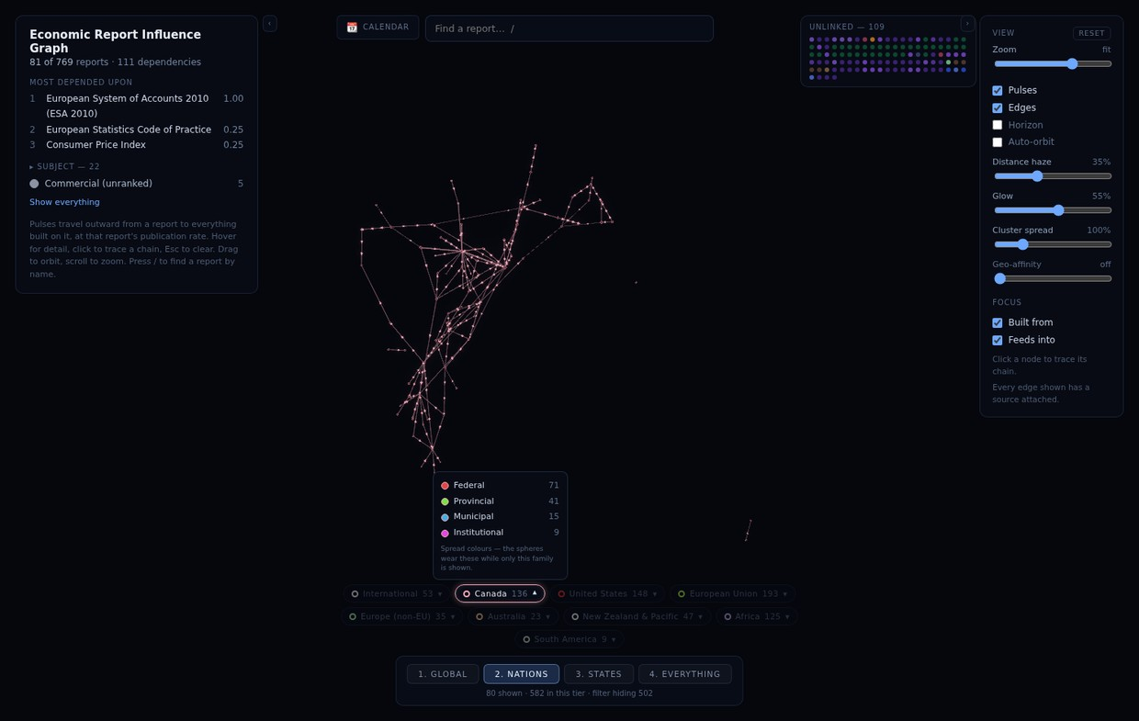

3. Next up
Relations drawn dotted + their nodes pulled off the shelf · Blueprint mode · perf HUD · bundle split — then calendar export, share links, the doc-drift session, and Africa. Say the word or just say carry on.
Q20 — Chip bar verdict, and anything to move/resize (position, chip size, flyout behaviour) — your answer:

