Round 3 — built, applied, and four questions
8:21 a.m. — fair. Noted that you review before breakfast while I write "evening" like a lounge act; timestamps are in your clock from now on. This round is different from the last two: your answers unblocked real work, so most of this doc is things that are DONE, sitting in your folder, validated. Four shaded boxes at the choice points (Q9–Q12). Same routine.

1. Shipped this round — in your folder now
Everything below is committed to your project, and the whole suite is green: 40 logic checks (new), the validator with every invariant, tsc, and a production build. Just run run.bat as usual — no reinstall needed.
The date landmine is dead, and armed against return. The fractional-month bug is fixed, and the new standing test file (40 assertions over the pure logic) now runs inside npm run validate — including a test that fails loudly if that exact bug ever comes back. This is the "help me wire this up dude" item: wired.
Every country has its name back. 35 missing names filled in (plus Burkina Faso, Togo, Gabon and Chad pre-named for §3). Countries without a drawn flag now show an honest little code chip labelled with the country’s real name — the globe that told screen readers Uganda was "International" is gone.
Grid and bounding box: deleted, code and all. The whole SpaceFrame component is retired to _to_delete/ with the drop lines. The View panel is two toggles shorter; the horizon remains as the one optional piece of scenery.
The camera now respects narrow windows (fits width as well as height), and the sliders reach the extremes you asked for: cluster spread 25%–375%, geo-affinity to 150%.
Adding a research slice is now: drop the JSON in the folder. That’s the whole procedure. A small generator keeps the load list in sync automatically before every dev/build/validate — the 105-line hand-maintained import list is gone, which is also how §3’s discovery surfaced.
Small stuff: the unlinked shelf’s scrollbar is grabbable now; the calendar uses the lookup that already existed; the stale platform-slab comment went down with the grid; the wrong "instanced particles" claim is corrected so no future performance hunt starts from a false premise.

2. Your Grok results — checked, then applied
I verified both cited pages live before touching anything; every quote checks out word-for-word (this is the citation-resolution pass that once caught four confident errors — Grok passed it clean this time). Applied: the three FOUND edges now carry their documents — the MPR↔rate-decision link via the Governor’s own July 2026 opening statement, and both SEP edges via the Fed’s Guide, which defines the projections on the BLS and BEA series by name. The five NOT FOUND edges are demoted to implied, each with a basis recording the search, the date, and why the belief still stands. That is the last of the eight unsourced seed edges — the whole corpus now meets the evidence standard, either with a document or with an honest dashed line.
Knock-on worth knowing: the implied set grew from 9 to 14 — which makes your "should implied edges even exist" question sharper, so it’s Q12 below rather than a footnote.

3. Data rulings applied — and one discovery
Nigeria (Q1): you asked to treat it as two nodes — monthly CPI plus the one-off rebasing. Checked: the monthly CPI series doesn’t exist as a node yet, only the rebasing report does. So the rebasing node now carries the slow pulse you described (0.1/year, with a note explaining the 9–20-year rebasing gaps), and minting the monthly ng-nbs-cpi node is the first item of the Africa branch — at which point your two-node picture exists exactly as you drew it.
TEA (Q3): 6/year applied, with the cadence note built from your six-week/HB 2/settle-up research.
nz-mbie-tif (Q2): deleted, with your restore condition honoured — the full node and all three edges are preserved verbatim in project memory, and the deletion notes in the slice say exactly where to find them. One consequence to see with your own eyes: its two data sources (the Accommodation Data Programme and the TECT card-transaction series) had no other edges, so they now sit on the unlinked shelf. They’re live programmes, so they stay as nodes; the corpus rule going forward is no discontinued programmes except where a live successor names them.
The discovery: ten finished research slices were never loaded. Rebuilding the loader surfaced ten JSON files sitting in the research folder that the old hand-written import list simply never included — four entire countries (Burkina Faso, Togo, Gabon, Chad — the WAEMU/CEMAC batches, whose palette entries exist while their reports never load), five municipal-finance slices (Cairo, Nairobi, Lagos, Johannesburg, plus an African municipal batch), and Brazil’s Fiscal Responsibility Law. Nothing anywhere records this as deliberate. I test-wired all ten: the corpus goes to 769 reports / 830 dependencies and the validator passes with zero errors — this is finished, validated work that fell through a crack. Wiring any of them back is deleting one line.
Q10 — Wire the ten lost slices? (all / just the four countries / pick some / leave them out) — your answer:

Of course

4. The compound-edge example you asked to judge by eye
You: Should we give those edges a glow relative to how many share the line? Can you find an example in the graph for me to focus on and judge with my eyes?
Found you the best one in the corpus, and it’s on the opening screen. At tier 1, the line from the EU orb to ESA 2010 is fifty-seven real edges drawn on top of each other — every member state’s compliance chain, collapsed onto one path. Second best: EU orb to Regulation 479/2009, twenty-seven deep. Today both draw as identical overlapping lines, so a 57-edge trunk looks the same as a 1-edge thread. Open the app as it is now, look at those two lines, and imagine the trunk a pixel wider and glowing — that’s your rule. It’s adopted for the build (with relations rendering, same part of the code); your eyes on that EU→ESA line are the calibration. We may need a logarithmic equation to quell the effect for these extreme cases

5. The palette, worked out — your picks plus my answer on India
Everything below is drawn on the app’s own background so you judge in context. Your picks are all in: XEU blue — and the rim is the EU family’s green, so "European" stays readable on the ring exactly as you specified; Australia orange; New Zealand brown with a white rim (I’ve grouped the Realm and the Pacific compact states with NZ — judgment call, flag if wrong); China yellow, held apart from the US tans by saturation the same way Canada/US already works; the rest of Asia teal. For India you asked me: magenta — the red-violet slice Australia and NZ vacate, kept off INT’s violet by the same documented gap that protected it before.
The two tight spots, said out loud: (1) two blues now exist — Africa’s bright azure and XEU’s deeper steel — separated by register and by completely different rims (pale blue vs green); if that ever reads confused on screen, XEU shifts darker, not Africa. (2) India’s deepest level sits near Canada’s deepest maroon; the rims differ and they’re half a world apart in the layout, but if the magenta bothers you, gold or cream are the fallbacks.
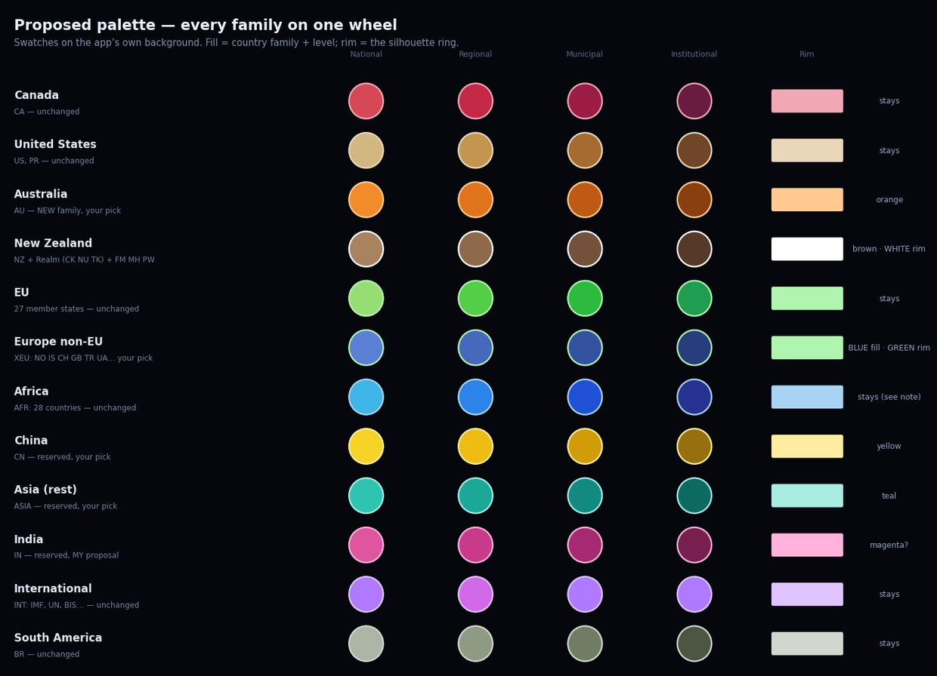
Q9 — Palette: approve as drawn, or tweak (say which rows)? — your answer:
The eu needs a thicker rim if you can, use lime green for it. Africa can be violet with no rim color, I think that would do. The international ones can be given a bold white rim. Make USA 255 blue and give it a bold red border. NZ needs a bolder rim too. I think the spectrums should go in reverse order too. National level being darkest, institutional lightest.

6. Two design calls only you can make
You: I don’t like the shapes. The spheres need to recolor and the sidebar needs a small sidebar illustrating what the colors translate to.
The recolour is coming regardless: filter to one country and the spheres take spread-out level colours (red, green, purple…), with a little legend showing the mapping — Batch B, no question there. The question is the first four words. If "I don’t like the shapes" means delete the tier shapes — cubes, octahedra, all of it — then spheres return everywhere, and outside a single-country filter the only level cue left is the shade ramps you originally called unreadable. If it means the shapes just aren’t doing enough on their own, they stay and the recolour lands on top. Deleting a day-old system is fine if it isn’t working for you — I’d just rather do it because you meant it, not because I guessed.
Q11 — Tier shapes: delete them (all spheres, colour does the work) or keep them under the recolour? — your answer:
The shapes are growing on me, lets just give them a fair chance after the recolour.

You: I am thinking the implied edges should go, they do not belong here do they?
The honest case for them: an implied edge is a belief held to a standard — strong grounds, recorded search, no document — drawn dashed, hidden by default, and provably unable to move any score (the validator asserts it). They’re the research backlog made visible, and your five freshly-demoted Bank-of-Canada/Fed edges just joined them: real relationships that everyone knows exist and no document states. The case against is yours: the graph’s one rule is "no document, no edge," and a dashed maybe-edge is still an edge on screen. If they go, nothing is lost as knowledge — each one becomes a dropped-note with its full reasoning — but the toggle and the dashed layer disappear, and "what is probably true" stops being a viewable thing. On styling: either way, relations get a dotted style clearly distinct from dashes, so that conflict resolves itself.
Q12 — Implied edges: keep the quarantined dashed layer, or retire it to dropped-notes? — your answer:

Retire it, refresh my mind on relations please

7. Building next (Batch B) — no answers needed
Already specced from your notes and starting next session: the by-level filter row; your isolate-first filter behaviour (click a domain or scope while everything’s on → it isolates; further clicks add to the combo; switching the last one off returns to all — so "Canada’s municipal level" is exactly one click); relations rendered dotted with the shelf fix ("yes, of course pull them into the graph"); the compound-edge trunk treatment; the spheres-recolour + mini legend, shaped by Q11; perf HUD; bundle split. The calendar export and share-links follow in Batch C, then the doc-drift session, then Africa — starting with the Nigeria monthly CPI node and, if Q10 says so, the four lost countries coming online the same week.
Corpus as of this doc: 727 reports · 808 dependencies · 17 relations · 14 implied · validator, tests, typecheck and build all green.

