Round 4 — all four answers built. Nothing left to ask; run it.
Every box from round 3 turned into shipped work this time — the ten slices are wired, the implied layer is retired, your palette is implemented and screenshotted from the running app, and the shapes stand unmolested awaiting their fair chance. One box at the end for whatever your eyes find. Corpus: 769 reports · 816 dependencies · 17 relations · 0 implied · all suites green.

1. The ten lost slices — wired (Q10: "Of course")
Burkina Faso, Togo, Gabon and Chad are on the map, along with the Cairo/Nairobi/Lagos/Johannesburg municipal-finance work, the African municipal batch, and Brazil’s Fiscal Responsibility Law: +42 reports, +22 dependencies, zero validator complaints. Africa now stands at 125 reports across 32 countries — worth knowing before the Africa branch starts, since some of what it would have researched turns out to already exist. One visible side-effect: the unlinked shelf grew from 87 to 109 dots, because the municipal slices carry nodes whose edges point at reports not yet researched. That is the shelf doing its job — those are leads, not litter.

2. The implied layer — retired (Q12: "Retire it")
All fourteen implied edges are out of the graph and preserved — each one whole, with its full original reasoning — as dropped-notes in a new file, research/retired-implied-edges.json. The Evidence section is gone from the View panel (it had nothing left to switch), the dashed rendering path is dormant, and the validator now ERRORS on any dependency that tries to carry evidence: "implied" — so the layer cannot silently regrow. The rule going forward is clean: a belief without a document is a note; a belief that finds its document becomes an ordinary edge. One nuance that stayed, deliberately: schedule entries still use "implied" to mark inferred DATES on the calendar — that is a different thing (a date we projected vs a date the publisher stated) and it remains essential.
You: refresh my mind on relations please
Relations are the corpus’s second kind of documented connection — facts between two reports that are NOT dependencies, because neither is built from the other. There are exactly two kinds. Supersedes: one instrument replaces another in time — SNA 2025 superseding SNA 2008, the UK Shared Prosperity Fund superseding the EU structural funds. Audits: one body’s published opinion assures another’s figures — the finding that made the schema, that New Zealand exports its Auditor-General to Niue and Tokelau while the US exports only its accounting method to the Compact states. Three rules keep them honest: every relation requires a document AND a URL (stricter than edges — no implied relations exist or ever will); they are structurally incapable of touching authority (buildGraph never receives them); and there are 17 today, all currently invisible. Batch B draws them: dotted lines — visually distinct from everything else — and the nodes they touch get pulled off the unlinked shelf into the scene, per your "yes, of course pull them into the graph."

3. Palette v2 — implemented exactly as you specified (Q9)
Everything from your box is live: ramps reversed (national darkest, institutional lightest); US in "255 blue" with a bold red rim; the EU’s rim thickened and switched to lime; Africa violet with no rim at all; INT bold white; NZ brown with a bold white rim; XEU steel-blue with the green rim; Australia orange; China yellow, rest-of-Asia teal, India magenta all reserved. This took a real mechanism, not just new hexes: rims now carry a per-family weight (bold / thick / normal / none) wired through the shader, so "bold red border" is genuinely wider and stronger, and Africa’s ringlessness survives every focus change.
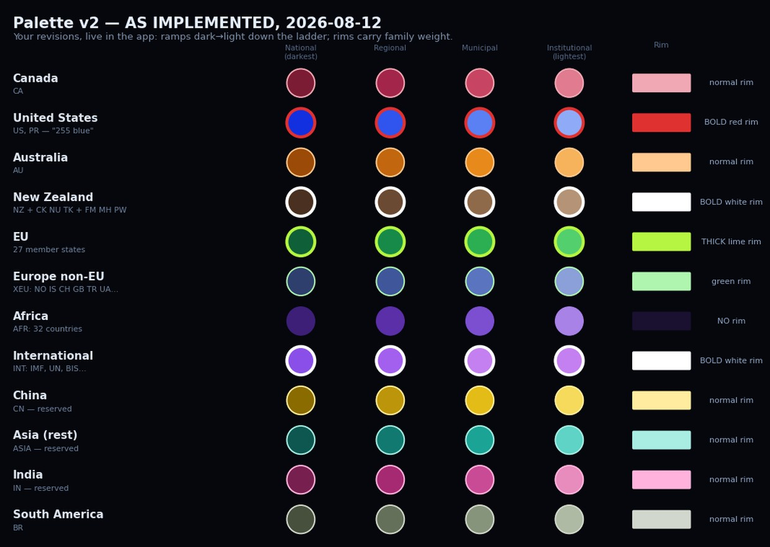
And the part a swatch sheet can’t show — the running app, new palette, wired corpus. Tier 1 (opening view) and Tier 2 (Nations):
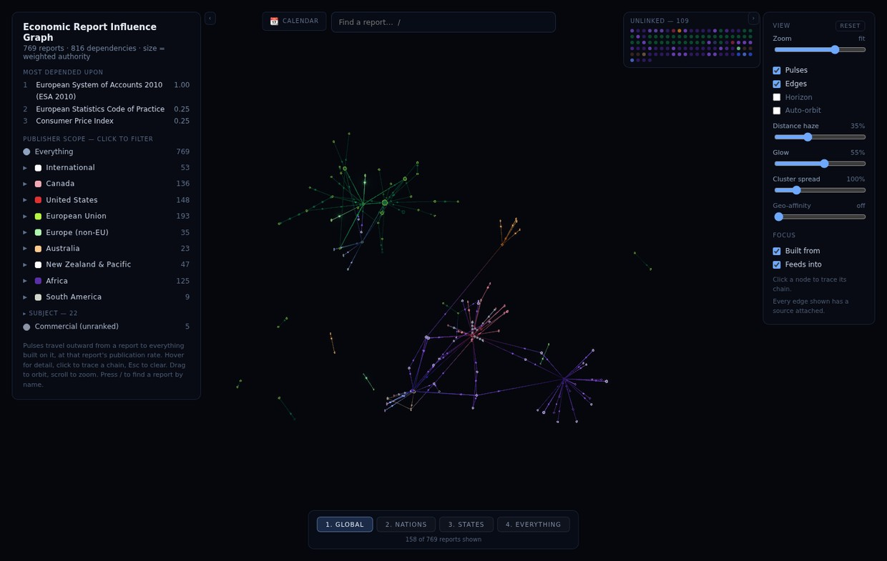
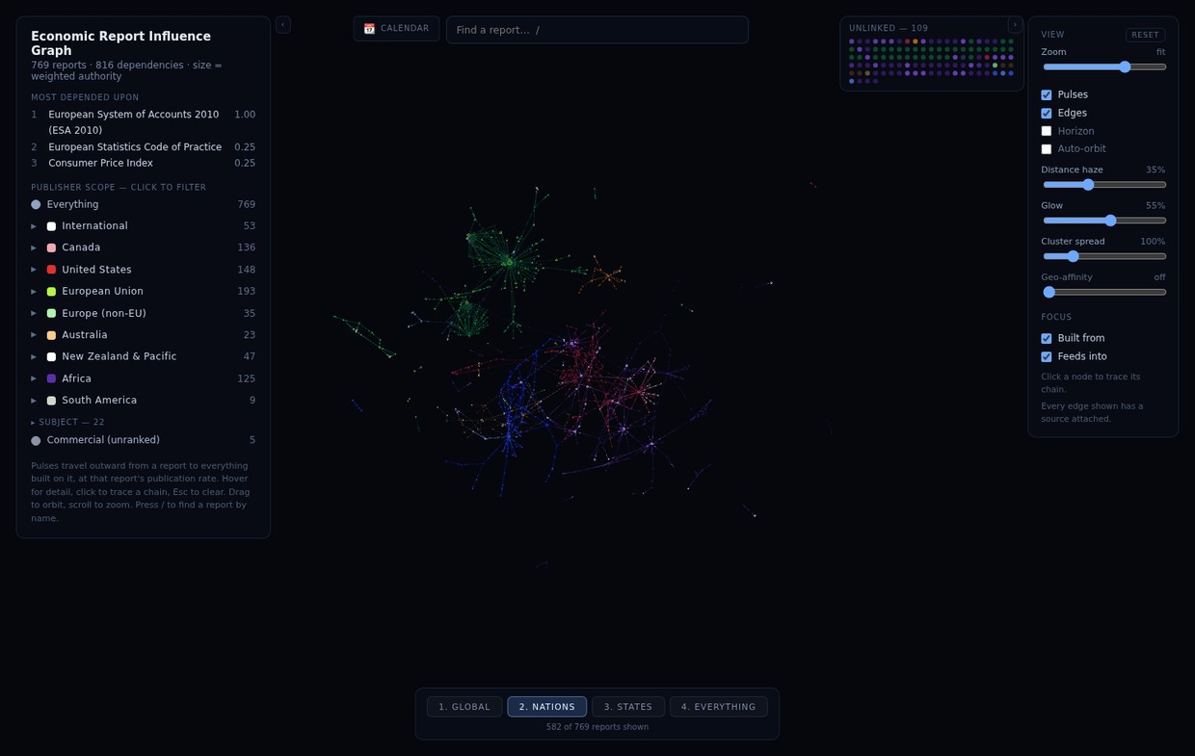
Three things to check with your own eyes when you run it: (1) US ultramarine vs XEU slate-blue — the bold-red vs green rims are the tiebreak; tell me if it’s not enough. (2) In the sidebar, New Zealand and International both show a white square (the legend square shows the rim); their fills differ completely but the squares match — flag it if it bothers you and I’ll make legend squares show fill+rim together. (3) Africa’s no-rim look against everything else’s rings.

4. Small print
You: We may need a logarithmic equation to quell the effect for these extreme cases
Exactly right, and adopted: the compound-edge treatment will scale width and glow with the logarithm of the stacked count, so the 57-edge EU→ESA trunk reads as unmistakably heavier without becoming a glowing pipe — roughly, every doubling of edges adds one step of weight. Lands with relations rendering in Batch B.
Shapes (Q11): untouched, as ruled — they get their fair chance once the single-country recolour is in and you can judge the two channels together.
Batch B, next session: the by-level filter row · your isolate-first click behaviour (one click = Canada municipal, alone) · relations drawn dotted + shelf fix · compound-edge trunks with the log scaling · single-country sphere recolour + mini legend · perf HUD · bundle split. Then the calendar export and share links, the doc-drift session, and Africa — which now starts 42 reports richer than it would have yesterday.
Q13 — After running it: palette verdict, tweaks, anything your eyes catch — your answer:

