GAME DESIGN DOCUMENT
Project PM

Project Postmortem

Last Updated:
5/23/2025

Prepared By:
Alexander Scrivner

TABLE OF CONTENTS

Game Analysis 3
Mission Statement 3
Genre 3
Platforms 3
Target Audience 3
Storyline & Characters 4
Gameplay 5
Overview of Gameplay 5
Player Experience 5
Gameplay Guidelines 5
Game Objectives & Rewards 5
Gameplay Mechanics 5
Level Design 6
Control Scheme 7
Game Aesthetics & User Interface 7
Schedule & Tasks 8

High Concept Statement
POST MORTEM is a tense, indie survival horror set in the ruins of post-outbreak Colorado, where players scavenge through urban labyrinths, decaying buildings, and hushed forests in search of safety from the mysterious mutagen infection that has ravaged the world. With unforgiving inventory limits, realistic gunplay, and a heavy focus on strategy, every twist and turn could mean life, death, or a fate far worse.

Genre
Survival Horror

Platforms
PC

Target Audience
This game is for a mature audience that enjoys survival horror, open worlds, and extraction shooters. Target demographics that like games like DayZ, The Walking Dead: Saints and Sinners, Escape from Tarkov, the Long Dark, and GTFO. Older Teenagers and Adults.

Storyline & Characters
In the world of POSTMORTEM it is unknown to the player the origins of the outbreak, only that their goal is to survive and progress to more zombie-dense locations for more and better resources. The zombies that roam the world of POSTMORTEM are akin to zombies like in the walking dead- they walk and roam the quiet streets and forests of Colorado (the setting of the game)- but their terrifying behavior to congregate and attack you in a slow, unyielding mob is unparalleled. Here are the aspects of the separate POSTMORTEM’s zombies from the usual trope:
TRYPOPHOBIA BODY HORROR
Signs of infection are indicated by tens of hundreds of holes that line the skin muscle and even bone of the victims. The progress of the infection can be qualitatively tracked by simply inspecting the arms and legs of the victims (because of the location of the holes), i.e. the closer you are to being infected, the closer the line of holes is to the brain or heart. It travels along the vascular system, veins and arteries as long that the victim is infected physically.

MUTATION
The infection is not a virus, bacteria, parasite, or fungus, but a mysterious mutagen that causes the holes to form. It can also cause rare forms of zombies to spawn in different environments or circumstances.

ORIGIN
Though this is still being workshopped, the working origin story of the mutagen is non-Euclidean in nature and originates from the “future” implying it was brought into the past by a time traveler which would give ample reasoning for the unique properties of the zombies.

THE FOG OF THE HORDE
When enough zombies congregate together and move in packs, they produce noxious fumes emanating from their “holes”. This forms a colored fog that travels with them as they wander the world.

EXPOSURE: BITE IS (NOT) THE END
Bites can absolutely be lethal, but so can exposure to tainted water, bodily fluids, and fumes of the zombies be as well. Becoming infected can come from a multitude of ways but should be treated as more of a gradual, cumulative, property like radiation, once you become “irradiated” enough: it’s over.

ANIMALS
Animals can become infected as well. Plants cannot.

MADNESS AND CONSCIOUSNESS
Victims begin to go mad before they turn and retain a slim bit of their consciousness after they turn, but they are compelled by the hunger from the mutagen to spread and consume regardless of any past bonds made by the victim.

The story of the world is told through the world and items as this is POST outbreak, when basic infrastructure and pillars of society have collapsed.

You play as an adult non-descript survivor. They can craft, reload weapons, manage inventories, shoot, and do things that otherwise any other survivor can do. Their look should be generally disheveled and build should be lean.

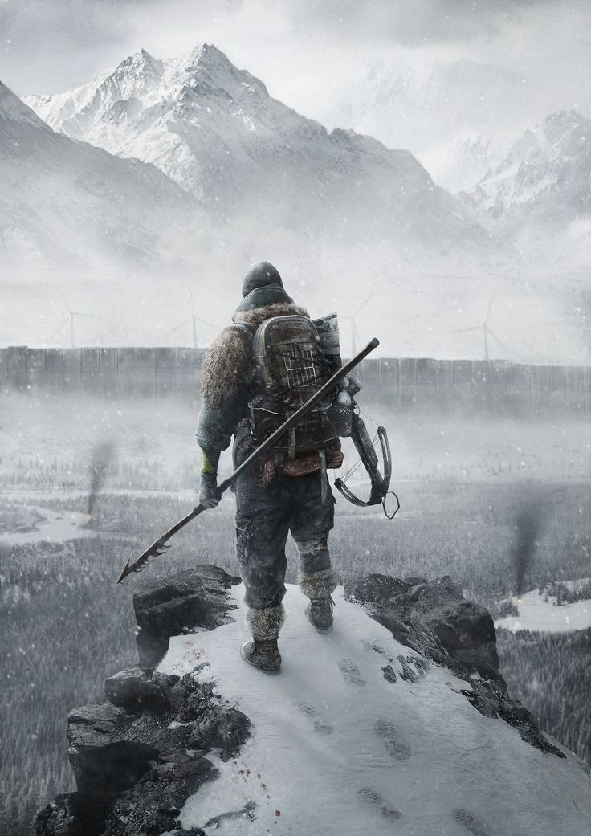

Gameplay

Overview of Gameplay
The game is a survival horror game. Join up to 3 friends, explore the world, sneak around zombies and hordes, loot abandon buildings and dead bodies, complete objectives to upgrade homebase, shoot guns, craft impromptu/crude weapons, complete “mini-games” to use weapons and medicine, and discover the story of POSTMORTEM

Core Mechanics

(Tactical/Realistic) First person shooter
First person camera, holster weapon, camera bob, strafing, sprinting, walking, crouch, lean left/right, equip and use, pull slide/bolt back (Pistols, Rifles), pump gun (Shotguns, lever action weapons), wind up (crossbow, bow), pull hammer back (Revolvers), reload, throw items, use melee weapons, slashing, pierce, bludgeon, shove, stomp, NO FIST FIGHTING**

Inventory Management and Clothing*
Grid system, larger more nuanced CLOTHING and BAGS = more SPACE (squares). ITEMS are ROTATABLE (Think Resident Evil 4 or Unturned). Heavy ITEMS and CLOTHING affect players’ WEIGHT which affects walking and running SPEED (Inverse variables). For example, carrying 5 rifles should make the player incredibly slow, but if players have an inventory full of spam, then the speed is largely unaffected (Balancing purposes). Different types of clothing affect AUDIO DECIBELS, i.e. cargo “tech-ware” and steel toe-ed boots are LOUD. The trade off being more pockets = more space but more likely to draw attention to oneself. LEATHER clothing acts as ARMOR (Bite resistant and non-porous to fluids like blood), but leather is naturally more HEAVY and LOUDER. BACKPACKS are the primary form of inventory and come in various types. They can also be placed/thrown to the ground to act as caches for the player and can be retrieved later even if the location is unloaded (Positions are saved). Each bag takes a different SHAPE in the inventory made up of these squares
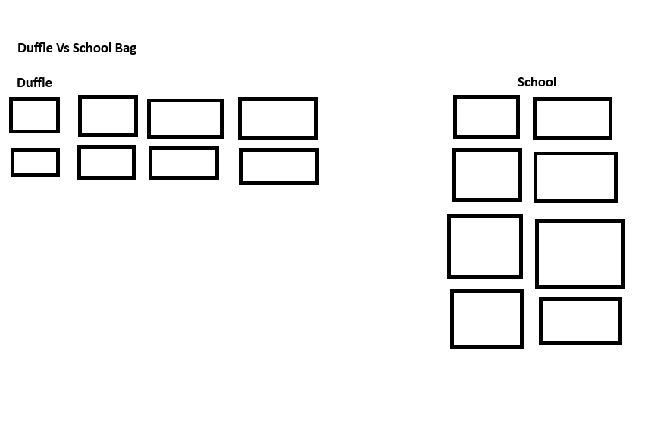
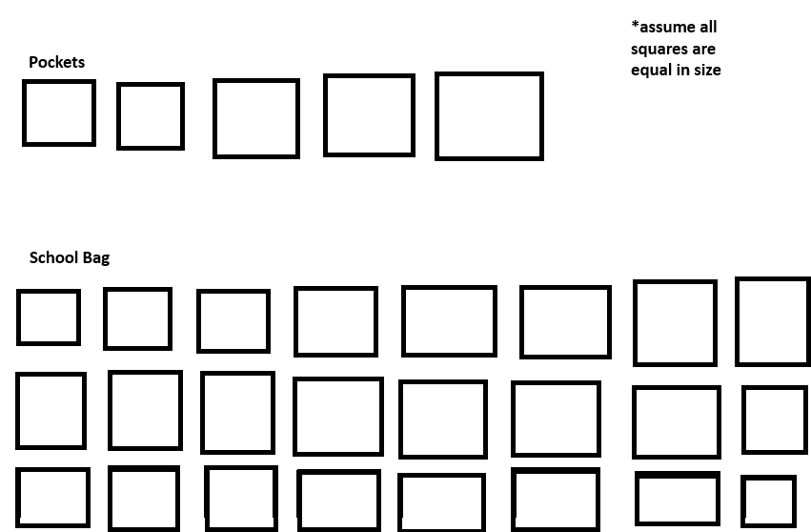

Backpack tiers

Small (1lb – 5lb if Empty) - Leather bag/sling bag/fanny pack = smallest space, light weight, quiet. Best option for solo and quick expeditions

Medium (6lb – 10lb Empty) - Duffle bags, school bags = Great compromise of space, speed, and loudness. One-size-fit-all for expeditions

Large (10lb+ Empty) – Alice Packs, Hikers Bag, Camping backpack = large amount of space, but if filled to the brim is surely a death sentence if corned or in enclosed spaces. Good for “hunkering” down, horde fights, and scavenging with teammates

Players can and are encouraged to reload and have weapons ready for emergency scenarios

Active VS Backpack inventories
Upon entering the inventory, the player can see that their screen is divided into two sections:
- Backpack inventory which is represented by more traditional 2D UI displaying their guns tools and other items in the flat rotations that they set them
- Containers like barrels or chests in the game world will have the same appearance of backpack inventories, it would replace the ‘Active Inventory’ side of the screen so the player can click and drag the items into their own inventory while retaining the 2D continuity
- Active inventory which is represented by large circles labeled respectively as 1,2,3 and QUICK/AMMO encompassing 3D models of items that the player chooses to be there. Whatever items are stored here are reflected in a hot bar in the game view. Hold right click and pan mouse directionally to rotate item. Items in active inventory have a small hollow 2D dot at the origin of the 3D model that fills and turns into a solid dot when the player clicks and drags to move the item within the active inventory or to shift it into the backpack where it reverts to a 2D icon. Think of Resident Evil ‘Inspect Item’.
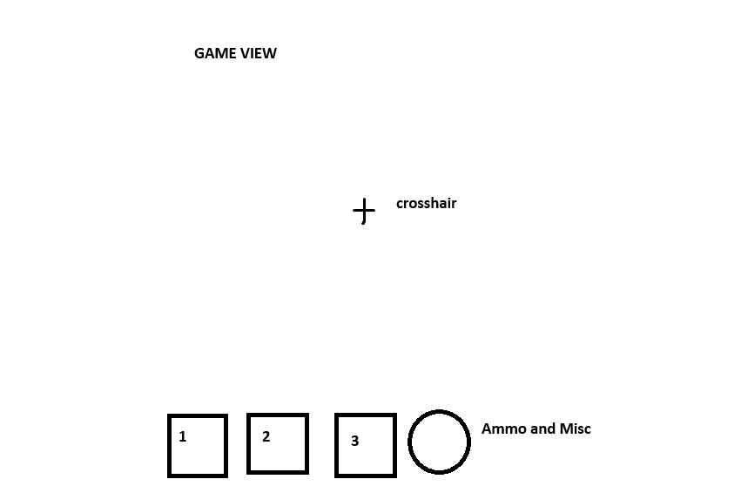
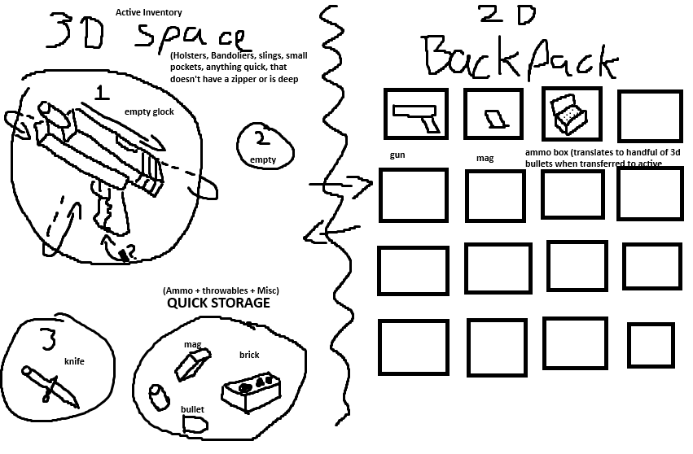

Rough examples from White Knuckle and Unturned reflecting the vision of active vs backpack inventories
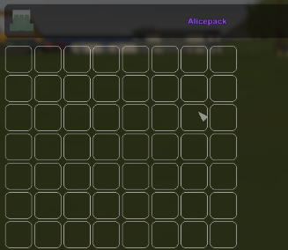
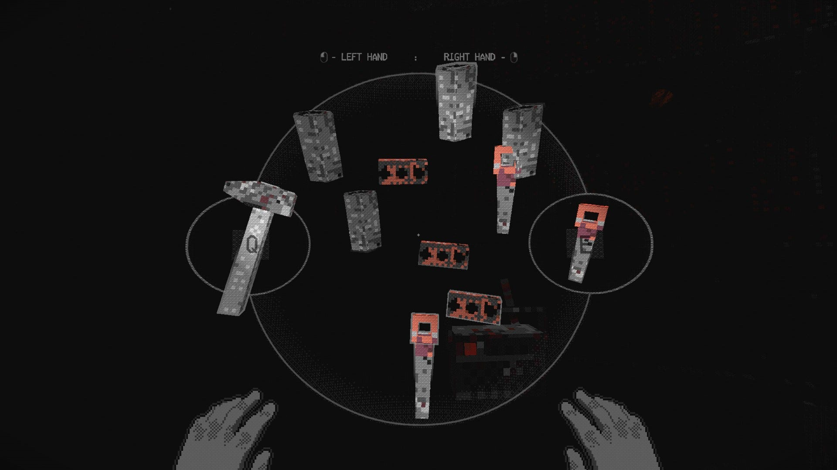

Medicine, Character Condition, and other medical viewpoints
The player can check the status of their character and diagram of their body by pressing ‘i’ or clicking the down arrow in the inventory screen. They are presented with an icon of the player’s body where they can see smaller icons representing bites, lesions, burns, etc.
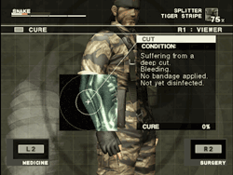
Think of Metal Gear 3
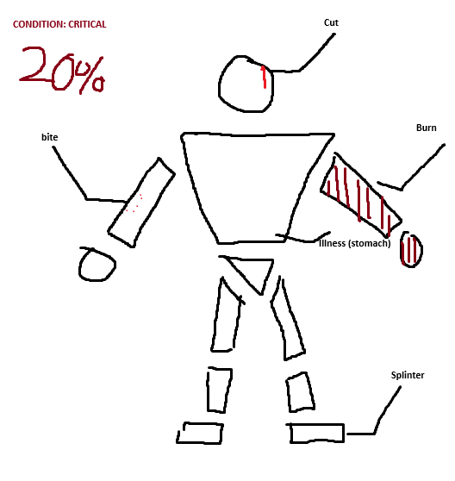
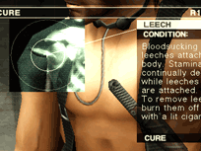

Modular Bodies
Zombies and players have modular bodies. Shooting a zombie’s leg enough will completely blow it off forcing them to crawl to the player (making them more slow, think Resident evil). Blowing off zombie’s heads will cause blood and gore chunks to explode in the vicinity if the blast is powerful enough. Players may be compelled to remove an arm or leg manually if a limb gets infected with bacteria or the mutagen, causing them to permanently be stuck in a state of crouching/prone (if leg(s) get removed) or become unable to use two handed weapons or weapons at all (arms).

Backpacking teammates
If a player is missing one or both legs, another player can wear them like a backpack (Note: the more limbs the HEAVIER they are). This should be treated more as a gimmick and quick way to save teammates in the face of danger. Some benefits are that the player being backpacked can look in a 180 direction, effectively acting surveillance, or if equipped with a small firearm, can act as a turret protecting the carrier. They can also access the same inventory space as the carrier. However, the drawback is that the carrier must put down their backpack to carry the player. The legless player can only have a small backpack equipped on them. This mechanic is like a symbiotic shared inventory space. This does bring up the ability for the backpacked player to ‘troll’ and sabotage the carrier so choose who you backpack wisely.

Generic Survival Mechanics
Hunger and Thirst are only present during expeditions, at homebase this does not get affected unless homebase is being attacked by horde events. Remedied by water and food that is scavenged. Eating rotten food or drinking contaminated water (which would be labeled as such) will cause the player to become sick and lose a small amount of health (flat). Perhaps there are some audible drawbacks as well (moaning, vomiting) that could draw zombies to your location.

Safe Zones & Impromptu Safe Houses
Players can set up a temporary outpost on expeditions. Cabins and stores present on the map can have players move heavy objects in front of doors or put metal shutters down (stores in a mall for example). The primary function of this is to save the game and pass time by sleeping, all players must be sleeping to save. This can be used to also avoid hordes.

Exposure
Players have a dedicated EXPOSURE meter, if this is maxed out, at a random point soon they will have the INFECTED status. Wandering in Horde Fog, swimming in contaminated water, bites, being mauled/cut by infected, getting blood splattered on the player increases their exposure.

Infected Status
Once the player becomes infected their character’s visible appearance worsens over time, showing symptoms like the holes, muscle atrophy, dilated pupils. When the player dies they become a zombie enemy wearing their equipment (Project Zomboid). From the infected player’s perspective, their controls might be inverted from time to time, they hear auditory hallucinations, and their vision begins to change: holes (blind spots and visual motif to the zombies), stretch and squash, fov increases and decreases. These symptoms worsen over time and become more frequent until death.

Bites
Bites can only be removed by amputation. Bites continually increase the exposure meter until the player is infected. Bites give the player a flat 20% exposure increase upon being bitten. So multiple bites are a guaranteed death sentence.

Mini-game-ification & replacing generic cooldowns*
Players cannot simply press ‘r’ to reload a weapon or left click a bandage to apply it, there is nuance and additional processes.

- Magazines must be individually loaded with correct bullets (click and drag) from either backpack inventory or active inventory (so 2d icons clicked and dragged onto 2d magazine or clicking and dragging 3d bullets into 3d magazine [Orientation does not matter in this case]) into the magazine before it can be used from quick storage within the active inventory or manually loaded. Note, you can load an empty magazine, it just gives the player a sad *click* when trying to use the gun.
- (In Active Inventory) Magazines must be manually loaded, click and dragged into the correct position and orientation of the gun. It will automatically slide in once done. Alternatively, they can have the magazine ready in the quick storage section, return the game view, press r, and press t to pull back the bolt, pump, slide, or hammer to reload and prepare the weapon.
- For pump-action shotguns, ‘r’ must be pressed every time to load each shell individually and ‘t’ pressed every time they fire to eject the shell and chamber a new one
- If the player wants the weapon to be fire-ready once they return to the game view (out of the inventory UI) they can manually (click, click + drag with mouse icon) pull back the pump, bolt, hammer, or slide in the active inventory.
- Players do not need a magazine to use the gun, they can put bullets in the quick storage and chamber rounds individually through the ‘r + t’ method or clicking and dragging through the active inventory.
- Revolvers must have their bullets individually placed into each slot after ejecting the spent bullets in the active inventory view. This is simplified with the ‘r + t’ game view method. ‘r’ to eject bullets and ‘r’ for every bullet they want to reload as the chamber is popped out. ‘t’ to pull back hammer if the revolver type calls for it

- Bandages can be applied to the player character by doing a spinning motion along the arm icon with a bandaged equipped via the mouse

- Injections click, drag, release onto spot in question

- Amputations can only be conducted with a sharp tool like a saw or knife. Players must do a sawing motion along a dedicated path with the mouse to achieve a clean cut

Player Experience
Provide a general overview of how the player experiences the game. Walk them through the screens they will see, what the level looks like and what their character can do. Give them a brief idea of objectives & hazards they will face. This should be in a second-person point of view using the word “you” to tell a story to the audience (players). Example: West of House. You are standing in an open field west of a white house, with a boarded front door. There is a small mailbox here.

Gameplay Guidelines
This is a set of guidelines that the game must adhere to throughout the development process. These include rules for what is allowed and not allowed in the game. For instance, if you are creating a game for children, you will want to define guidelines for the level of violence presented in the game, what language can be used, and so on.

Game Objectives & Rewards
This is where you present more details on how the gameplay will motivate the player to progress through the game. Discuss rewards and penalties and the difficulty level.

List ways of how the player is rewarded and when.

Discuss things that hinder the player on progressing.

Discuss the difficulty levels within the game.

Gameplay Mechanics
This is where you start getting more specific on how some of the systems in the game will work. This includes how characters move in the game, what gameplay actions are available, item inventory and attributes, and how the game progresses from level to level.

Character Abilities
Character Attributes
Character | Movement Abilities / Actions Available
Name of character | List the characters abilities & how the player can perform them
Game Modes
Game Mode / Difficulty Name | Describe the objectives, hazards in the game mode. And discuss how the player progresses from level to level
Scoring System
Points/Coins/Stars/Grades/Etc. | How it’s Awarded & Benefits
List the scoring attribute | Describe how the player obtains this and the benefits. For instance, does getting more points unlock a special level.

Level Design
Discuss the levels. How many levels will the game have, what will be included in each level. Include overall look and feel, hazards the level presents, difficulty, objectives, etc. Include sketches of your levels.

Control Scheme

Button/ Touch Input | Action it Performs
List the buttons | Describe what functionality the button press has within the game.

Game Aesthetics & User Interface
Will the game look realistic or have some other art style? Describe the look & shape of the characters, environment, and pathways. Discuss what type of theme the game will have & what type of emotional impact you are hoping players experience. Discuss how the player’s gestures/interactivity influences the visual experience. For example do the characters move like stop motion or anime?

Present a general overview of the UI. How will the buttons be laid out, how will the HUD work, how does the menu system function, and so on. Insert your reference photos, diagrams or other concept art to help explain the UI.

Add other images to help show an overview of your game from your references.

Notes

