GAME DESIGN DOCUMENT
Project PM

Zombie Survival

Last Updated:
7/19/2025

Prepared By:
Alexander Scrivner & Skyler Martin

TABLE OF CONTENTS

Game Analysis 3
Mission Statement 3
Genre 3
Platforms 3
Target Audience 3
Storyline & Characters 4
Gameplay 6
Overview of Gameplay 6
Core Mechanics 6
Gameplay Loop 14
Gameplay Guidelines 14
Game Objectives & Rewards 15
Tables & Charts 16
Level Design 28
Control Scheme 30
Game Aesthetics & User Interface (WIP) 32
Sound Design 33

High Concept Statement
POST MORTEM is a tense, indie survival horror set in the ruins of post-outbreak, Colorado-inspired setting. This is where players scavenge through urban labyrinths, decaying buildings, and hushed forests in search of safety from the mysterious mutagen infection that has ravaged the world. With unforgiving inventory limits, realistic gunplay, and a heavy focus on strategy, every twist and turn could mean life, death, or a fate far worse.

Genre
Survival Horror

Platforms
PC

Target Audience
This game is for a mature audience that enjoys survival horror, open worlds, and extraction shooters. Target demographics that like games like DayZ, The Walking Dead: Saints and Sinners, Escape from Tarkov, The Long Dark, and GTFO. Older Teenagers and Adults.

Storyline & Characters
In the world of POST MORTEM, it is unknown to the player the origins of the outbreak, only that their goal is to survive and progress to more dangerous locations for resources. The zombies that roam the world of POST MORTEM are akin to zombies like in the Walking Dead: they walk and roam the quiet streets and forests but their terrifying behavior to congregate and attack you in a slow, unyielding mob is unparalleled. Here are the aspects of the separate POST MORTEM’s zombies from the usual trope:
TRYPOPHOBIA BODY HORROR
Signs of infection are indicated by tens of hundreds of holes that line the skin, muscles, and even bones of the victims. The progress of the infection can be qualitatively tracked by simply inspecting the arms and legs of the victims (because of the location of the holes), i.e., the closer you are to being infected, the closer the line of holes is to the brain or heart. It travels along the vascular system - veins and arteries - if the victim is infected physically.

MUTATION
The infection is not a virus, bacteria, parasite, or fungus, but a mysterious mutagen that causes the holes to form. It can also cause rare forms of zombies to spawn in different environments or circumstances.

ORIGIN
Though this is still being workshopped, the working origin story of the mutagen is non-Euclidean in nature and originates from the future. Thus, implying it was brought into the past by a time traveler, which would give ample reasoning for the unique properties of the zombies.

THE FOG OF THE HORDE
When enough zombies congregate together and move in packs, they produce noxious fumes emanating from their holes. This forms a colored fog that travels with them as they wander the world.

EXPOSURE: BITE IS (NOT) THE END
Bites can absolutely be lethal, but so can exposure to tainted water, bodily fluids, and fumes of the zombies as well. Becoming infected can come from a multitude of ways, but it should be treated as more of a gradual, cumulative property like radiation; however, once you become “irradiated” enough: it’s over.

ANIMALS
Animals can become infected as well. Plants cannot.

MADNESS AND CONSCIOUSNESS
Victims begin to go mad before they turn, retaining a slim bit of their consciousness afterwards; however, they are compelled by the hunger from the mutagen to spread and consume regardless of any past bonds made by the victim.

STORY DELIVERY
The story of the world is told through the world and items as this is POST-outbreak when basic infrastructure and societal pillars have collapsed.

SURVIVOR
You play as an adult, non-descript survivor. They can craft, reload weapons, manage inventories, shoot, and do things that otherwise any other survivor can do. Their look should be generally disheveled, and build should be lean.

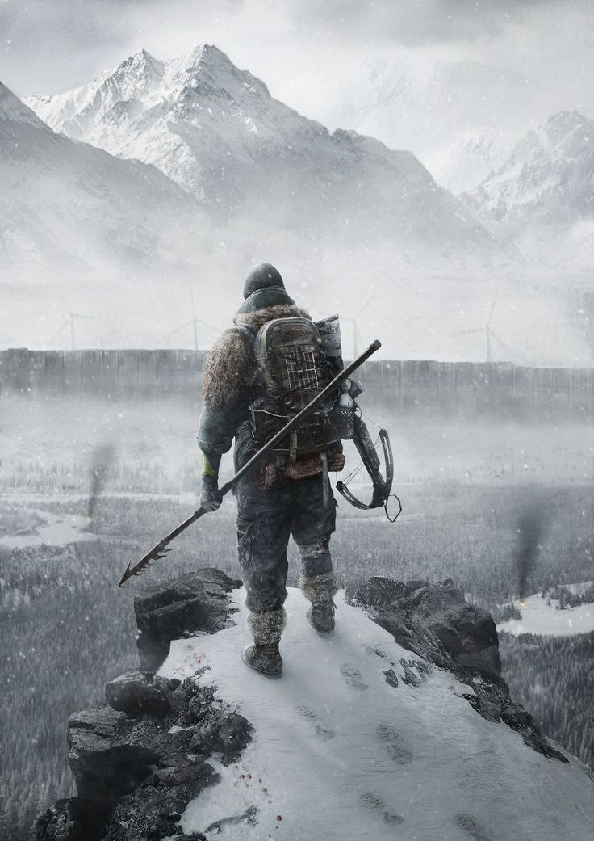

Gameplay

Overview
The game is a survival horror game. Join up to 3 friends to explore the world, sneak around zombies and hordes, loot abandoned buildings and dead bodies, complete objectives to upgrade homebase, shoot guns, craft impromptu/crude weapons, complete minigames to use weapons and medicine, and discover the story of POST MORTEM.

Core Mechanics
(Tactical/Realistic) First person shooter
FIRST PERSON CAMERA: camera bobbing, strafing, sprinting, walking, crouching, leaning left/right, equipping and using), reloading weapon, holstering weapon, pulling slide/bolt back (Pistols/Rifles), pumping guns (Shotguns/Lever-action weapons), winding up (crossbows/bows), pulling hammer back (Revolvers), etc.
NO FIST FIGHTING: throwing items, using melee weapons, slashing, piercing, bludgeoning, shoving, stomping, etc.

Inventory Management and Clothing
GRID SYSTEM: larger, more nuanced CLOTHING and BAGS = more SPACE (squares). ITEMS are rotatable (Think Resident Evil 4 or Unturned). Heavy ITEMS and CLOTHING affect players’ weight which affects walking and running speed (Inverse variables).
For example: carrying 5 rifles should make the player incredibly slow, but if players have an inventory full of spam then the speed is largely unaffected (Balancing purposes).

COHESIVE AUDIO: Different types of clothing affect AUDIO DECIBELS, i.e., cargo “tech-ware” and steel toe-ed boots are loud. The tradeoff being that while more pockets means more space, the player is more likely to draw attention to oneself. Leather clothing acts as ARMOR (Bite resistant and non-porous to fluids like blood), but leather is naturally more HEAVY/LOUD.

STREAMLINED STORAGE: Backpacks are the primary form of inventory and come in various types. They can also be placed/thrown to the ground to act as caches for the player and can be retrieved later even if the location is unloaded (Positions are saved). Each bag takes a different SHAPE in the inventory made up of squares (see diagram below).
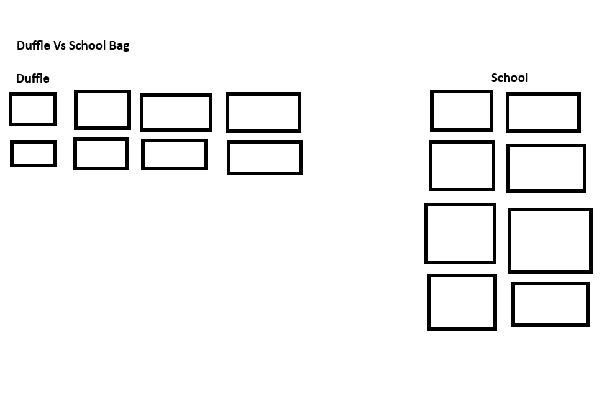
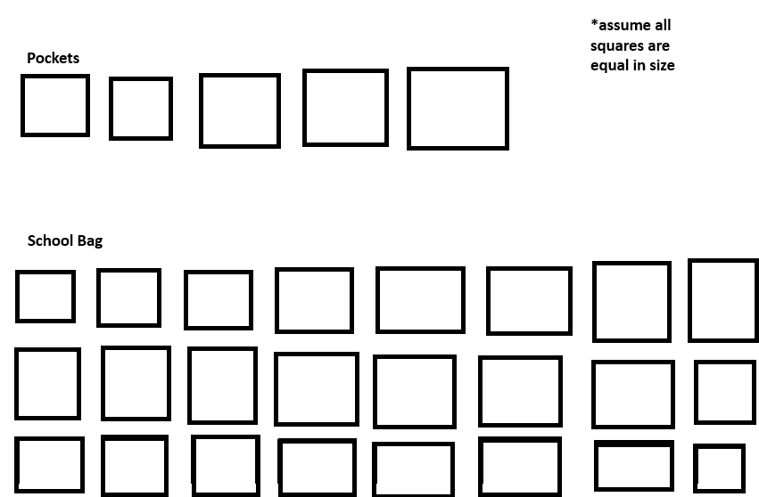

Backpack Tiers
Small (1lb – 5lb if Empty) - Leather bag/sling bag/fanny pack = smallest space, light weight, quiet. Best option for solo and quick expeditions

Medium (6lb – 10lb Empty) - Duffle bags/school bags = Great compromise of space, speed, and loudness. One-size-fit-all for expeditions

Large (10lb+ Empty) – Alice Packs/hiker’s bag/camping backpack = large amount of space, but if filled to the brim is surely a death sentence if cornered or in enclosed spaces. Good for “hunkering” down, horde fights, and scavenging with teammates

Players can and are encouraged to reload and have weapons ready for emergency scenarios

Active vs Backpack inventories
Upon entering the inventory, the player’s screen is divided into two sections:
- BACKPACK INVENTORY: represented by more traditional 2D UI displaying their guns, tools, and other items in the flat rotations that they set them.
  - Containers like barrels or chests in the game world will have the same appearance of backpack inventories, and it would replace the ‘ACTIVE’ side of the screen so the player can click and drag the items into their own inventory while retaining the 2D continuity.
- ACTIVE INVENTORY: represented by large circles encompassing 3D models of items that the player chooses to be there; labeled respectively as 1,2,3 and QUICK/AMMO. Whatever items are stored here are reflected in a hot bar during gameplay (holding right click and panning the mouse directionally rotates them).
  - Items in this inventory have a small circle at the origin of the 3D model that fills and turns into a solid dot when the player clicks and drags. This either moves the item within the active inventory or shifts it into the backpack where it reverts to a 2D icon. (Think of Resident Evil’s ‘Inspect Item’ function)

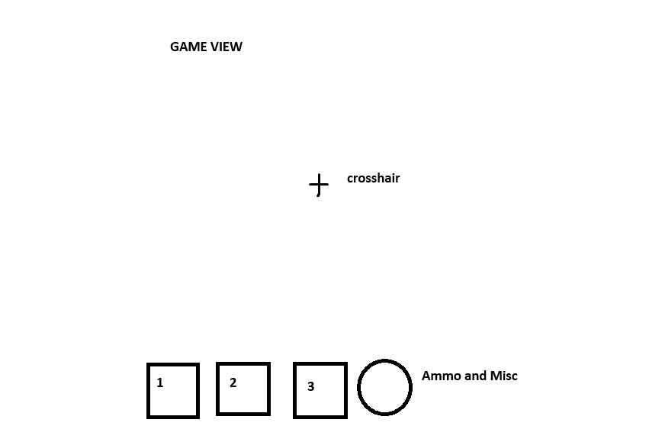
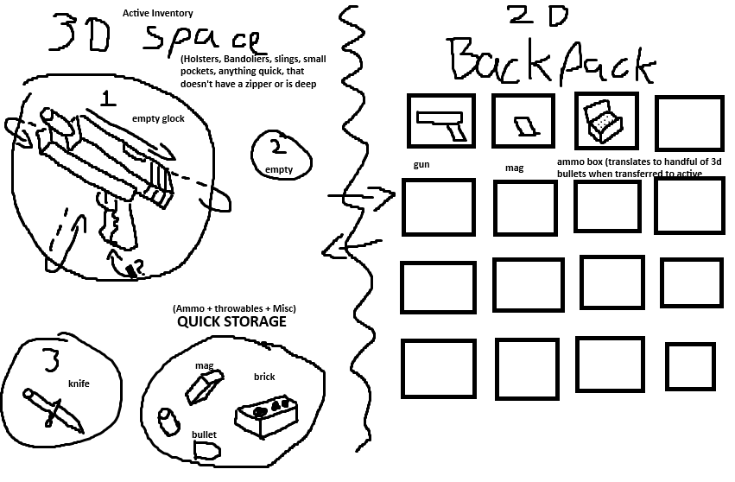

Example of this inventory dynamic using White Knuckle and Unturned (see below).
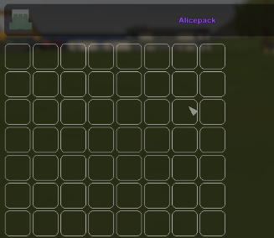
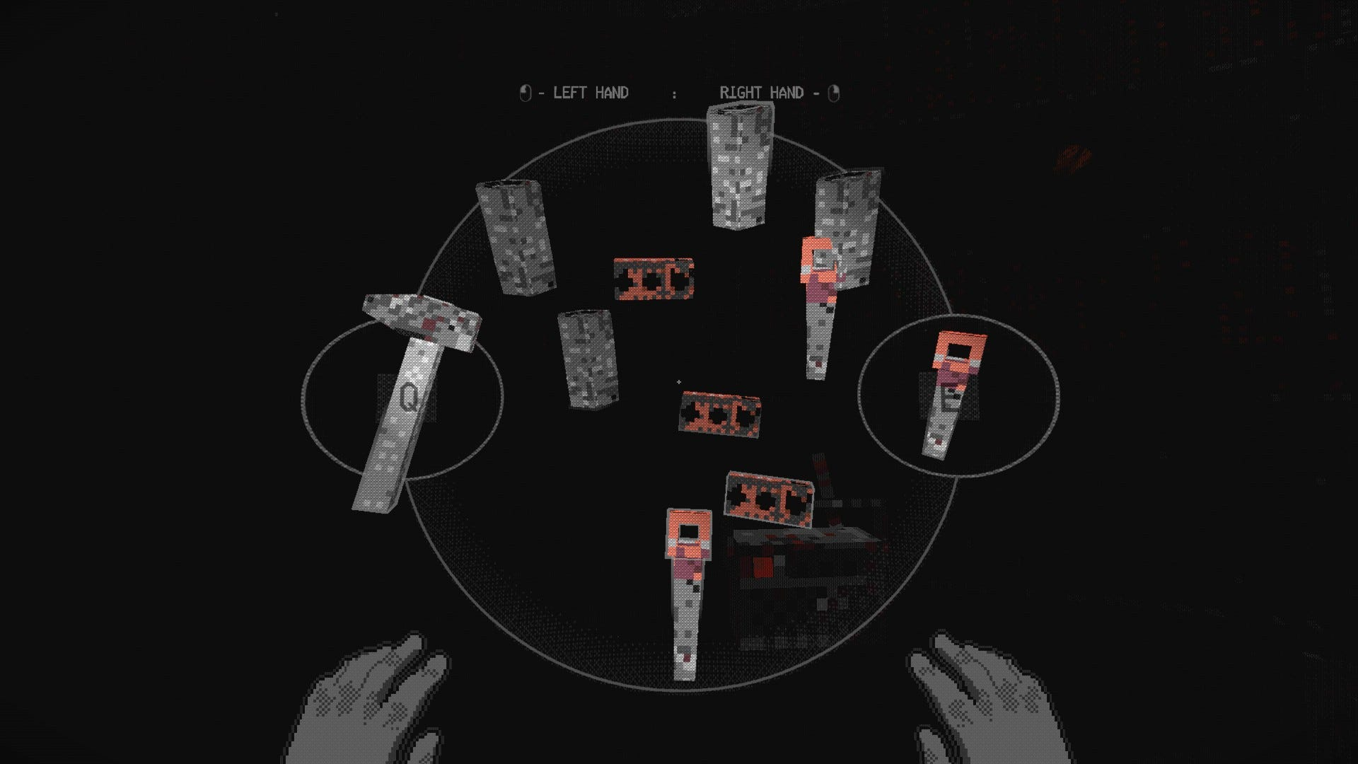

Medicine, Character Condition, and Other Medical Viewpoints
The player can check the status of their character using a diagram of their body by pressing ‘i’ or by clicking the down arrow in the inventory screen. They are presented with an icon of the player’s body where they can see smaller icons representing bites, lesions, burns, etc.

Example of this interface, including an example from Metal Gear Solid 3 (see below).
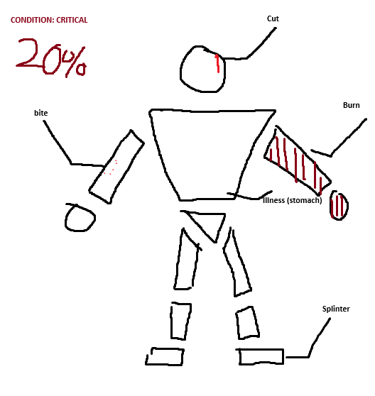
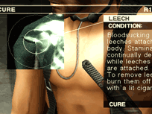

Modular Bodies
Zombies and players have modular bodies. Shooting a zombie’s leg enough will completely blow it off forcing them to crawl to the player (making them slower, think Resident evil). Blowing off zombie’s heads will cause blood and gore chunks to explode in the vicinity if the blast is powerful enough. Players may be compelled to remove an arm or leg manually if a limb gets infected with bacteria or the mutagen, causing them to permanently be stuck in a state of crouching/prone (if leg(s) get removed) or become unable to use two handed weapons or weapons at all (arms).

Backpacking Teammates
If a player is missing one or both legs, another player can wear them like a backpack (Note: the more limbs the HEAVIER they are). This should be treated more as a gimmick and quick way to save teammates in the face of danger. One benefit is that the backpacked player can look in a 180 direction, effectively acting as surveillance or - if equipped with a small firearm - as a turret. They can also access the same inventory space as the carrier. The drawback, however, is that the carrier must put down their backpack to carry the player. The legless player can only have a small backpack equipped on them. This mechanic is like a symbiotic inventory. This does mean that the backpacked player can ‘troll’ and sabotage the carrier, so choose who you backpack wisely.
Survival Mechanics
Hunger and Thirst are mechanics that only exist while out on expeditions or while under attack at homebase. Eating rotten food or drinking contaminated water (which would be labeled as such) will cause the player to become sick and lose a small amount of health (flat). Perhaps there are some audible drawbacks as well, such as moaning or vomiting, that could draw zombies to your location.

Movement Mechanics
- VAULTING: over 0.5-1 Meter obstacles.
- CLIMBING: over 2 Meter obstacles slowly over an animation period.
  - Players can also place and/or climb ropes and chains.
- LEANING: left and right using the [Q &E] Buttons on the keyboard.
  - It should play a smooth fade in/out animation of the camera, rotating no more than 45°. Ideally this would be somewhere in the 40° - 30° range.
- BOOSTING: over teammates by vaulting over them, remaining on top of the bottom player’s hitbox, and the bottom player can release the crouch button to elevate the top player.
  - This is to encourage co-operation and reach areas that would otherwise be inaccessible while playing solo (think of games like Counterstrike).
- PRONE: fit through small crawl spaces, reduce visibility, and reduce sound
  - Effectively acting as a stealth mechanic.

Safe Zones & Impromptu Safe Houses
Players can set up a temporary outpost on expeditions. Cabins and stores present on the map can have players move heavy objects in front of doors or put metal shutters down (stores in a mall for example). This is to primarily save the game and pass time by sleeping (all players must be sleeping to save). This can also be used to avoid hordes.

Exposure
Players have a dedicated EXPOSURE meter which, if maxed out, at a random point soon they will acquire the INFECTED status. Wandering in Horde Fog, swimming in contaminated water, being mauled/cut/bit by infected, and getting blood splattered on the player increases their exposure.

Infected Status
Once the player becomes infected their character’s visible appearance worsens over time, showing symptoms like the holes, muscle atrophy, and dilated pupils. When the player dies they become a zombie enemy which wears their equipment (think Project Zomboid). From the infected player’s perspective their controls might be inverted from time to time, they will hear auditory hallucinations, and their vision will begin to degrade: holes (blind spots and visual motif to the zombies), stretch and squash, FOV increases and decreases. These symptoms worsen over time and become more frequent until death.

Bites
Bites can only be removed by amputation. Bites continually increase the exposure meter until the player is infected. Bites give the player a flat 20% exposure increase upon being bitten. So multiple bites are a guaranteed death sentence.

Minigame-ification & Juicing Up Cooldowns
Players cannot simply press ‘r’ to reload a weapon or clicking a bandage to apply it: there is an additional nuance to normally forgettable mechanics.
- Magazines must be individually loaded with correct bullets from either backpack inventory or active inventory (so 2D icons clicked and dragged onto 2D magazine, or 3D bullets into 3D magazine [Orientation does not matter in this case]) into the magazine before it can be used from quick storage within the active inventory or manually loaded.
  - Note: you can load an empty magazine, it just gives the player a sad click when trying to use the gun.
- (Active Inventory) Magazines must be manually loaded and clicked and dragged into the correct position/orientation of the gun. It will automatically slide in once done. Alternatively, they can have the magazine ready in the quick storage section, return to the game view, press ‘r’ to reload, then press ‘t’ to pull back the bolt, pump, slide, or hammer to prepare the weapon.
- (‘r + t’ Method) For pump-action shotguns, ‘r’ must be pressed every time to load each shell individually, and ‘t’ pressed every time they fire to eject the shell and chamber a new one.
- If the player wants the weapon to be fire-ready once they return to the game view (out of the inventory UI) they can manually (click, click + drag with mouse icon) pull back the pump, bolt, hammer, or slide in the active inventory.
- Players do not need a magazine to use guns. They can put bullets in the quick storage and chamber rounds individually through the ‘r + t’ method, or by clicking and dragging through the active inventory.
- Revolvers must have their bullets individually placed into each slot after ejecting the spent bullets in the active inventory view.
  - This is simplified with the ‘r + t’ method. ‘r’ to eject bullets and ‘r’ for every bullet they want to reload as the chamber is popped out. ‘t’ to pull back hammer if the revolver type calls for it.
- Bandages can be applied to the player character by doing a spinning motion along the arm icon with a bandage equipped via the mouse.
- Injections can be applied by clicking, dragging, and releasing onto the spot in question.
- Amputations can only be conducted with a sharp tool like a saw or knife. Players must do a sawing motion along a dedicated path with the mouse to achieve a clean cut.

Hazards
The map of Post Mortem is riddled with traps and potential hazards for the player. Players not only need to be vigilant of the undead but must also be careful of surrounding traps.
- INFECTED WATERS: These are bodies of water that have or are in contact with the undead. For example, a large pool of still water that has a mass of corpses laying at rest at the bottom. If a player swims/traverses in this water, their exposure meter rises based on the conditions of the water. Drinking water from a river that has a corpse further up the river increases exposure drastically.
[Afflictions: Exposure, mutagen infection]
- BEAR TRAPS: Players that walk over a bear trap get ensnared and start bleeding. They move about half their normal speed to simulate dysfunctional legs. The trap must be removed through a minigame. In the medicine view, hold and click the afflicted body part and press ‘t’ rapidly to pry the trap open and stash in the inventory. The player yells once ensnared.
[Afflictions: Broken leg, bleeding, potential bacterial infection, loud noise]
- SOUND TRAPS: Bells rigged to trip wires, broken glass on a solid surface, pots, and pans, etc. These can vary in severity based on the environment. For example, breaking into an abandoned survivor camp and setting off a purposeful bell trap would be extremely loud. A minor trap would just be some glass near a broken window that would alert nearby zombies
[Afflictions: Loud – moderate noise]
- ROPE HUNTING TRAPS: Rope that hangs from the ceiling or branch of a tree that has a loop large enough to snare the leg of a human or small animal. If a player becomes ensnared they are flipped upside down and must cut the rope in a minigame (like amputation mouse movements) to free themselves from the trap. Generates moderate sound.
[Afflictions: Flipped upside down, moderate noise]
- DOOR TRAPS: traps that are rigged to activate when a door is opened. This can be a wire rigged to a gun, falling object, or IED. To combat this, players can open the door a tiny bit and peer into the next room. Inspecting the floor near the doorframe for wire, or wire on the doorknob on the other side should indicate to the player if the door is rigged or not. These traps are rare and should only be found in places that humans once resided in.
[Afflictions: Burns, Bleeding, Lesions, Death, loud-moderate noise]
- PIT FALLS: Holes that are purposely concealed with loose material to camouflage it to the surrounding environment. Most of them are not deadly as they are meant to contain unintelligent zombies, but some do contain more deadly consequences like spikes.
[Afflictions: Bleeding, Sprained Ankle, Death]
- HORDE FOG: Mist that coats the moving horde in a somewhat cylindrical shape. There are zombies within that can be spaced out up to 30 meters, with the center of the fog being denser with the more crowded areas of the horde. Traversing inside the fog increases exposure, with more dense areas (Many zombies in an indoor area, or several condensed in the horde) increasing the rate of exposure. This can be combated with a gas mask or special machinery meant to dispel the fog.
[Afflictions: Exposure]

- WEATHER: Going to high mountaintops or searing hot valleys can become an issue to players if they are not properly equipped. Leather clothing is great for cold climates while less thick clothing is better for warm environments.
[Afflictions: Debuffs (Walking slower, accelerated water loss for heat), gradual HP loss (Can be restored if going to an indoor environment or setting up a campfire)]

Homebase Management
Homebase is the player’s HQ. Players can upgrade their homebase by returning with resources from their expeditions. Located on a cliffside, repurposing an old historical site that natives used to live in. Here players can regenerate their health, pass time, restore their food and water, and craft new items. Players returning with key objectives like a generator can restore power to the site. See Homebase upgrades for full list.

Bullet Penetration and Ricochet
Hand guns and shotguns have low penetration on materials while rifles using large bullets have a higher penetration on materials. Here are the materials:
- Soft (20% Damage Reduction for low caliber bullets, 10%, for Medium Caliber Bullets, 0% for high caliber bullets): Paper (like books on a shelf), residential walls (Sheet rock), chain link fences, Branches, Glass
- Medium (50% Damage Reduction for low caliber bullets, 30% for Medium Caliber, 15% for High Caliber): Wooden Planks, Sheet Metal, Wooden Doors, Pipes
- High (Doesn’t Penetrate, High Caliber bullets produce more particle effects): Sandbags, Concrete, Most Metal Materials (Ricochet)

Stunned Affliction
When ADS (Aiming Down sights): rapidly firing or using the automatic feature on some weapons have a chance of stunning the player character if they have poor recoil control. Being stunned is like being struck with a flashbang (seeing stars, blurred vision, potential ear-ringing).

Jammed Weapons
Using guns and keeping them in poor condition (Wet, Muddy, Rusty) increases the chance of the weapon jamming. To solve this problem, clean the weapon with the SOAP, TOWEL, or OIL items. If the gun becomes jammed, the player must press the ‘t’ button many times until the bullet ejects or fixes itself.

Cleanliness
The SOAP and TOWEL items can be used to clean players to reduce their exposure meter. Got zombie blood all over you? Either remove the effected clothing or clean it with soap or a towel. Swimming in water is also a solution for this but is not nearly as good as SOAP.

Punishment for Death
Works similarly to dying in Project Zomboid: If your character becomes infected you need to defeat your zombie self to get a portion of your items back. KEY ITEMS that are important for story and regular game progression DO NOT DISAPPEAR.

Wet
Swimming in a body of water or being outside during rainfall causes the player character to have the WET status effect. This increases their likelihood of developing frostbite or other cold-related afflictions. This can be solved by starting a fire, drying off in an indoor environment, or by using the TOWEL Item.

Durability
Weapons and some tools have a durability percentage or status that worsens over use. Makeshift weapons are more prone to breaking rather than factory-made, non-rusted objects. Key Items do not have durability. Food has durability that tells the player whether a food or drink item has the capacity to be eaten without becoming ill or infected

Shortcuts
Ropes, Ladders, and other paths that open later allow players to skip areas they have already explored. The navigation of levels should not be linear. Think Dark Souls 1 shortcuts and progression.

Sleeping
Sleeping in a safehouse allows the player to pass time; however, if their safe house is not fully secured, there is a chance they could be attacked in their sleep. Think coin-flipping after sleeping in a bed in Fear and Hunger.

Special Infected
To keep the gameplay not-monotonous, variations of infected appear to increase difficulty of existing and future areas.

Protruding Objects
Throwing items like spears or using a weapon that shoots bolts/arrows allows the players to retrieve them later from the bodies or ground. Look up Rust for reference.

Gameplay Loop
After opening in the Title Menu and creating a new save, the player has the option to queue with 2 other friends. The loop goes as follows:
- Players start off at homebase, initially rundown and decrepit.
- Players go out on expeditions, via a menu in the homebase.
- Players sneak, collect, shoot, navigate tense environments, reinforce safehouses, use teamwork to solve puzzles, and survive while using the minigame-ified mechanics.
- Players find their objective (Collection, Elimination, Progress Story) and must return safely to homebase.
- Players locate an extraction point or hidden loading screen to return to homebase.
- Players at homebase upgrade, craft, and spend resources to progress.
- [LOOP]

Gameplay Guidelines
- Realistic tone, diegetic sounds and music, grounded. Anything “unrealistic” comes from the zombies since they are the point of suspension of disbelief.
- No children, no child zombies.
- The only NSFW content should be gore, body-horror (minus visible genitalia), and dark themes.
- Refrain from making any part of the narrative revolve around Indigenous tribes or use their cultural icons and traditions in a demeaning way for any of the designs of the levels and enemies.
- No futuristic guns or content. The origin of the infection is up for debate.
- No cars or horses.
- No mini maps; maps should not display where the player is.

Game Objectives & Rewards
The player’s objective in the game is to survive, improve their homebase, and unlock/explore more areas.

Tutorial
[T] Objective 1: Gather wood to create planks.
Reward: Knowledge on how to interact with game objects and craft items at a crafting bench.

[T] Objective 2: Create a weapon.
Reward: Wooden Plank + Nails blueprint.

[T] Objective 3: Kill a Zombie.
Reward: Zombie drops a pistol and a few 9mm, but with no magazine.

[T] Objective 4: Defend yourself from zombies.
Reward: Player gets to keep the pistol past the tutorial.

[T] Objective 5: The noise has attracted a mob… Board up the windows! Close the shutters and block the entrance.
Reward: Player learns how to make safehouses.

[T] Objective 6: Place a cot, and sleep.
Reward: Player learns how to pass time and skip horde events.

Main Game (WIP)
[M] Objective 1: Approach the historical site.
Reward: Player Discovers their HQ.

[M] Objective 2: Find matches in the nearby town.
Reward: Player has a fireplace in their HQ, learns how to stop frostbite.

[M] Objective 3: Find Seeds for food at a botanist shop 1.
Reward: Player will never fall below 20% food while at HQ.

[M] Objective 4: Find a generator.
Reward: Player restores power to the HQ.

[M] Objective 5: Find a rechargeable battery 1.
Reward: Player recharges equipment like flashlights while at HQ.

[M] Objective 6: Find a radio.

Item & Enemy Tables
Items and Attributes
GUNS & PROJECTILE WEAPONS |  | See PureRef’s for Visual References*
Item | Color “Rarity” Tag & Type | Attributes | Description
Derringer | Rare | 2 Rounds, Low Pen, low caliber bullets, semi-automatic  Weight Rating: 1 | A small handgun with two barrels. Often described as the smallest usable handgun of any given caliber. Takes up little space and handy in a life-or-death scenario.
M16 | Very Rare | 20 Rounds, Medium Pen, Medium Caliber Bullets, semi-automatic, burst, can jam  Weight Rating: 5 | Unmodified, standard issue rifle of the military. Historically used for jungle warfare despite it being found sometimes unreliable for harsh environments
Lever Action Rifle [Winchester Lever Action] | Rare | 10 Rounds, Medium Pen, Medium Caliber Bullets, Semi, [T] to use the lever, can jam  Weight Rating: 4 | A lever action rifle. Popular for sporting and hunting uses, Hard to use in the prone position
Revolver [Colt] | Rare | 6 Rounds, Medium-small Pen, Medium-small bullets, semi, [R] spin the cylinder out of the chamber.  Weight Rating: 2 | A handgun with a revolving cylinder with multiple chambers. Renowned for their reliability as they have a significantly less likely to jam
Heavy Revolver [Raging Bull, .357 Magnum] | Exceedingly Rare | 6 Rounds, Large Pen, High caliber, Semi, [T] to pull hammer back/spin the cylinder out of the chamber  Weight Rating: 3 | Larger, heavier, variant of typical revolvers. Explosive fire power and sure to put down even the largest of beasts with decisive but accurate aim.
Bolt Action Rifle [Remington 800] [M24] | Rare | 8 Rounds, large, large Caliber Bullets, Semi, [T] to pull the bolt back, can jam  Weight Rating: 4 | A bolt action rifle, commonly used for sniping and hunting.
.22 Home Defense Gun [M1-Carbine, M1-Garand, Lee-Enfield] | Rare | Rounds Vary, Medium-Large Size, Medium Caliber Bullets, Semi, [T] to pull bolt/lever back, [R] To reload bullet into chamber, clip into m1-garand, magazine into M1-Carbine  Weight Rating: 3 | Rifle used for home defense and hunting. Decommissioned from the military but revered for its light-weightiness and ease of use
Pump-Action Shotgun  [Remington 870] [Mossberg Breach Shotgun] | Rare | 8 12-gauge shells, Med. Pen., Semi., [T] to pump the shotgun/eject shell, [R] for each shell inserted  Weight Rating: 4 | A shotgun that shoots 12-gauge shells. devasting at close-medium ranges but less effective at longer ones. It is useful for close encounters inside buildings or hunting when you aren’t too concerned about preserving all the meat. Shells must be individually loaded.
Saw-ed off Shotgun | Rare | 8 12-gauge shells, Med. Pen., Semi., [T] to pump the shotgun/eject shell, [R] for each shell inserted  Weight rating: 3 | A pump action shotgun with a sawed-off barrel. It retains its destructive short-range power, but the spread is significantly worse at medium-to-long ranges; takes up significantly less inventory space.
Double Barrel Shotgun | Rare | 2 12-Gauge Shells, Med. Pen., Semi., [T] to pry open shotgun, [R] to reload shells  Weight Rating: 3 | Common Home Defense and Hunting Shotgun
Drilling Gun | Rare | 2 12-Gauge Shells, Med. Pen (Shells). Large Pen (Rifle Round), [T] To pry open gun, [R] to reload shells first then rifle round  [X] to switch from firing shells to rifle round and vice-versa  If the player fires the shells first, the rifle round will be the 3rd shot, if the player shoots the rifle round first the last two rounds will be the shell.  Weight Rating: 4 | Versatile Break-action weapon that uses two 12-guage shells and a single rifle bullet. Commonly referred to as a “Forester’s gun” due to its versatility in many hunting scenarios. Issued to pilots of old wars as a luxurious survival weapon.
Magazine Fed Pistol [TLE-1911, M1911, Beretta, Glock 19/21/22, P320, Five-Seven] | Rare Gun | 15 Rounds, small pen., small bullets, Semi, [T] to pull the slide back, can jam  Weight Rating: 2 | A handheld firearm. When kept in good condition, it’s a reliable weapon to quickly pull out and deal with a threat. Common firearm of law enforcement.
Magazine Fed Pistol (High Caliber) [Desert Eagle] | Exceedingly Rare | 7 Rounds, Large Pen., [T] to pull slide back, can jam, Semi.  Weight Rating: 3 | Heavy Handheld Firearm. Heavy fire-power and heavy recoil. Recognizable even to non-gun enthusiasts because of popular representation and romanization in various media from the old world.
SMG [MP5, UMP-45, UZI, Mac-10] | Exceedingly Rare | 30 Rounds, Small Pen., Small Bullets, Semi, Auto, doesn’t require a [T] motion, can jam  Weight Rating: 3 | A small machine gun. An ergonomic alternative to regular machine guns. Preferred by many for urban fighting due to its maneuverability in indoor environments, relatively low weight, and ease of use.
Automatic Shotgun [Benili-M4] | Exceedingly Rare | 8-10 shells, Med. Pen, 12-gauge Shells, Automatic, does not “require” [T] Function, CAN JAM [T] to clear chamber  Weight Rating: 5 | An automatic shotgun that provides tremendous fire power, users must have incredible recoil control to use rapidly. Best suited for crowd control
Bow | Uncommon Weapon | 1 round, small pen, arrows, hold left click to draw back, release to release  Weight Rating: 2 | The preferred ranged weapon for most of recorded history.
Compound Bow | Rare Weapon | 1 round, Arrows, Hold left click to draw back (faster), release to release  Weight rating: 3 | An improved version of the regular bow. Drawing back the string is often found to be easier than a traditional bow and has more precision.
Crossbow | Exceedingly Rare Weapon | 1 Round, Small Pen., Arrows/bolts, Spam or hold [T] to pull back string  Weight rating: 3 | Ranged weapon that uses a loaded elastic string and a bolt. Commonly used for Hunting.
Tools and Key Items | These Items do not get lost upon death, should never, or rarely despawn.
Item | Rarity and Tags | Use | Description
Binoculars | Rare Tool | Zoom into the distance | Useful for scouting across long distances
Flashlight | Key Tool | Creates a cone of light | A necessity to navigate a world submerged in darkness
Glow Stick | Uncommon Tool  Throwable | Creates a soft glow when thrown or placed | A smart navigator’s trusty disposable tool. Useful for marking routes already taken and to illuminate potential threats without stimulating them substantially.
Watch | Rare Tool | Displays the time in the inventory | Useful for keeping track of time in indoor environments, where the sun would otherwise not be visible.
Pen | Key Tool | Gives the player the ability to write notes and draw on maps with the mouse | A writing tool that uses ink. This pen seems unused. Useful for writing notes and drawing on maps
Compass | Very Rare Tool | Gives the player the ability to display North, West, East, and south on their HUD when the compass is equipped, displays the direction they are facing when in inventory | A tool that uses magnetic north to display the cardinal directions the user is facing. Originally a device used for divination, it later became adopted as an integral tool for navigators.
Survival Knife | Key Tool | Gives the player the ability to melee attack, treat certain wounds, and to craft early game items | A must have for any survivalist.
Saw | Rare Tool | Can create planks w/o a crafting bench. Can be used to amputate and/or release a player from a trap using a sawing motion with the mouse | A tool that uses a back-and-forth motion to create a smooth cut between hard materials. Hopefully, it won’t have to serve another purpose…
Matches | Uncommon Tool | Light fires, Creates a small amount of light in a sphere. To ignite, the player uses the mouse to drag it across the match box | A small stick with a highly flammable material coated on one end that can be ignited with friction.
Rope | Uncommon Tool/Medicine/Crafting Material | Used to create shortcuts, used as a crafting material, and used for impromptu splits/tourniquet | Long, fibrous material that is used in a multitude of ways
Blow Torch | Rare Tool/Medicine | Cauterize Wounds, Craft many more items | Gas Fed torch used to craft items. May have some unconventional uses.
Torch | Rare Tool | Illuminates surrounding environment, direct and much improved upgrade of a match, can light fires, Scares animals  Weight Rating: 2 | A stick with a fire at the end of it
Crafting Materials
Item | Rarity and Tag | Use | Description
Twine | Common Crafting Material | Craft items that use Twine | Twisted strong threads used for a multitude of items
Wood Logs | Common Crafting Material | Craft Items that use Logs | Raw material that is the basis of all things
Wooden Planks | Uncommon Crafting Material | Craft Items that use Wooden Planks, Board up Doors and Windows | Processed version of Wooden logs in the shape of a rectangle, used commonly for barricading and many crafting recipes.
Empty Casing (S, M, L, Shell) | Common material | Crafting material for bullets and scrap | Expended bullet/shell casing
Gun Powder | Rare Material | Crafting Material for explosives and makeshift bullets | The foundation of anything that goes boom
Makeshift Bullet/shell | Uncommon Consumable | Acts like a bullet, does half the damage of a regular bullet
Battery | Uncommon Crafting Material | Replenishes energy of small electrical devices, [?] Currency | A rarity of the new world, used for plenty of useful devices that are not reliant on charging stations. Sometimes it serves as a form of currency and commonly used for bartering
Medicine/Consumable/ Hygiene
Item | Rarity and Tag | Use | Description
Anti-biotics | Rare Medicine | Can treat infected wounds and prevent standard infections | Considered to be one of the greatest inventions of all time that has saved countless lives throughout modern human history. Used to treat wounds from being infected by bacteria.
Stiches | Uncommon Medicine | Can treat lesions | Closes wounds to potentially deadly exposure to outside elements
Gauze/Dressing | Uncommon Medicine | Can treat cuts, burns, bleeding, and protects from infection | Medical covering for wounds made from cloth. Promotes healing of a wound in a hopefully sterile environment
Splint | Rare Medicine | Can treat sprained and broken bones | Keeps fractured and sprained limbs in place to promote proper healing
Hot Knife | Uncommon Medicine | Sterile Knife that can Cauterize Wounds within 30 seconds. Does a little more damage to enemies | A knife with a significantly hot blade. Can Cauterize wounds and prevent further bleeding. Perfect for killing unwelcomed guests- big or microscopic.
Tourniquet Kit | Rare Medicine | Slows bleeding significantly | A device used to apply pressure to a limb or extremity to stop or slow the flow of blood. Could mean the difference between life and death.
Soap | Rare Consumable | Cleans Weapons, clothes, and body from dirt mud and exposing material like blood | A bar of soap; a normalcy and far cry of a society long gone. The best preventative measure of illness and helps upkeep equipment
Towel | Uncommon Consumable | Cleans Weapons, clothes, and body from dirt mud and exposing material like blood. Reduces/removes Wet affliction | A piece of fabric meant to clean and dry materials
Dirty Rag | Common Consumable | Poorly Cleans Weapons, clothes, and body from dirt mud and exposing material like blood.  Reduces/Removes Wet Affliction, very slightly increases exposure, can be turned into a towel if the player combines with soap | Better than nothing
Misc/Yet to labeled
Item | Rarity and Tag | Use | Description
Bear Trap | Rare Placeable | Traps the legs of those who fall in it, inflicts bleed, fractures, and lesions  Weight Rating: 4 | Powerful foot trap for unsuspecting animals or humanoids.
Bottle | Common Throwable | Creates noise on the impact of a solid surface, does not work on grass, creates a small field of glass on impact | An empty bottle
Makeshift Spear | Uncommon Weapon | Hits enemies around 2 meters in front of the player  Weight Rating: 2 | A weapon to hit enemies from a respectable distance
Clothing & Armor |  |  | See Pureref’s for Visual References. Starred Items*
Bags |  |  | Weight Rating # = When empty
Bag | Rarity & Tag | Details | Storage & Weight
Fanny Pack | Common  Small Bag | Goes across player’s chest or rests just above their hips in front or behind the player  Doesn’t produce noise on walk cycle | Storage: Low  Weight Rating: 1
Satchel | Uncommon  Small Bag | Satchel with a sling that rests on nears the players hip with the strap going across their chest  Quiet | Storage: Relatively Low  Weight Rating: 1
School Bag | Common  Medium Bag | School bag that comes in a variety of colors, Place on the players back.  Produces little noise on walk cycle | Storage: Medium  Weight Rating: 2
Duffle Bag | Uncommon  Medium Bag | A bag typically used to hold sports equipment that can be worn near the hips with a strap across the chest, but preferable rests on the players back  Produces noise on walk cycle | Storage: Medium  Weight Rating: 2
Leather/Wool Backpack | Rare  Medium Bag | A backpack with leather straps and waterproof/wooly fabric. Can also be made out of leather.  Largest of the Medium bags  Produces noise in walk cycle | Storage: Medium  Weight Rating: 2
Hiker’s/Climber’s Backpack | Very Rare | Vertically Large backpack meant to hold long rope, and an assortment of items meant for the outdoors. Made from water proof material like nylon  Produces a lot of sound, especially when full | Storage: Large  Weight Rating: 3
Alicepack | Extremely Rare | Large backpack used by the military features many pouches on its exteriors and clips  Produces a lot of sound, especially when full | Storage Large  Weight Rating: 3
Survivalist Backpack | Very Rare | Leatherbag meant for large stretches of time out in the wilderness  Produces a lot of sound, especially when full | Storage Large  Weight Rating: 3
Holsters
Name | Rarity & Tag | Details | Storage & Weight
Drop Leg Holster | Extremely Rare | Drop leg holster for Pistols  Reduces equip time for pistols | Large enough for a pistol  Weight Rating: 1
Gunslinger Holster | Extremely Rare | Leather holster that has slots for bullets unique to it. Meant for revolvers  Reduces equip time for pistols | Pistol/revolver sized  Weight Rating: 1
Shoulder Holster | Extremely Rare | Leather shoulder holster that has storage for magazines and a pistol that rests underneath the character’s arms  Reduces Equip time for pistols and reduces reload time | Large enough for a pistol and 2 magazines  Weight Rating: 1
Knife Holster/scabbard | Very rare | A holster for a knife that can attach to the arm or legs  Reduces equip time for the knife | Fits a knife  Weight Rating: 0
Jackets
Name | Rarity & Tag | Details | Storage, Weight, AR
Rain Jacket | Rare | Jacket made out of water proof material  Reduces Wet accumulation by 50% | Storage: Very Low  AR: 1  Weight Rating: 1
Winter Jacket | Rare | Jacket that keeps the player warm in winter conditions  Helps prevent the player from accumulating cold | Storage: Low  AR: 2  Weight Rating: 2
Trench Coat | Very Rare | Long Jacket that keeps the player somewhat warm and helps keep them safe from the rain. Usually made from leather  Noisy, Bite resistant | Storage: Low  AR: 5  Weight Rating: 4
Leather Jacket | Very Rare | Jacket made from thick leather, keeps the player warm and protects against enemies bites  Noisy, Bite Resistant | Storage: Low  AR: 4  Weight Rating: 3
Jacket | Uncommon | Generic Cotton jacket, helps against the cold somewhat but more of a stylish/storage thing | Storage: Low  AR: 1
Hoodie | Uncommon | Generic Hoodie, protects against cold | Storage: Very Low  AR: 1
Enemies, NPCs, and animals
Colloquial Name | Spawns Points | Bestiary/Regular Description | Drops
Zombie (WIP) | Everywhere, Urban Areas | Shuffling revived human remains looking to spread the mutagen, can be found in packs. Signs of the mutagen virus like holes are found everywhere across their bodies | Contaminated food, clothing, player zombies drop their items, bullets (rare), often they don’t drop anything
Shedder | Damp environments | Zombies that have had all their skin rot away and “shed” like snake skin, their tendons and bones are exposed, with the muscle atrophying. They “shuffle-speed-walk” and moan towards the players, exposed bones can create lesions | Nothing
Bloomer | Rare | Shedders that took skin from their victims and took parts of their environment to camouflage and cover their exposed muscles and bones. Their face flaps open like the Demogorgon from “stranger things” revealing the skull and muscle underneath. During this animation they spit forth particles of blood a short distance away. The extra skin and debris act like armor. Either destroy a leg or attack when their face opens. See Pureref for reference
Spider, Hunters | Rare, forest, Mountains, Caves | Their skin has hardened from the forces of nature and blackened from necrosis; the mutagen has caused their limbs to extend over time to adapt to navigating rough terrain. They sometimes are seen with fur or extra limbs or joints. They can climb, Hug trees, wait in water. They are the new apex predators of the forests and dark environments. They can shuffle across the ceilings like a spider. Beware of their blood spilling down. Avoid it when possible.
Nightmare | Rare | An infected bear, notorious for being a bullet sponge, like a normal bear already wasn’t a tank, targeting exposed tissue, bones and the brain will help take this beast down
Biters | Uncommon, infected waters | Infected fish that have a taste for blood, move in schools, | Contaminated fish meat
Coral Heads/Feelers | Uncommon | Infected that have a malformed head that resembles coral, makes it harder to kill in one shot to the head, targeting the limbs is advised. They are blind and deaf and feel around in their environment for prey, making them dangerous scouts in enclosed areas. They often get stuck in crawl spaces like caves, vents, etc.

Level Design

The levels of POST MORTEM can be described as “mini-open worlds.” While they may feel vast and open, with indoor areas presenting challenges, they are essentially large levels segmented by loading screens. The game functions similarly to an extraction shooter like Escape from Tarkov, where players choose a level to deploy in and must meet specific conditions to return to HQ. Previous locations can be revisited after acquiring key items like rope or story-based tools, adding metroidvania elements. The design draws inspiration from games like Dark Souls (particularly the first), where levels connect back to HQ and shortcuts open paths to earlier checkpoints.

Progression
Instead of following a linear path, level exploration in POST MORTEM emphasizes discovery, trial-and-error navigation, and route planning over clearly defined objectives. Early on, players are expected to rely heavily on their pen and map by sketching layouts, taking notes, and marking deadly traps.

Revisits
On repeated visits to a level, rare random events help keep routes unpredictable. These can include new trap placements, zombies roaming into different areas, or deadlier threats like horde events.

Safehouses
Checkpoints are represented as safe houses. Early in the game, these come with built-in safety measures. Later, players must spend resources to secure them. For example, while navigating an abandoned mall, a player might find a relatively intact store. To make it a usable safe house for saving or skipping time, they must:
- Lower the metal shutters
- Board up broken windows
- Block large entrances with heavy furniture
- Block small entrances like visible vent openings, or crawlspaces
- Find and kill zombies that are dormant or hiding in the room
- Place a Cot/Sleeping Bag

Safe houses are designed to give players a mental break, a moment to decompress from the constant tension, similar to typewriter rooms in Resident Evil or workbenches in Dead Space. However, players shouldn't become too comfortable or conditioned to feel entirely safe. To maintain unease, occasional scares can occur, such as ambushes, unsettling sounds, attempted break-ins that interrupt sleep (forcing players to skip time again), interruptions during crafting, or environmental cues like flickering lights.

Hazards
Levels are filled with a variety of hazards spread across the map, including environmental dangers, traps, and weather effects. For example, a swamp might feature thick mud that increases the chance of weapon jams, while a water treatment plant could have large, submerged areas that require swimming. (See the Hazards list under Mechanics for more detail.)

Enemy Placements
Enemies spawn within designated zones during the map’s loading phase, with their exact positions randomized within each zone. When designing these areas, it's important to leave enough clearance around walls and objects to prevent enemies from spawning inside geometry.
Some enemies can be manually placed for scripted events such as a Coral Head lodged in a vent or a chase sequence involving a Nightmare. These events are one-time occurrences and do not repeat.
Larger, boss-like enemies require dedicated arenas if they are intended to be fought or used as major obstacles, to account for their size and movement capabilities.

HQ
The headquarters is a repurposed cliff dwelling that upgrades over time as the player progresses. Originally built from sandstone, structures are gradually reinforced with wood and metal, transforming into fully repaired buildings. As the HQ evolves, lights are installed, fences are strengthened, paths become clearer, gardens appear, and fortifications are added. The visual difference between the starting and fully upgraded state should be distinct and meaningful.

Control Scheme

Button/ Touch Input | Action it Performs
WASD | Move Up Down Left Right
Space | Vault, Climb, Climb Rope, Climb Ladder, Climb Player
Right Click (Hold) | Ready weapon to fire in a general bloom cone, Think PUBG
Right Click (Tap) | ADS, Iron Sight, Scope
Left Click | Fire, Interact with inventory Items, Place Items (Workbenches, Cots, Fireplace)  [Empty Hands] Open Door Slowly upon clicking door knob
Middle Mouse Button (Push) | Character Points (No Weapon Equipped)  Activate Weapon Attachment (Flash Light, Laser)
X | Change Firing Mode
V | Push to Talk
ESC | Pause Menu
TAB | ACTIVE/QUICK INVENTORY  With Bag in hand, Split View of ACTIVE/QUICK INVENTORY
B | Holster Unholster Backpack
M | Pen, Map, and Compass View
N | Quest Notes, Blank Notes, Bestiary?
Shift | Run
Alt | Walk
CTRL | Crouch
Z | Prone
F | Interact (Containers, Doors, Misc.)
F (Hold) | Slow Open Doors
1,2,3,4 | Equip/Holster Active Inventory
Q, E | Lean Left, Lean Right, Flip Pages in Notes and Books
CTRL + ALT | Slow Crouch (Stealthy)
T | Weapon Functionality and In-Menu Interactivity functions
R | Reload and rotate item in inactive inventory
~ (Hold) | Free-Look Camera

Game Aesthetics & User Interface
WIP

Sound Design
In POST MORTEM, diegetic sound is key. Sounds of zombies and the environment should tell all the player needs to know. Unless an important story beat is occurring, there should be no music. Details like what type of clothing the player character is wearing - such as a baggy jacket or steel toe-ed boots - should make a difference on how properly the zombies can detect players, and the sounds that they produce should be different as well. More details are included on the cue sheet.

Music
Music is exclusively played on menus such as the title screen and the pause menu. It should be reminiscent of games like The Last of Us and The Walking Dead. Somber and melancholic are the correct adjectives to describe it since the setting of the game is post-apocalyptic. Another avenue to explore is drone-y/ambient sounding music consisting of pads that evoke mystery and/or an ominous presence. A Diegetic example within the game would be, once the player repairs a radio, they can hear music coming from it, in which case it would be more generic but reflective of the Colorado environment.

Equipped Items
Equipped items affect the walk cycle looping sounds, particularly heavy items. For example: walking with a heavy cargo jacket equipped makes thick rustling sounds within the world, having a thick Alice pack on top of that makes both of those looping sounds play at the same time. In other words, it is cumulative and reflective of what the player is wearing in the game world. Hence this makes lighter clothing a better selection for being sneaky despite the lesser-inventory drawbacks.

Environments
Howling winds during a storm, Breeze through the trees, Caves adding reverb, indoor areas making sound from the outside drowned out, water also drowning out sound. The environment affects diegetic sounds.

Proximity Voice Chat
Players have the option to use the in-game proximity voice chat, bringing opportunities for the players to “role-play” as their characters. There is an option before the player plays if the game has consent to turn on their microphone. Upon clicking yes, most pre-recorded vocals for the characters should be muted with exceptions for winces and death-related sound effects.

Upon death, players’ voices in proximity chat taper off as to not break immersion over a course of ~5 seconds if the death is related to infection or blood loss. Players that die from head trauma like a large fall or explosives have their microphones cut off immediately.

UI
Small ticks and tacks describe what the player is hovering their mouse over, ticking boxes that are empty or not empty also have different sounds, and clicking on items and rotating them makes noise. When interacting with items in the ACTIVE INVENTORY view their 3D Models make their respective sounds. Medical views and operations make sounds as well.

