**Academia International College**

Tribhuvan University

Institute of Science and Technology



*Lab Report on*

**Multimedia Computing**

**Submitted To:**

Prajwal Bista

Department of Computer Science & IT

Academia International College

**Submitted By:** Paras Limbu

Bsc Csit 5th semester

Roll no:16

**Lab Report:** Illustrate the morphing technique.

Objective

The objective of this lab is to create a morphing between two sunset images using Macromedia Flash.

Morphing:

Morphing is a special effect in motion pictures and animations that changes (or morphs) one image or shape into another through a seamless transition. It is often used to show a transformation, such as a character changing shape or a face aging. This effect can be achieved using computer graphics software that interpolates the changes between the start and end images, creating intermediate frames that gradually transition from one image to the other.

Step 1: Import Images

Open Macromedia Flash.

Import both sunset images into the Flash library by selecting File > Import > Import to Library.

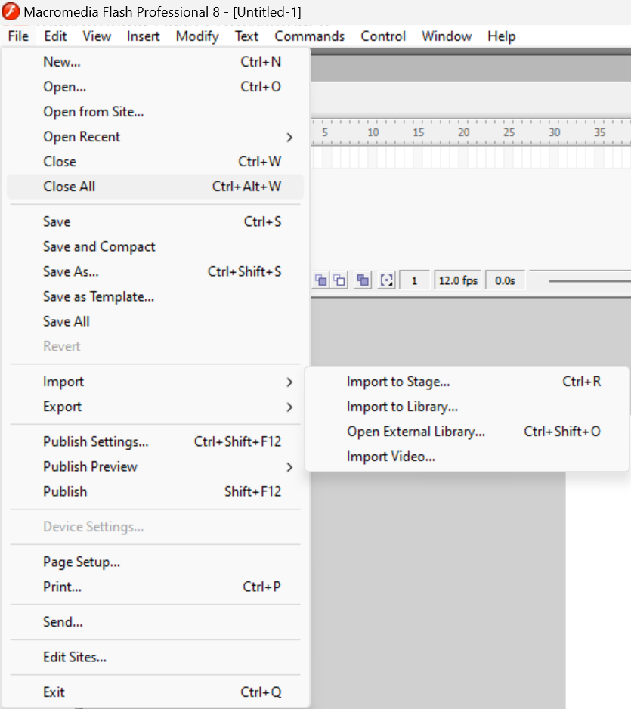

Select the images you want to import and press enter. Imported images should be shown at the right-hand side.

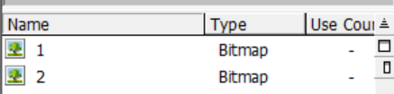

Step 2: Set Up Layers

Create a new Flash document.

Add two layers in the timeline: one for each image.

Name the layers "Image 1" and "Image 2".

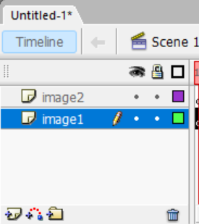

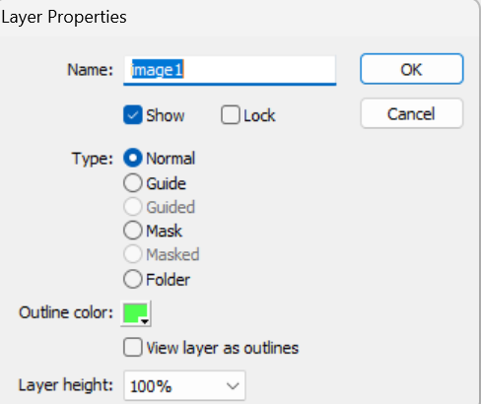

Step 3: Insert Key frame

Select frame and press f6 to create key frame.

Make keyframe in about 30 for image 1 and 50 for image 2

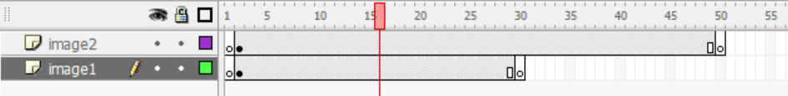

Step 4: Place Images on the Stage

Drag Image 1 from the library onto the stage in the "Image 1" layer.

Drag Image 2 from the library onto the stage in the "Image 2" layer, positioning it exactly over Image 1.



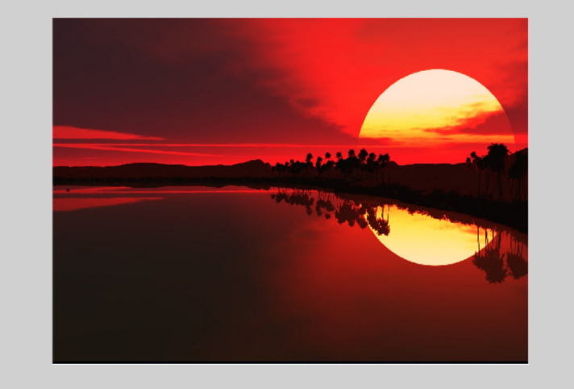

Step 5: create motion tween

Select any where between two frames form layer 1 and right click -> create motion tween

Do same for layer 2.

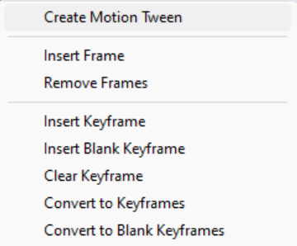

Step 5: Make fade away effect

For layer 1:

Select frame 1 and make alpha level to max 100%

Then select frame last 30 and make alpha level to min like 10%

For layer 2:

Select frame 1 and make alpha level to min 0% up to like 25 frames.

Select 25 frame and again make alpha level 0%

Select last frame 50 and make alpha level of image to 100%



Step 6: Adjust and reefing

Adjust and refine according to your requirement.

Output:







CONCLUSION

From the above experiment, we concluded that we can smoothly change one image to another image using macromedia flash.