# Exercise 1

2) 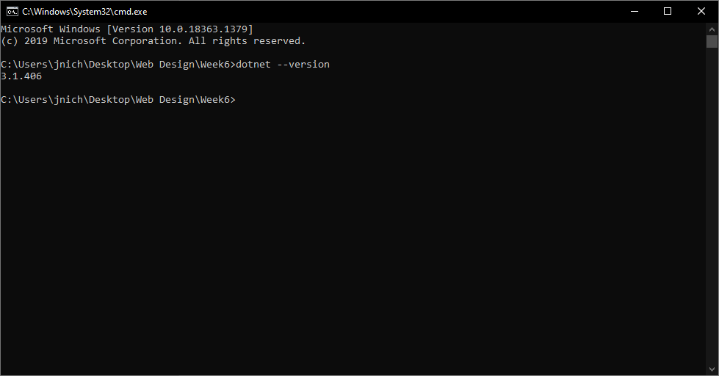

3)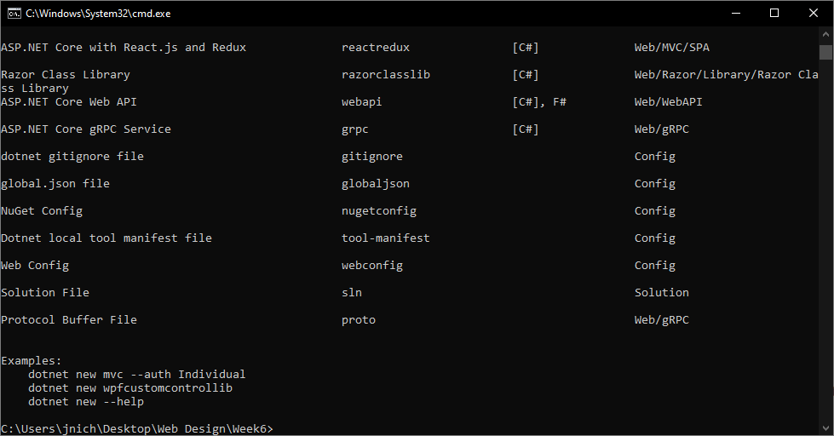

# Exercise 3

7) 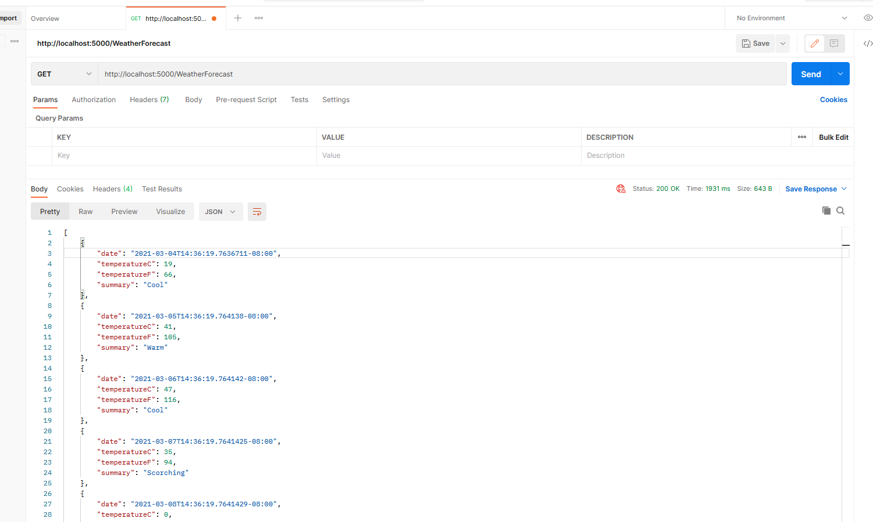

8) 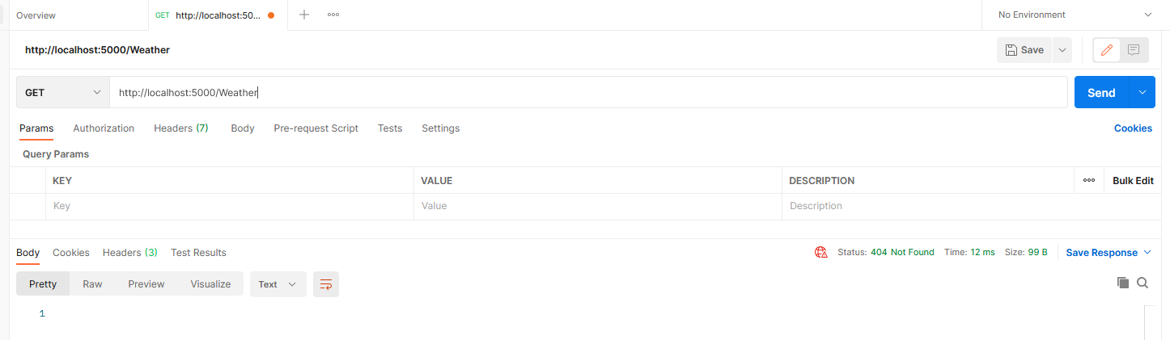

# Exercise 4

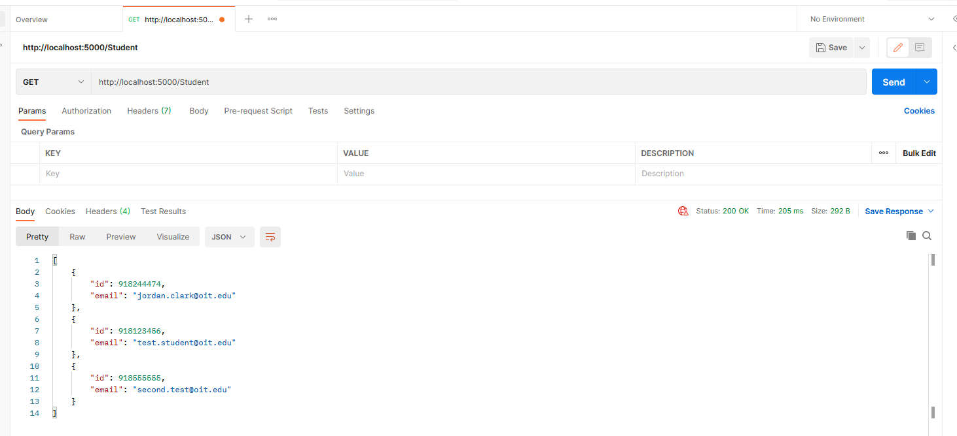

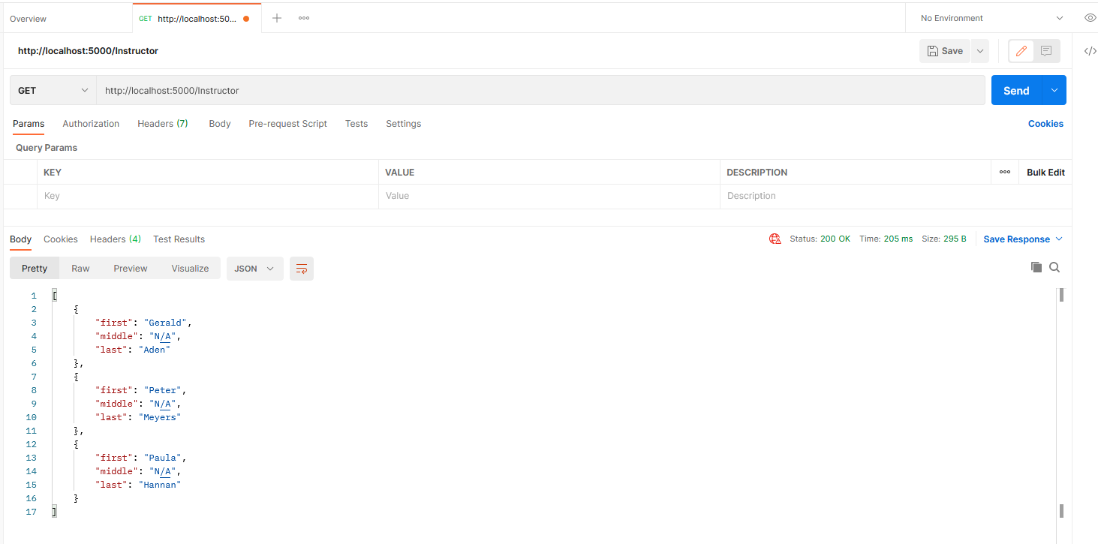

GitHub: https://github.com/Drilbur-CST126/CST356/tree/main/Week6

Docker: https://hub.docker.com/repository/docker/jordanclark308/week6app