# Exercise 1

7) 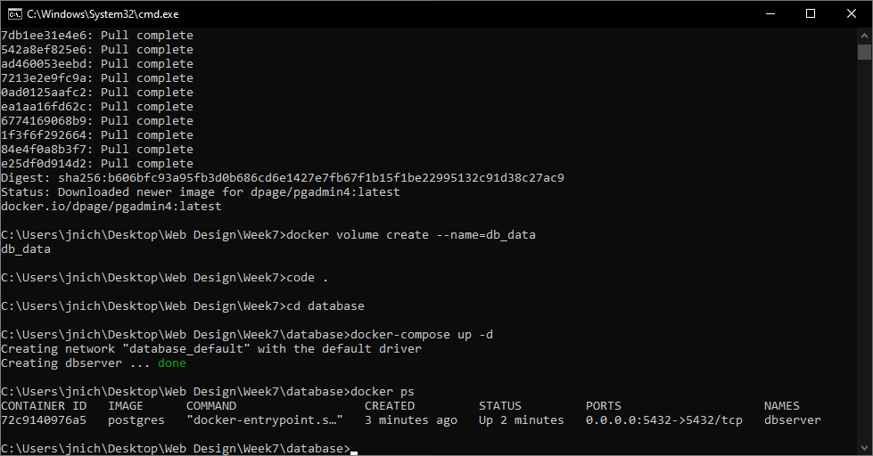

8) 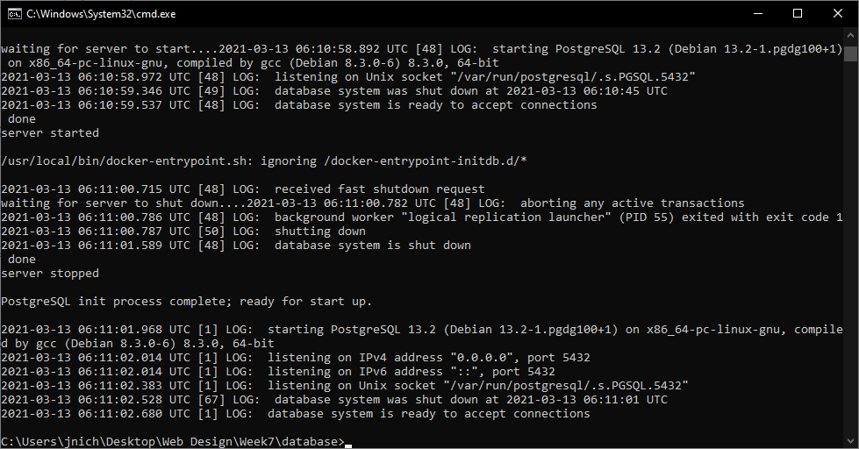

10) 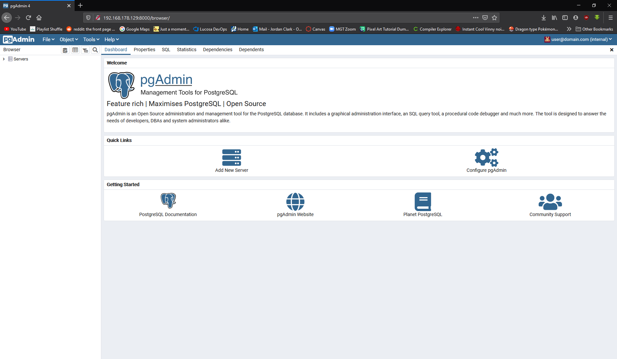

# Exercise 2

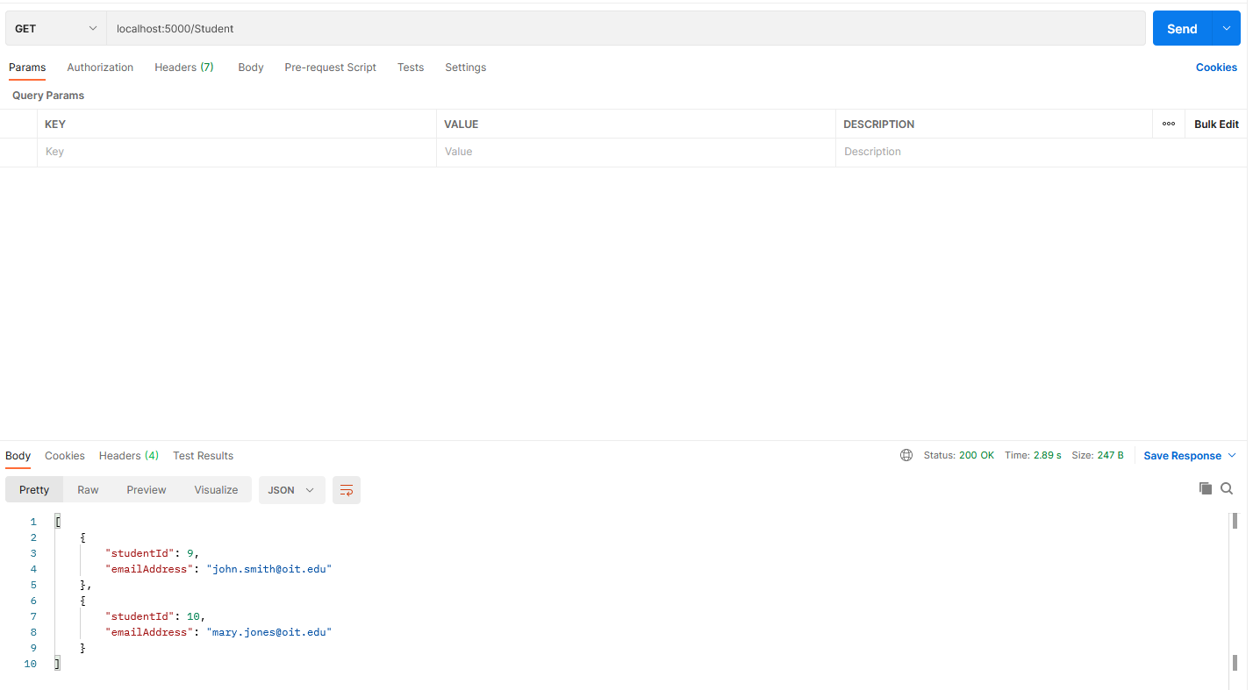

# Exercise 4

7.1)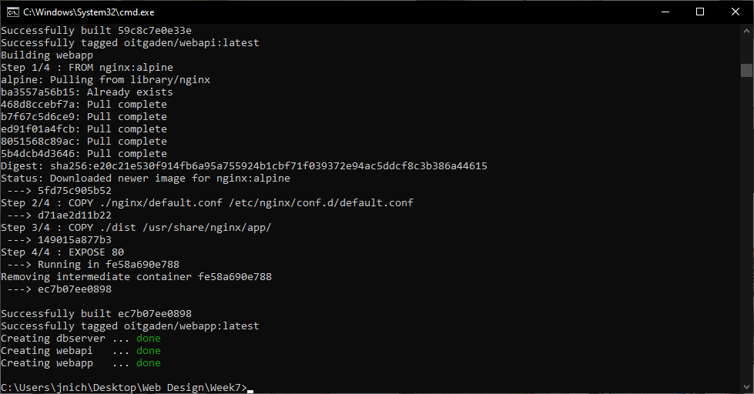

7.2) 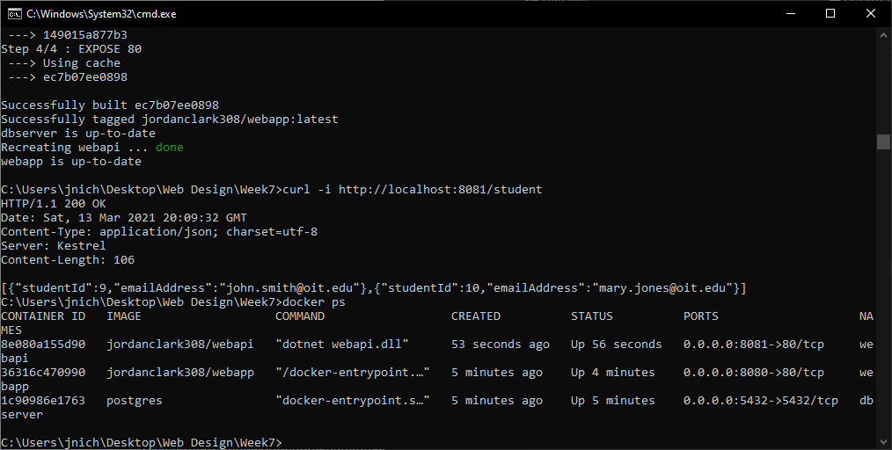

GitHub: <https://github.com/Drilbur-CST126/CST356/tree/main/Week7>

Docker Images:

<https://hub.docker.com/repository/docker/jordanclark308/webapp>

<https://hub.docker.com/repository/docker/jordanclark308/webapi>