Nov 1st – report

- Collar modalities which cause issue:
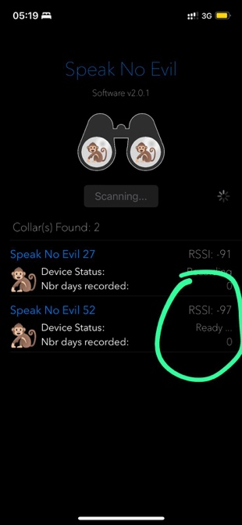
- Ready mode. We cannot launch recording, it’s blocked. We can only drop. Can you do anything at the app so that we can try to record with this collar?
- We activated collars this morning and rechecking again after 2h and it’s hardware off again

- Bluetooth portability issues:
  - We have to get too close
  - It has max 15 meters portability which is not normal and the distance is not stable - also because below 90 RSSI we cannot transmit the command in a stable way
  - Euphorbia tree is shielding the signal
- App displaying:
  - The the way the remaining days is displayed is highly inefficient and it relies on the launch of the recording, which cannot be the case as we have to restart the recordings from time to time

