

Developing and Deploying Intelligent Chat Bots

Objectives

In this lab, we will use the Text Analytics API from Cognitive services to evaluate the sentiment of movie Avatar reviews. We will be using the Text Analytics API in our bots.

Getting a Key

1. Go to [portal.azure.com](https://azure.microsoft.com/en-in/services/cognitive-services/text-analytics/) and sign in. Sign up for an account if you do not have one.
2. Select the Text Analytics API as shown below:

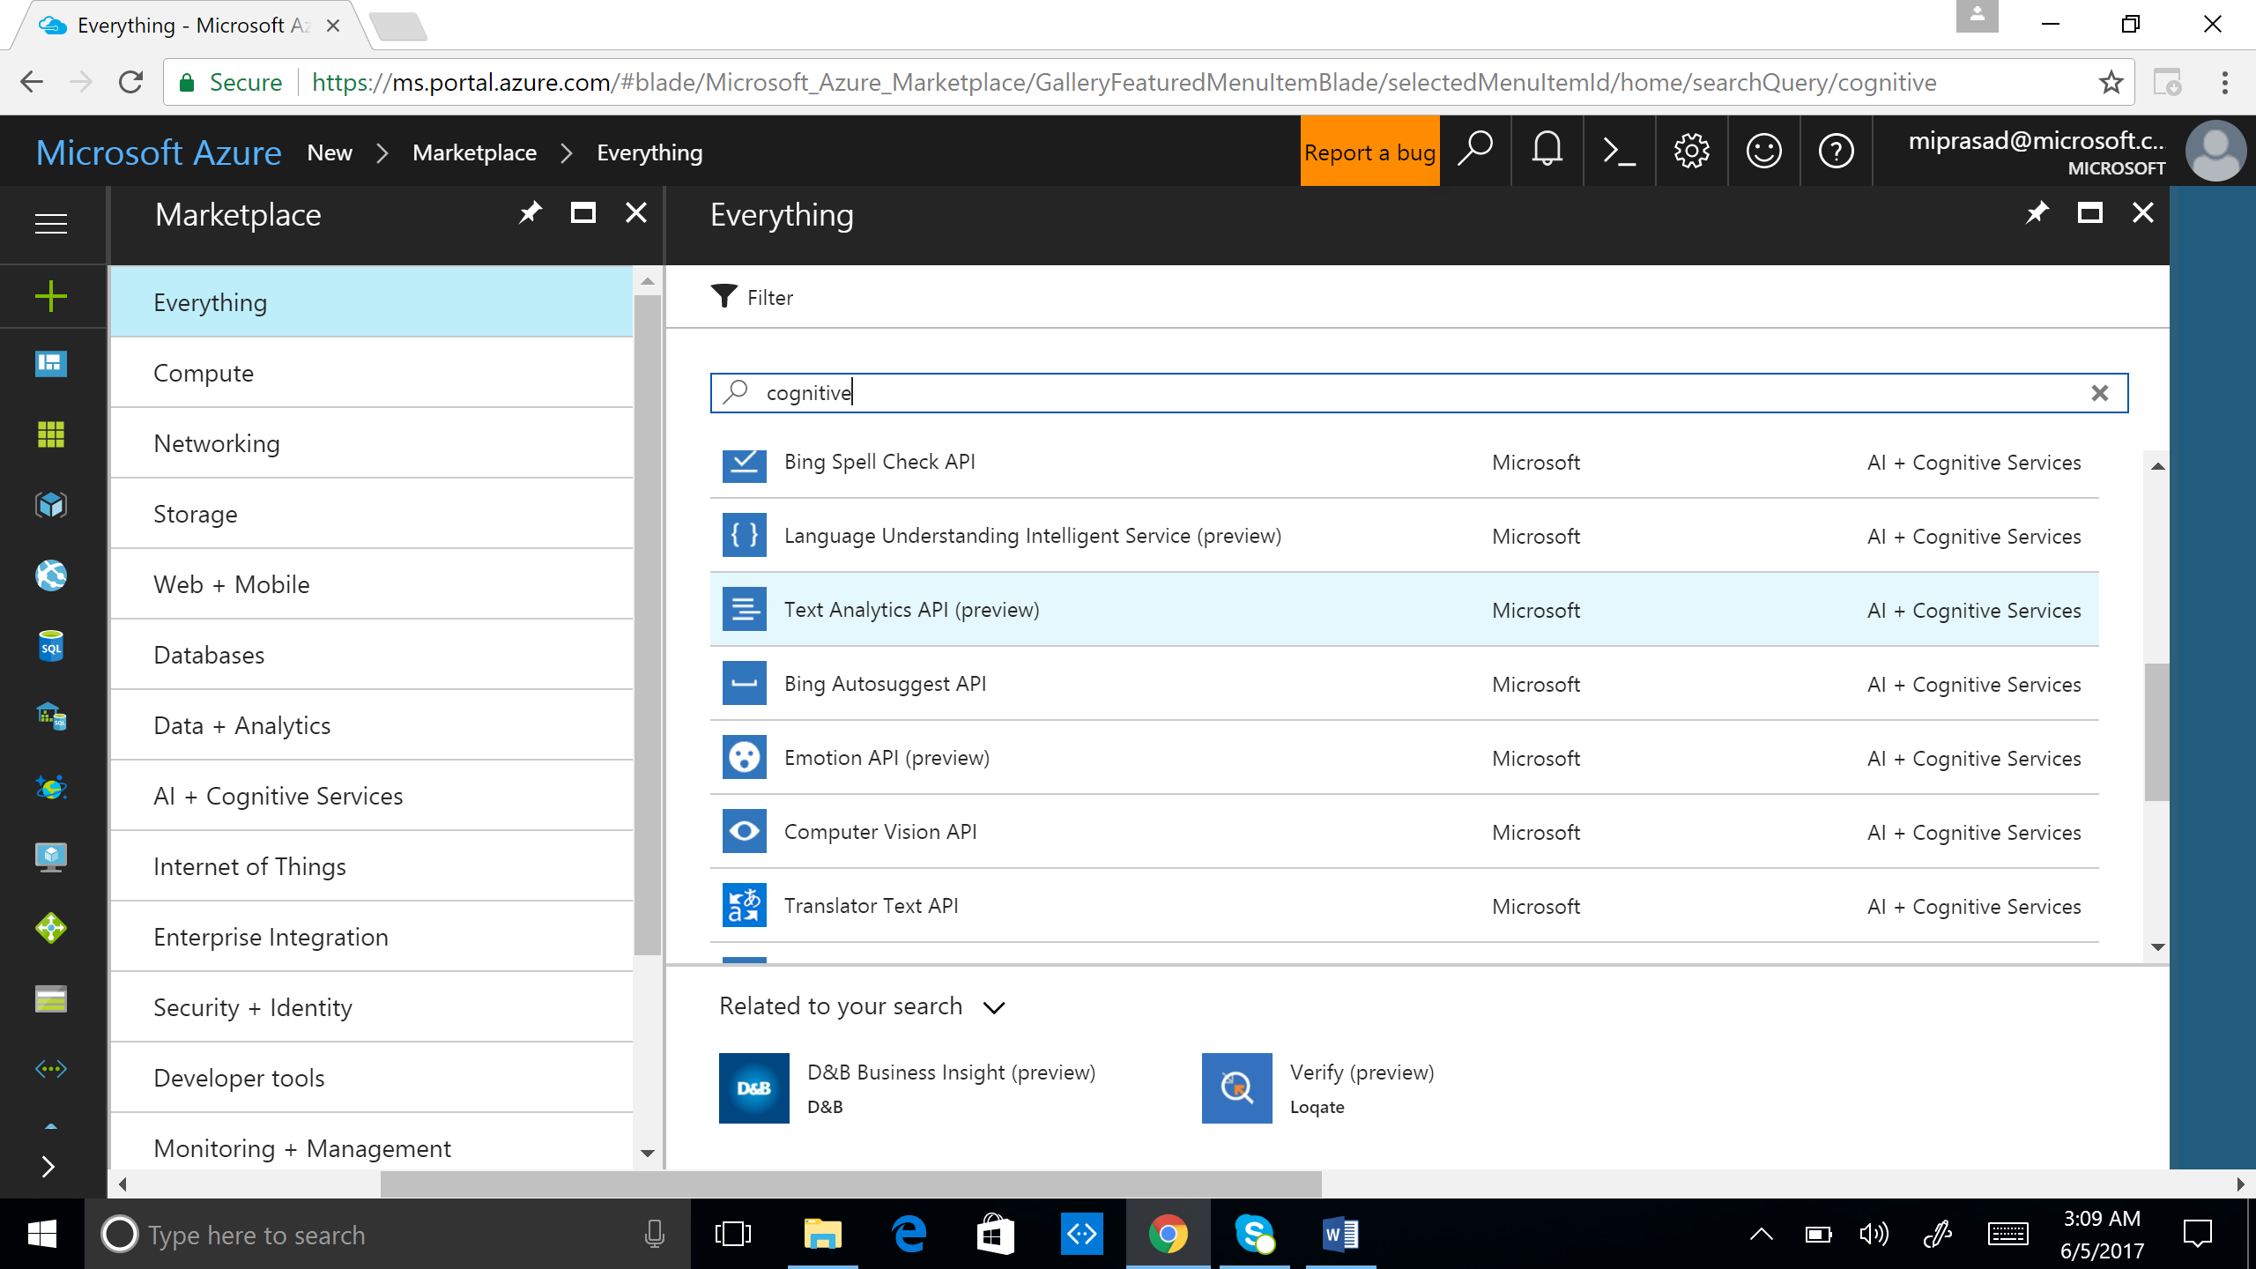

1. Create an account by filling out all the mandatory fields after clicking “create”.

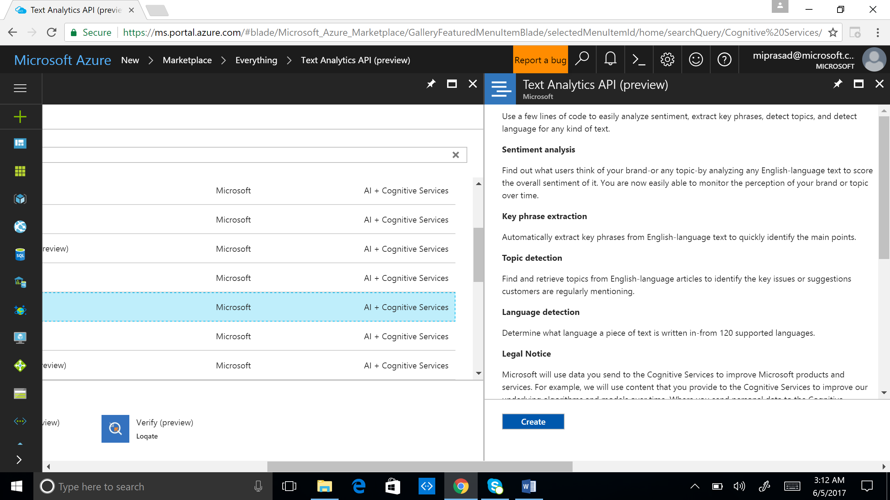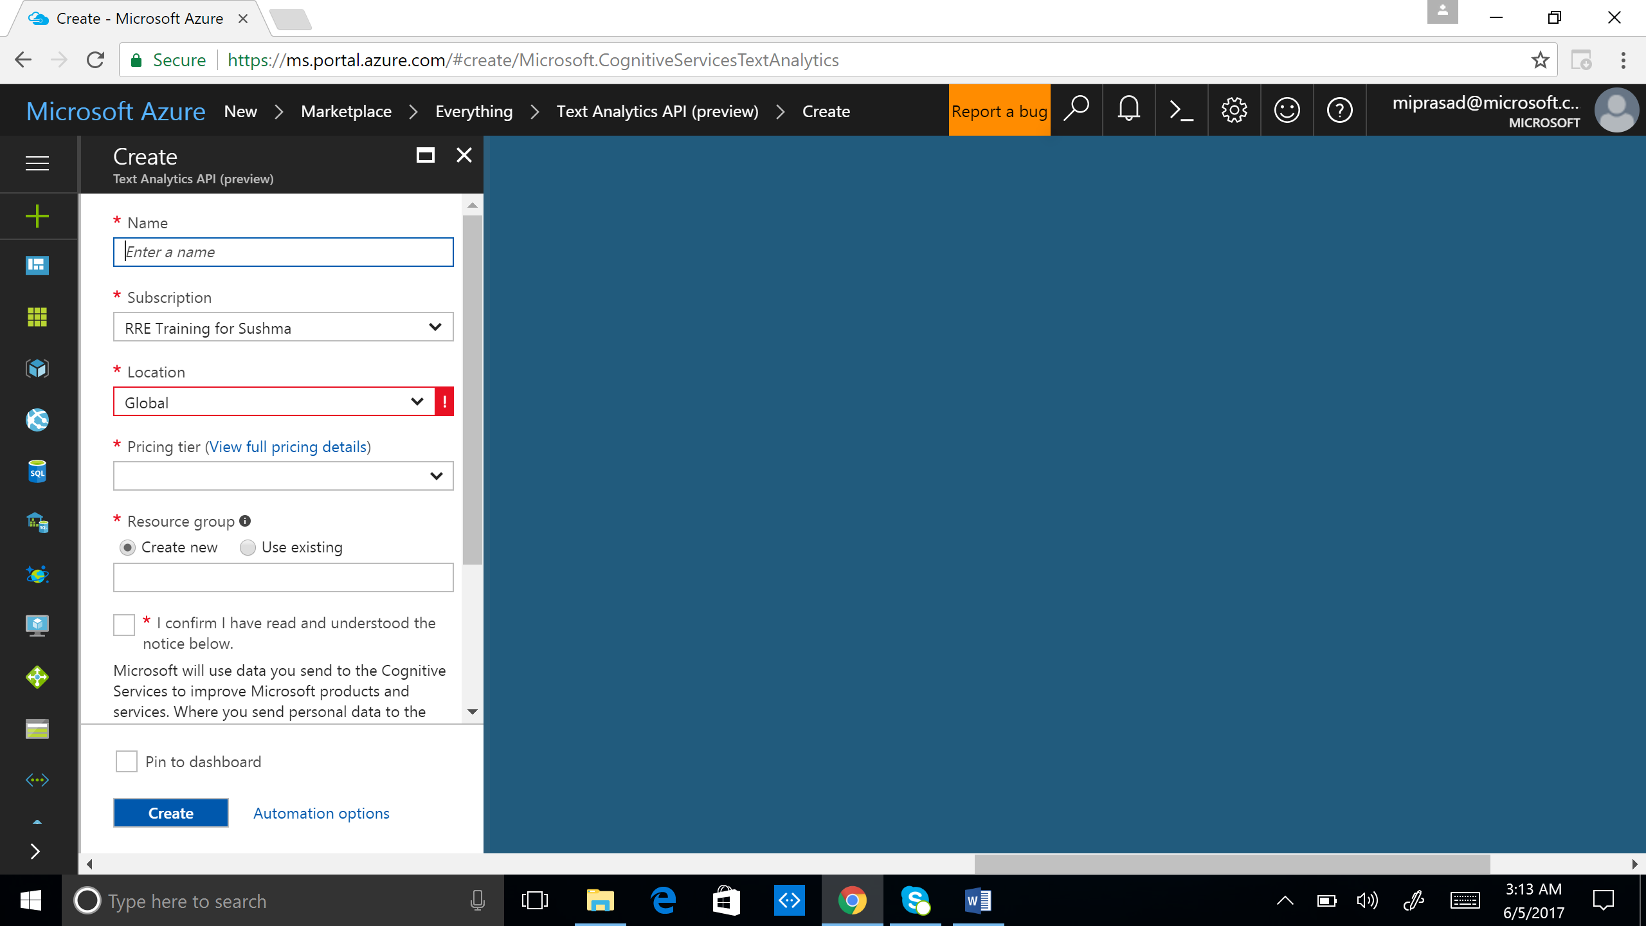

1. Note that there are plenty of useful links to help you develop applications using the API in Text Analytics page of the portal:

[Documentation](https://go.microsoft.com/fwlink/?linkid=848377)  
[Code samples](https://go.microsoft.com/fwlink/?LinkId=759345&clcid=0x409)  
[API reference](https://go.microsoft.com/fwlink/?linkid=848379)  
[Pricing](https://go.microsoft.com/fwlink/?linkid=848381)  
[Regional availability](https://go.microsoft.com/fwlink/?linkid=848309)

API Testing Console

The API Testing Console allows you to test the API using your key.

1. Click Code Samples and Open the API testing console for sentiment as shown below:

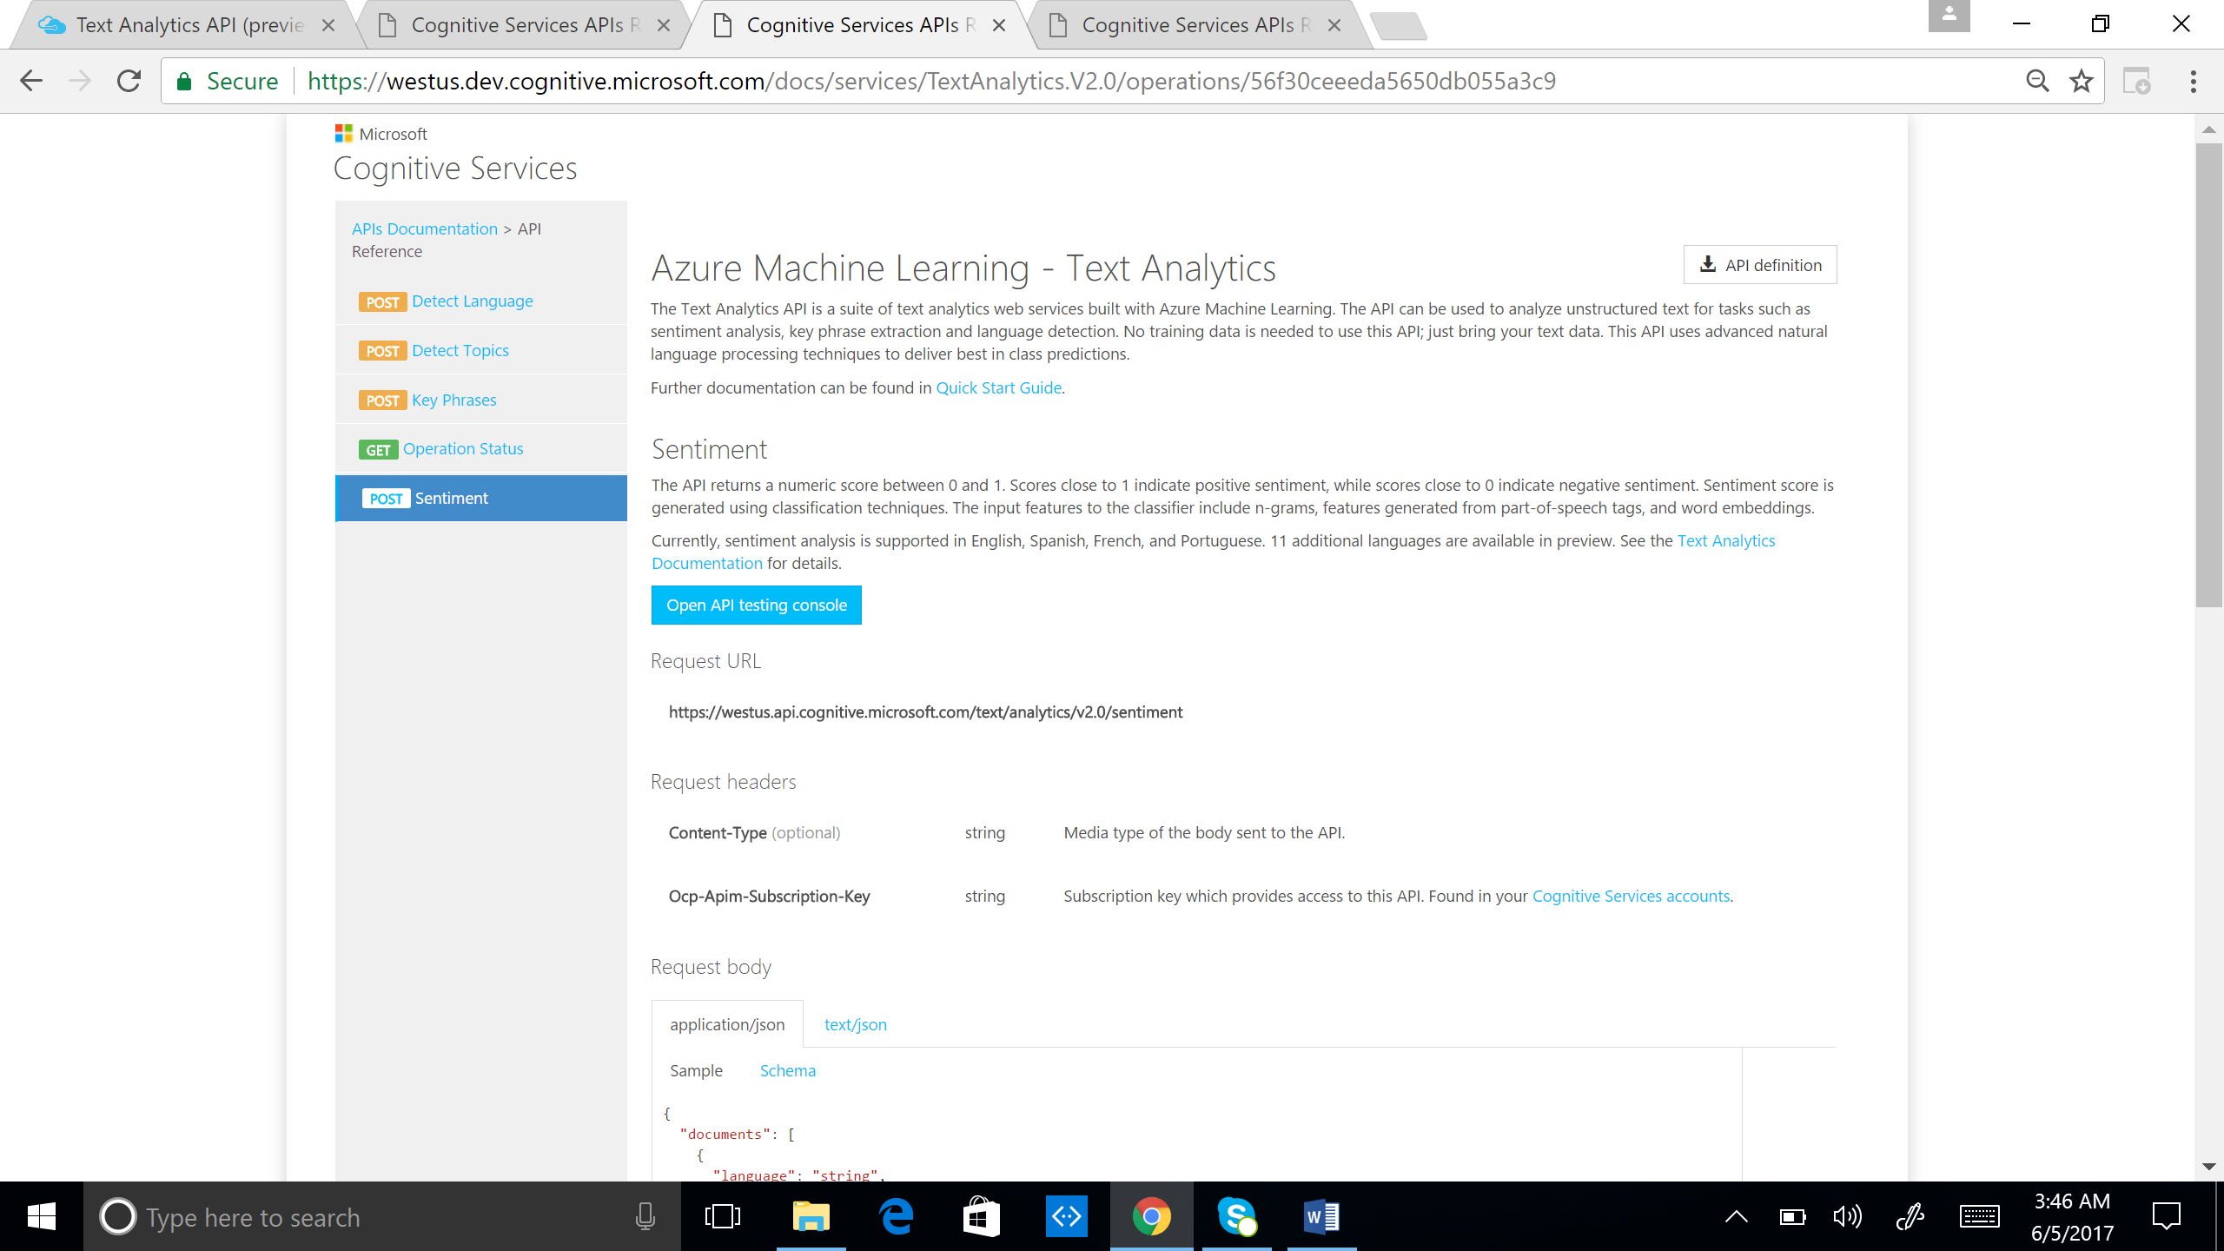

1. To test that the key is working, change the request body:

{

"documents": [

{

"language": "string",

"id": "string",

"text": "string"

}

]

}

Enter the subscription key. In the request body, change language to “en”, id to any number in quotes and insert text to test the sentiment. Click “Send” to submit the request to obtain the sentiment.

Sentiment Code

Several Code Samples in C#, Java, JavaScript, ObjC, PHP, Python, Ruby are available among the useful links in the portal.

1. Pick a programming language of your choice and develop an application to read the “Avatar Reviews” dataset. Use the Code Samples to aid.

2. Get the sentiment of each review. Do you have to run the sentiment API for each sentence in the review and aggregate?

3. Aggregate the sentiment scores for all reviews. What is the overall sentiment of the movie?

4. What can be the potential limitations of sentiment analysis?