|  |
| --- |
| 1 SHREE L. R. TIWARI COLLEGE OF ENGINEERING, MIRAROAD (Approved by AICTE, Govt. of Maharashtra & Affiliated to University of Mumbai)  **DEPARTMENT OF INFORMATION TECHNOLOGY**  **2020-21**  **Certificate**    This is to certify that    **Name of the Student Roll No.**    DURGESH PRAJAPTI 43    GULAB SINGH 26    SUJIT PANDIT 42  ANKITA YADAV 61      Have submitted the Internet Programing Project **“BLOOD DONATION MANAGEMENT SYSTEM”** as per the requirement of the syllabus of the **DEGREE (INFORMATION TECHNOLOGY)** course, according to the rules laid down by the **DTE**, during the academic year 2020-2021 in view of fulfilment of the degree in Information Technology      Date: ________    ______________ ______________  Prof. Madhuri Gedam External Examiner  Guide & Project Co-ordiator  _____________ ______________  Prof. sunil yadav Dr. S. Ram Reddy  Head of Department Principal |

# AIM

In current situation there is need to all people blood on time otherwise it will result in their death. So, This project aims at maintaining all information regarding blood donors, different blood groups available in blood banks as wells as blood camps and help them manage in a better way.

**INTRODUCTION**

Blood donation is required during an organ transplant, accidents, cancer treatment etc. For blood donation, one needs to check for a donation camp or needs to visit blood bank. The Manual Blood donation system has many disadvantages which includes, it is too time consuming, often leads to error prone results, consumes lot of manpower, lacks donor information, retrieval of data takes a lot of time, percentage of accuracy is less. In the time of emergency, it becomes difficult to approach the right donor. Rare blood groups are not available all the time at all blood banks and recipients find difficulties to track the right blood donor. To overcome this problem, Nevon Projects has proposed a system. There are many blood donation management systems, but these systems only maintain the information of blood banks and donors. But Nevon projects has proposed a system which not only maintains the information of blood banks, but also maintains information of blood camps which makes blood transfusion process easier. This online blood donation management system maintains the list of blood donors and also helps the recipients to track and search the right donor easily. It has two modules namely Admin and User. Admins can add hospitals having blood banks and can also add various blood donation camps. He/she can also view the list of donors of a particular area with proper Blood cross match. He/she can also check for blood requests and in case of emergency he/she can send notifications to blood donors as per the requirements. Users can register and make a request. Users can also register as a donor. Donors can check for Blood camps and hospitals for blood donation and will be getting notifications in case of emergency. They can either accept or ignore it. This project aims at maintaining all information regarding blood donors, different blood groups available in blood banks as wells as blood camps and help them manage in a better way

**ABSTRACT**

The project is on "BLOOD DONATION MANAGEMENT SYSTEM" This port serves the purpose of elaborating the analysis and the implementation phases of the above mentioned project. All the features that have been included in the final implementation have hem clearly explained to make the project cay b understand. It has been taken care that this document elicits the development process in a clear and well documented manner.

This course is aimed at making student a complete and of programmer Wear given all the needed knowledge about the structure and the basis of computers first stage, then study of various business bed in the last semester as project work. This candidate is exposed to real time environ They have to work in any organization and have to change a mutually working system in a computerised system so that they are understand the problems earning out of such an environment.

# PROPOSED SYSTEM

The main objective of this application is to automate the complete operation of the blood bank. They need maintain hundreds of thousands of records. Also searching should be very faster so they can find required details instantly.

To develop a web-based portal to facilitate the co-ordinator between supply and demand of blood This system makes conveniently available good quality, safe blood and other had common which can be provided in a sound ethical and acceptable manner, consistent with the long terms well being of the commonly I actively encourage voluntary blood donation motivate and maintain a well indeed record of blood down and last the community on the benefit of blood donation. This will able serve as these for action of best practices in reducing unnecessary of blood help the state work more efficiently toward self –sufficiency in blood.

# EXISTING SYSTEM

In the previous existing campgrounds based website , there was no proper discussion forum where people can share their experiences about the place. The website only had limited resources where the user can login and only view different campgrounds without any proper discussion forum i.e there was no proper communication channel. There was no check performed on validation and type of questions to be entered under particular forum. In existing system, there was no proper password recovery method, and the admin does not have the power to delete users, their activity and points which is assigned to them. Also there was not a proper camping site where user can actually see the all details of blood managemnet.

**Options of the Forum**

There are mainly four options are there,

1. The user who is not a registered member can’t access the comments and add new campground page, he doesn’t have any control on it.
2. The user who is able to login because they are the registered member having full control on forum.
3. Administrator is having the full control on the whole website and he can see the whole content and the comment of campground. he can manage the topic also.
4. The review facilities is also available where user can put their review regarding any topic it is also recommended that no one should do any personal message as everyone can able to see the review.

**MODULES :-**

The system comprises of 3 major modules with their sub-modules as follows:

1. **Admin:**
   * Add hospital: Admin can add hospitals and blood donation camps.
   * View list: Admin can view the list of camps and hospit
   * View donors (filter by area & blood group)
   * Check Request
   * Send notification as per requirements
2. **User:**
   * Register
   * Create Blood Request
   * Register as Donor
   * View Camps / Hospital
   * View Blood Request (accepts/deny)

# RESPONSIVE WEB DESIGN FRAMEWORK

**What is a framework?**

A framework is *a standardized set of concepts, practices and criteria for dealing with a common type of problem*, which can be used as a reference to help us approach and resolve new problems of a similar nature.

In the world of web design, to give a more straightforward definition, a framework is defined as a*package made up of a structure of files and folders of standardized code (HTML, CSS, JS documents etc.)* which can be used to support the development of websites, as a basis to start building a site.

Most websites share a very similar (not to say identical) structure. The aim of frameworks is to provide a common structure so that developers don’t have to redo it from scratch and can reuse the code provided. In this way, frameworks allow us to cut out much of the work and save a lot of time.

**Bootstrap**

Bootstrap is an open source toolkit for developing with HTML, CSS, and JS. Quickly prototype your ideas or build your entire app with our Sass variables and mixins, responsive grid system, extensive prebuilt components, and powerful plugins built on jQuery.

**Nodejs**

Node.js is an [open-source](https://en.wikipedia.org/wiki/Open-source_software), [cross-platform](https://en.wikipedia.org/wiki/Cross-platform) [JavaScript](https://en.wikipedia.org/wiki/JavaScript) [run-time environment](https://en.wikipedia.org/wiki/Runtime_system) that executes JavaScript code outside of a browser. Typically, JavaScript is used primarily for [client-side scripting](https://en.wikipedia.org/wiki/Client-side_scripting), in which scripts written in JavaScript are embedded in a webpage's HTML and run client-side by a JavaScript engine in the user's web browser. Node.js lets developers use JavaScript to write Command Line tools and for [server-side scripting](https://en.wikipedia.org/wiki/Server-side_scripting) running scripts server-side to produce [dynamic web page](https://en.wikipedia.org/wiki/Dynamic_web_page) content *before* the page is sent to the user's web browser. Consequently, Node.js represents a "JavaScript everywhere" paradigm, unifying [web application](https://en.wikipedia.org/wiki/Web_application) development around a single programming language, rather than different languages for server side and client side scripts.

Though .js is the conventional [filename extension](https://en.wikipedia.org/wiki/Filename_extension) for JavaScript code, the name "Node.js" does not refer to a particular file in this context and is merely the name of the product. Node.js has an [event-driven architecture](https://en.wikipedia.org/wiki/Event-driven_architecture) capable of  [asynchronous I/O](https://en.wikipedia.org/wiki/Asynchronous_I/O" \o "Asynchronous I/O). These design choices aim to optimize [throughput](https://en.wikipedia.org/wiki/Throughput) and [scalability](https://en.wikipedia.org/wiki/Scalability) in web applications with many input/output operations, as well as for [real-time Web](https://en.wikipedia.org/wiki/Real-time_Web) applications (e.g., [real-time communication](https://en.wikipedia.org/wiki/Real-time_communication) programs and [browser games](https://en.wikipedia.org/wiki/Browser_game)).

The Node.js [distributed development](https://en.wikipedia.org/wiki/Distributed_development) project, governed by the Node.js Foundation, is facilitated by the [Linux Foundation](https://en.wikipedia.org/wiki/Linux_Foundation)'s Collaborative Projects program.

**MongoDB** (Database)

MongoDB is a [free and open-source](https://en.wikipedia.org/wiki/Free_and_open-source_software) [cross-platform](https://en.wikipedia.org/wiki/Cross-platform) [document-oriented database](https://en.wikipedia.org/wiki/Document-oriented_database) program. Classified as a [NoSQL](https://en.wikipedia.org/wiki/NoSQL" \o "NoSQL) database program, MongoDB uses [JSON](https://en.wikipedia.org/wiki/JSON)-like documents with [schemata](https://en.wikipedia.org/wiki/Database_schema). MongoDB is developed by [MongoDB Inc.](https://en.wikipedia.org/wiki/MongoDB_Inc." \o "MongoDB Inc.), and is published under a combination of the [Server Side Public License](https://www.mongodb.com/licensing/server-side-public-license) and the Apache License.

**Passport.js**

Passport.js is authentication middleware for [Node.js](https://nodejs.org/). Extremely flexible and modular, Passport can be unobtrusively dropped in to any [Express](https://expressjs.com/)-based web application. A comprehensive set of strategies support authentication using a [username and password](http://www.passportjs.org/docs/username-password/), [Facebook](http://www.passportjs.org/docs/facebook/), [Twitter](http://www.passportjs.org/docs/twitter/), and [more](http://www.passportjs.org/packages/).

**Server Side Security in Website**

YelpCamp is secured by any external attacks and also unwanted using of scripts in website. The security is implemented using node.js and express frameworks i.e:

**express-sanitizer**

express sanitizer is an package which is used to sanitize the input in our website. i.e user can only put text in input tag or form, inserting javascript tag in input is not allowed because it will get filtered out by express-sanitizer which will discard it.

**Passport.js**

Passport.js is authentication middleware for [Node.js](https://nodejs.org/). Extremely flexible and modular, Passport can be unobtrusively dropped in to any [Express](https://expressjs.com/)-based web application

We have used passport.js to provide security to user authentication details i.e user name and password. Passport.js will take the password and convert it into hash value using hash function by applying cryptographic algorithm to password

Now that hash value is stored in our database.

**Express-session**

Express-session keeps track on and handles the login, logout sessions of YelpCamp

It associate a request to any other request, you need a way to store user data between HTTP requests. Cookies and URL parameters are both suitable ways to transport data between the client and the server. But they are both readable and on the client side. Sessions solve exactly this problem. You assign the client an ID and it makes all further requests using that ID. Information associated with the client is stored on the server linked to this ID.

# TYPES OF CSS

**CSS comes in three types:**

* In a separate file (**external**)
* At the top of a web page document (**internal**)
* Right next to the text it decorates (**inline**)

**External** style sheets are separate files full of CSS instructions (with the file extension .css). When any web page includes an external stylesheet, its look and feel will be controlled by this CSS file (unless you decide to override a style using one of these next two types). This is how you change a whole website at once. And that's perfect if you want to keep up with the latest fashion in web pages without rewriting every page!

**Internal** styles are placed at the top of each web page document, before any of the content is listed. This is the next best thing to external, because they're easy to find, yet allow you to 'override' an external style sheet -- for that special page that wants to be a nonconformist!

**Inline** styles are placed right where you need them, next to the text or graphic you wish to decorate. You can insert inline styles anywhere in the middle of your HTML code, giving you real freedom to specify each web page element. On the other hand, this can make maintaining web pages a real chore!

**CSS Code**

**main.css**

#top{

background-color: maroon;

list-style-type: none;

margin: 0;

padding: 0;

overflow: hidden;

color: white;

text-align: center;

}

ul {

list-style-type: none;

margin: 0;

padding: 0;

overflow: hidden;

background-color: red;

}

li {

float: left;

}

li a {

display: block;

color: white;

text-align: center;

padding: 14px 16px;

text-decoration: none;

}

li a:hover:not(.active) {

background-color: #111;

}

/*.active {

background-color: maroon;

}*/

#describe{

background-color: maroon;

height:13.75em;

width: 31.25em;

color: white;

text-align: center;

float: left;

margin-left: 25%;

margin-top: 5%;

}

#moreabout{

margin-left: 60%;

background-color: red;

border-color: red;

}

.login{

width: 382px;

overflow: hidden;

margin: auto;

padding: 40px;

background: maroon;

border-radius: 15px ;

align-content: center;

}

label{

color: #08ffd1;

font-size: 17px;

}

#Uname{

width: 300px;

height: 30px;

border: none;

border-radius: 3px;

padding-left: 8px;

}

#Pass{

width: 300px;

height: 30px;

border: none;

border-radius: 3px;

padding-left: 8px;

}

#log{

width: 300px;

height: 30px;

border: none;

border-radius: 17px;

padding-left: 7px;

color: blue;

}

span{

color: white;

font-size: 17px;

}

#a_forgot{

float: left;

background-color: white;

}

#a_pass{

float: right;

background-color: white;

}

#para{

width: 50%;

height: 40%;

float:left;

margin-left:25%;

}

.footer{

background-color: maroon;

margin-top: 22%;

bottom: 0;

}

.footin{

background-color: maroon;

color: white;

margin:1% auto 1% 10%;

border-right-color: black;

border-left-color: black;

border-width: 5px;

border-top:none;

border-bottom: none;

}

#img1{

width: 24.3%;

margin-top: 5%;

border:2px maroon solid;

}

#recentdonar{

height:16.25em;

width:13.75em;

float:right;

margin-top: 2%;

margin-right: 2%;

}

#modi{

width: 45%;

float: left;

margin-bottom: 2%;

}

#modidis{

float: right;

}

.vanue{

float:left;

margin-left: 15%;

color: maroon;

}

**HTML CODE**

**index.html**

<!DOCTYPE html>

<html>

<head>

<title>BLOOD DONATION</title>

<!-- Bootstrap link for CSS -->

<link rel="stylesheet" href="https://maxcdn.bootstrapcdn.com/bootstrap/4.0.0/css/bootstrap.min.css" integrity="sha384-Gn5384xqQ1aoWXA+058RXPxPg6fy4IWvTNh0E263XmFcJlSAwiGgFAW/dAiS6JXm" crossorigin="anonymous">

<link rel="stylesheet" href="style.css">

</head>

<body>

<h1 id="top"> BLOOD DONANTION </h1>

<ul>

<li><a href="index.html">Home</a></li>

<li><a id="about" href="about.html" >About </a></li>

<li><a href="contact.html">Contact</a></li>

<li style="float:right"><a class="active" href="login.html">Login</a></li>

</ul>

<div class="column1">

<div id="describe">

<h1>Blood Donation Management System.</h1>

<p>

A blood bank is a center from where you can donate blood as well as donate blood for a person,

by one time donation you can save a life.

</p>

<a href="about.html"><button id="moreabout" > view more about ...." </button></a>

</div>

<div>

<img id="img1" src="blood1.jpg">

</div>

</div>

<br><br>

<div class="column2">

<div id="para">

<h1>About Blood Donation Management System</h1>

<hr>

<p> A blood bank is a center where blood gathered as a result of blood

donation is stored and preserved for later use in blood transfusion.

The term "blood bank " typically refers to a division of

a hospital where the stirage of blood product occurs and where proper testing is performed (to reduce the riisk of transfusion related adverse events). Howere , it sometimes refers to a collection center, and indeed some hospitals also perform collection.</p>

</div>

<div id="recentdonar">

<h3>RECENT DONAR</h3>

<hr>

<div id="donar1">

<img id="modi" src="modi.jpg">

</div>

<div id="modidis">

<p><strong>Narendra Modi,</strong><br>

he has donated <br>recently blood <br>through our site.</p>

</div>

<hr>

<br>

<div id="donar1">

<img id="modi" src="mamata.jpg">

</div>

<div id="modidis">

<p><strong>Mamta Banergy</strong><br>

she has donated<br> on 4 April 2021 .</p>

</div>

</div>

</div>

<div class="footer">

<input class="footin" type="button" value="ORGANIZED BY">

<input class="footin" type="button" value="SLRTCE FOUNDATION">

<input class="footin" type="button" value="SLRTCE RESEARCH CENTER">

<input class="footin" type="button" value="TE-IT BLOOD BNK">

</div>

</body>

<script type="text/javascript" src="javascript.js"></script>

</html>

**about.html**

<!DOCTYPE html>

<html>

<head>

<title>About </title>

<!-- Bootstrap link for CSS -->

<link rel="stylesheet" href="https://maxcdn.bootstrapcdn.com/bootstrap/4.0.0/css/bootstrap.min.css" integrity="sha384-Gn5384xqQ1aoWXA+058RXPxPg6fy4IWvTNh0E263XmFcJlSAwiGgFAW/dAiS6JXm" crossorigin="anonymous">

<link rel="stylesheet" href="style.css">

</head>

<body>

<h1 id="top"> BLOOD DONANTION </h1>

<ul>

<li><a href="index.html">Home</a></li>

<li><a id="about" href="about.html" style="background-color: maroon;">About </a></li>

<li><a href="contact.html">Contact</a></li>

<li style="float:right"><a class="active" href="login.html" >Login</a></li>

</ul>

<div id="para">

<h1>About Blood Donation Management System</h1>

<hr>

<p> A blood bank is a center where blood gathered as a result of blood

donation is stored and preserved for later use in blood transfusion.

The term "blood bank " typically refers to a division of

a hospital where the stirage of blood product occurs and where proper testing is performed (to reduce the riisk of transfusion related adverse events). Howere , it sometimes refers to a collection center, and indeed some hospitals also perform collection.</p>

<p>

While the first tranfusion were made directly from donar to reciver before coagulation, it was discovered that by adding anticoagulation and refrigerating the blood it was possible to store it for some days , thus opening the way for develompment of blood banks.

</p>

<p>

Shree L R Tiwari college organizing many camps for blood donation, If you want to donate blood then you can register here.

</p>

</div>

</body>

<script type="text/javascript" src="javascript.js"></script>

</html>

**Contact.html**

<!DOCTYPE html>

<html>

<head>

<title>Contact </title>

<!-- Bootstrap link for CSS -->

<link rel="stylesheet" href="https://maxcdn.bootstrapcdn.com/bootstrap/4.0.0/css/bootstrap.min.css" integrity="sha384-Gn5384xqQ1aoWXA+058RXPxPg6fy4IWvTNh0E263XmFcJlSAwiGgFAW/dAiS6JXm" crossorigin="anonymous">

<link rel="stylesheet" href="style.css">

</head>

<body background="contact.jpg" style="background-repeat: no-repeat;">

<h1 id="top"> BLOOD DONANTION </h1>

<ul>

<li><a href="index.html">Home</a></li>

<li><a id="about" href="about.html" >About </a></li>

<li><a href="contact.html" style="background-color: maroon;">Contact</a></li>

<li style="float:right"><a class="active" href="login.html" >Login</a></li>

</ul>

<div class="vanue">

<p> <strong>Venue</strong><br>

Mira Road(East),<br> Shree L. R. Tiwari College of Engineering.

</p>

</div>

<div class="vanue">

<p> <strong>Call</strong><br>

022-021-023<br> 9819971639.

</p>

</div>

<div class="vanue">

<p> <strong>Massage</strong><br>

9819971639<br>7977532342

</p>

</div>

</body>

<script type="text/javascript" src="javascript.js"></script>

</html>

**Login.html**

<!DOCTYPE html>

<html>

<head>

<title>Login Page </title>

<!-- Bootstrap link for CSS -->

<link rel="stylesheet" href="https://maxcdn.bootstrapcdn.com/bootstrap/4.0.0/css/bootstrap.min.css" integrity="sha384-Gn5384xqQ1aoWXA+058RXPxPg6fy4IWvTNh0E263XmFcJlSAwiGgFAW/dAiS6JXm" crossorigin="anonymous">

<link rel="stylesheet" href="style.css">

<style>

.usertype{

background-color: tomato;

border-radius: 10px;

margin-left: 43%;

}

</style>

</head>

<body>

<h1 id="top"> BLOOD DONANTION </h1>

<div>

<ul>

<li><a href="index.html">Home</a></li>

<li><a id="about" href="about.html" >About </a></li>

<li><a href="contact.html">Contact</a></li>

<li style="float:right"><a class="active" href="login.html" style="background-color: maroon;">Login</a></li>

</ul>

</div>

<br><br>

<div >

<button type="submit" class="usertype" onclick="myFunction()">Sign In as Patient</button><br><br>

<button type="submit" class="usertype" onclick="myFunction()">Sign In as Doctor</button><br><br>

<button type="submit" class="usertype" onclick="myFunction()">Sign In as Laborator</button><br><br>

</div>

<div class="login" id="formlogin">

<form id="login" method="get" >

<label><b>User Name</b></label>

<input type="text" name="Uname" id="Uname" placeholder="Username">

<br><br>

<label><b>Password</b></label>

<input type="Password" name="Pass" id="Pass" placeholder="Password">

<br><br>

<button id="log" value="Open Window" onclick="openWin()">Log In </button>

<br><br>

<input type="checkbox" id="check">

<span>Remember me</span>

<br><br>

<a id="a_forgot" href="#">Forgot</a> <a id="a_pass" href="#">Password</a>

</form>

</div>

<div class="footer">

<input class="footin" type="button" value="ORGANIZED BY">

<input class="footin" type="button" value="SLRTCE FOUNDATION">

<input class="footin" type="button" value="SLRTCE RESEARCH CENTER">

<input class="footin" type="button" value="TE-IT BLOOD BNK">

</div>

</body>

<script type="text/javascript" src="javascript.js">

</script>

</html>\

**File.html**

<!DOCTYPE html>

<html>

<head>

<title>File</title>

<link rel="stylesheet" href="style.css">

<style >

.filelabel{

color: black;

}

.filebtn{

background-color: blue;

width: 10%;

padding:1%;

margin: 2%;

}

</style>

</head>

<body>

<div>

<ul style="background-color: gray;">

<li><a >File</a></li>

<li><a id="about" >View </a></li>

<li><a >Edit</a></li>

<li style="float:right"><a href="index.html" style="background-color: maroon;">Log Out</a></li>

</ul>

</div>

<div>

<form class="file">

<p> 1. Do you have any disease ?</p>

<input type="radio" id="disease" name="disease" value="YES"> <label class="filelabel">YES</label><br>

<input type="radio" id="nodisease" name="nodisease" value="No"><label class="filelabel">NO </label><br>

<p> 2. Do you have donate before ?</p>

<input type="radio" id="donate" name="donate" value="YES"> <label class="filelabel">YES</label><br>

<input type="radio" id="nodonate" name="nodonate" value="No"><label class="filelabel">NO </label><br>

<p> 3. Do you have any blood Pressure Problem ?</p>

<input type="radio" id="bp" name="bp" value="YES"> <label class="filelabel">YES</label><br>

<input type="radio" id="nobp" name="nobp" value="No"><label class="filelabel">NO </label><br><br><br><br>

<button id="filesubbtn" class="filebtn" onclick="alert('thanks to donate your blood.')">Submit</button> <button id="fileeditbtn" class="filebtn">Edit</button>

</form>

</div>

<div class="footer">

<input class="footin" type="button" value="ORGANIZED BY">

<input class="footin" type="button" value="SLRTCE FOUNDATION">

<input class="footin" type="button" value="SLRTCE RESEARCH CENTER">

<input class="footin" type="button" value="TE-IT BLOOD BNK">

</div>

</body>

</html>

**SKELETON**

Architecture and flow of the website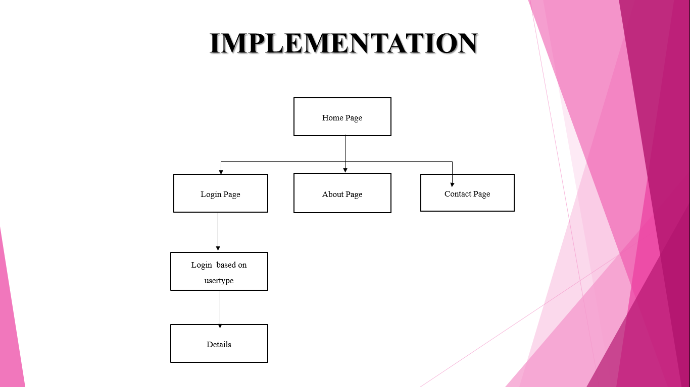

# SKELETON

Architecture and Flow of the Website.

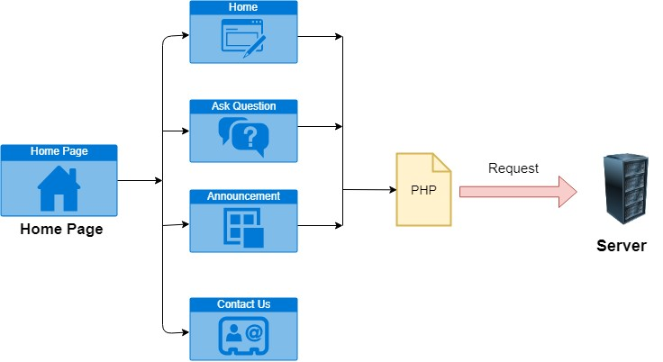

# SCREENSHOT

Home Page:

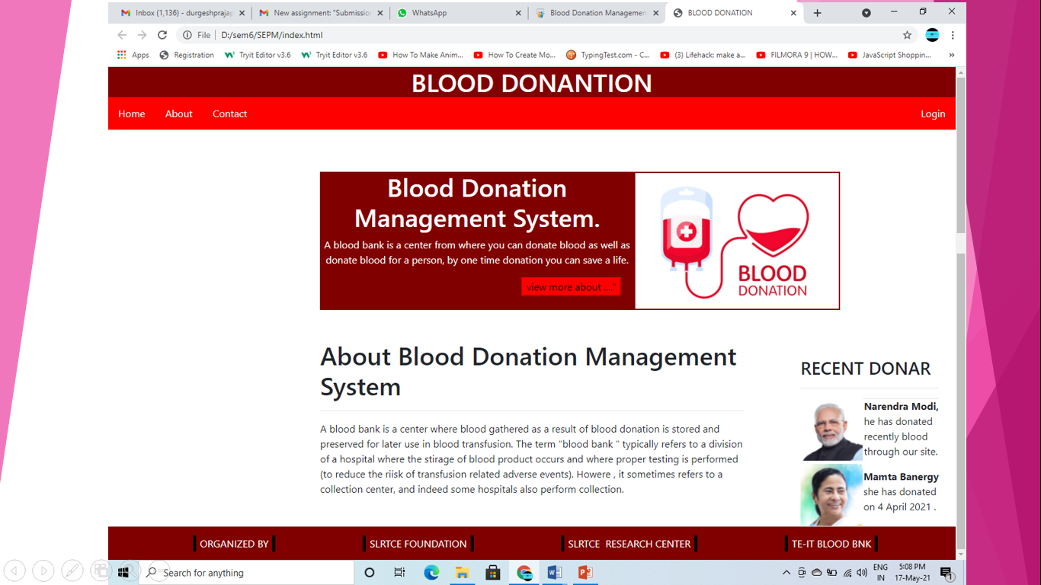

About Page:

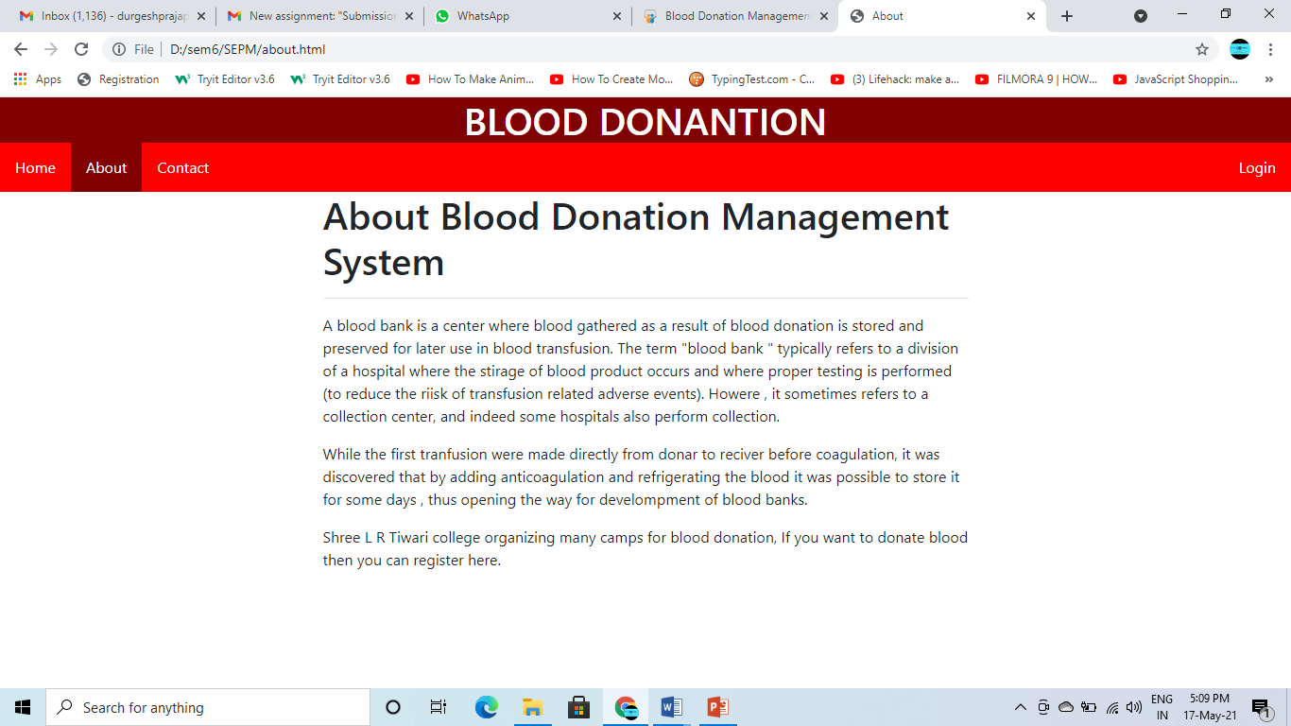

Login page:

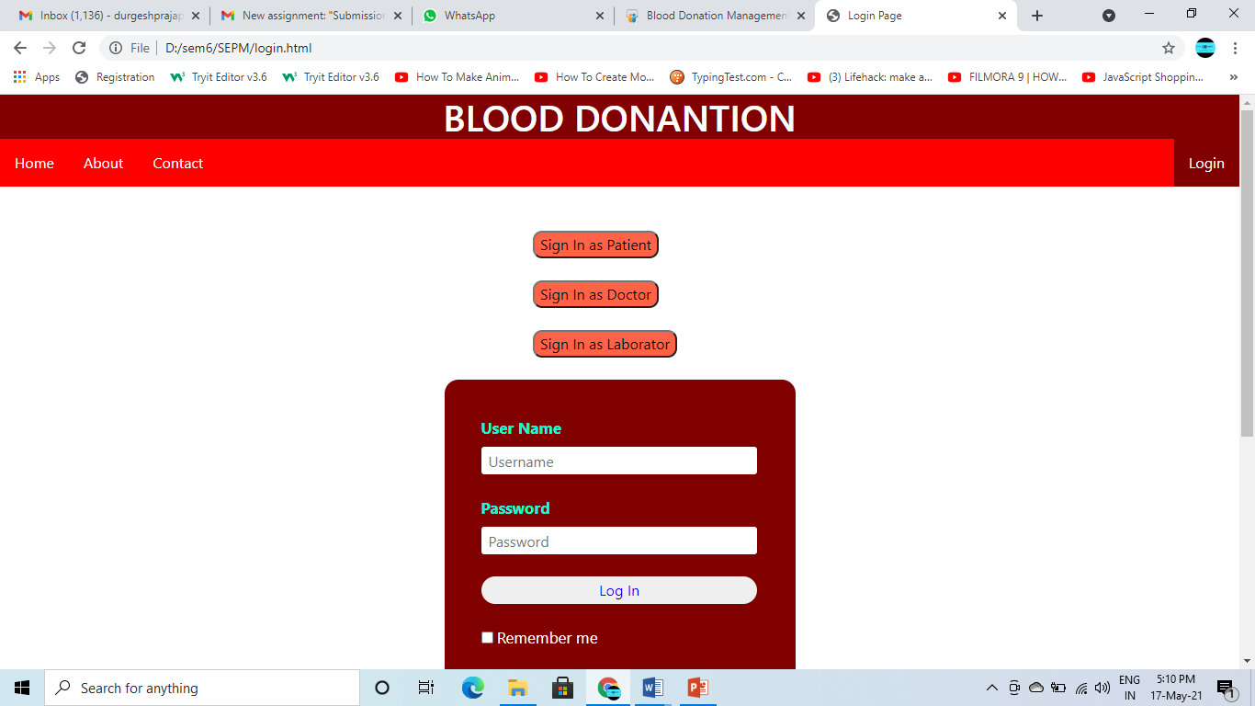

Contact Page:

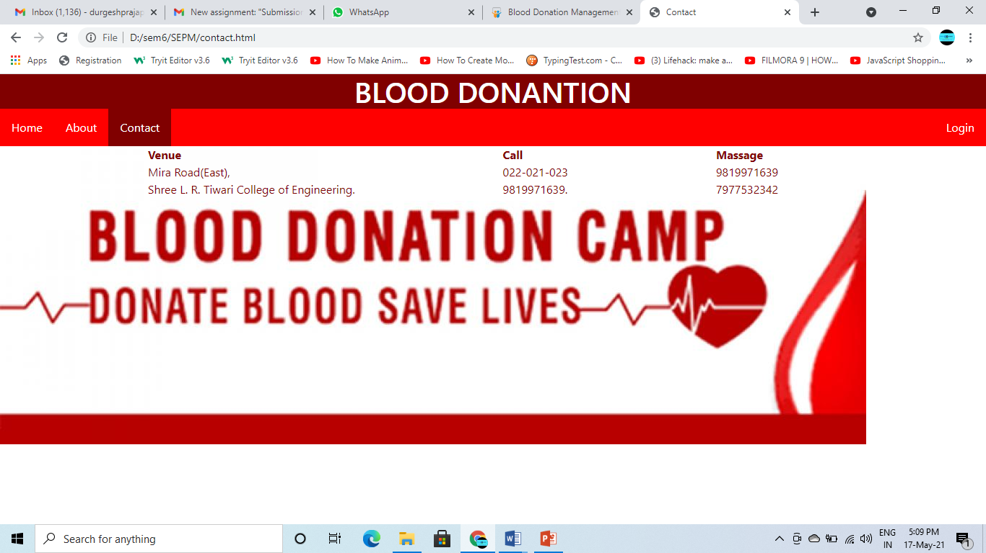

More info:

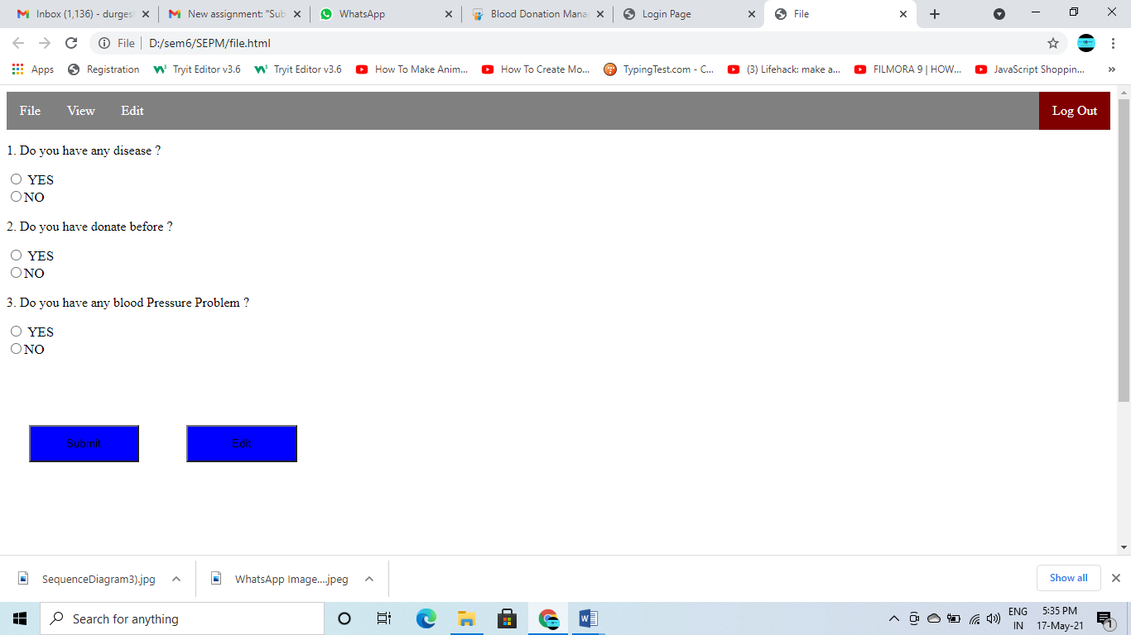

# CONCLUSION

Through this project we took a step towards to minimize the gap between the blood donar and blood receiver using a common intraction platform using HTML , Javascript , CSS for review purpose. Through this project we have implemented a site for patient and doctor where users can login and see the availability of blood on site. and also give order to site. Our project contributes to understanding with the html5, css3, Node.js, MongoDb database, etc. By giving the responsive web design for our project, the site can be visited through any device with browser and internet. By applying the future scope the site can be made more advanced and interactive for users. Also more features can be added.

# ACKNOWLEDGEMENT

We are greatly indebted to the authorities for providing us the necessary facilities to successfully complete this project for this we thank and express us solicit gratitude to Principal, Dr. S. Ram Reddy and H.O.D Sunil Yadav for providing us their valuable time, help and support which helped us a lot in successfully completing our project.

We express our sincere thanks to our Project Guide, Prof. Madhuri Gedam. We are highly grateful for her guidance, help and valuable feedback which always made us aim for perfection. Guiding us through the project also providing valuable suggestions and guidance for completing our project. They helped us to understand the intricate issues involved in project making besides effectively presenting it. Our project has been a success only because of their guidance.

We would also like to thank to all faculty members, Librarian and other staff members for their support.