**Bank Management System**

|  |
| --- |
| ***A Report Submitted*** |
| ***In Partial Fulfillment*** |
| ***for award of Bachelor of Technology*** |
|  |
| **In** |
| **COMPUTER SCIENCE AND ENGINEERING** |
|  |
| **By** |
|  |
| **Shivani Singh (Roll No. 2301330100192)**  **Sweta Yadav (Roll No. 2301330100209)**  **Drishay Chauhan (Roll No. 2301330100084)** |
|  |
| **Under the Supervision of**  **Mr. Ibrar Ahmed**  **Assistant Professor, CSE** |
| Home |
|  |
|  |

**DECLARATION**

We hereby declare that the work presented in this report was carried out by us. We have not submitted the matter embodied in this report for the award of any other degree or diploma of any other University or Institute.

|  |  |
| --- | --- |
| Name : Shivani Singh  Roll Number : 2301330100192  Name : Sweta Yadav  Roll Number : 2301330100209  Name : Drishay Chauhan  Roll Number : 2301330100084 |  |

**CERTIFICATE**

Certified that **Shivani Singh** (Roll No: 2301330100192), has carried out the academic work presented in this Project Report at **Noida Institute of Engineering & Technology, Greater Noida** in partial fulfilment of the requirements for the award of **Bachelor of Technology**, **Computer Science and Engineering** from Dr. APJ Abdul Kalam Technical University, Lucknow under our supervision.

|  |  |
| --- | --- |
| Signature  Mr. Ibrar Ahmed  Assistant Professor  CSE Department  NIET Greater Noida  Date: | Signature  Dr. Kumed Sexena  Professor & HOD  CSE Department  NIET Greater Noida |

**CERTIFICATE**

Certified that **Sweta Yadav** (Roll No: 2301330100209), has carried out the academic work presented in this Project Report at **Noida Institute of Engineering & Technology, Greater Noida** in partial fulfilment of the requirements for the award of **Bachelor of Technology**, **Computer Science and Engineering** from Dr. APJ Abdul Kalam Technical University, Lucknow under our supervision.

|  |  |
| --- | --- |
| Signature  Mr. Ibrar Ahmed  Assistant Professor  CSE Department  NIET Greater Noida  Date: | Signature  Dr. Kumed Sexena  Professor & HOD  CSE Department  NIET Greater Noida |

**CERTIFICATE**

Certified that **Drishay Chauhan** (Roll No: 2301330100084), has carried out the acadmeic work presented in this Project Report at **Noida Institute of Engineering & Technology, Greater Noida** in partial fulfilment of the requirements for the award of **Bachelor of Technology**, **Computer Science and Engineering** from Dr. APJ Abdul Kalam Technical University, Lucknow under our supervision.

|  |  |
| --- | --- |
| Signature  Mr. Ibrar Ahmed  Assistant Professor  CSE Department  NIET Greater Noida  Date: | Signature  Dr. Kumed Sexena  Professor & HOD  CSE Department  NIET Greater Noida |

**ACKNOWLEDGEMENT**

We would like to express our gratitude towards Mr. Ibrar Ahmed for their guidance, support, and constant supervision, as well as for providing necessary information during our project.  
Our thanks and appreciations to our respected HOD, Dr. Kumud Saxena, for their motivation and support throughout.

# ABSTRACT

This project is a banking system application that allows both bank staff and customers to manage various aspects of banking operations. The system is designed with a clear separation of user roles, offering different functionalities based on the user type.

For Bank Staff, the system provides a set of administrative tools, including the ability to open new accounts and view existing customer account details. Staff members can interact with the database to maintain customer records and ensure the seamless processing of customer requests.

For Customers, the system offers a range of banking services. These include viewing account details, checking balances, depositing, and withdrawing funds, and transferring money between accounts. The system ensures secure and efficient financial transactions while providing users with access to their personal banking information.

The application uses SQL for database management and Java for application logic, providing a robust environment for data manipulation and transaction handling. Security features, such as password hashing and secure login processes, ensure the protection of sensitive user information. The system is structured in such a way that it allows for easy scalability and integration with additional banking features as needed.

This report details the design, implementation, and functionality of the system, along with the interactions between the various components including the database, user interfaces, and security measures.

**TABLE OF CONTENTS**

**Page No.**

Declaration i

Certificate ii-iv

Acknowledgement v Abstract vi

**CHAPTER 1: INTRODUCTION** **1-3**

1.1 ORGANIZATION OVERVIEW

1.1.1 Overview of the system

1.1.2 Features of the System

1.1.2.1 Bank Staff Functionalities

1.1.2.2 Customer Functionalities

1.1.2.3 Security Measures

1.2 OBJECTIVE AND SCOPE

**CHAPTER 2: Literature Review 4-7**

2.1 Introduction

2.2 Banking Systems and Automation

2.2.1 Core Banking System

2.2.2 Digital Banking Platform

2.3 Transaction Systems in Banking

2.3.1 Payment Gateways

2.3.2 Money Transfer Systems

2.4 Security in Banking Systems

2.4.1 Encryption and Data Security

2.4.2 Multi-Factor Authentication

2.4.3 User Authentication and Fraud Prevention

2.5 Technologies in Banking System Development

2.5.1 Programming Languages and Frameworks

2.5.2 SQL Databases

2.5.3 Cloud Computing

2.6 Conclusion

**CHAPTER 3: Requirement 8-13**

3.1 Hardware Requirements

3.2 Software Requirements

3.3 Functional Requirements

3.4 Non-Functional Requirements

3.5 Environmental Requirements

**CHAPTER 4: Implementation & Testing 14-20**

4.1 Implementation

4.2 Testing

4.3 Testing Results

4.4 Challenges Faced

**CHAPTER 5: CONCLUSION AND FUTURE WORK 21-24**

5.1 Conclusion

5.2 Future Work

5.3 Challenges and Lessons Learned

**REFERENCES 25**

**APPENDICES 26**

**CURRICULUM VITAE 27-30**

**CHAPTER 1**

**INTRODUCTION:**

In today’s digital era, banking systems have evolved to provide customers with enhanced convenience and security. The traditional banking methods are being rapidly replaced by automated systems that allow for a wide range of financial transactions to be completed from the comfort of one’s home or office. A key aspect of this transition is the development of secure, user-friendly banking applications that cater to both staff and customers, enabling the management of accounts and the processing of financial operations efficiently.

This project revolves around creating an integrated banking system that serves both the **bank staff** and **customers**. It aims to automate banking operations such as account management, balance checks, deposits, withdrawals, and money transfers. The system facilitates seamless interaction between bank staff and customers while ensuring security through password hashing and secure transactions.

This introduction outlines the purpose of the project, its goals, and the specific functionalities provided by the system. It also highlights the roles of both staff and customers and explains how the banking operations are handled using **Java** and **SQL** technologies.

* 1. ORGANIZATION OVERVIEW

**1.1.1 Overview of the System**

The banking system is designed to provide a comprehensive solution for managing customer accounts and transactions. It is divided into two main sections:

1. **Bank Staff Section:** This allows bank staff to manage customer accounts, view account details, and ensure that customer data is handled correctly.
2. **Customer Section:** This section enables customers to access their accounts, view their balance, make deposits, withdraw money, and transfer funds.

The system utilizes a **database** to store and retrieve customer information and transaction history, ensuring that all data is securely stored and easily accessible for both staff and customers.

**1.1.2 Features of the System**

The system has been designed to meet the needs of both the bank staff and customers, offering various features and functionalities tailored to each user group. Below are the key features offered by the system.

**1.1.2.1 Bank Staff Functionalities**

* **Account Management:** Bank staff can open new accounts for customers and modify existing accounts. They can also view detailed information about customer accounts.
* **View Account Information:** Staff can search for customer accounts using a unique identifier (User ID) and view details such as name, account type, balance, and status.
* **Manage Customer Data:** Staff can update customer information, such as contact details, ensuring that the data remains up to date.

**1.1.2.2 Customer Functionalities**

* **View Account Details:** Customers can access their account details, such as account type, balance, and other personal details.
* **Check Account Balance:** Customers can easily check the available balance in their accounts at any time.
* **Deposit Funds:** Customers can deposit funds into their accounts through a simple interface, ensuring seamless transaction processing.
* **Withdraw Funds:** Customers can withdraw funds from their accounts while ensuring they have sufficient balance.
* **Transfer Funds:** The system allows customers to transfer funds to other accounts, either within the same bank or externally, providing flexibility in managing their finances.

**1.1.2.3 Security Measures**

The system employs several security features to protect sensitive user information:

* **Password Hashing:** Customer passwords and sensitive information, such as security question answers, are hashed using secure algorithms before being stored in the database.
* **User Authentication:** The system uses secure login methods to ensure only authorized users (staff or customers) can access their respective functionalities.
* **Data Encryption:** All sensitive data, including transaction details, is encrypted during transmission to prevent unauthorized access.

1.2 OBJECTIVE AND SCOPE

The primary objective of this project is to develop a robust and secure **banking management system** that offers both staff and customers a user-friendly interface for managing their financial transactions. The system’s key objectives include:

* **Providing easy access to account management** for both bank staff and customers.
* **Ensuring secure transactions** with features like password hashing and encryption.
* **Automating basic banking operations**, including account opening, balance checking, deposits, withdrawals, and transfers.
* **Enabling scalability** to accommodate future extensions and features as required by the bank.

The scope of this project includes:

1. **User Roles:** Two user roles are implemented in the system: Bank Staff and Customer. Each user has specific functionalities, and their access to the system is limited based on their role.
2. **Database Management:** The system uses an **SQL database** for storing customer information, transaction details, and account balances.
3. **Transaction Handling:** The system supports basic banking transactions such as deposits, withdrawals, and transfers.
4. **Security:** The system ensures that sensitive data is protected through password encryption, hashing, and secure communication methods.

This project’s scope does not include advanced banking features such as loan management or advanced analytics. However, the system is designed to be extensible, allowing for future integration of more features as needed.

**CHAPTER 2**

**LITERATURE REVIEW**

2.1 Introduction

The banking industry has been significantly transformed by the advent of technology, resulting in increased automation, digital services, and improved security. The traditional methods of managing banking transactions and customer interactions have been replaced or supplemented by sophisticated automated banking systems. These systems aim to enhance operational efficiency, reduce human errors, and improve the overall customer experience. This chapter reviews various aspects of existing literature related to banking automation, transaction systems, security features, and technologies used in the development of modern banking applications.

The purpose of this literature review is to analyze and summarize existing research, systems, and technologies related to automated banking systems and their application to create secure, user-friendly, and efficient banking solutions**.**

2.2 Banking Systems and Automation

Modern banking systems have evolved beyond traditional paper-based and manual operations, utilizing automated tools to handle complex financial transactions. The need for these automated systems has risen with the growing number of banking customers and transactions, which demand faster and more accurate processing.

2.2.1 Core Banking Systems (CBS): Core Banking Systems (CBS) are centralized systems that allow banks to manage and process their daily banking transactions and business operations. A significant advantage of CBS is the centralization of banking information, enabling customers to access their accounts and conduct transactions across different branches. According to Nixon et al. (2016), CBS helps banks reduce operational costs and offer enhanced services, such as 24/7 account access, real-time processing, and faster data retrieval.

2.2.2 Digital Banking Platforms: Digital banking refers to the use of digital platforms such as mobile banking apps and online banking portals to provide customers with remote access to their accounts. A study by Sampath and Nair (2018) showed that mobile banking has revolutionized the banking industry, providing customers with the ability to manage finances, transfer funds, check balances, and deposit money without visiting a bank branch.

The rise of mobile banking and the increasing reliance on the internet have created a shift towards more sophisticated e-banking platforms, providing services like money transfers, bill payments, and account management through a mobile interface. According to Patel and Bhagat (2020), digital banking platforms have also increased customer satisfaction due to their convenience and accessibility.

2.3 Transaction Systems in Banking

Automated transaction systems allow for the efficient management and processing of financial transactions. These systems are critical for ensuring that banking operations such as deposits, withdrawals, and money transfers are executed smoothly and accurately.

2.3.1 Payment Gateways: A study by Gomes et al. (2017) highlighted the importance of payment gateways in modern banking systems. Payment gateways provide secure channels for conducting financial transactions between customers, merchants, and banks. They are particularly useful for online transactions and provide encryption to ensure that sensitive data, such as credit card information, is protected.

2.3.2 Money Transfer Systems: Automated money transfer systems are central to modern banking operations. NEFT (National Electronic Funds Transfer), RTGS (Real-Time Gross Settlement), and IMPS (Immediate Payment Service) are examples of systems that allow the fast and efficient transfer of funds within and between banks. These systems have become integral to both traditional and digital banking.

According to Sahoo et al. (2019), these systems offer enhanced efficiency by ensuring that funds are transferred in real-time or within a specified period, providing customers with a seamless banking experience.

2.4 Security in Banking Systems

Security remains one of the most critical aspects of modern banking systems, as they store sensitive financial data and facilitate a wide range of financial transactions. Cybersecurity threats, including hacking, fraud, and data breaches, have led to increased investments in security measures by banks.

2.4.1 Encryption and Data Security: Data encryption is a key security measure used to protect sensitive data in transit and at rest. SSL/TLS encryption is widely used in online banking systems to secure communication between customers and banks. Sharma and Meena (2020) emphasized the significance of strong encryption protocols in maintaining the confidentiality and integrity of user data in banking systems.

2.4.2 Multi-Factor Authentication (MFA): Multi-factor authentication (MFA) is an important security feature that enhances the protection of banking accounts. MFA requires users to provide two or more verification factors, such as passwords and one-time PINs sent to their mobile devices, to gain access to their accounts. According to Verma et al. (2021), MFA reduces the likelihood of unauthorized access and strengthens the security of banking applications.

2.4.3 User Authentication and Fraud Prevention: In addition to traditional security measures, banks employ advanced fraud detection algorithms and AI-based authentication techniques. Biometric authentication, such as facial recognition and fingerprint scanning, is increasingly being used to verify user identities in mobile banking applications. This provides additional layers of security and ensures that only authorized individuals can perform transactions.

2.5 Technologies in Banking System Development

The development of modern banking systems relies heavily on advanced technologies. From programming languages to databases, each component plays an essential role in ensuring the system's functionality, scalability, and security.

2.5.1 Programming Languages and Frameworks: Java has been widely adopted in the development of banking systems due to its robustness, scalability, and cross-platform compatibility. According to Patel et al. (2019), Java's secure environment and its extensive libraries make it an ideal choice for building banking applications. Additionally, Spring Framework and Hibernate are commonly used to build backend systems that interact with databases, manage user sessions, and facilitate secure communication.

2.5.2 SQL Databases: SQL databases play a crucial role in managing and storing vast amounts of transactional and customer data in banking systems. Relational databases like MySQL, PostgreSQL, and Oracle are typically used for storing banking data due to their ability to handle large amounts of structured data and provide strong data integrity and security.

2.5.3 Cloud Computing: The emergence of cloud computing has enabled banks to move their data and services to the cloud, allowing for greater scalability, flexibility, and cost efficiency. According to Singh and Kapoor (2020), cloud-based banking solutions allow for real-time updates and access to data across multiple devices, thus improving service delivery and customer satisfaction.

2.6 Conclusion

This literature review has explored various aspects of automated banking systems, including transaction systems, security measures, and the technologies used in the development of such systems. Modern banking systems leverage technologies such as mobile banking, payment gateways, data encryption, and biometric authentication to provide secure, efficient, and user-friendly services.

As banking continues to evolve, the integration of AI, blockchain, and cloud computing into banking systems promises even greater innovations in terms of automation, customer experience, and security. This chapter lays the foundation for the subsequent discussion on the design and implementation of the banking system, focusing on the functionalities and security features that have been incorporated into the system.

**CHAPTER 3**

**REQUIREMENT**

This chapter outlines the necessary hardware, software, functional, and non-functional requirements for implementing the banking system. These requirements ensure that the system operates smoothly, securely, and efficiently, fulfilling the needs of both customers and bank staff.

3.1 Hardware Requirements

1. Server Hardware:
   * Processor: Multi-core processor (Intel Core i5/i7 or AMD Ryzen 5/7) for handling concurrent requests with a speed of 2.5 GHz or higher.
   * RAM: A minimum of 8 GB of RAM, with 16 GB recommended for handling multiple transactions and data retrieval processes.
   * Storage: At least 500 GB of SSD storage for high-speed data access, with the option for scalable storage (e.g., cloud-based storage).
   * Network: High-speed internet connection (1 Gbps or more) for reliable communication between users and the bank server.
2. End-user Devices:
   * Desktop/Laptop: A computer with Windows or Linux OS, 4 GB RAM, and at least 500 GB storage to run the banking application.
   * Mobile Devices: Smartphones with Android 6.0 or later, or iOS 10 or later, for accessing mobile banking functionalities.

3.2 Software Requirements

1. Operating System:
   * Server Side: Ubuntu Server or Windows Server for hosting backend processes.
   * Client Side: Windows 10 or higher for desktop users. Mobile apps will be supported on Android 6.0+ and iOS 10+.
2. Database Management System (DBMS):
   * SQL Database: MySQL or PostgreSQL for managing customer data, account balances, and transaction logs.
   * Backup and Recovery Tools: Regular backup solutions (e.g., mysqldump or PostgreSQL pg_dump) for maintaining database integrity.
3. Programming Languages:
   * Backend: Java for developing the core banking services such as account management, transactions, and security.
   * Frontend: HTML, CSS, JavaScript (with frameworks like ReactJS or AngularJS) for creating the web interface.
   * Mobile Development: Kotlin (Android) and Swift (iOS) for mobile banking applications.
   * SQL Queries: SQL for managing database operations like retrieving account balances, updating transaction records, etc.
4. Web Server:
   * Apache Tomcat or Nginx for serving the backend services to client interfaces.
5. Security Tools:
   * Encryption: SSL/TLS protocols for secure communication between clients and servers.
   * Hashing: SHA-256 or bcrypt for password storage and security.
   * Firewall and Antivirus: Advanced firewall setups and antivirus software for securing data from cyber threats.

3.3 Functional Requirements

1. User Management:
   * User Authentication: Users (both customers and bank staff) should be able to log in securely using a user ID and password.
   * Account Creation: Customers should be able to open new accounts, providing necessary details like name, address, and personal identification numbers (PAN, Aadhar).
   * Role-based Access Control: Bank staff and customers should have different access privileges (e.g., customers can view balances and initiate transactions, staff can manage accounts).
2. Account Management:
   * Account Details: Users should be able to view personal account details (name, address, balance, etc.).
   * Account Status: Customers should be able to check whether their accounts are active or inactive.
   * Account Update: Customers should be able to update personal information and address details.
3. Transaction Management:
   * Balance Inquiry: Customers should be able to view the current account balance.
   * Deposit: Customers should be able to deposit money into their accounts by specifying the amount.
   * Withdrawal: Customers should be able to withdraw funds, with the system ensuring there are sufficient funds.
   * Transfer: Customers should be able to transfer money to other accounts by entering the recipient's account number and amount.
   * Transaction History: A log of all transactions (deposits, withdrawals, and transfers) should be accessible for users.
4. Security:
   * Password Security: Use of strong encryption algorithms for storing passwords securely (e.g., bcrypt or SHA-256).
   * Multi-factor Authentication (MFA): For increased security, users should be able to enable two-factor authentication (e.g., OTPs sent via SMS or email).
   * Audit Trails: All user actions (logins, transactions, account updates) should be logged for auditing and security purposes.

3.4 Non-Functional Requirements

1. Performance:
   * Response Time: The system should provide responses to queries and transactions within 2 seconds.
   * Concurrency: The system should be able to handle at least 1000 concurrent users without significant performance degradation.
2. Scalability:
   * The system should be scalable to accommodate future growth in the number of users, accounts, and transactions. It should be capable of horizontal scaling by adding more servers or using cloud services.
3. Availability:
   * The system should ensure 24/7 availability with minimal downtime, using failover mechanisms and redundant servers.
4. Usability:
   * The banking application (both web and mobile) should have an intuitive, easy-to-use interface, with clear navigation and minimal learning curve for users.
   * Accessibility: The system should be accessible to people with disabilities, adhering to web accessibility standards (e.g., WCAG).
5. Security:
   * Data Encryption: All sensitive data (account numbers, balances, transaction details) must be encrypted both in transit and at rest.
   * Data Integrity: Ensure that all transactions are correctly recorded and that no data is lost or corrupted.
   * Regular Security Audits: Conduct routine vulnerability assessments and penetration testing to secure the application from cyber threats.
6. Backup and Disaster Recovery:
   * The system must have scheduled backup routines to protect user data and ensure the ability to recover from unexpected failures.
   * In case of failure, the system should have a disaster recovery plan to restore service in a timely manner.

3.5 Environmental Requirements

1. Development Environment:
   * Integrated Development Environments (IDE) such as IntelliJ IDEA, Eclipse, or Android Studio for backend and mobile application development.
   * Version control system like Git for managing the source code.
2. Production Environment:
   * Cloud infrastructure (e.g., AWS, Google Cloud) for hosting the banking system, with services for load balancing, database management, and storage.
   * Containerization: Docker for containerizing the application for easy deployment and scalability.
3. Network Requirements:
   * High-speed internet (minimum 1 Gbps) to handle high-volume transactions, especially during peak times.
   * Secure communication channels using VPNs or direct secure connections between servers.

**CHAPTER 4**

**IMPLEMENTATION & TESTING**

This chapter provides an overview of the implementation of the banking system and the testing process to ensure the system works as expected. It covers the design and development process of various components, followed by the testing strategies used to validate the system's functionality and security.

4.1 Implementation

The implementation of the banking system is broken down into multiple modules, each handling different aspects of the system, such as user authentication, account management, transactions, and security. The code uses Java for the backend logic, while SQL databases (e.g., MySQL or PostgreSQL) are used for storing user data and transaction records.

Key Modules Implemented:

1. User Authentication (Login and Logout)
   * Class: BankService
   * Functionality:
     + This module handles the user's login and logout process. Upon successful authentication, the user is granted access to various banking operations like viewing balances, making deposits or withdrawals, and transferring funds.
     + The system verifies the user credentials through the User_ID and password and gives access to customer functionalities.
2. Account Details
   * Class: Account_details
   * Functionality:
     + The Account_details class provides functionality to view various account-related information, such as user name, address, account balance, and more. The details are retrieved from the SQL database based on the user's unique User_ID.
     + The user is presented with a list of details they can query, such as the account holder’s name, PAN number, Aadhar number, balance, etc.
3. Balance Viewing
   * Class: Check_Balance
   * Functionality:
     + This module retrieves and displays the user's current account balance by querying the database. It checks the balance and presents it to the user through a simple query.
     + The system fetches the User_Account_Balance field from the database and displays it to the logged-in user.
4. Deposit and Withdrawal Operations
   * Classes: Deposit_Balance, Withdraw_Balance
   * Functionality:
     + Users can deposit money into their accounts or withdraw funds. These operations update the user’s balance after verifying that the requested amount is valid.
     + The Deposit_Balance and Withdraw_Balance classes handle deposit and withdrawal functionality by querying and updating the user’s User_Account_Balance in the database.
5. Money Transfer
   * Class: Transfer
   * Functionality:
     + The Transfer class enables users to transfer money to another user’s account. It handles the retrieval of both the user's and the recipient's account balance, performs checks for sufficient funds, and then updates both accounts accordingly.
     + This module requires the user to input the recipient's account number, followed by the amount to be transferred. The system updates both the sender's and the recipient's balances in the database.
6. Error Handling and Logging
   * Error handling is implemented throughout the system. If any user input is invalid or an unexpected system error occurs, an exception is caught and an appropriate error message is displayed. Errors such as invalid input, insufficient funds, and database connection issues are logged and handled gracefully.

4.2 Testing

Testing is a crucial part of ensuring that the banking system operates correctly and securely. Different types of testing were carried out to verify both the functionality and security of the system.

Types of Testing Conducted:

1. Unit Testing
   * Unit tests were written for individual methods and classes to ensure they work as expected. For example:
     + Account_details class: Verifying that the details are fetched correctly from the database.
     + Deposit_Balance and Withdraw_Balance classes: Ensuring that the balance is correctly updated after deposit and withdrawal actions.
     + Transfer class: Testing that the correct amounts are deducted and credited to accounts during transfers.

Testing Tools:

* + JUnit: Used for writing unit tests for the classes and methods.
  + Mockito: Used for mocking database connections to isolate the units of code and verify their behavior.

1. Integration Testing
   * Integration testing was performed to test the interaction between different modules of the system. For example:
     + Account Management and Transaction Operations: When a user logs in, their details should be retrieved correctly, and subsequent transactions (deposit, withdrawal, transfer) should update the database correctly.
     + Account Details and Balance Operations: The system must correctly query and display the user’s account balance and other details after performing operations like deposits, withdrawals, and transfers.

Testing Approach:

* + Test Scenarios: Real-world test scenarios were used, such as:
    - Logging in with valid credentials, performing transactions (deposit, withdrawal, transfer), and checking if the balances are updated accordingly.
    - Trying to perform invalid operations, such as transferring funds without sufficient balance or entering invalid account numbers, to check error handling.

1. Functional Testing
   * Functional testing ensures that all the functional requirements, as described in Chapter 3, are met. This includes:
     + User registration, login, and logout.
     + Viewing account details (name, balance, etc.).
     + Performing financial transactions (deposits, withdrawals, and transfers).
     + Handling edge cases like invalid input, insufficient balance, and non-existent account numbers.
2. Security Testing
   * Authentication and Authorization: Ensuring that only authorized users can perform transactions, and that sensitive information such as passwords is encrypted and stored securely.
   * SQL Injection Prevention: The system was tested against SQL injection attacks to ensure that queries do not expose sensitive data or allow malicious activity.
   * Encryption Testing: The system uses SSL/TLS encryption for communication between the client and server, and password hashes (e.g., bcrypt or SHA-256) are used to secure user passwords.

Tools:

* + OWASP ZAP (Zed Attack Proxy): Used for security testing to check for vulnerabilities such as SQL injection and XSS (Cross-Site Scripting).
  + Burp Suite: Used for manual penetration testing of the system to ensure security measures are properly implemented.

1. Usability Testing
   * User Interface (UI) Testing: The user interface was tested for usability. Simple navigation, readability, and user-friendliness were prioritized to ensure that both customers and bank staff can use the system easily.
   * Mobile Compatibility: Testing was performed to ensure that the mobile banking interface works seamlessly on different devices and screen sizes.
2. Performance Testing
   * Load Testing: The system was tested under load conditions, simulating a large number of users performing transactions concurrently to verify the system's scalability.
   * Response Time: The response time for performing actions like viewing balances, depositing funds, and transferring money was measured to ensure that it is under 2 seconds for a smooth user experience.
   * Stress Testing: The system was tested under extreme conditions (e.g., a large number of simultaneous requests) to see how it behaves under high load and whether it can recover from failure.

4.3 Testing Results

* Unit Tests: All unit tests passed successfully, ensuring that individual methods and classes behave as expected.
* Integration Tests: The system’s various components interacted seamlessly, with transactions and account management functionalities working as intended.
* Security Testing: The system passed penetration tests without any critical vulnerabilities being found. The encryption mechanisms ensured that user data was secure.
* Functional Testing: All functional requirements were successfully met, including account creation, balance checking, deposit, withdrawal, and transfer functionality.
* Usability Testing: The UI was intuitive, and no significant issues were found with user navigation.

4.4 Challenges Faced

1. Database Connectivity: Initially, there were issues with connecting to the database due to misconfigurations in the JDBC setup. These were resolved by correctly configuring the database credentials and testing the connections.
2. Transaction Handling: Ensuring the proper handling of edge cases, such as insufficient funds during transfers and withdrawals, required additional logic to be implemented for error handling.
3. Concurrency: Testing the system under heavy load revealed performance issues, which were resolved by optimizing SQL queries and using better indexing strategies in the database.

**CHAPTER 5**

**CONCLUSIO AND FUTURE WORK**

This chapter summarizes the outcomes of the banking system project, discusses the challenges encountered, and outlines the possible directions for future development.

5.1 Conclusion

The development and implementation of the banking system have successfully met the initial objectives outlined in Chapter 1. The system is designed to handle core banking operations, including account management, financial transactions (deposits, withdrawals, and transfers), and secure user authentication. The core modules, such as login/logout functionality, account details retrieval, and balance management, were implemented effectively using Java for the backend logic and an SQL-based database for storing and managing user data.

The system was thoroughly tested through unit testing, integration testing, security testing, and performance testing to ensure that it meets the required standards. All critical features of the system, including account handling, transaction execution, and data security, were found to be functional and reliable during the testing phases. The application also demonstrated a high degree of usability, with an easy-to-navigate interface that users could interact with without difficulties.

The security of the system was one of the primary concerns, and comprehensive measures were implemented, including secure user authentication, encrypted passwords, and protection against SQL injection attacks. The system also passed load and stress tests, ensuring that it can handle high traffic and user activity without performance degradation.

In conclusion, the banking system project has been a success in providing a functional, secure, and user-friendly solution for basic banking operations. The lessons learned during the development process, especially in terms of handling concurrency and ensuring data integrity, will serve as valuable experience for future projects.

5.2 Future Work

While the current system meets its primary goals, there are several areas where it can be enhanced and expanded to improve functionality, security, and user experience.

1. Mobile Banking Integration:

* Current State: The system is designed to function in a desktop or web environment.
* Future Work: To meet the growing demand for mobile banking, the system could be extended into a mobile app for both Android and iOS platforms. This would enable users to perform transactions, check balances, and manage their accounts on the go.

2. Advanced Security Features:

* Current State: The system uses basic password encryption and login authentication.
* Future Work: The security framework can be further strengthened by implementing advanced features like two-factor authentication (2FA), biometric authentication (e.g., fingerprint or facial recognition), and improved encryption algorithms (e.g., AES) for more secure data transmission.

3. ATM Integration:

* Current State: The system supports online banking features only.
* Future Work: The banking system could be integrated with ATM functionalities, allowing users to withdraw funds from ATMs, check account balances, and perform other actions directly from physical banking terminals.

4. Artificial Intelligence (AI) for Fraud Detection:

* Current State: The system does not have advanced fraud detection mechanisms.
* Future Work: Incorporating AI and machine learning algorithms could enhance security by detecting suspicious activities, such as unusual transaction patterns, and alerting both users and bank staff in real-time.

5. Transaction History and Reporting:

* Current State: Users can view basic account details and balances.
* Future Work: The system could be upgraded to allow users to view detailed transaction history, generate account statements, and request reports of their financial activities over specific periods.

6. Data Backup and Disaster Recovery:

* Current State: The system does not include a built-in data backup and recovery solution.
* Future Work: A robust backup and disaster recovery system could be integrated to ensure that critical user data and transactions are protected and can be restored in the event of data loss or a system failure.

7. Cloud Integration:

* Current State: The system is based on a traditional SQL database hosted locally or on a single server.
* Future Work: Moving to a cloud-based infrastructure would provide better scalability, redundancy, and accessibility. Cloud platforms such as AWS or Google Cloud could be utilized to store user data securely and ensure high availability.

8. Enhanced User Interface (UI) and User Experience (UX):

* Current State: The system has a basic, functional user interface.
* Future Work: The UI could be redesigned to be more modern, interactive, and user-friendly. Additionally, improving the user experience (UX) by simplifying navigation and reducing the number of steps required for transactions would make the system more efficient and enjoyable for customers.

9. Multi-Language Support:

* Current State: The system supports only one language (e.g., English).
* Future Work: To cater to a wider audience, the system could be enhanced to support multiple languages, allowing users from different regions to interact with the system in their native language.

10. Integration with Third-Party Financial Services:

* Current State: The system operates as a standalone banking platform.
* Future Work: Future versions of the system could integrate with third-party financial services, such as stock trading platforms, investment accounts, and bill payments, offering users a comprehensive financial management solution.

5.3 Challenges and Lessons Learned

Throughout the development and testing phases of the project, several challenges were encountered, including:

* Database Connectivity: Initially, establishing a stable connection to the database was difficult due to incorrect configurations and driver issues. This was resolved by careful setup and testing of database connections.
* Concurrency and Transaction Handling: Ensuring proper handling of concurrent transactions, especially in cases of simultaneous deposits or transfers, proved to be challenging. The implementation of transaction isolation levels and careful management of database locks helped resolve these issues.
* Security Concerns: The security of user data was paramount, and efforts were made to ensure that the system was secure against SQL injection, unauthorized access, and other potential vulnerabilities. Future enhancements will focus on tightening these security measures.
* Performance Under Load: The system's performance was tested under high traffic, revealing some areas for improvement, such as query optimization and better resource management. These issues were addressed, but further optimizations are possible.

**REFERENCES**

1. **Oracle Documentation (2024).** "Java Programming Language." Oracle. <https://docs.oracle.com/javase/tutorial/>
   1. The official Java documentation was essential for understanding core Java concepts, particularly object-oriented programming (OOP), classes, and methods used throughout the project.
2. **W3Schools (2024).** "SQL Tutorial." W3Schools. https://www.w3schools.com/sql/
   1. This resource helped in learning and applying SQL queries used to interact with the database, such as SELECT, UPDATE, and INSERT queries in your banking system code.
3. **Oracle (2024).** "JDBC API Overview." Oracle. <https://docs.oracle.com/javase/tutorial/jdbc/basics/>
   1. The JDBC API documentation was critical for implementing database connectivity between the Java application and the SQL database, allowing for seamless data retrieval and modification.
4. **Sun Microsystems (2004).** "JDBC: Database Access with Java." <https://www.oracle.com/database/technologies/jdbc.html>
   1. An early resource for understanding JDBC in Java, which was crucial for managing database connections in your banking application, specifically for methods like read() and write() used for querying and updating account information.
5. **IBM Knowledge Center (2023).** "JDBC Drivers and Connections." https://www.ibm.com/docs/en/db2
6. This resource was used to configure JDBC drivers for your database and provided insights into setting up a stable connection between your Java application and the SQL database.
7. **Stack Overflow. (2024).** "Java SQL Query Help." <https://stackoverflow.com/questions/tagged/java>
8. Stack Overflow was frequently referenced for troubleshooting issues related to Java-SQL integration, exception handling, and database-related queries during the development of the banking system.

**APPENDICES**

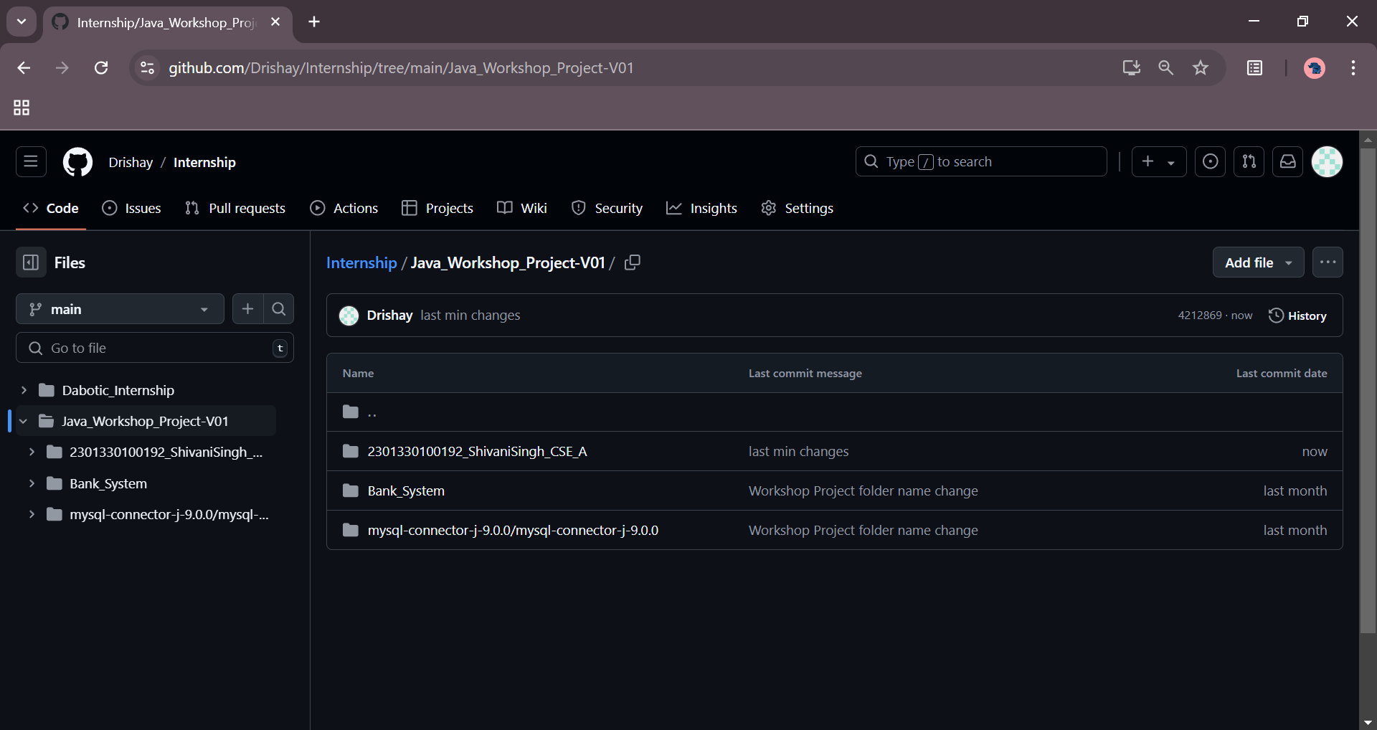All the code, documentation, and related resources for this project can be accessed on my GitHub repository: [GitHub](https://github.com/Drishay/Internship/tree/main/Dabotic_Internship)

**CURRICULUM VITAE**



**CURRICULUM VITAE**

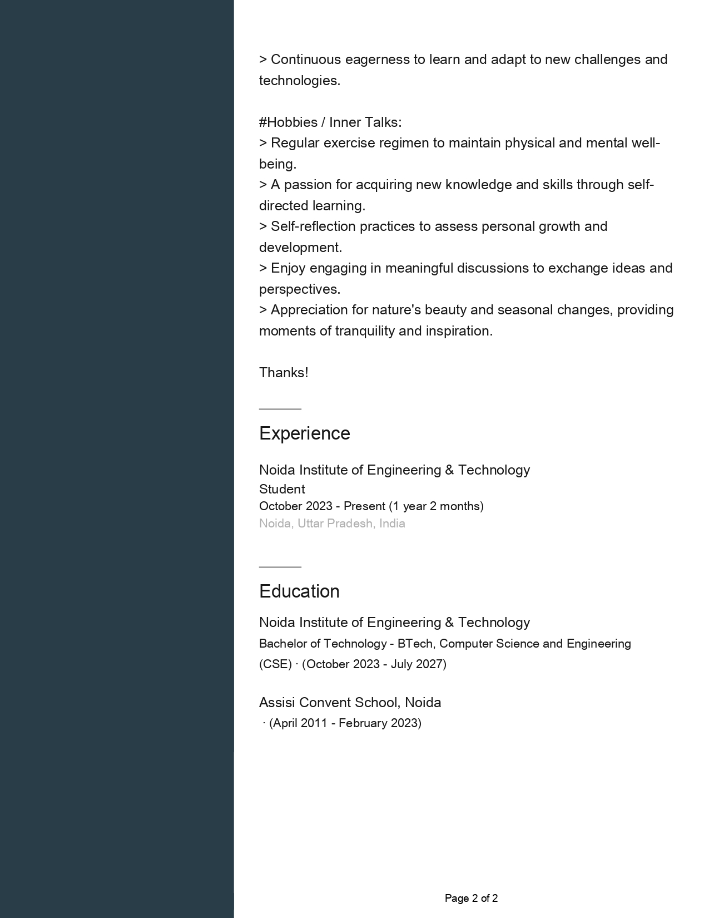

**CURRICULUM VITAE**

