1.   
use University

db.students.insertMany([{name:"Alice",age:20,department:"Computer Science",grades:{"math":85,"english":92}},

{name:"Bob",age:21,department:"Physics",grades:{"math":80,"english":90}},

{name:"Charlie",age:22,department:"Mathematics",grades:{"math":95,"english":89}}

])

2. // Write a query to display all students who are in the Computer Science department.

db.students.find({department:"Computer Science"})

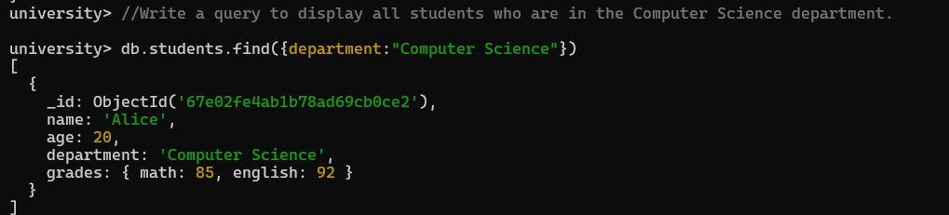

3. // Write a query to update the grades of a student named Alice by adding a new subject programming with a grade of 93.

db.students.updateOne( { name: "Alice" }, { $set: { "grades.programming": 93 } }

// I use grades. Programming cause when I use push or add to set it’s giving error of grades cannot be non-array type so grades.progamming made work easier without changing anything

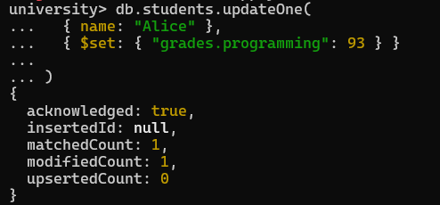

4. // Write a query to increment the age of all students by 1.

db.students.updateMany({},{$inc:{age:1}})

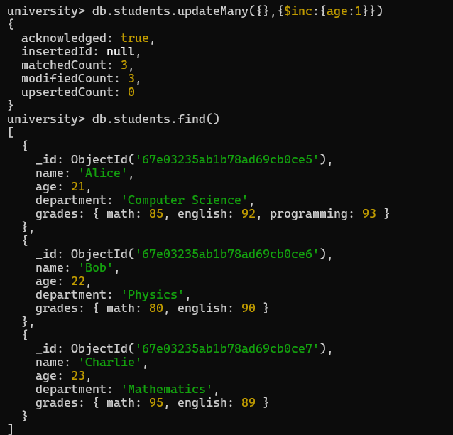

5. // Write a query to add a new field graduated set to false for all students who are in the Mathematics department.

db.students.updateMany({department:"Mathematics"},{$set:{graduated:false}})

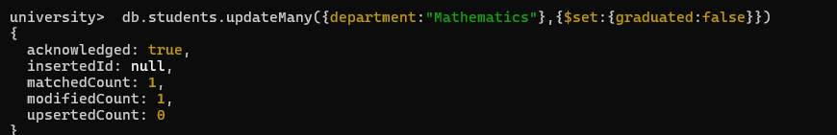

6. // Write a query to create an index on the name field of the students collection.

db.students.createIndex({ name: 1 })

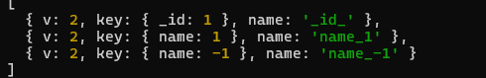

7. // Write an aggregation query to group students by their department and calculate the average age in each department.

db.students.aggregate([ { $group: { _id: "$department", averageAge: { $avg: "$age" } } }] )

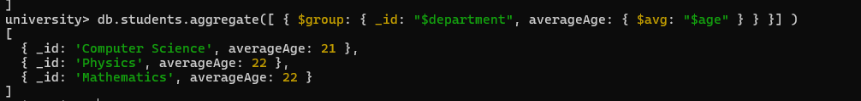

8. // Write a query to find all students who have scored more than 90 in any subject.

db.students.find({$or:[{"grades.math":{$gt:90}},{"grades.english":{$gt:90}},{"grades.programming":{$gt:90}}]})

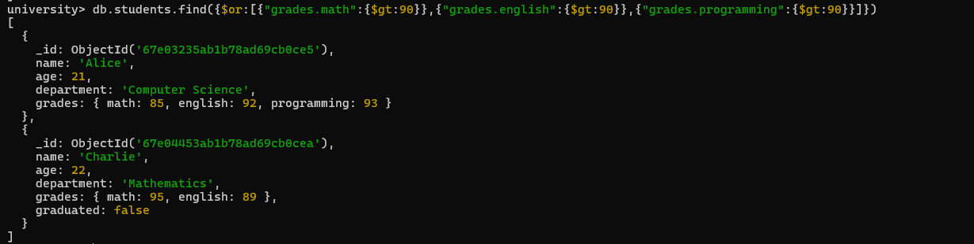

9. // Write a query to delete all students who are 23 years old.

db.students.deleteMany({age:{$eq:23}})



10. // How can you retrieve only the name and department fields for all students, excluding the _id field?

db.students.find({},{name:1,department:1,_id:0})

