Background:
Olist is an e-commerce company in Brazil that connects multiple small businesses through a single channel. Those merchants can sell their products through Olist stores and ship them directly to customers. Between 2016 and 2018, Olist experienced rapid growth, generating over 100000 orders. However, leadership lacked clear visibility into revenue drivers, customer retention, product performance, delivery performance, and their impact on customer satisfaction.
To support data-driven decision-making, a SQL analysis was conducted to uncover operational inefficiencies, revenue concentration risks, payment, and behavioral patterns affecting long-term growth.

Project Goal:
The objective of this project is to analyze business performance, measure customer retention, evaluate product and revenue concentration, assess payment risks, assess delivery efficiency, and examine how operational factors affect customer satisfaction.
The goal is to analyze real-world data using SQL and demonstrate a strong understanding of:
- Data modeling
- CTE structuring
- Window functions
- Aggregations
- Business metrics design

Data Source:
This analysis is based on a public Brazilian e-commerce dataset provided by Olist, containing ~100000 orders from 2016-2018. The dataset includes transactions (Orders), customers, products, payments, sellers, and review data, allowing end-to-end analysis of the e-commerce lifecycle.
Data Modeling:
Snowflake data model is designed to support analytical queries efficiently, where Orders is the central fact table connected to customers, products, sellers, payment, and reviews.
Table | Purpose | Key Relationships
Geolocation | Dimension table with geographic information | The geolocation table contains multiple rows for the same Zip code with different latitude and longitude values. Due to the non-unique behavior, geolocation is treated as reference data, and no physical foreign key constraints are enforced.
Prod_Catg_Nm_Eng | Reference table storing English transactions of product categories | This table serves as a reference for products. A physical foreign key constraint to the Products is intentionally not enforced, as some product categories do not have a corresponding English translation.
Products | Dimension table containing product attributes | Prod_ID Order_Item.Prod_ID
Customers | Dimension table with customer-specific data | Cust_ID Orders.Cust_ID
Seller | Dimension table with seller details and location data | Seller_ID Order_Item.Seller_ID
Orders | Fact table containing order details | Order_ID Order_Item.Order_ID  Order_ID Order_Payment.Order_ID  Order_ID Order_Review.Order_ID  Foreign Key: Cust_ID Customers.Cust_ID
Order_Item | Bridge table connecting Orders to product and sellers at the item level | Foreign Key: Order_ID Orders.Order_ID, Prod_ID Products.Prod_ID, Seller_ID Seller.Seller_  ID
Order_Payment | Table storing payment information per order | Foreign Key: Order_ID Orders.Order_ID
Order_Review | Contains customer review data linked to Orders | Foreign Key: Order_ID Orders.Order_ID
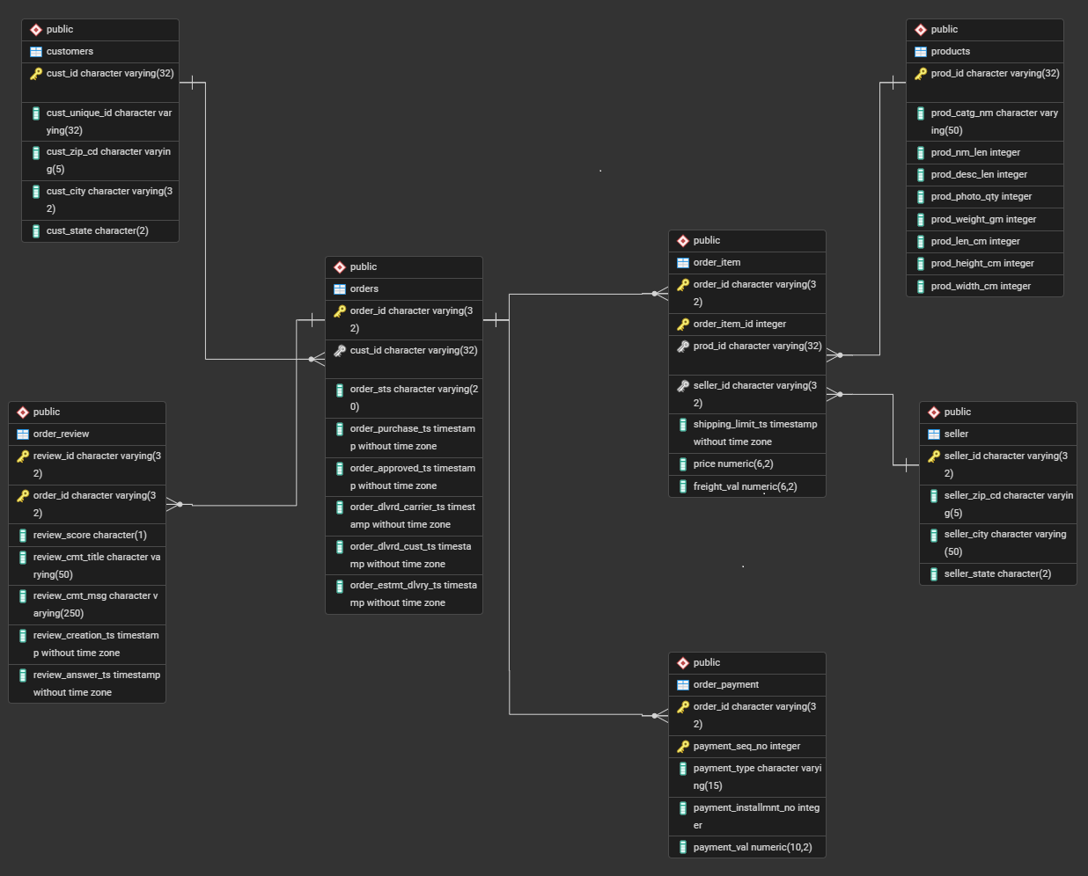

Assumptions:
- Revenue is calculated using Payment_Val from Order_Payment table. Freight charges are included where reflected in the payment value.
- Customers are uniquely identified using Unique_Cust_Id.
- Only delivered orders are analyzed.
- An order is considered on time when Order_Dlvrd_Cust_Ts <= Order_Estmt_Dlvry_Ts
- Customer lifetime revenue is calculated as historical cumulative revenue per customer. This is not predictive CLV.
- Orders are classified as installment-based in Payment_Installmnt_No >1
Metrics and Analysis Approach:
- Revenue and Growth:
Metric | SQL approach | Business Insight
Total monthly revenue | SUM of Payment_Val grouped by Year/Month | Understand overall revenue trends and seasonality
Average Order Value (AOV) | SUM(Payment_Val) / Count (distinct Order_ID) | Identifying order size over time
Month-over-Month Revenue Growth | (Current month revenue – Previous month revenue) / Previous month revenue using LAG () | Measure growth rate

- Customer Behavior:
Metric | SQL approach | Business Insight
New vs Repeat Customers | ROW_NUMBER () OVER (PARTITION BY cust_unique_ID ORDER BY Order_Purchase_Ts) = 1 to tag first order as ‘New’ and others as ‘Repeat’ | Assess customer retention
Repeat Purchase Rate | COUNT (distinct repeat customers) / COUNT (distinct all customers) | Evaluate loyalty and recurring revenue potential
Customer Lifetime Value (CLV) | SUM (Payment_Val) per customer | Determine the long-term revenue of each customer

- Product Performance:
Metric | SQL approach | Business Insight
Revenue per Product Category | SUM (Price + Freight_Val) by product category | Identify top-selling product categories
Revenue Concentration (Pareto Analysis) | Rank product categories by revenue, top 10% contribution using ROW_NUMBER and count (Prod_ID) over () | Identify the Products Categories driving the majority of revenue

- Operational metrics:
Metric | SQL approach | Business Insight
Order fulfillment Time | Order_Dlvrd_Cust_Ts – Order_Purchase_Ts | Measure the total time taken to deliver an order after purchase
On-time Delivery Rate | Count (Orders delivered on time) / Count (Total Orders) | Order fulfilment efficiency
Late Delivery Rate | Count (Orders delivered late) / Count (Total Orders) | Identifying operational bottleneck

- Payment and Risk:
Metric | SQL approach | Business Insight
Payment Method Breakdown | SUM of Revenue per payment type | Understand revenue distribution across payment methods
Installment Analysis | Tag Order as single payment vs installments, and calculate the average order value | Identify whether higher order value rely on installment payments

- Customer Satisfaction:
Metric | SQL approach | Business Insight
Revenue Vs Review Score | CORR (Review_Score, Revenue) | Determine if higher revenue orders lead to better reviews
Late Delivery Impact | Compare the average review score for ‘On-Time’ Vs ‘Late’ Orders | Assess operational impact on customer satisfaction

Key Findings:
Tools Used:
- SQL: For data extraction and loading
- Database Management System: PostgreSQL to host and manage the dataset
- Programming Language: SQL for data processing and scripting
Note:
For this SQL-focused phase, I intentionally worked with the raw dataset to reflect real-world analytical conditions. Instead of globally cleaning the data, I handled quality issues within each query through filters, joining strategies, and documented assumptions. In the future phase, I plan to implement formal data modeling and data quality checks using dbt.

