**HINDUSTAN TIMES**

**3rd September,2024**

**Sumit makes it a double, Nitesh adds to gold rush**

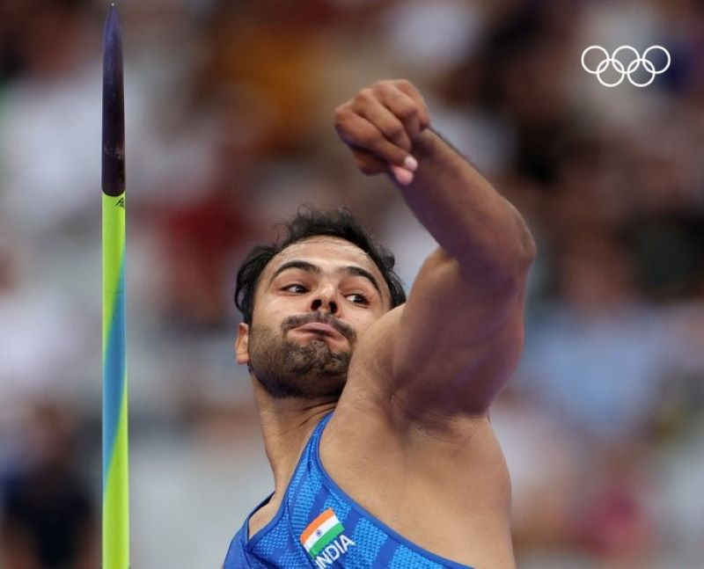

**Sumit Antil during one of his throws at the Paris Paralympics on Monday.**

**M**

**umbai:** If there was an air of heightened optimism around Neeraj Chopra returning with a second Olympic Javelin throw medal from Paris, there was almost a sense of surety about Sumit Antil grabbing a second Paralympic javelin throw gold in Paris.

For the world record holder in the men’s F64 category is, quite simply, a cut above the rest. From the moment he entered the Stade de France on Monday evening with an aura of a champion, Antil lived up to every bit of that hype. And with it, he brought home a second Paralympic gold for himself and for India with a throw of 70.59m off his second attempt that shattered the Paralympic record.

No Indian before Antil had ever won back-to-back gold medals in track & field at the Paralympics. In Tokyo, where he rewrote the world record three times over through the course of the event, was an announcement of his potential, Paris, where he came in increasing the world mark(73.29m) at last year’s Asian Games, was a stamp of his class.

Monday was also a stamp on one of India’s best days in the history of the Paralympics. Antil’s was the second gold of the day after shuttler Nitesh Kumar grabbed a dramatic top finish in the men’s singles SL3 category beating his nemesis Daniel Bethell of Great Britain 2-1(21-14, 18-21, 23-21) in the final.

[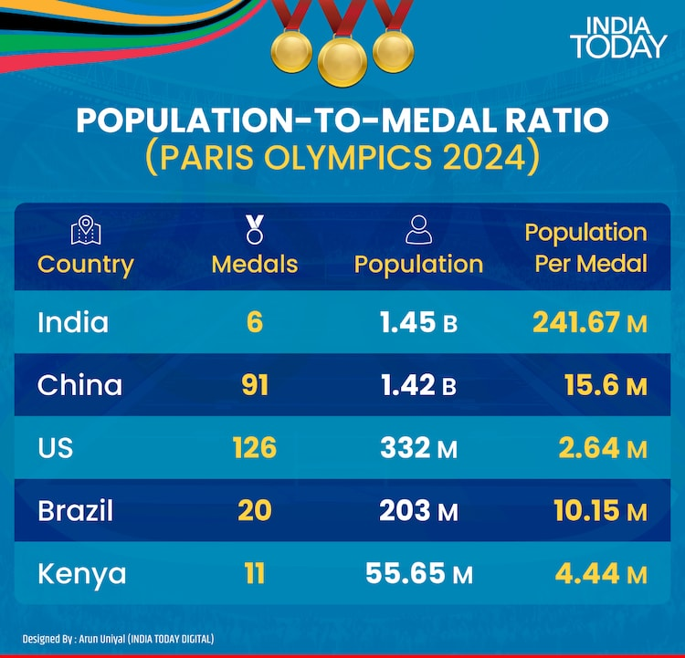](Linked%20to%20Article.docx)

In between, medals flew thick and fast- Thulasimathi Murugesan(silver), Suhas Yathiraj(silver) and Manisha Ramdass(bronze) in Badminton, Yogesh Kathuniya(silver) in athletics and the mixed archery team of Sheetal Devi and Rakesh Kumar which overcame a crushing shoot-off semi-final defeat by millimeters to bag the bronze beating Italians Eleonora Sarti and Matteo Bonacina by a close 156-155 margin.

Nothing about the Javelin event was close. Antil’s first roar of the evening before hurling the Javelin, and the attempt of 69.11m, placed him at an arm’s length to anyone else in the 10-man field. After that, it was only about how farther could Antil go on the night. He went beyond 70m, while only four others, including India’s Sandeep who finished fourth, threw in the region of 60s.

The 26-year old Antil, from Khewra village in Sonipat, wasn’t sure what life had in store for when, in 2015, a bike accident forced his left leg to be amputated from below the knee. Less than a decade later, he can call himself a two-time Paralympic champion.

Applying the early golden glow on India’s day in Paris was Nitesh, the IITian who beat Bethell in a pulsating men’s singles SL3 final. The Indian had never beaten the Britain in their previous meeting, losing as many as nine times against him. The Indian wouldn’t go down that path one more time, the 10th time, keeping his poise amid every twist and turn that the contest offered.

A football-loving kid growing up in Charkhi Dadri, Haryana, a train accident in 2009 left Nitesh bedridden for months and his left leg in need of prosthetics. Undeterred, he chose to pursue electrical engineering from IIT Mandi. That’s where his badminton ambitions began to brew.

He progressed to defeat Tokyo gold medallist Pramod Bhagat in the 2020 Nationals, won the singles silver at the 2022 World Championships and last year’s Asian Para Games. A gold in a major competition was the only piece missing from the engineer’s CV, and the 29-year-old has that now.

“I still don’t feel it,” Nitesh said moments after the final. “Maybe once I see the (India) flag going up (on the podium), I’ll feel it.”

Also feeling the joy of their first ever Paralympic medals were Thulasimathi and Manish, the two women from Tamil Nadu who delivered a 1-2 finish for India in the women’s singles SU5 category. The former went down 17-21, 10-21 to China’s defending champion Yang Qiu Xia in the final while the latter defeated Denmark’s Cathrine Rosengren 21-12, 21-8 for the bronze.

Her left hand affected by congenital deformity, a major injury from an accident further dented the mobility of her left hand, but not her resolve to pursue para sports with the support of her father who dedicated much of his time training her. Manisha was born with Erb’s palsy and yet, inspired by Saina Nehwal, the youngster made rapid strides in para badminton that landed her a medal in her first Paralympics outing.

Two men in their second Paralympics grabbed their second silver medal. Shuttler Yathiraj, the 41-year-old IAS officer, had flashes of 2021 again as the Indian was beaten in straight games (9-21, 13-21) by Frenchman Lucas Mazur in the men’s singles SL4 final.