**CLOUD COMPUTING LAB -05**

**Name: Drishti.**

**Roll No.: 1928228**

**Date: 02/02/2022**

**Task01:**

Change user bases each time and compare their average response time by retaining one datacenter in only one area (e.g., North America).

In this software, there are a total of 6 regions (continents) ( North America-0, South America-1, Europe-2, Asia-3, Africa -4, Australia-5)

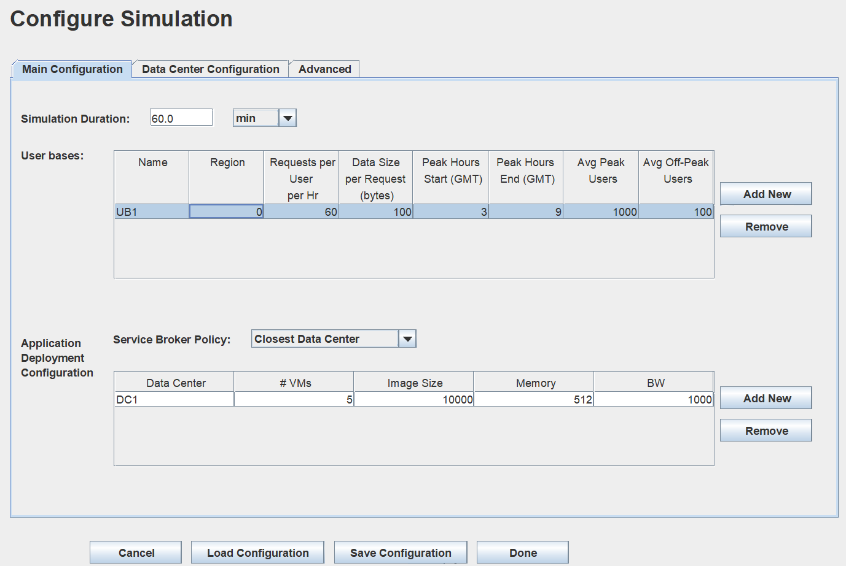

Changing the values here 0,1,2,3,4,5 for diff regions.

Following are the screenshots and the export from the cloud simulator.

Here the there is one datacentre and 1 user base. Data centre is in region 0 as well as userbase (North America)

The average response time is: 50.1 millisecond

The minimum response time is: 39.5 millisecond

The maximum response time is: 61.6 millisecond

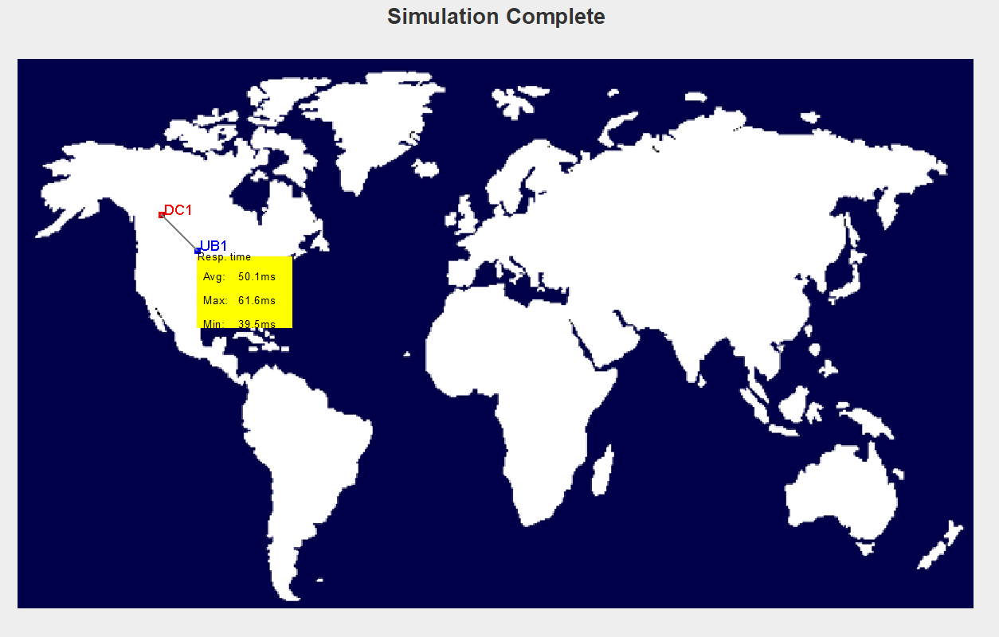

Here the there is one datacentre and 1 user base. Data centre is in region 0(North America) and userbase in region 1 (South America)

The average response time is: 200.1 millisecond

The minimum response time is: 158.1 millisecond

The maximum response time is: 246.1 millisecond

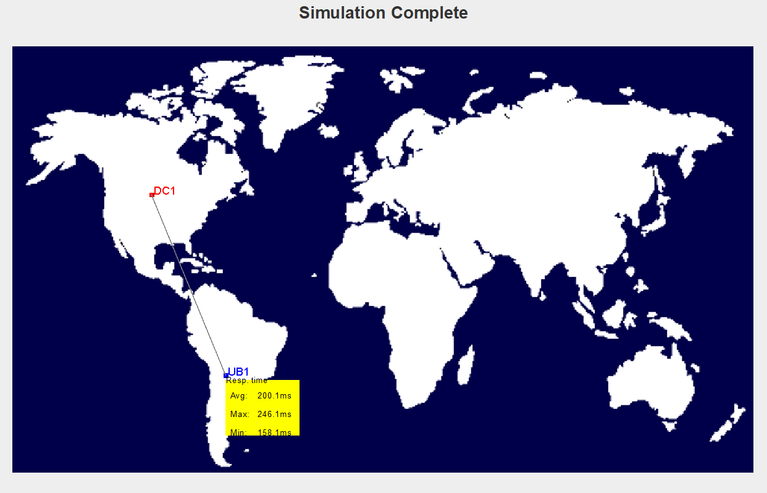

Here the there is one datacentre and 1 user base. Data centre is in region 0(North America) and userbase in region 2 (Europe)

The average response time is: 300.1 millisecond

The minimum response time is: 237.1 millisecond

The maximum response time is: 369.1 millisecond

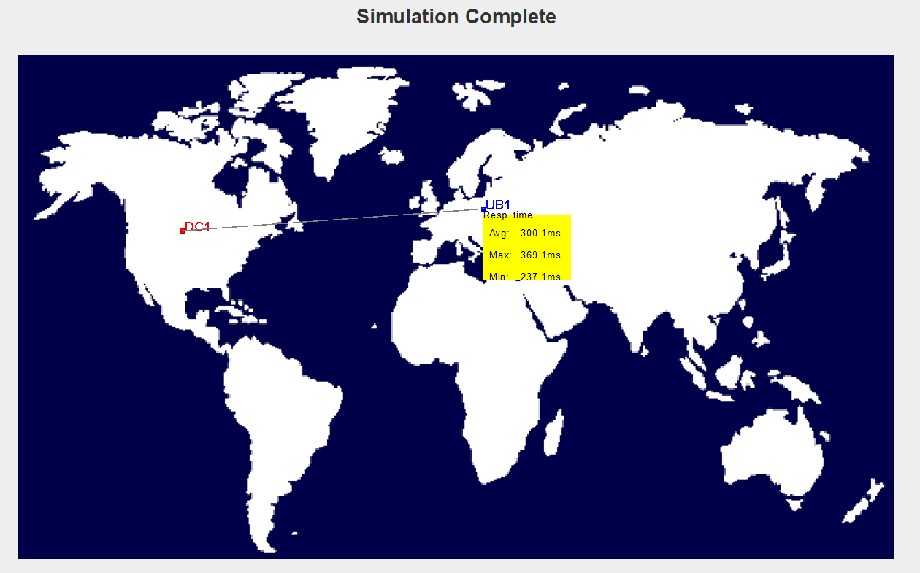

Here the there is one datacentre and 1 user base. Data centre is in region 0(North America) and userbase in region 3 (Asia)

The average response time is: 500.0 millisecond

The minimum response time is: 395.1 millisecond

The maximum response time is: 615.1 millisecond

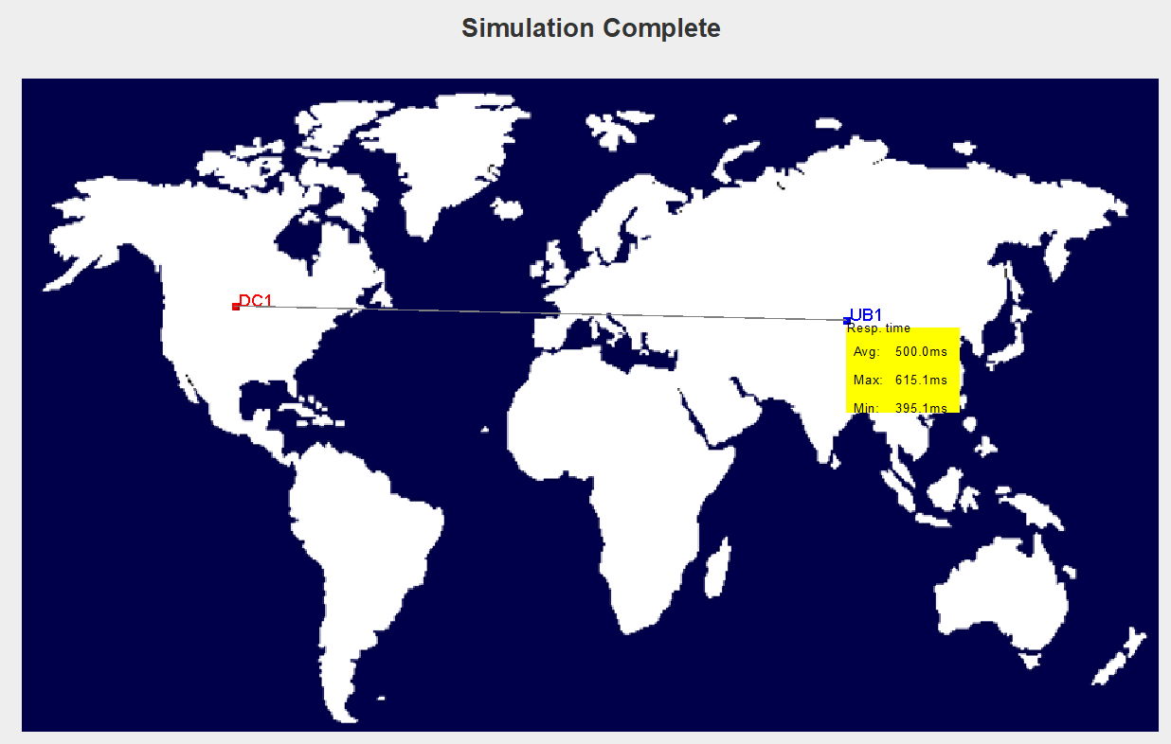

Here the there is one datacentre and 1 user base. Data centre is in region 0(North America) and userbase in region 4 (Africa)

The average response time is: 500.0 millisecond

The minimum response time is: 395.1 millisecond

The maximum response time is: 615.1 millisecond

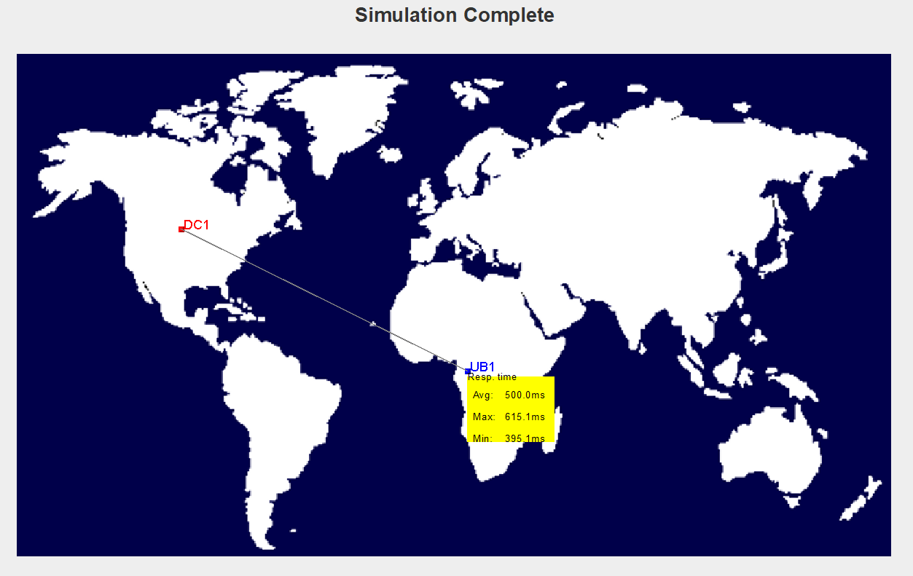

Here the there is one datacentre and 1 user base. Data centre is in region 0(North America) and userbase in region 5 (Australia)

The average response time is: 200.1 millisecond

The minimum response time is: 158.1 millisecond

The maximum response time is: 246.1 millisecond

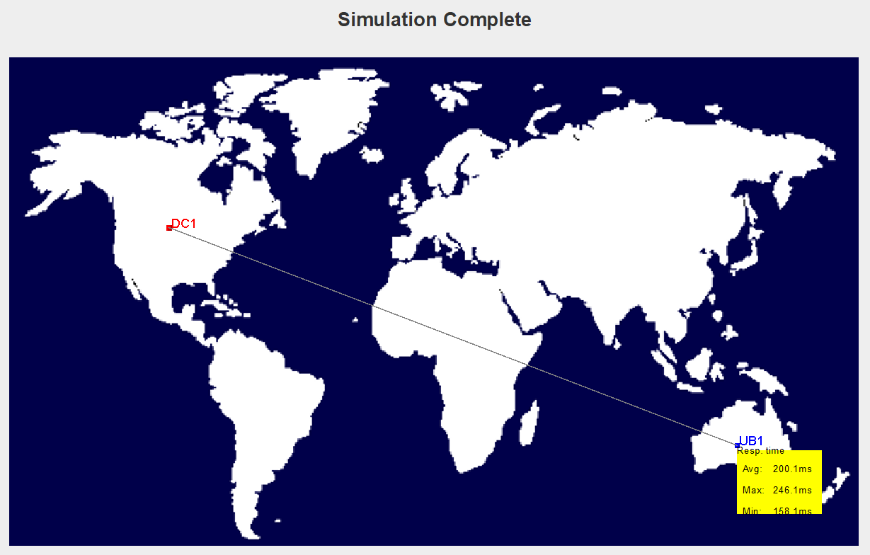

Graph comparing average response time, maximum response time and minimum response time of all the user base in different regions with respect to the data center in region-0 (North America)

in milliseconds

Australia

Africa

Asia

Europe

South

America

North

America

**Task02:**

In this case, we're looking at six user bases, each of which is located in a different region ranging from 0,1,2,3,4,5, and four data centres in 0,1,2,3 regions. We'll examine how long it takes for all of the connections to respond, based on the service broker's policies for efficient data centre use.

1. Closest Datacentre First:

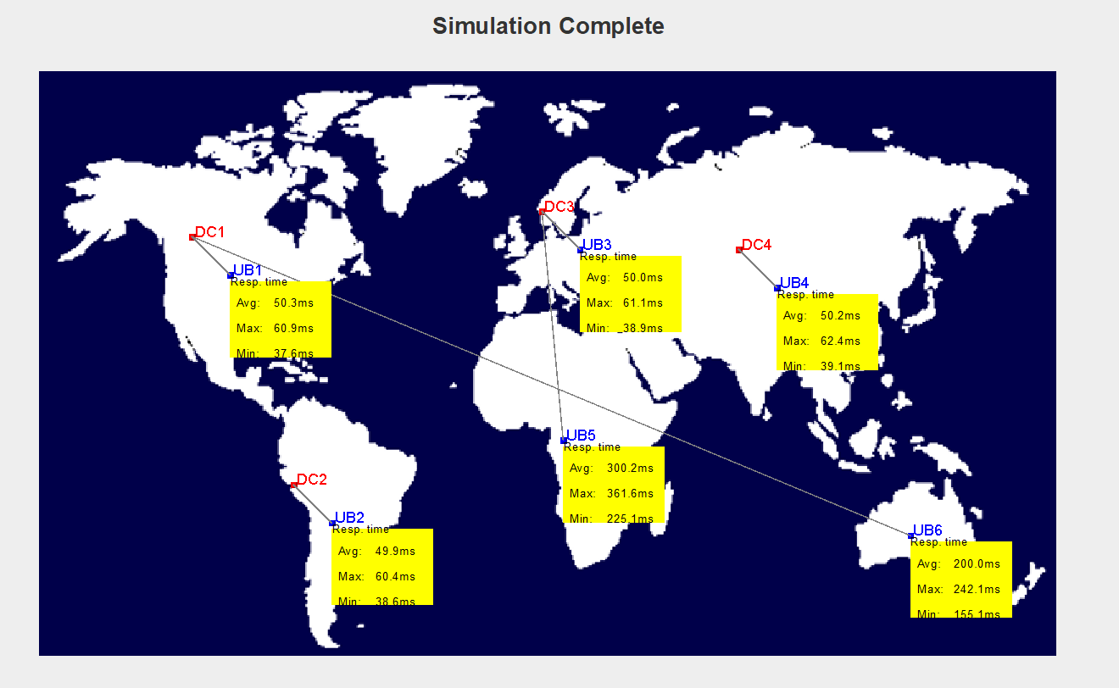

2)Optimized Resource Time:

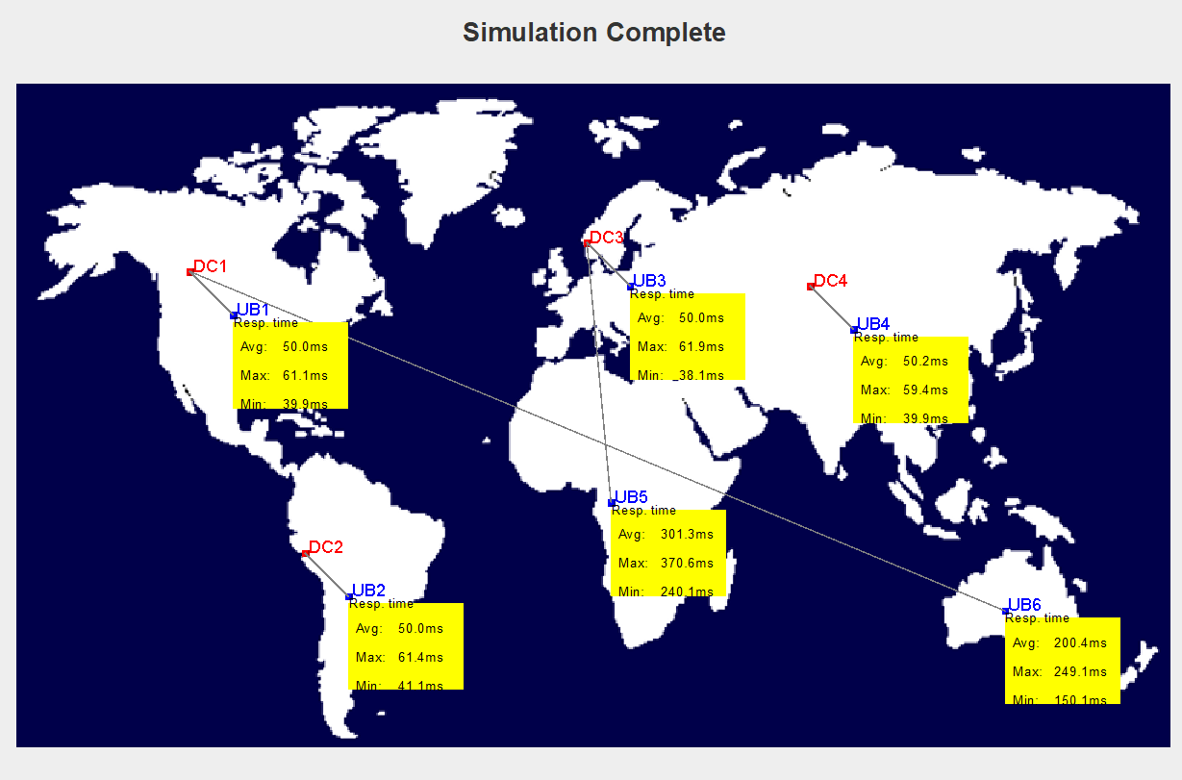

1. Reconfigure Dynamically:

