**CLOUD COMPUTING LAB06**

**Name: Drishti.**

**Roll No.: 1928228**

**Date: 09/02/2022**

Q: For five user bases with 170 request per user base and 4 data centers for the service broker policy( closest data centre, optimize response time and reconsider dynamically), use all three load balancing algorithms (Round robin, Equally spread current execution load and Throttled) and analyze the performance based on average response time.

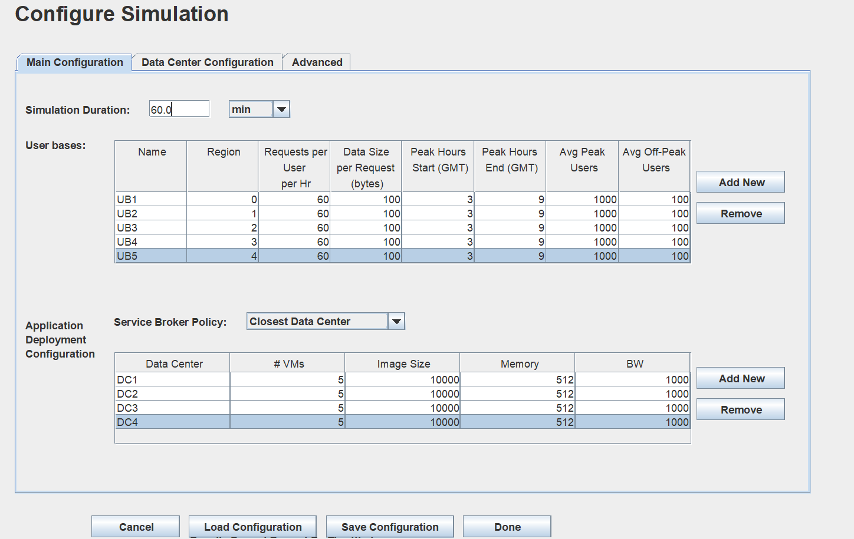

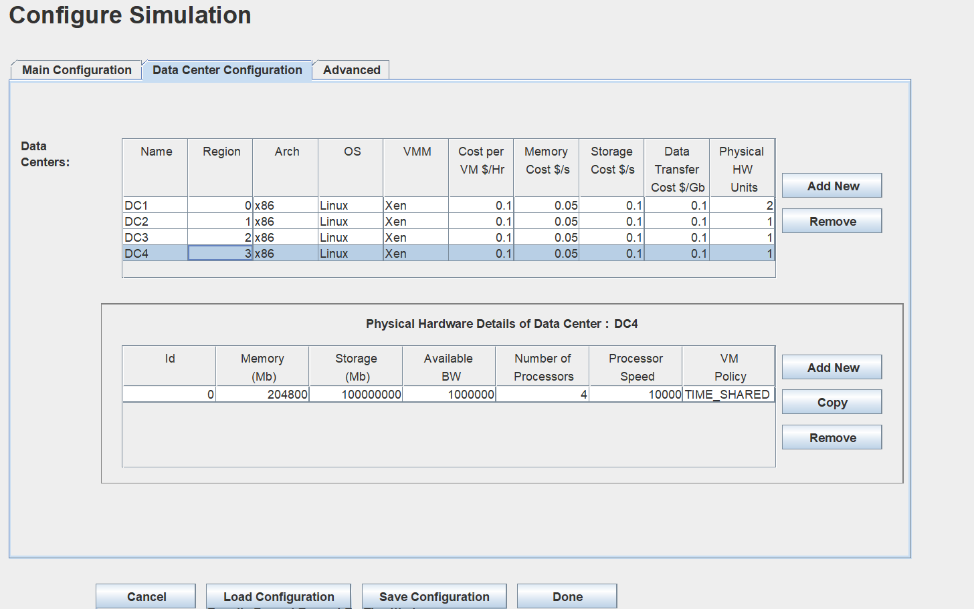

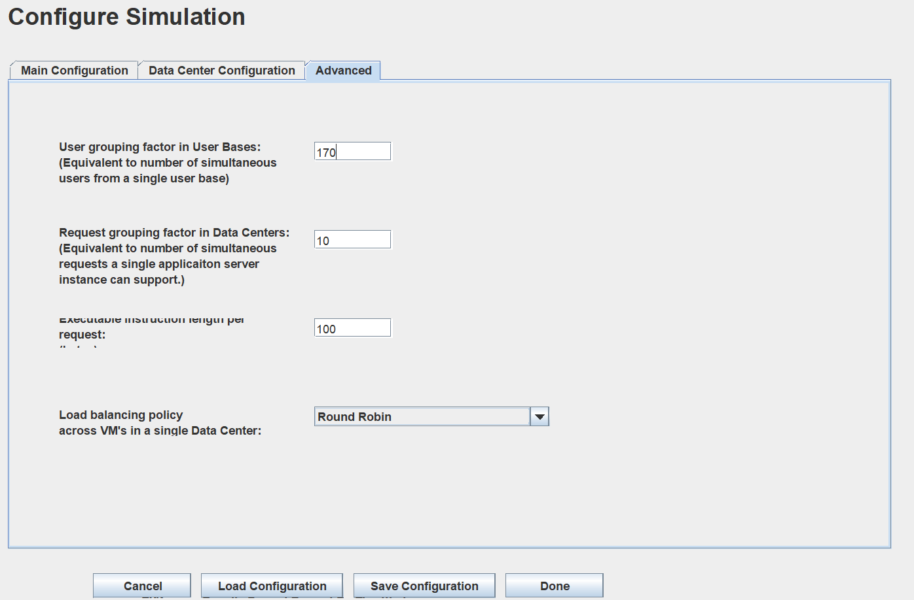

Under all broker policies: comparison of all load balancing algorithms (Round Robin, Equally spread current execution load and Throttled)

1)

2)

3)