CRUD Operations :
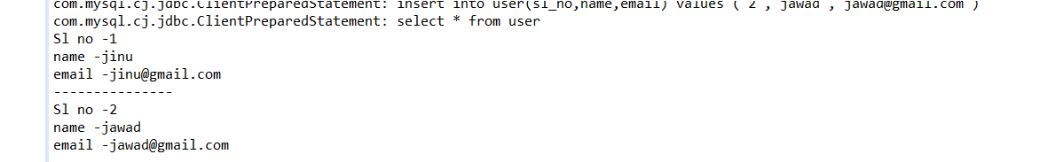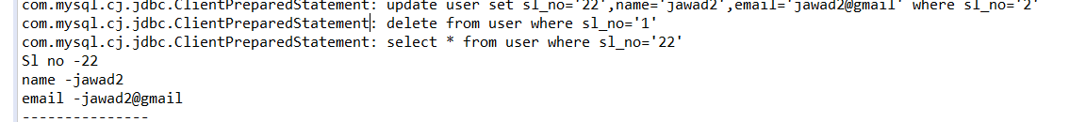

MongoDB Connection :
