**Assignment No: 01**

**Basic python programming**

1. **Write a python program to find the largest number in an given array**

**Code:**

import array as arr

#input values

input_num = arr.array('i',[])

number = int(input("Enter the number of elements in the array : "))

for i in range(number):

 x = int(input("Enter the next number : "))

 input_num.append(x)

# display

print ('Largest number in the array is : ', max(input_num))

**Output:**

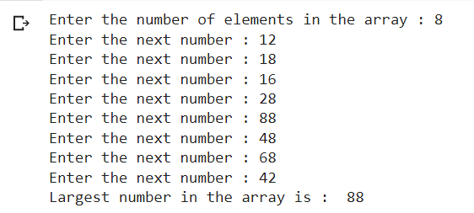

**Conclusion:** We have successfully written a python program to find the largest number in a given array