**Go to ganache-> Copy the private key from the addresses**



**Go to meta mask-> Import Account-> Paste the copied private key.**

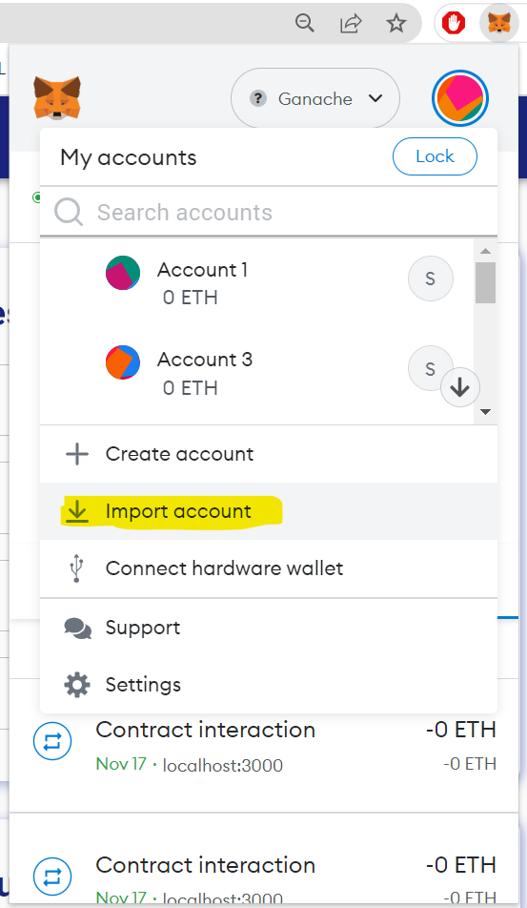 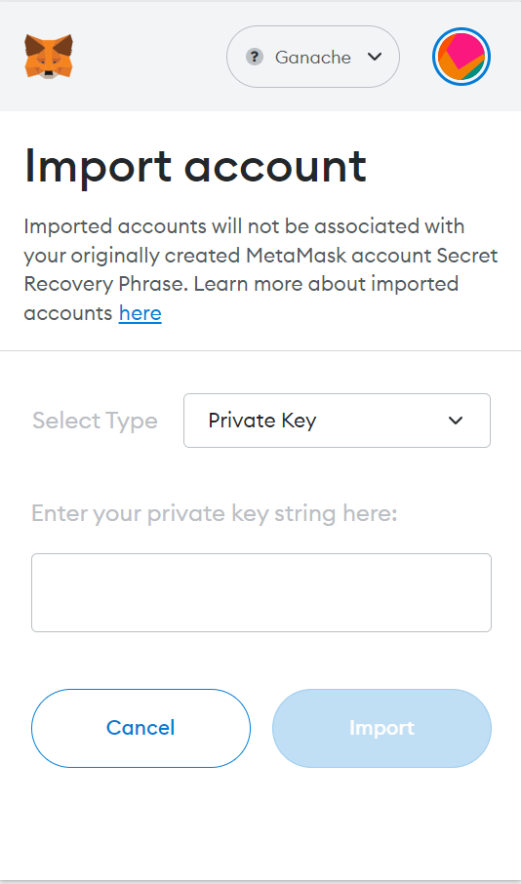

**Import 4 such unique accounts and name them respectively**

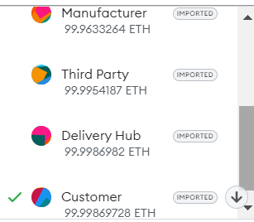

**In the terminal:**

1. **cd client**
2. **npm start**

**Go to Assign and Assign the private keys to respective account names in the main page**

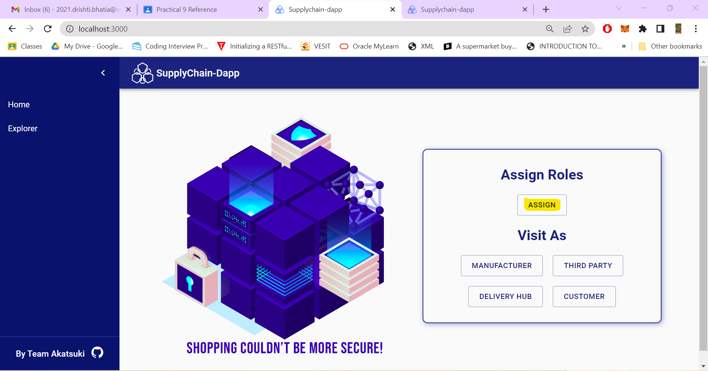

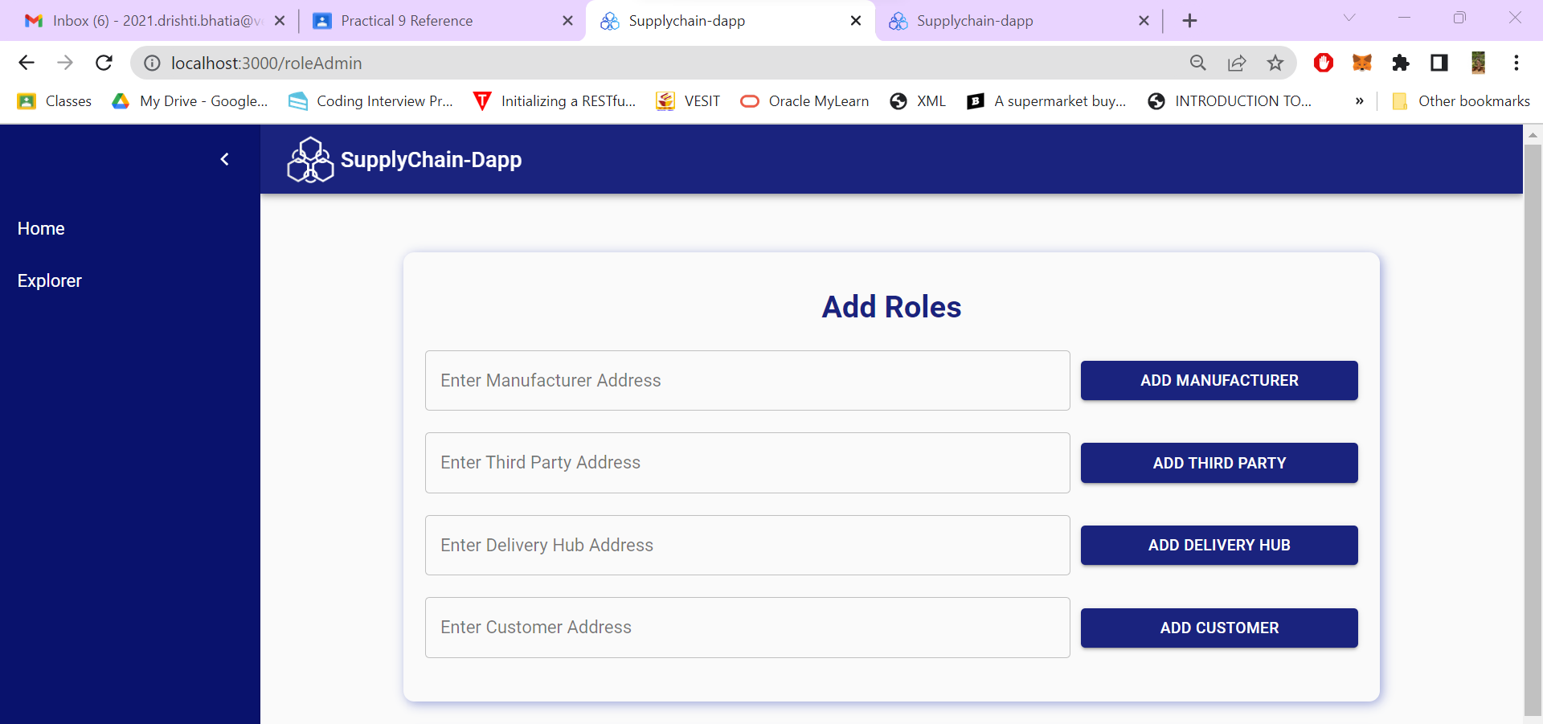

**Life cycle Step 1: Go to manufacturer and add the details *(Select the Manufacturer’s meta mask account while doing so)***

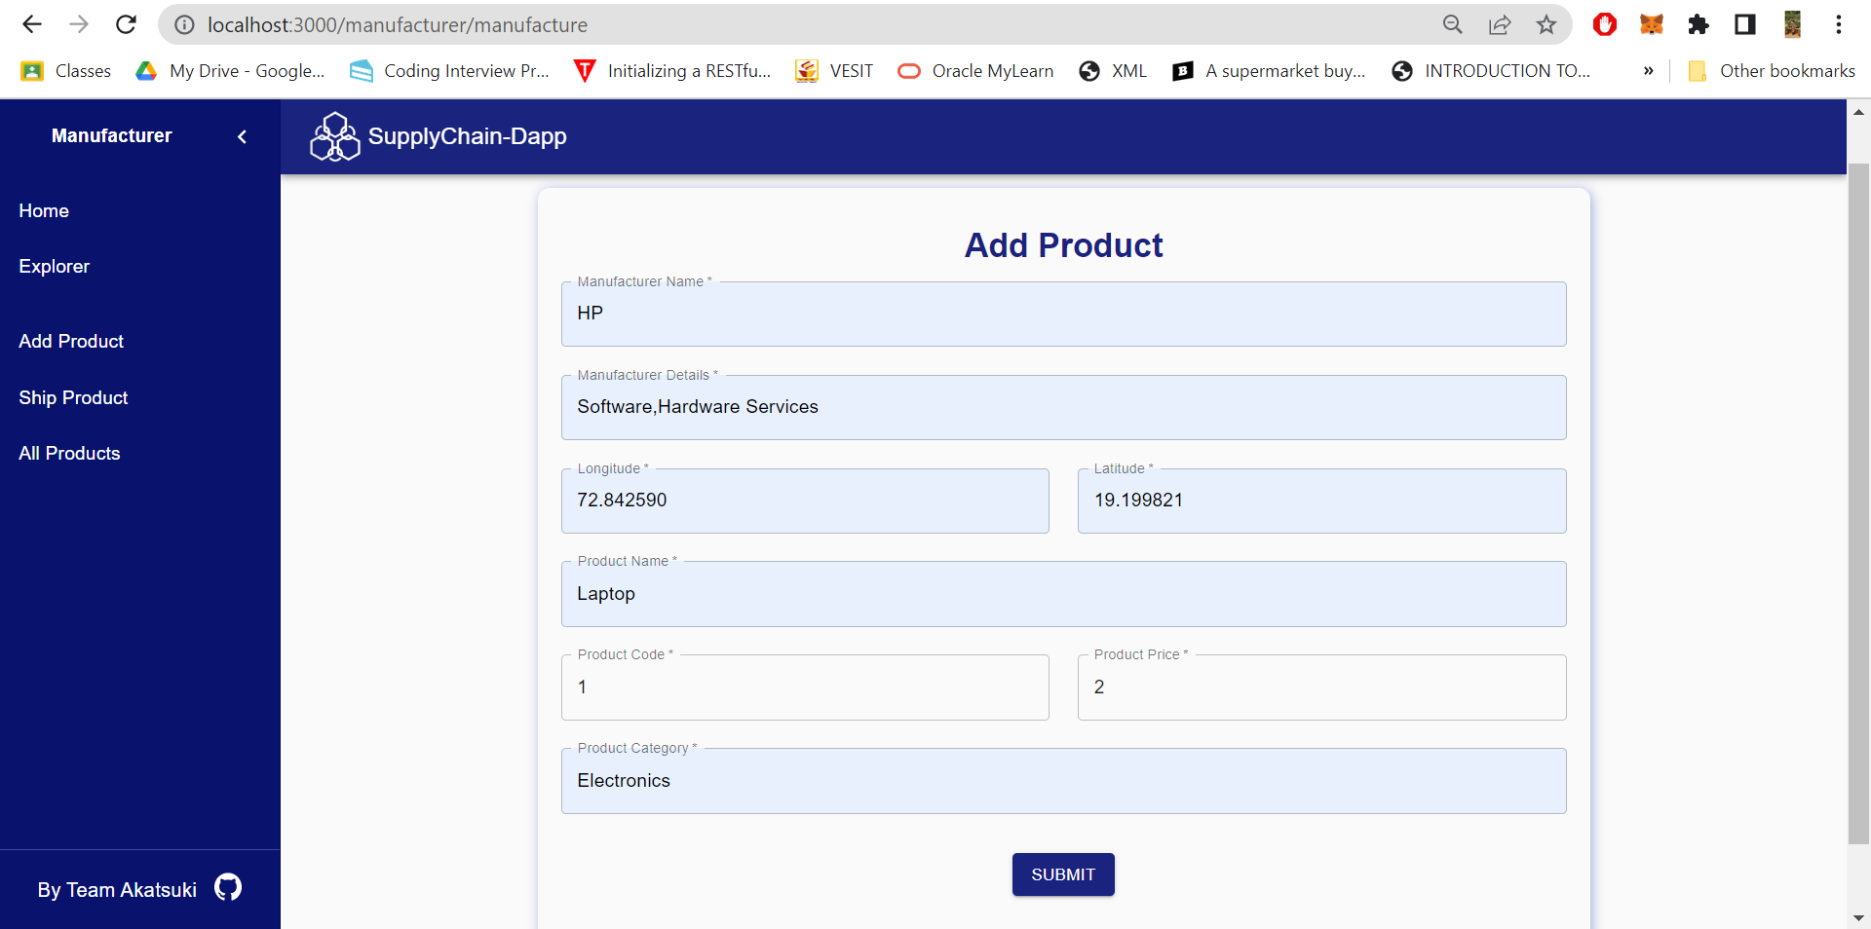

**Once you click on submit you will get a confirmation, please click on confirm**

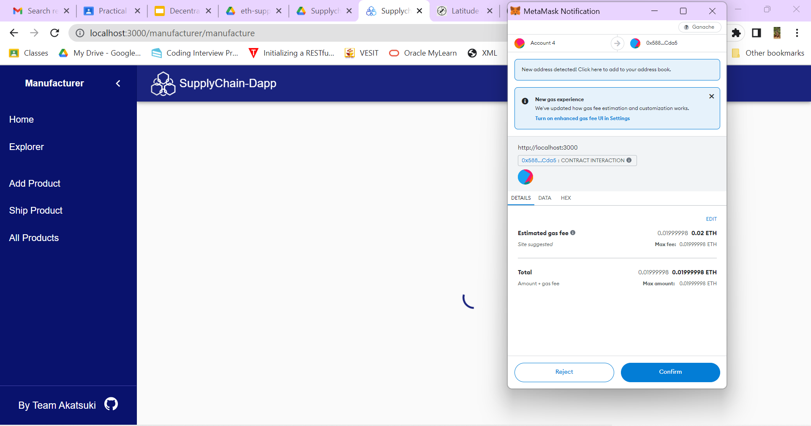

**Buy(Change metamask account to Third Part)**

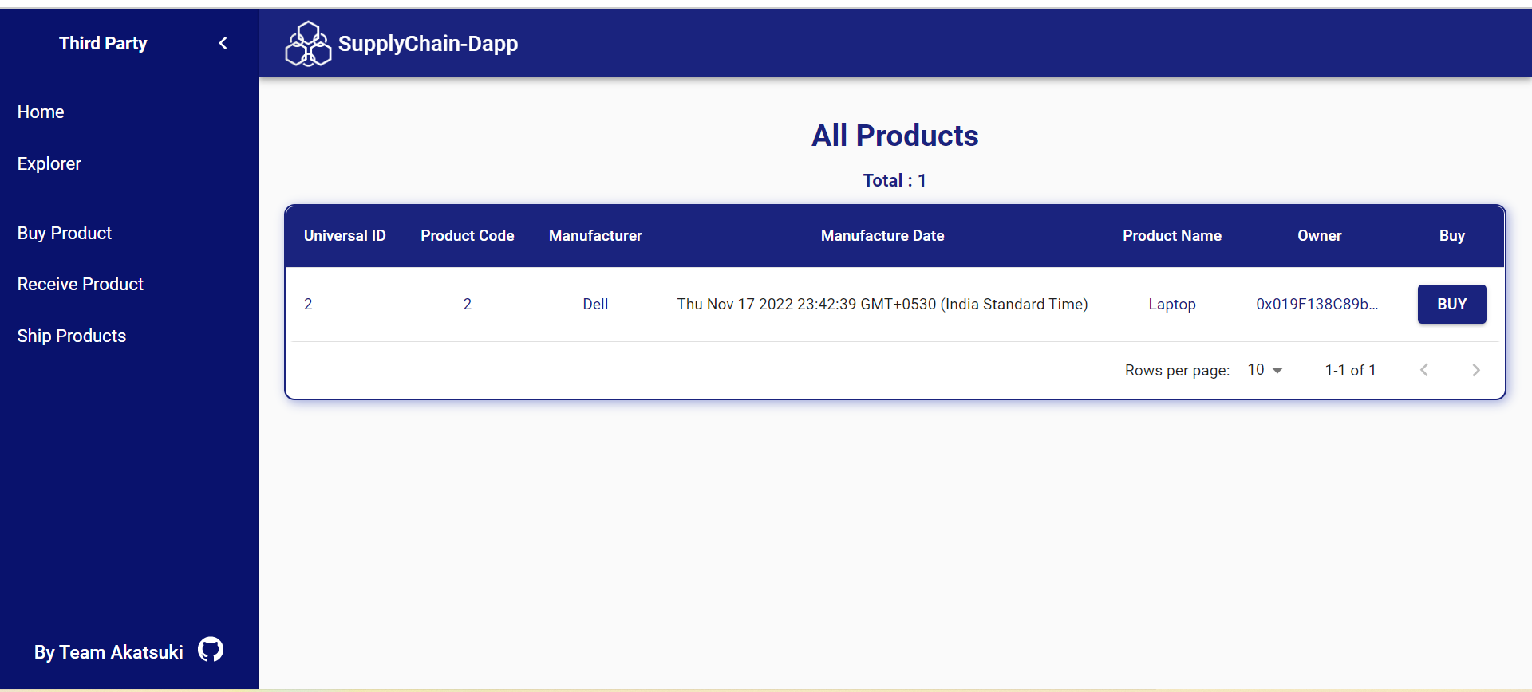

**Shipping (Change Account to Manufacturer):**

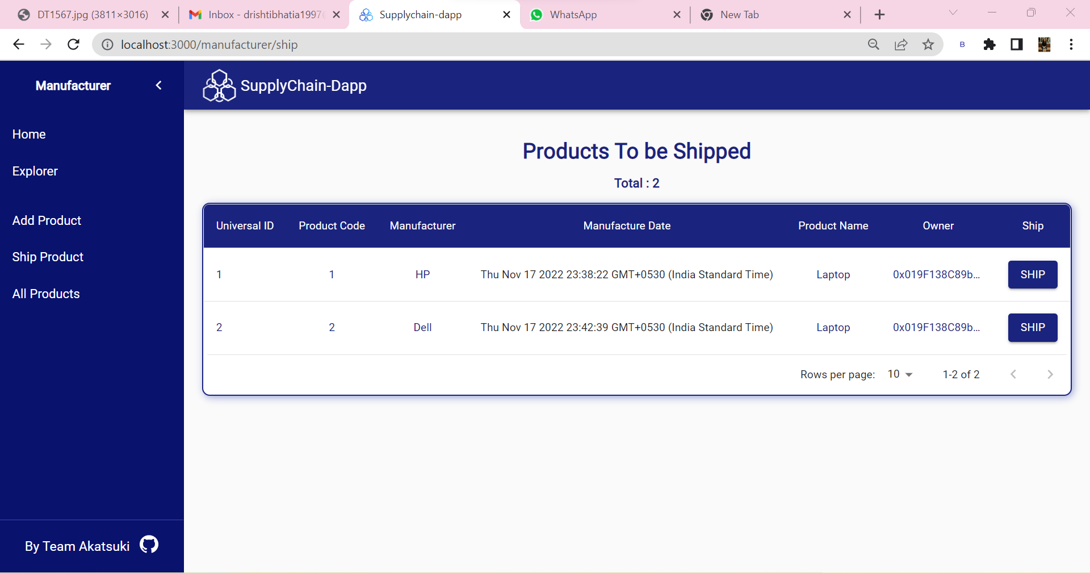

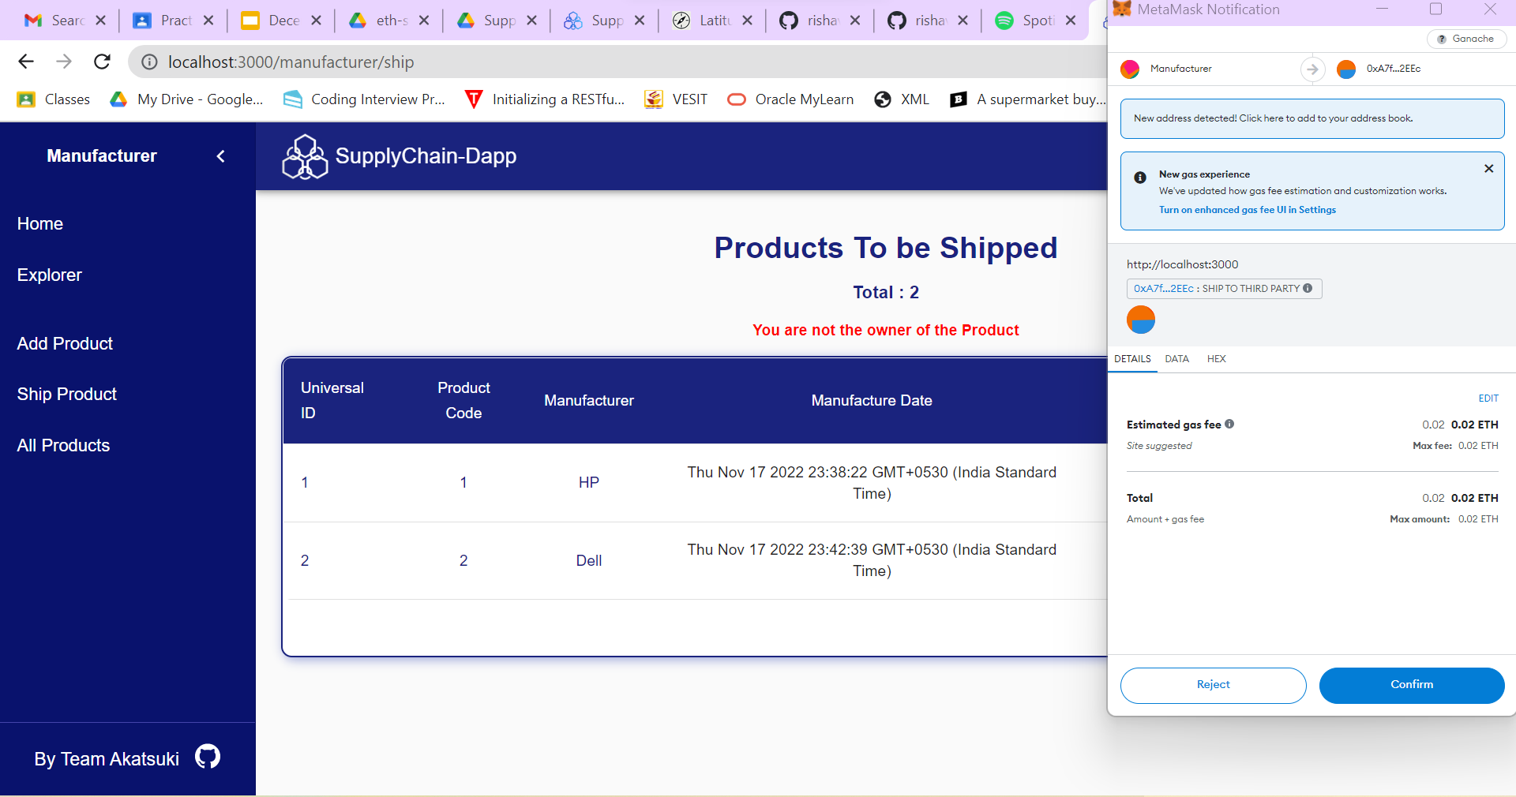

**After Confirming:**

