Branch: MCA (Data Science) | Semester: 2nd
Student Name: Drishti Bhatia | UID: 25MCD10008
Subject Name: Technical Training - I Lab | Subject Code: 25CAP-652
Section/Group: 25MCD- KAR1 | Date of Performance: 07-04-2026

Experiment No.: 9
1. Experiment Aim:
To implement database triggers in PostgreSQL to automatically calculate values and enforce constraints during data insertion operations.
2. Tools used: PostgreSQL
3. Objectives:
- Trigger Implementation: To understand how to create and use triggers in PostgreSQL.
- Automation: To automate calculation of total payable amount using triggers.
- Data Integrity: To enforce constraints using trigger conditions.
- Real-time Processing: To execute logic automatically before inserting data.
4. Theory:
Triggers are special database objects that automatically execute a function when a specified event (INSERT, UPDATE, DELETE) occurs on a table. In PostgreSQL, triggers are associated with trigger functions written in PL/pgSQL. They help maintain data integrity, enforce business rules, and automate tasks.

5. Experiment Steps:

Step 1: Creating Table Query: CREATE TABLE employee ( emp_id INT PRIMARY KEY, emp_name VARCHAR(50), working_hours INT, perhour_salary NUMERIC, total_payable_amount NUMERIC
);
Step 2: Creating Trigger Function Query:
CREATE OR REPLACE FUNCTION CACULATE_PAYABLE_AMOUNT()
RETURNS TRIGGER
AS
$$
BEGIN
NEW.total_payable_amount := NEW.perhour_salary * NEW.working_hours;

IF NEW.total_payable_amount > 25000 THEN
RAISE EXCEPTION 'INVALID ENTRY BEACUSE PAYABLE AMOUNT CAN
NOT BE GREATER THAN 25000';
END IF;

RETURN NEW;
END;
$$ LANGUAGE PLPGSQL;

Step 3: Creating Trigger Query:
CREATE OR REPLACE TRIGGER
AUTOMATED_PAYABLE_AMOUNT_CALCULATION
BEFORE INSERT ON employee
FOR EACH ROW
EXECUTE FUNCTION CACULATE_PAYABLE_AMOUNT();

Step 4: Inserting Valid Data Query:
INSERT INTO EMPLOYEE(emp_id, emp_name, working_hours, perhour_salary) VALUES (1, 'AKASH', 10, 1000);

Output:
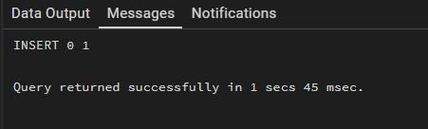

Step 5: Inserting Invalid Data (Exception
Case)
Query:
INSERT INTO employee(emp_id, emp_name, working_hours, perhour_salary) VALUES (2, 'Ankush', 8, 100000);

Output:
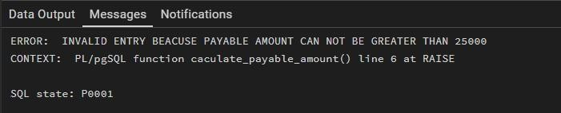

Step 6: Retrieving Data Query:
SELECT * FROM EMPLOYEE;

Output:
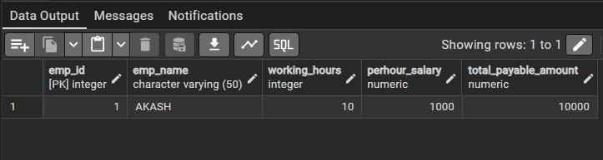

6. Learning Outcomes:
- I will be able to create and use triggers in PostgreSQL.
- I will understand how to automate calculations using triggers.
- I will enforce constraints using trigger conditions.
- I will understand real-time execution of database logic.

