Branch: MCA (Data Science) | Semester: 2
Student Name: Drishti Bhatia | UID: 25MCD10008
Subject Name: Technical Training - I Lab | Subject Code: 25CAP-652
Section/Group: 25MCD- KAR1 | Date of Performance: 31-03-2026

Experiment No.: 8
- Aim of the practical:

To apply the concept of Stored Procedures in database operations in order to perform tasks like insertion,

updating, deletion, and retrieval of data efficiently, securely, and in a reusable manner within the database system.

- Tools Used: PostgreSQL
- Objectives of the practical:

Apply stored procedure concepts for database operations

- Theory:

A Stored Procedure is a precompiled collection of SQL statements stored in the database that can be executed whenever required. It is used to perform operations like INSERT, UPDATE, DELETE, and SELECT in a structured and reusable way.

Stored procedures help in improving performance, security, and code reusability in database systems.

Key Features:
- Precompiled Code
Stored procedures are compiled once and stored, which makes execution faster compared to normal SQL queries.
- Reusability
The same procedure can be called multiple times without rewriting the code.
- Security
Users can be given permission to execute procedures without direct access to database tables.
- Reduced Network Traffic
Instead of sending multiple SQL queries, a single procedure call performs multiple operations.
- Modularity
Complex database logic can be divided into smaller procedures, making it easier to manage.

Experiment / Practical Steps:

CREATE TABLE employee_ (
emp_id INT PRIMARY KEY,
emp_name VARCHAR(100) NOT NULL,
salary NUMERIC(10,2) NOT NULL,
department VARCHAR(50)
);

INSERT INTO employee_ (emp_id,emp_name, salary, department) VALUES
(1,'Alice', 50000, 'HR'),
(2,'Bob', 60000, 'IT'),
(3,'Charlie', 55000, 'Finance');

CREATE OR REPLACE PROCEDURE UPDATA_SALARY_PROC(IN P_EMP_ID INT,INOUT P_SALARY NUMERIC(20,3),OUT
STATUS VARCHAR(20))
AS
$$
DECLARE
CURR_SAL NUMERIC(20,3);
BEGIN

SELECT SALARY+P_SALARY INTO CURR_SAL FROM EMPLOYEE_ WHERE EMP_ID=P_EMP_ID;
IF NOT FOUND THEN
RAISE EXCEPTION 'EMPLOYEE NOT FOUND';
END IF;
--CURR_SAL:=CURR_SALARY+P_SALARY;

UPDATE EMPLOYEE_
SET SALARY=CURR_SAL
WHERE EMP_ID=P_EMP_ID;

P_SALARY:=CURR_SAL;
STATUS:='SUCCESS';

EXCEPTION
WHEN OTHERS THEN
IF SQLERRM LIKE '%EMPLOYEE NOT FOUND%' THEN
STATUS:='EMPLOYEE NOT FOUND';
END IF;
END
$$ LANGUAGE PLPGSQL;

DO
$$
DECLARE
EMP_ID INT:=1;
STATUS VARCHAR(20);
SALARY NUMERIC(20,3):=500;
BEGIN
CALL UPDATA_SALARY_PROC(EMP_ID,SALARY,STATUS);
RAISE NOTICE 'YOUR STATUS IS % ',STATUS;
END;
$$
OUTPUT:
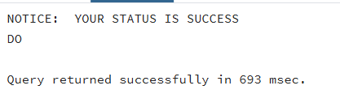

DO

$$
DECLARE
EMP_ID INT:=99;
STATUS VARCHAR(20);
SALARY NUMERIC(20,3):=500;
BEGIN
CALL UPDATA_SALARY_PROC(EMP_ID,SALARY,STATUS);
RAISE NOTICE 'YOUR STATUS IS % ',STATUS;
END;
$$
OUTPUT:

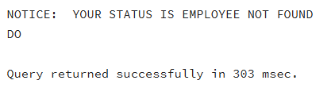

SELECT * FROM EMPLOYEE;

OUTPUT:
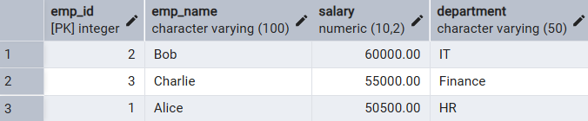

- Learning Outcomes:
- Understood the concept and importance of stored procedures in database systems.
- Learned how to create and execute stored procedures for CRUD operations.
- Gained knowledge about improving database performance and security using procedures.
- Developed skills to write reusable and modular SQL code for real-world applications.

