Branch: MCA (Data Science) | Semester: 2nd
Student Name: Drishti Bhatia | UID: 25MCD10008
Subject Name: Technical Training - I Lab | Subject Code: 25CAP-652
Section/Group: 25MCD- KAR1 | Date of Performance: 03-02-2026

Experiment No.: 4

Implementation of Iterative Control Structures using FOR, WHILE, and LOOP in PostgreSQL
- Aim of the practical:

To understand and implement iterative control structures in PostgreSQL conceptually, including FOR loops, WHILE loops, and basic LOOP constructs, for repeated execution of database logic.

- Tools Used: PostgreSQL
- Objectives of the practical:
- To understand why iteration is required in database programming
- To learn the purpose and behavior of FOR, WHILE, and LOOP constructs
- To understand how repeated data processing is handled in databases
- To relate loop concepts to real-world batch processing scenarios
- To strengthen conceptual knowledge of procedural SQL used in enterprise systems

- Theory:

In real-world database applications, tasks often need to be repeated multiple times. Examples include processing employee records, generating reports, validating data, applying salary increments, and running batch jobs. Standard SQL is declarative and works well for single operations, but repeated logic requires procedural control.

PostgreSQL provides PL/pgSQL, a procedural extension that supports iteration using loop structures. These loops allow SQL statements to execute repeatedly until a specific condition is met.

Iteration in PostgreSQL is commonly used inside:
- Stored procedures
- Functions
- Anonymous execution blocks

Large organizations such as Amazon, SAP, Oracle, and Rippling use loop-based logic for payroll processing, billing cycles, analytics, and automation workflows.

Types of Loops in PostgreSQL

1. FOR Loop (Range-Based)
- Executes a fixed number of times
- Useful when the number of iterations is known in advance
- Commonly used for counters, testing, and batch execution

2. FOR Loop (Query-Based)
- Iterates over rows returned by a query
- Processes one row at a time
- Frequently used for reporting, audits, and row-wise calculations

3. WHILE Loop
- Executes repeatedly as long as a condition remains true
- Suitable for condition-controlled execution
- Often used in retry logic or threshold-based processing

4. LOOP with EXIT Condition
- Executes indefinitely until explicitly stopped
- Provides maximum control over execution flow
- Used in complex workflows where exit conditions are custom-defined

Experiment / Practical Steps:
Prerequisite Understanding
Example 1: FOR Loop – Simple Iteration
- The loop runs a fixed number of times
- Each iteration represents one execution cycle
- Useful for understanding basic loop behavior
Application: Counters, repeated tasks, batch execution

Example 2: FOR Loop with Query (Row-by-Row Processing)
- The loop processes database records one at a time
- Each iteration handles a single row
- Simulates cursor-based processing
Application: Employee reports, audits, data verification

Example 3: WHILE Loop – Conditional Iteration
- The loop runs until a condition becomes false
- Execution depends entirely on the condition
- The condition is checked before every iteration
Application: Retry mechanisms, validation loops

Example 4: LOOP with EXIT WHEN
- The loop does not stop automatically
- An explicit exit condition controls termination
- Gives flexibility in complex logic
Application: Workflow engines, complex decision cycles

Example 5: Salary Increment Using FOR Loop
- Employee records are processed one by one
- Salary values are updated iteratively
- Represents real-world payroll processing
Application: Payroll systems, bulk updates

Example 6: Combining LOOP with IF Condition
- Loop processes each record
- Conditional logic classifies data during iteration
- Demonstrates decision-making inside loops
Application: Employee grading, alerts, categorization logic

- Code:
--Example1
DO $$
DECLARE
i INT;
BEGIN
FOR i IN 1..5 LOOP
RAISE NOTICE 'Iteration number: %', i;
END LOOP;
END $$;

--Example2
CREATE TABLE employee1 (
emp_id SERIAL PRIMARY KEY,
emp_name VARCHAR(50),
department VARCHAR(30),
salary INT
);

INSERT INTO employee1 (emp_name, department, salary) VALUES
('Aarav', 'HR', 45000),
('Diya', 'Finance', 60000),
('Kabir', 'IT', 75000),
('Meera', 'IT', 52000),
('Rohan', 'Marketing', 40000);

DO $$
DECLARE
rec RECORD;
BEGIN
FOR rec IN SELECT emp_id, emp_name FROM employee1 LOOP
RAISE NOTICE 'Employee ID: %, Name: %', rec.emp_id, rec.emp_name;
END LOOP;
END $$;

--Example3
DO $$
DECLARE
counter INT := 1;
BEGIN
WHILE counter <= 5 LOOP
RAISE NOTICE 'Counter value: %', counter;
counter := counter + 1;
END LOOP;
END $$;

--Example4
DO $$
DECLARE
num INT := 1;
BEGIN
LOOP
RAISE NOTICE 'Number: %', num;
num := num + 1;

EXIT WHEN num > 5;
END LOOP;
END $$;

--Example5
DO $$
DECLARE
rec RECORD;
BEGIN
FOR rec IN SELECT emp_id FROM employee1 LOOP
UPDATE employee1
SET salary = salary + 1000
WHERE emp_id = rec.emp_id;
END LOOP;
END $$;

select * from employee1;

--Example6
DO $$
DECLARE
rec RECORD;
BEGIN
FOR rec IN SELECT emp_name, salary FROM employee1 LOOP
IF rec.salary >= 60000 THEN
RAISE NOTICE '% is a High Salary Employee', rec.emp_name;
ELSE
RAISE NOTICE '% is a Regular Salary Employee', rec.emp_name;
END IF;
END LOOP;
END $$;

- Output:
Example 1:
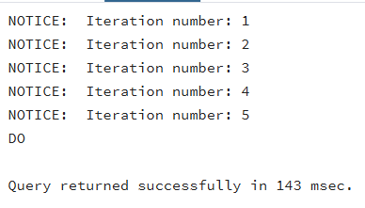

Example 2:
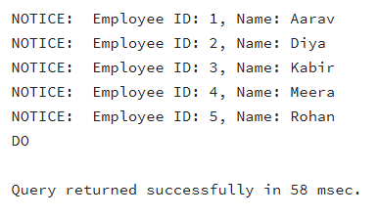

Example 3:
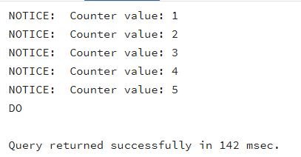

Example 4:
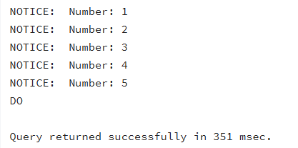

Example 5:
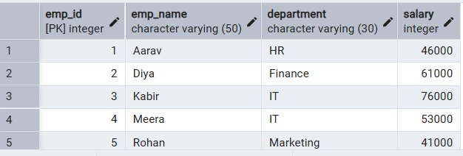

Example 6:
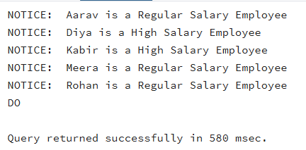

- Learning Outcomes:

- Understood the concept of iterative control structures in PostgreSQL
- Identified appropriate use cases for FOR, WHILE, and LOOP constructs
- Implemented procedural logic using PL/pgSQL loops
- Applied loops for row-by-row data processing and conditional execution
- Gained foundational knowledge required for enterprise-level database applications

