Branch: MCA (Data Science) | Semester: 2nd
Student Name: Drishti Bhatia | UID: 25MCD10008
Subject Name: Technical Training - I Lab | Subject Code: 25CAP-652
Section/Group: 25MCD- KAR1 | Date of Performance: 27-02-2026

Experiment No.: 5
- Aim of the practical:

To gain hands-on experience in creating and using cursors for row-by-row processing in a database, enabling sequential access and manipulation of query results for complex business logic. (Company Tags: Infosys, Wipro, TCS, Capgemini)

- Tools Used: PostgreSQL
- Objectives of the practical:
- Sequential Data Access: To understand how to fetch rows one by one from a result set using cursor mechanisms.
- Row-Level Manipulation: To perform specific operations or calculations on individual records that require conditional procedural logic.
- Resource Management: To learn the lifecycle of a cursor: Declaring, Opening, Fetching, and importantly, Closing and Deallocating to manage system memory.
- Exception Handling: To handle cursor-related errors and performance considerations during large-scale data iteration.

- Theory:

While SQL is generally set-oriented, certain tasks require a procedural approach where we process one row at a time. This is where Cursors are used:
- Cursor Types: Cursors can be Implicit (managed by the system) or Explicit (defined by the developer). They can also be Forward-Only (moving only toward the end) or Scrollable (moving back and forth).
- The Lifecycle: * DECLARE: Defines the SQL query for the cursor.
  - OPEN: Executes the query and establishes the result set.
  - FETCH: Retrieves a specific row into variables for processing.
  - CLOSE: Releases the current result set.
  - DEALLOCATE: Removes the cursor definition from memory.
- Use Case: Cursors are ideal for generating row-specific reports, updating balances based on complex historical data, or migrating data where each record needs individual validation.

Experiment / Practical Steps:
Step 1: Implementing a Simple Forward-Only Cursor
Creating a cursor to loop through an Employee table and print individual records.

Query:
--create table
CREATE TABLE employeee (
emp_id SERIAL PRIMARY KEY,
emp_name VARCHAR(100),
salary NUMERIC(10,2),
experience INT,
performance_rating NUMERIC(3,1)
);

--insert sample data
INSERT INTO employeee (emp_name, salary, experience, performance_rating)
VALUES
('Amit Sharma', 30000, 2, 3.5),
('Neha Verma', 45000, 5, 4.2),
('Rahul Singh', 60000, 8, 4.8),
('Priya Mehta', 35000, 3, 2.9),
('Karan Malhotra', 70000, 10, 4.5);

--step1
DO $$
DECLARE
emp_record RECORD;
emp_cursor CURSOR FOR
SELECT emp_id, emp_name, salary FROM employeee;
BEGIN
OPEN emp_cursor;

LOOP
FETCH emp_cursor INTO emp_record;
EXIT WHEN NOT FOUND;

RAISE NOTICE 'ID: %, Name: %, Salary: %',
emp_record.emp_id,
emp_record.emp_name,
emp_record.salary;
END LOOP;

CLOSE emp_cursor;
END $$;

Output:
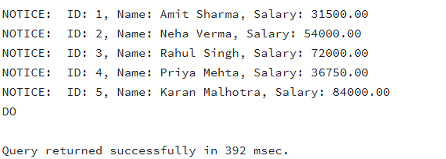
Step 2: Complex Row-by-Row Manipulation
Using a cursor to update salaries based on a dynamic "Experience-to-Performance" ratio logic.

Query:
--step2
DO $$
DECLARE
emp_record RECORD;
ratio NUMERIC;
emp_cursor CURSOR FOR
SELECT emp_id, salary, experience, performance_rating
FROM employeee
FOR UPDATE;
BEGIN
OPEN emp_cursor;

LOOP
FETCH emp_cursor INTO emp_record;
EXIT WHEN NOT FOUND;

ratio := emp_record.experience * emp_record.performance_rating;

IF ratio > 20 THEN
UPDATE employeee
SET salary = salary * 1.20
WHERE CURRENT OF emp_cursor;

ELSIF ratio BETWEEN 10 AND 20 THEN
UPDATE employeee
SET salary = salary * 1.10
WHERE CURRENT OF emp_cursor;

ELSE
UPDATE employeee
SET salary = salary * 1.05
WHERE CURRENT OF emp_cursor;
END IF;

END LOOP;

CLOSE emp_cursor;
END $$;

--view updated table
select * from employeee;

Output:
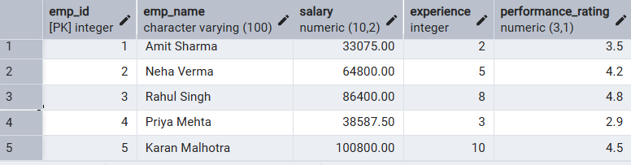

Step 3: Exception and Status Handling
Ensuring the cursor handles empty result sets or termination signals gracefully.

Query:
--step3
DO $$
DECLARE
emp_record RECORD;
emp_cursor CURSOR FOR
SELECT emp_id, emp_name FROM employee;
row_count INT := 0;
BEGIN
OPEN emp_cursor;

LOOP
FETCH emp_cursor INTO emp_record;
EXIT WHEN NOT FOUND;

row_count := row_count + 1;

RAISE NOTICE 'Processing Employee: % - %',
emp_record.emp_id,
emp_record.emp_name;
END LOOP;

IF row_count = 0 THEN
RAISE NOTICE 'No employees found.';
ELSE
RAISE NOTICE 'Total Employees Processed: %', row_count;
END IF;

CLOSE emp_cursor;

EXCEPTION
WHEN OTHERS THEN
RAISE NOTICE 'Error: %', SQLERRM;
IF emp_cursor IS NOT NULL THEN
CLOSE emp_cursor;
END IF;
END $$;
Output:
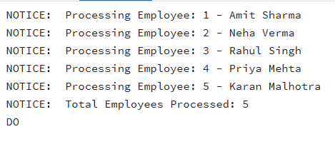

- Learning Outcomes:

- Cursor Implementation: Students will be able to design, implement, and manage cursors to solve row-wise processing problems.
- Lifecycle Mastery: Students will demonstrate the correct syntax for declaring, opening, fetching, and closing cursors.
- Error Prevention: Students will understand how to properly handle row-by-row processing exceptions and prevent memory leaks via deallocation.
  - Analytical Thinking: Students will be able to apply cursor-based logic to solve real-world scenarios like multi-level payroll adjustments or data migrations.

