Branch: MCA (Data Science) | Semester: 2nd
Student Name: Drishti Bhatia | UID: 25MCD10008
Subject Name: Technical Training - I Lab | Subject Code: 25CAP-652
Section/Group: 25MCD- KAR1 | Date of Performance: 27-02-2026

Experiment No.: 6
- Aim of the practical:

Learn how to create, query, and manage views in SQL to simplify database queries and provide a layer of abstraction for end-users. (Company Tags: Amazon, Zoho, ServiceNow)

- Tools Used: PostgreSQL
- Objectives of the practical:
- Data Abstraction: To understand how to hide complex table joins and calculations behind a simple virtual table interface.
- Enhanced Security: To learn how to restrict user access to sensitive columns by providing views instead of direct table access.
- Query Simplification: To master the creation of views that pre-join multiple tables, making reporting easier for non-technical users.
- View Management: To understand the syntax for creating, altering, and dropping views, as well as the naming conventions required for efficient data access.

- Theory:

A View is essentially a virtual table based on the result-set of an SQL statement. It does not contain data of its own but dynamically pulls data from the underlying "base tables".
- Simple Views: Created from a single table without any aggregate functions or grouping. These are often updatable.
- Complex Views: Created from multiple tables using JOINs, or including GROUP BY and aggregate functions. These provide a consolidated summary of the database.
- Security Layer: In enterprise environments, views are used to grant permissions on specific subsets of data. For example, a "SalaryView" might exclude the "Employee_SSN" or "Home_Address" columns for privacy.
- Benefits: They simplify the user experience, ensure data consistency across reports, and reduce the risk of accidental data modification by providing read-only abstractions.

Experiment / Practical Steps:

Step 1: Creating a Simple View for Data Filtering
Implementing a view to provide a quick list of active employees without exposing the entire table structure.

Query:
--create tables
CREATE TABLE employees (
emp_id SERIAL PRIMARY KEY,
emp_name VARCHAR(100),
salary NUMERIC(10,2),
status VARCHAR(20), -- Active / Inactive
dept_id INT
);

CREATE TABLE departments (
dept_id SERIAL PRIMARY KEY,
dept_name VARCHAR(100)
);

-- Insert Departments
INSERT INTO departments (dept_name)
VALUES
('HR'),
('IT'),
('Finance'),
('Marketing');

-- Insert Employees
INSERT INTO employees (emp_name, salary, status, dept_id)
VALUES
('Amit Sharma', 50000, 'Active', 2),
('Neha Verma', 60000, 'Active', 3),
('Rahul Singh', 45000, 'Inactive', 1),
('Priya Mehta', 70000, 'Active', 2),
('Karan Malhotra', 55000, 'Inactive', 4);

--step1
CREATE VIEW active_employees AS
SELECT emp_id, emp_name, salary, dept_id
FROM employees
WHERE status = 'Active';

--view table
SELECT * FROM active_employees;

Output:
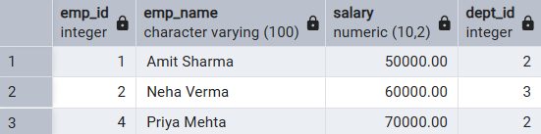

Step 2: Creating a View for Joining Multiple Tables
Simplifying the retrieval of data distributed across Employees and Departments tables

Query:
--step2
CREATE VIEW employee_department_view AS
SELECT
e.emp_id,
e.emp_name,
e.salary,
e.status,
d.dept_name
FROM employees e
JOIN departments d
ON e.dept_id = d.dept_id;

--view tables
SELECT * FROM employee_department_view;

Output:
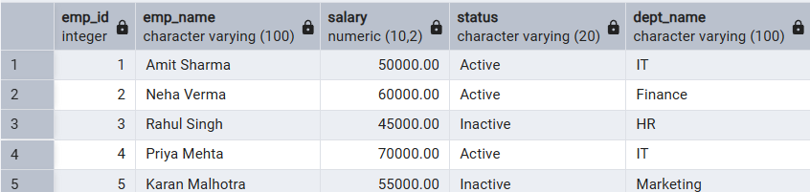

Step 3: Advanced Summarization View
Creating a view to provide department-level statistics automatically

Query:
--step3
CREATE VIEW department_summary AS
SELECT
d.dept_name,
COUNT(e.emp_id) AS total_employees,
COUNT(CASE WHEN e.status = 'Active' THEN 1 END) AS active_employees,
AVG(e.salary) AS avg_salary,
SUM(e.salary) AS total_salary_expense
FROM departments d
LEFT JOIN employees e
ON d.dept_id = e.dept_id
GROUP BY d.dept_name;

--view tables
SELECT * FROM department_summary;

Output:
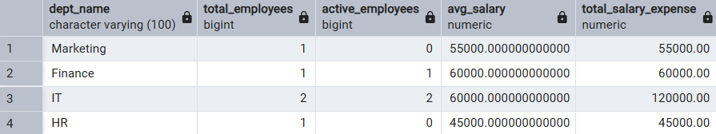

- Learning Outcomes:

- Abstraction Proficiency: Students will be able to create and query views to simplify efficient data access and abstraction.
- Security Implementation: Students will understand how to use views for data masking and providing restricted access to sensitive information.
- Syntactic Accuracy: Students will demonstrate the correct syntax for creating and querying views, ensuring logical clarity in naming conventions.
- Real-world Application: Students will be able to design views for practical domains like Library Management Systems or Payroll Systems to demonstrate functionality.

