Branch: MCA (Data Science) | Semester: 2nd
Student Name: Drishti Bhatia | UID: 25MCD10008
Subject Name: Technical Training - I Lab | Subject Code: 25CAP-652
Section/Group: 25MCD- KAR1 | Date of Performance: 07-04-2026

Experiment No. : 10

- Aim of the Session:

To understand and apply transaction control in PostgreSQL using BEGIN, COMMIT, ROLLBACK, and SAVEPOINT to maintain data integrity during database operations.

- Software Requirements:
- PostgreSQL
- pgAdmin
- Windows Operating System

- Objectives of the Session:

Apply transaction control commands for safe and reliable database updates.

- Theory:

Transaction control in PostgreSQL ensures that a group of database operations is executed safely as a single unit. Using BEGIN, a transaction starts; COMMIT permanently saves the changes, while ROLLBACK undoes them if an error occurs. SAVEPOINT allows partial rollback to a specific point within a transaction. These commands help maintain data integrity and consistency, especially during complex or multi-step operations.
- Practical / Experiment Steps:

Step 0: Table creation and data insertion.

Code:

-- Create table

CREATE TABLE payroll (

emp_id INT PRIMARY KEY,

emp_name VARCHAR(50),

salary DECIMAL(10,2) CHECK (salary > 0)

);

INSERT INTO payroll VALUES

(1, 'Sanju', 30000),

(2, 'Riya', 40000),

(3, 'Sidhi', 50000);

START TRANSACTION;

UPDATE payroll

SET salary = 1000

WHERE emp_id = 3;

UPDATE payroll

SET salary = 1000

WHERE emp_id = 3;

ROLLBACK;

SELECT * FROM payroll;

START TRANSACTION;

UPDATE payroll

SET salary = salary + 5000

WHERE emp_id = 1;

SAVEPOINT sp1;

UPDATE payroll

SET salary = salary + 7000

WHERE emp_id = 2;

UPDATE payroll

SET salary = -1000

WHERE emp_id = 3;

ROLLBACK TO sp1;

COMMIT;

SELECT * FROM payroll;

Output:

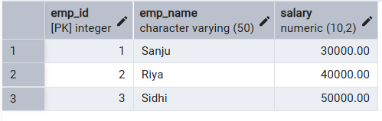

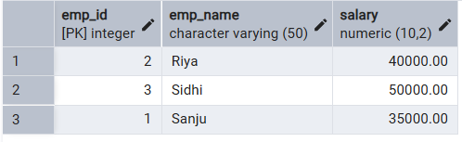

- Learning Outcomes (What I have learned):
- BEGIN starts a transaction block for grouping multiple SQL commands.
- ROLLBACK cancels changes made inside the transaction.
- SAVEPOINT allows partial rollback without losing all valid updates.
- CHECK constraint ensures salary remains greater than zero.
- PostgreSQL transaction control helps maintain consistency and data integrity.

