Branch: MCA (Data Science) | Semester: 2nd
Student Name: Drishti Bhatia | UID: 25MCD10008
Subject Name: Technical Training - I Lab | Subject Code: 25CAP-652
Section/Group: 25MCD-1(A) | Date of Performance: 21-01-2026

Experiment No.: 2
- Aim of the practical: To implement and analyze SQL SELECT queries using filtering, sorting, grouping, and aggregation concepts in PostgreSQL for efficient data retrieval and analytical reporting.

- S/W Requirement: Oracle Database Express Edition and PGAdmin.
- Objectives:

Implementation of SELECT Queries with Filtering, Grouping and Sorting in PostgreSQL
- To retrieve specific data using filtering conditions
- To sort query results using single and multiple attributes
- To perform aggregation using grouping techniques
- To apply conditions on aggregated data
- To understand real-world analytical queries commonly asked in placement interviews

- Experiment Steps:

Step 1: Database and Table Preparation
- Start the PostgreSQL server.
- Open the PostgreSQL client tool.
- Create a database for the experiment.
- Prepare a sample table representing customer orders containing details such as customer name, product, quantity, price, and order date.
- Insert sufficient sample records to allow meaningful analysis.
- Purpose: To create a realistic dataset for performing analytical queries.

Step 2: Filtering Data Using Conditions
- Execute data retrieval operations to display only those records that satisfy specific conditions, such as higher‑priced orders.
- Observe how filtering limits the number of rows returned.

Observation: Filtering reduces unnecessary data processing and improves query efficiency.

Step 3: Sorting Query Results

● Retrieve selected columns from the table and arrange the output based on numerical values such as price.

● Perform sorting using both ascending and descending order.

● Apply sorting on more than one attribute to understand priority‑based ordering.

Observation: Sorting is essential for reports, rankings, and ordered displays.

Step 4: Grouping Data for Aggregation

● Group records based on a common attribute such as product.

● Calculate aggregate values like total sales for each group.

● Analyze how multiple rows are combined into summarized results.

Observation: Grouping transforms transactional data into analytical insights.

Step 5: Applying Conditions on Aggregated Data

● Apply conditions on grouped results to retrieve only those groups that satisfy specific aggregate criteria.

● Compare the difference between row‑level filtering and group‑level filtering.

Observation: Conditions applied after grouping allow refined analytical reporting.

Step 6: Conceptual Understanding of Filtering vs Aggregation Conditions

● Analyze scenarios where conditions are incorrectly applied before grouping.

● Correctly apply conditions after grouping to avoid logical errors.

Observation: Understanding execution order prevents common SQL mistakes frequently tested in interviews.

- Code:

--Step1
CREATE TABLE customer_orders
(
order_id INT PRIMARY KEY,
customer_name VARCHAR(50),
product VARCHAR(50),
quantity INT,
price DECIMAL(10,2),
order_date DATE
);

INSERT INTO customer_orders (order_id,customer_name, product, quantity, price, order_date) VALUES
(101,'Aman', 'Laptop', 1, 55000, '2024-01-10'),
(102,'Ridhi', 'Mobile', 2, 30000, '2024-01-12'),
(103,'Mohan', 'Laptop', 1, 60000, '2024-01-15'),
(104,'Sakshi', 'Tablet', 3, 15000, '2024-01-18'),
(105,'Gaurav', 'Mobile', 1, 25000, '2024-01-20'),
(106,'Pihu', 'Laptop', 2, 52000, '2024-01-22');

SELECT * FROM customer_orders;

--Step2
-- Display high-priced orders
SELECT *
FROM customer_orders
WHERE price > 30000;

-- Filter based on product and price
SELECT customer_name, product, price
FROM customer_orders
WHERE product = 'Laptop' AND price > 55000;

--Step3
-- Sort by price (ascending)
SELECT customer_name, product, price
FROM customer_orders
ORDER BY price ASC;

-- Sort by price (descending)
SELECT customer_name, product, price
FROM customer_orders
ORDER BY price DESC;

-- Sorting by multiple attributes
SELECT customer_name, product, price
FROM customer_orders
ORDER BY product ASC, price DESC;

--Step4
-- Total sales per product
SELECT product, SUM(quantity * price) AS total_sales
FROM customer_orders
GROUP BY product;

-- Average price per product
SELECT product, AVG(price) AS avg_price
FROM customer_orders
GROUP BY product;

--Step5
-- Products with total sales greater than 1,00,000
SELECT product, SUM(quantity * price) AS total_sales
FROM customer_orders
GROUP BY product
HAVING SUM(quantity * price) > 100000;

--Step6
SELECT product, SUM(quantity * price) AS total_sales
FROM customer_orders
WHERE order_date >= '2024-01-15'
GROUP BY product
HAVING SUM(quantity * price) > 50000;

- Output:

Select query:
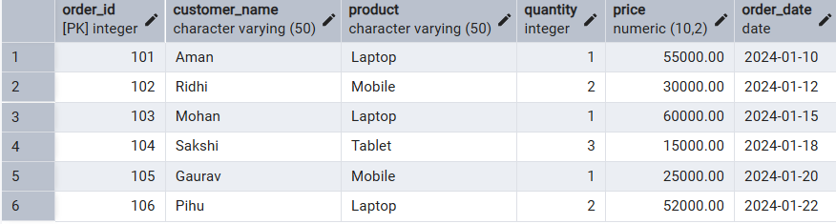

Display high priced orders:
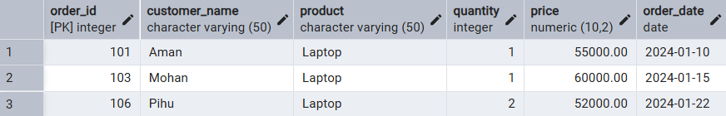

Filter based on product and price:
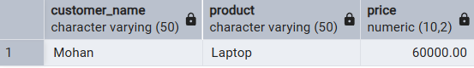

Sort by price (ascending):
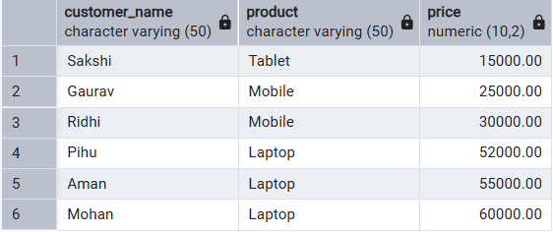
Sort by price (descending):
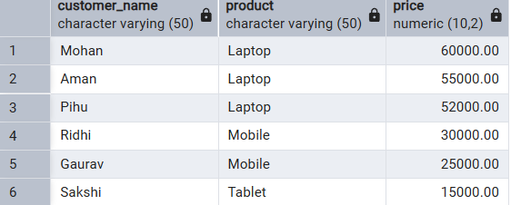

Sorting by multiple attributes:
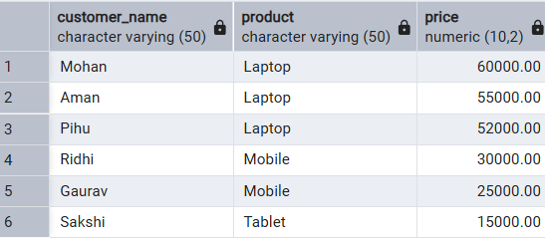
Total sales per product:
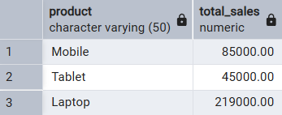

Average price per product:
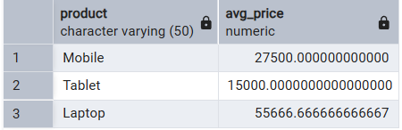
Products with total sales greater than 1,00,000:
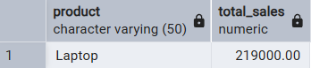
Using where , group by and having together:
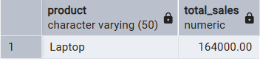

- I/O Analysis (Input / Output)
Input:
- Customer order details
- Filtering, sorting, grouping, and aggregation queries
Output:
- Filtered customer records
- Sorted result sets
- Group-wise sales summary
- Aggregated revenue reports
(Screenshots of output attached)

- Learning Outcomes:

  - We understood how data can be filtered to retrieve only relevant records from a database.
  - We learned how sorting improves readability and usefulness of query results in reports.
  - We gained the ability to group data for analytical purposes.
  - We can clearly differentiate between row-level conditions and group-level conditions.
  - We developed confidence in writing analytical SQL queries used in real-world scenarios.
  - We are better prepared to answer SQL-based placement and interview questions related to filtering, grouping, and aggregation.

