MOTOR INSURANCE REPORT

While you invest your best in eyeing that perfect car or bike model, we will invest our best to offer you the perfect cover to protect your vehicle against financial liabilities arising out of unforeseen contingencies.

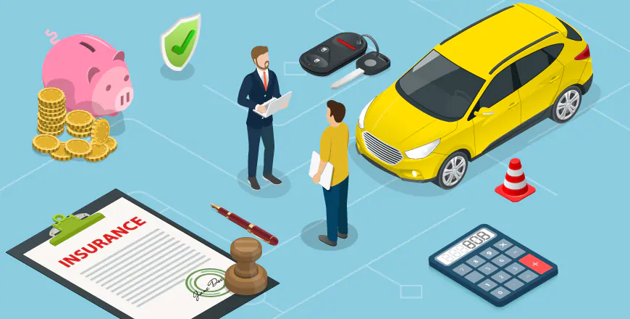

**GROUP 2-**

**DRISHTI CHULANI, JILL MORAKHIYA, KHUSHWANT TRIPATHI, SALONI BERA, SANDOWEN RAMASAWMY.**

15.06.2020

# 

# INTRODUCTION

Motor insurance is no longer a formality for your vehicle’s upkeep and maintenance! It is the legal minimum to have your two-wheeler and four-wheeler out on the road.Your car gives you independence and freedom of movement. Allowing the whole family to move together, it becomes a part of the family itself. So, let’s give it the care and protection it needs. Allow us to be a part of the family and insure your car against any kind of unanticipated situations such as accidents or theft, natural calamities. A commercial vehicle may be a source of livelihood for you & your family members. It is compulsory to at least have a Liability Only policy in place, that protects third-parties against any damages and losses that could be caused by your commercial vehicle.Any accidental damage or theft to this may result in a huge financial loss to you or may even result in the shut down of business. Living with such uncertainties is very risky hence requires an insurance policy to minimize such uncertainty & risk.

# HYPOTHESIS

To design the structure of motor insurance, develop a pricing model and strategy by keeping a track on Underwriting/Claims. To have a proper understanding of data analysis and follow a correct modelling procedure. Understanding the risk parameters and pricing the products accordingly.

# DATA

<https://docs.google.com/spreadsheets/d/1HE9-uSsqp3fuby3f_0a4d8Fgw4P13GRSRX00CWEGQ3c/edit#gid=1850341845>

# REFERENCES

1. [car_insurclaim](https://docs.google.com/spreadsheets/d/1HE9-uSsqp3fuby3f_0a4d8Fgw4P13GRSRX00CWEGQ3c/edit#gid=397171419)
2. [Motor_insurance_Pricing](https://docs.google.com/spreadsheets/d/1GO_QHUlt3yHNwjT2UO1Ew1V_rT_qlj5c_MFiCJ9XRLE/edit#gid=1531189604)

THE REPORT

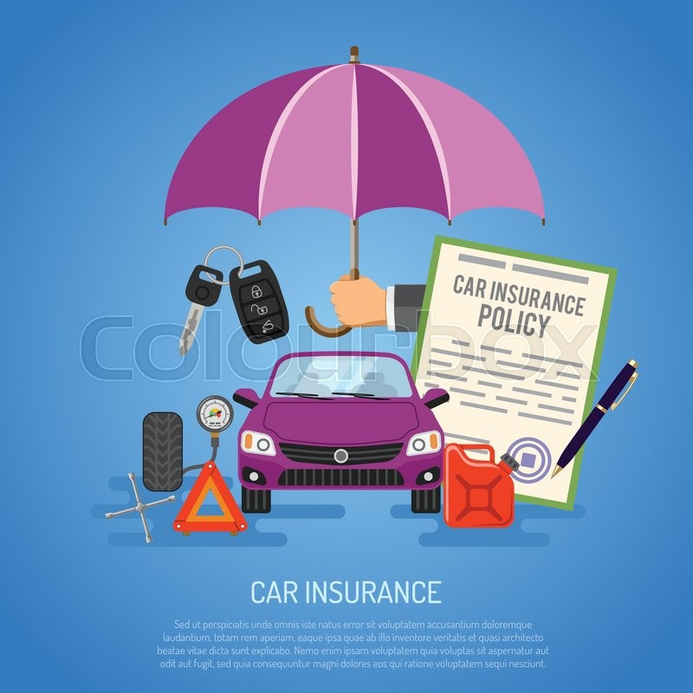

# DATA EXPLORATION

# Barplot of Motor Vehicle Record Points

# 

According to the MVR_PTS Barplot, we can see there is an inverse relationship as the number of points increases there is a decrease in the percent of records. It's good to see around 45%-50% of the population has zero points. This means people with zero points are good at driving hence less likely to have a car crash, however, as the number increases on the scale from 1-10, the probability of them getting involved in a car crash is high.

Coding for barplot of MVR_PTS

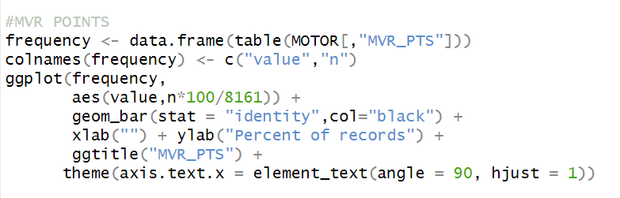Frequency of Variables and their Type of Distribution

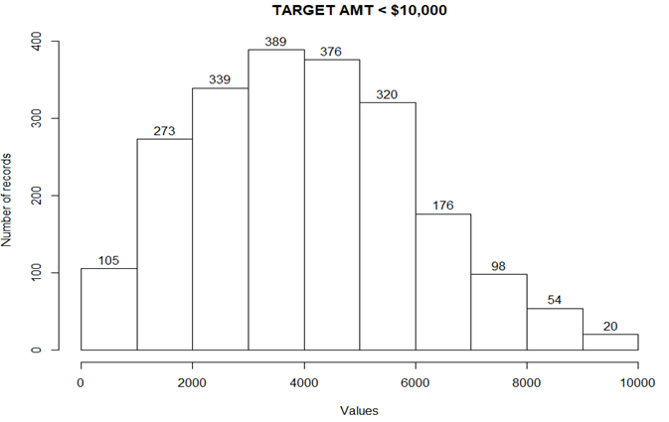 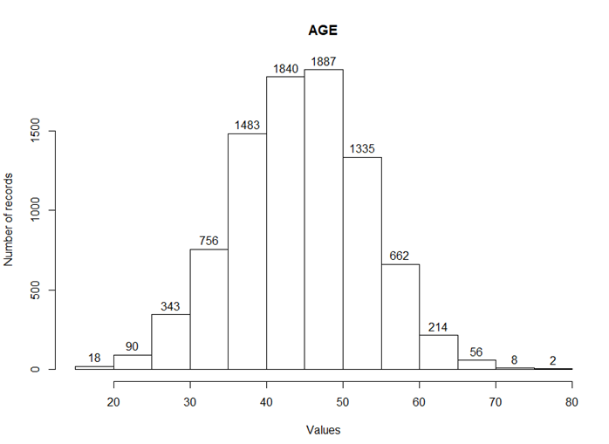

TARGET_AMT<$10000 which is the claim amount less than $10000 has an approximately normal distribution. The frequency of claim amounts below $10000 is more. Hence it is considered to be a more important factor. AGE is also normally distributed, there is a tendency where young people(below 30 years old) are more likely to crash their car due to lack of experience. Hence age is also a considerable factor.

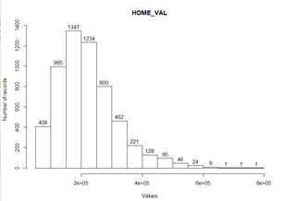 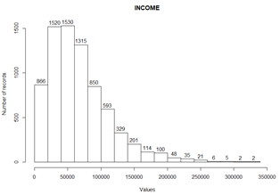

HOME_VAL and INCOME are positively skewed, also both of them have a positive correlation with each other (+0.5). This means if there is an increase in an income by 100% then there will be an increase of 50% in home value and a decrease in income will reduce the home value.

To check correlation click here:- <https://docs.google.com/spreadsheets/d/1HE9-uSsqp3fuby3f_0a4d8Fgw4P13GRSRX00CWEGQ3c/edit#gid=910954160>

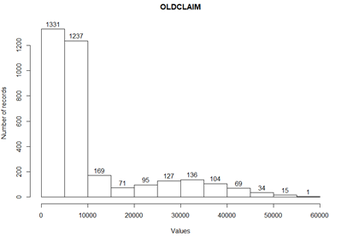 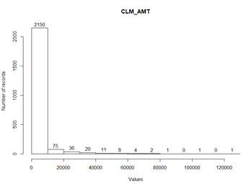

OLDCLAIM and CLM_AMT are positively skewed. The correlation between the two is +0.08, we can say that both are independent of each other. If a policyholder had a claim last year doesn’t mean he/she might have claimed this year too. The number of claims for high sum assured is less because the underwriting for these policies is done thoroughly.

Coding for histogram of TARGET_AMT<$10000, AGE, TRAV_TIME, BLUEBOOK, HOME_VAL, INCOME, OLD CLAIM and CLM_AMT. 

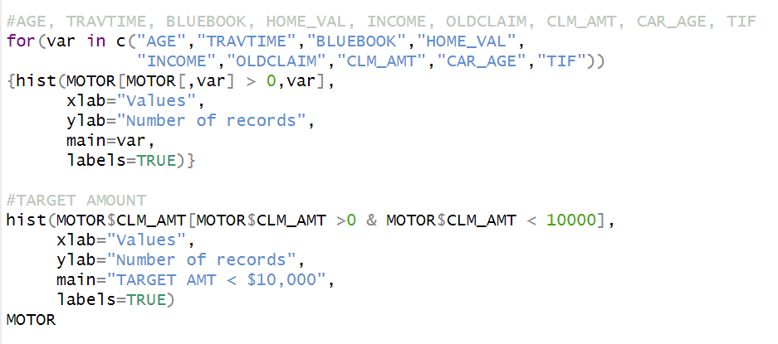

### 

### Frequency of Binary Variables

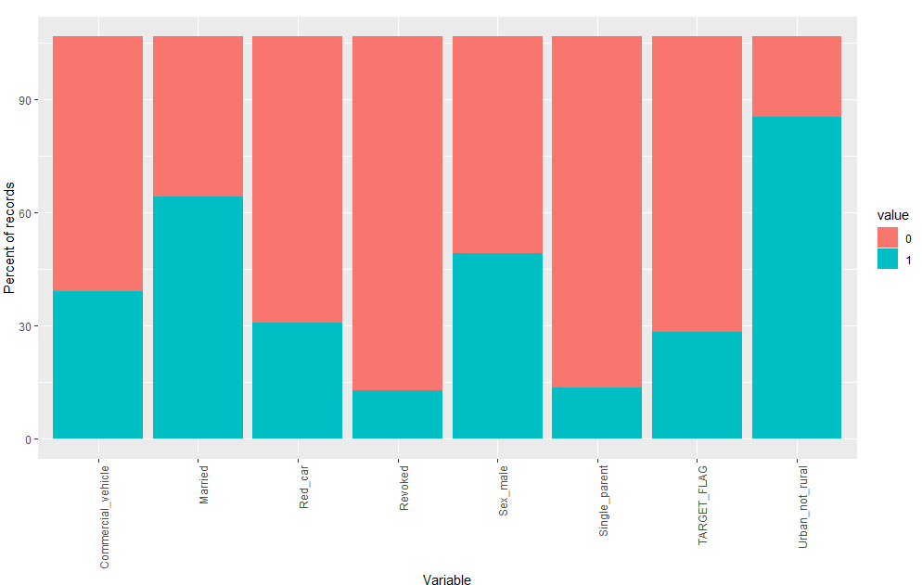

In the data we find that there is a bit over 25% of records for individuals who were in a car crash (TARGET_FLAG). Some predictor binary variables are relatively evenly split (e.g. a 60/40 split for whether people are married, or a nearly 50/50 split by sex). Others are less even (e.g. it looks like around 80% of records are for single parents , working in an urban area and revoked).

 Coding for the frequency of binary variables

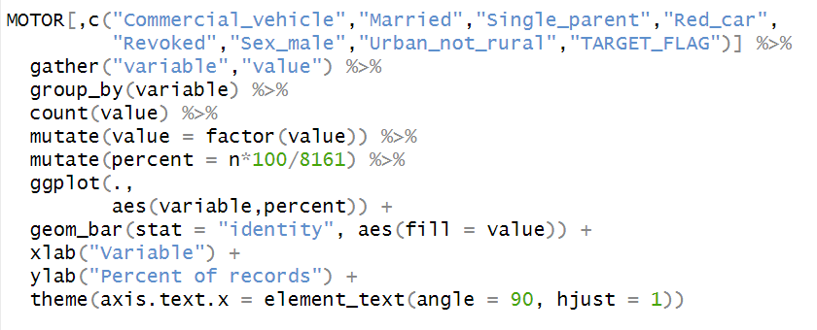

### 

### Frequency of Factor and Select Discrete Numeric Variables

These include factor variables (like education) as well as select discrete numeric variables like HOMEKIDS.

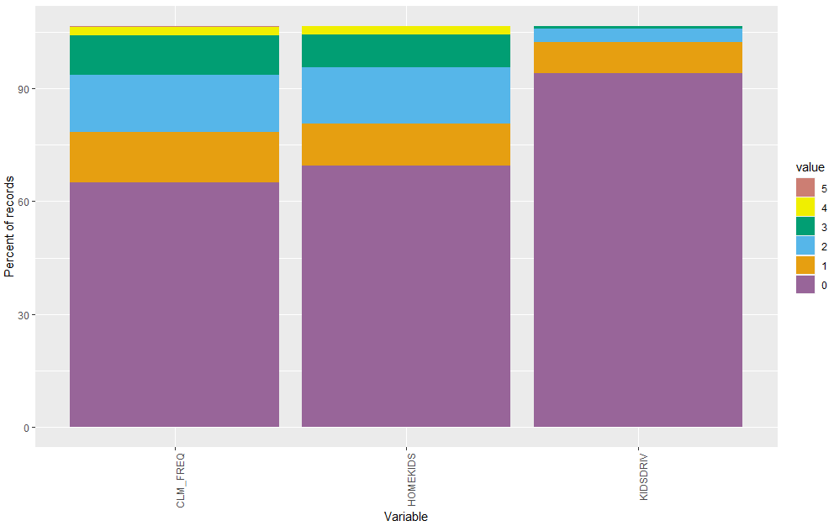

According to the diagram, the data has 80% records of value zero in KIDSDRIV . This is a good sign because driving children seem to cause car crashes more often as they are not so mature nor experienced. This reduces the chances of claim occurring.

 Coding for percent of points against CLM_FREQ, HOMEKIDS and KIDSDRIV

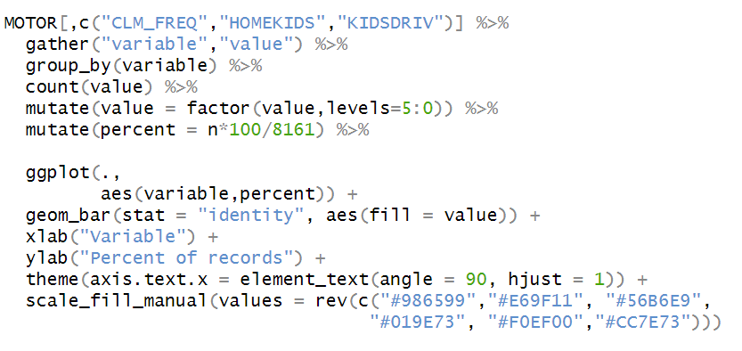

DATA ANALYSIS

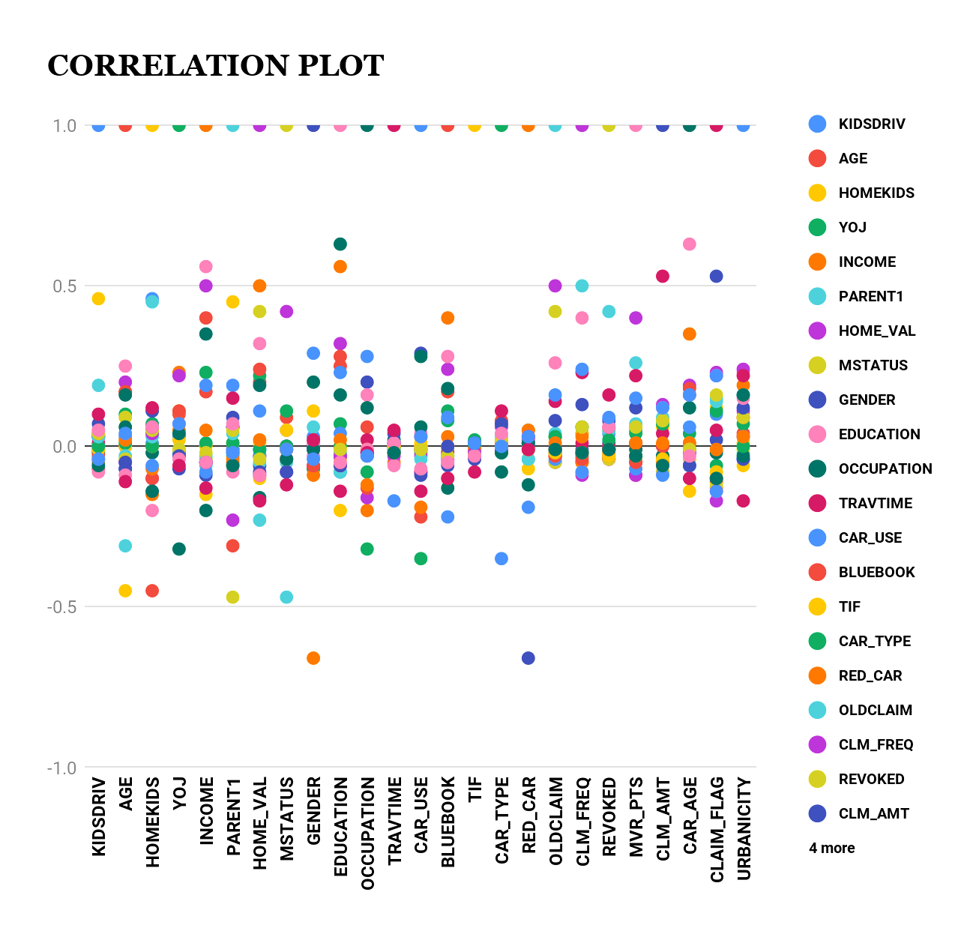

In this data, there are two response variables. The first response variable, CLAIM_FLAG, is a 1 or a 0. A “1” means that the person was in a car crash. A zero means that the person was not in a car crash. The second response variable is CLM_AMT. This value is zero if the person did not crash their car. But if they crash their car, this number will be a value greater than zero. However, we can also say CLM_AMT is dependent on CLAIM_FLAG.

Let us see how CLAIM_FLAG is correlated with other dependent variables in this graph :-

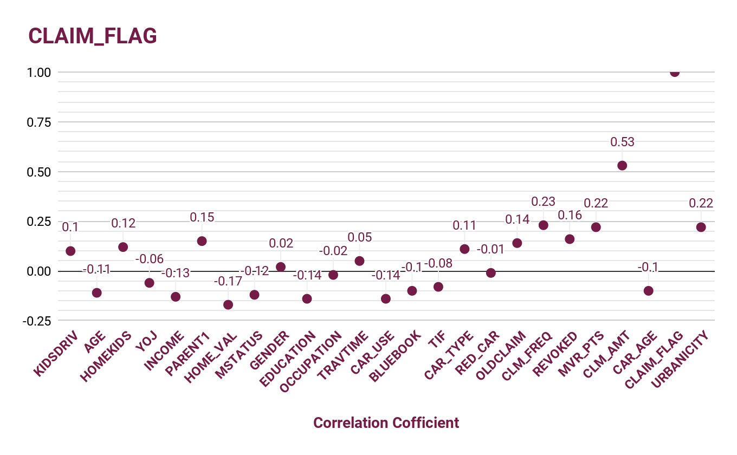

CLAIM_FLAG has a positive correlation with KIDSDRIV, HOMEKIDS, PARENT1, GENDER, TRAVTIME, CAR_TYPE, OLDCLAIM, CLM_FREQ, REVOKED, MVR_PTS, CLM_AMT and URBANICITY. This means an increase in the value of dependent variables will increase the probability of car crashes(CLAIM_FLAG). This makes sense because for example, we take KIDSDRIV, it is the Whereas, an increase in the value of other variables will decrease the probability of car crashes because they are negatively correlated. The variables are AGE, YOJ, INCOME, HOME_VAL, MSTATUS, EDUCATION, OCCUPATION, CAR_USE, BLUEBOOK, TIF, RED_CAR, and CAR_AGE.

Now let's have a look at the second response variable- CLM_AMT.

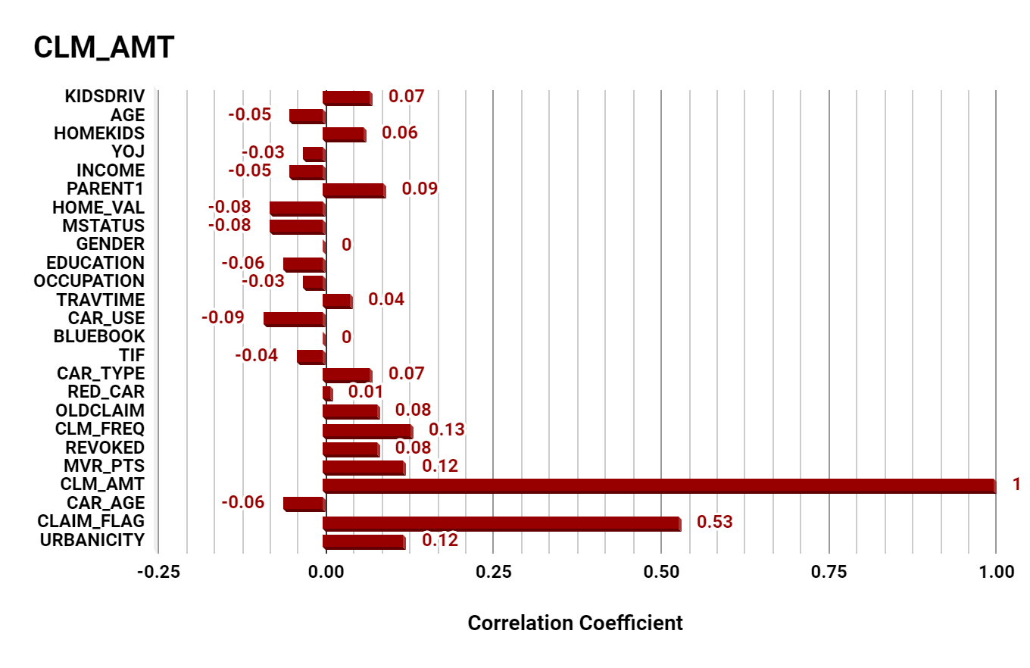

CLM_AMT has a strong positive correlation with CLAIM_FLAG ONLY. Rest all dependent variables of CLM_AMT are weakly correlated. There is no association between CLM_AMT with GENDER and BLUEBOOK which means irrespective of what is the gender or value of vehicle claim amount is not affected by it. This result So we can conclude GENDER and BLUEBOOK are not a dependent variable for CLM_AMT.

We have also noticed in the data that RED_CAR and GENDER have a correlation coefficient of -0.66. This can just be a coincidence.

# 

# 

MODELLING PROCESS

**The basic steps of the model-building process are:**

1. **Model Selection**
2. **Model Fitting.**
3. **Model Validation.**
4. MODEL SELECTION

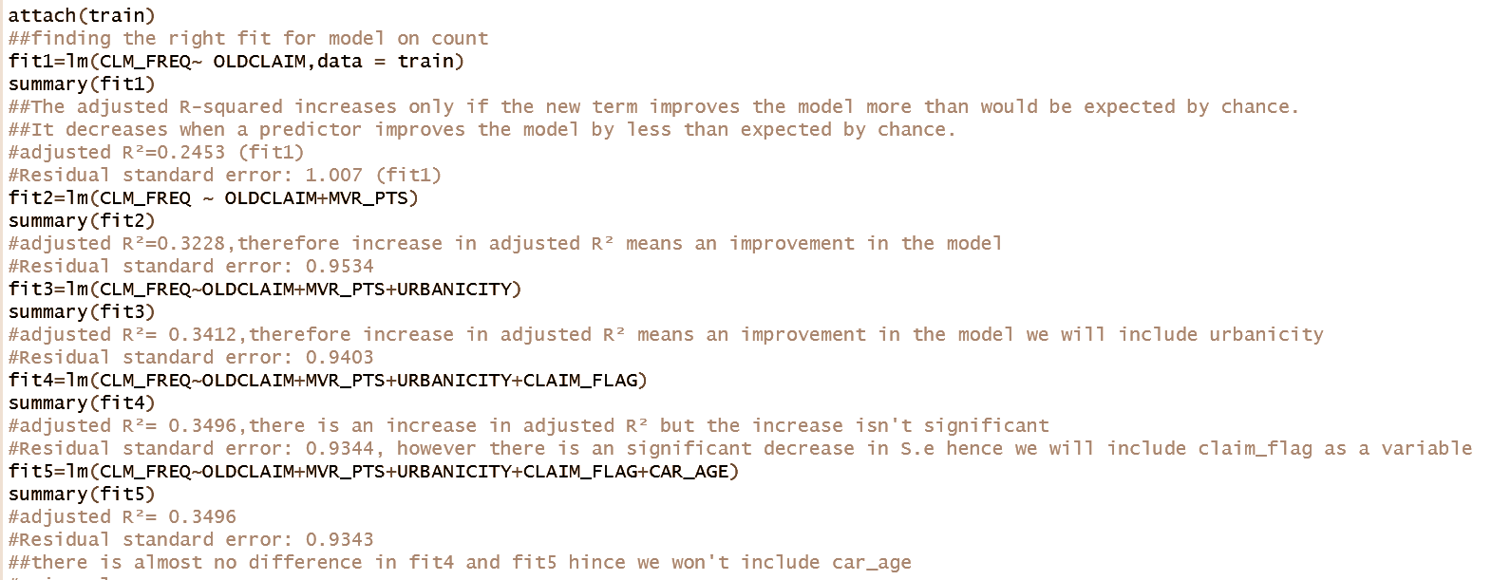

1. MODEL FITTING

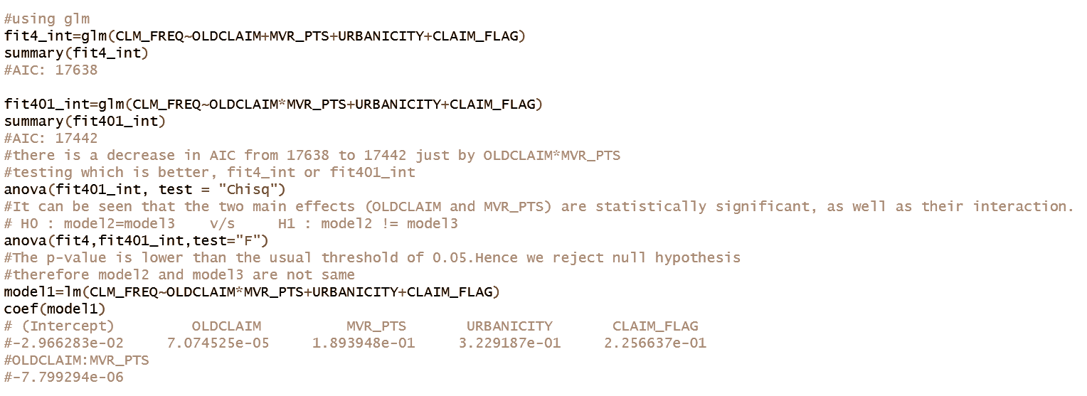

1. MODEL VALIDATION

**MODEL REGRESSION PLOT**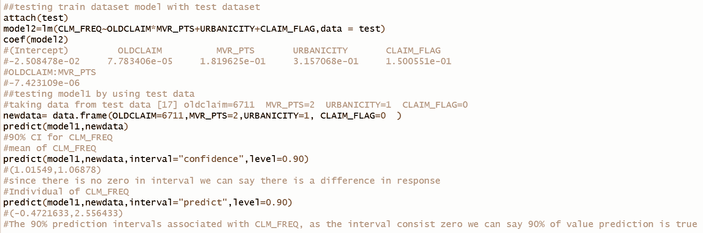

1. **PLOT RESIDUAL AGAINST FITTED VALUES**

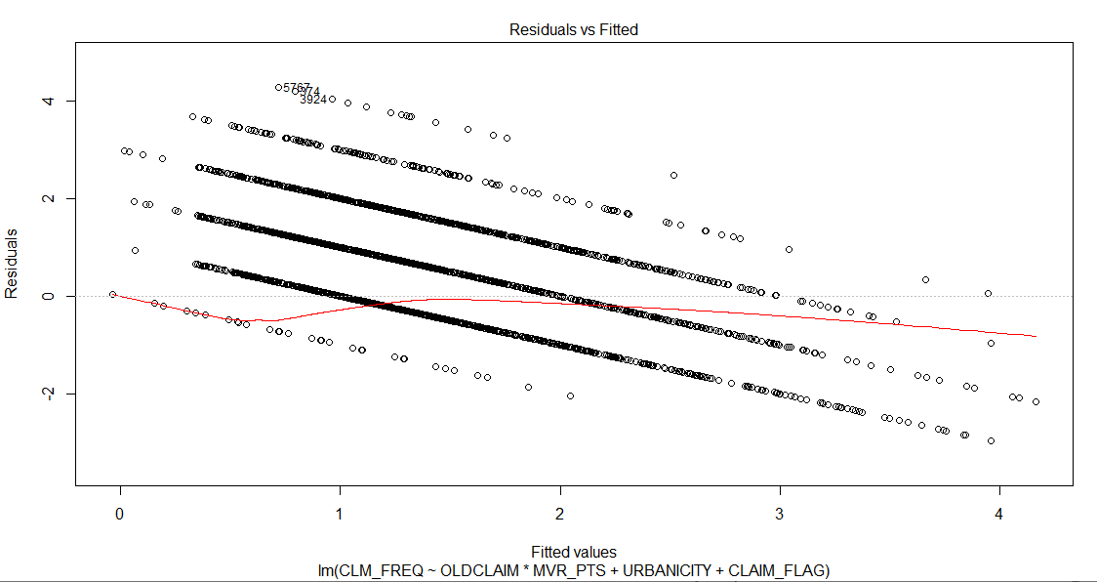

Here we see that linearity seems to hold reasonably well, as the red line is close to the dashed line. We can also note the heteroskedasticity: as we move to the right on the x-axis, the spread of the residuals seems to be decreasing. Residual = Observed – Predicted. Residual seems to have a negative linear relationship.

1. **NORMAL Q-Q PLOT**

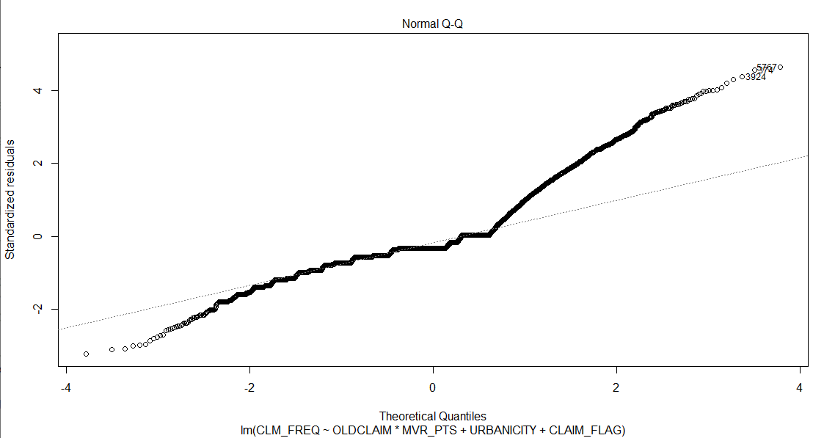

This looks like a positively skewed distribution which is fat tailed as the curve is apart from the line at both the end. It is positively skewed because the points seem to fall about a straight line on the left side of the x-axis.

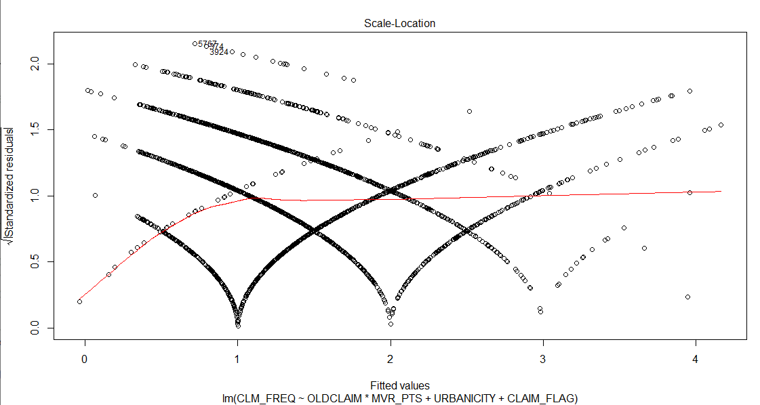

The red line tends to behave like an exponential series. The values seem to have an exponential rise after a certain point in each factor.

**What is the cook's distance?**

Cook’s distance, Di, is used in Regression Analysis to find influential outliers in a set of predictor variables. In other words, it’s a way to identify points that negatively affect your regression model. The measurement is a combination of each observation’s leverage and residual values; the higher the leverage and residuals, the higher the Cook’s distance.

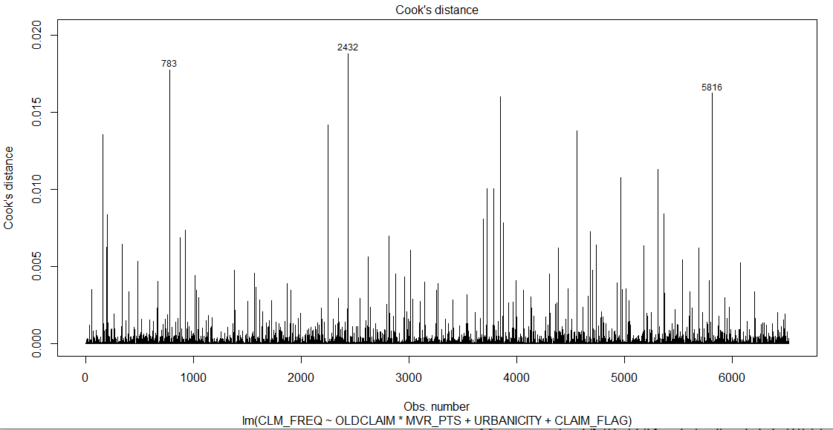

Any “large” Di should be investigated. The consensus seems to be that a Di value of more than 1 indicates an influential value, but you may want to look at values above 0.5. Any value that sticks out from the other (like the one in the above chart) should also be investigated. In the above plot, the values are below 0.02 however since three values are sticking out (783, 2432 and 5816), it should be investigated.

PRODUCT CONCEPT AND STRUCTURE

**Motor insurance** gives complete protection against physical damage or loss due to unforeseen instances from natural and man-made calamities. Motor insurance has been made mandatory by the government. It broadly covers

* Injuries/death to person or persons
* Damage to property
* Damage to the vehicle itself
* Thefts of parts or the theft of the vehicle itself

**Perils covered under the motor insurance**

Own Damage policy

One of the core reasons behind offering standalone Own Damage policy is to provide the car owner more independence in customizing their insurance.

Covers damage to own car due to either of the following reasons :

* By fire explosion self-ignition or lightning
* By burglary housebreaking or theft
* By riot and strike
* Natural calamities
* By accidental external means
* By malicious act
* By terrorist activity
* Whilst in transit by road rail inland-waterway lift elevator or air

**What is not covered in Own damage insurance cover?**

* Third-party liabilities
* Insured driving drunk
* Driving without a license
* Add-ons not bought
* Consequential damages - Consequential damages refer to damages that take place after an accident. Unfortunately, those won’t be covered unless the damage has happened during the accident itself.

Third-party liability

When the policyholder collides with the car of a third party leading to death or bodily injury to the third party, your liability to the third party is covered by the insurer. This cover offers you protection if the other party is uninsured or underinsured.

There are two types of automobile third-party liability coverage.

* **bodily injury liability** covers costs resulting from injuries to a person.
* **property damage liability** coverscosts resulting from damages or loss of property.

**What does third party insurance cover?**

Third-party liability insurance covers death or bodily injury to any person including occupants carried in the vehicle.

Damage to property other than property belonging to the insured or held in trust or in the custody or control of the insured.

|  |  |  |
| --- | --- | --- |
|  | **Third-Party Premium** | **Own Damage Premium** |
| Basis of Calculation | It is fixed by the Insurance Regulator depending on the Cubic Capacity of the vehicle. | Own Damage Premium, on the other hand, is computed based on the IDV, year of purchase, location, and type of the vehicle. |
| Stability | The Third-Party premium can be increased and decreased by the regulator IRDAI. | The Own Damage premium will decrease as the value of the vehicle will depreciate over the years. |
| Share in Motor Premium | Always would be a share as fixed in the Motor Policy, be it comprehensive or standalone. | It may or may not form a share in the Motor Policy premium. |

Comprehensive cover

This is an all-round cover for the car- it not only takes care of the third-party liabilities but also covers for the insured and his/her own car.

**What Does Comprehensive Insurance Cover?**

Comprehensive insurance is one of the most valuable types of vehicle insurance that covers both third-party liabilities and damages to own vehicle as well. The detailed coverage of the comprehensive motor insurance plan is as described below:

**Own-damage cover** - This includes protection for the insured vehicle from the following events:

* Accidental damages
* Damages while in transit via rail, road, waterways, lift, etc.
* Damages caused by natural calamities, such as earthquakes, floods, etc.
* Damages from man-made disasters such as strikes, riots, vandalism, etc.
* Theft of the insured vehicle

Additionally, the comprehensive motor insurance plan offers personal accident cover to the owner-driver.

**Third-party liability cover** - This part of the comprehensive motor insurance policy protects the policyholder from legal liabilities to a third party from accidental injuries/death or property damage. The maximum amount of coverage under this insurance for injuries/death is unlimited.

**What Does Comprehensive Insurance Not Cover?**

* Depreciation
* Wear and tear of the vehicle
* Electrical or Mechanical breakdown
* Damage caused to the vehicle by a person driving without a valid license
* Damage caused due to drunken driving
* Damage caused due to driving under the influence of drugs
* Damage to tyres and tubes.
* Loss/damage to the car caused by war, mutiny or nuclear risk

ADD-ONS FOR PRIVATE VEHICLE

Add-ons are the extra protection that you opt over your comprehensive insurance policy- because there are a lot of damages that are excluded from your own-damage cover. The amount of add-on premium depends upon the type and the number of add-ons that you have chosen. You cannot purchase an add-on if you opt for [third party car insurance](https://www.dhflinsurance.com/third-party-liability-insurance/).

Add-ons in our policy option are:-

1. **Engine Secure** - Engine is the most expensive part of your vehicle; thus, any damage that your vehicle’s engine will have a huge impact on your wallet. You will have to shell out a huge amount of money for engine repairs. Further, your policy doesn’t cover the damages caused to your engine; here, an engine protection add-on will help you a lot. This add-on covers all the expenses for your engine replacement and repairs. 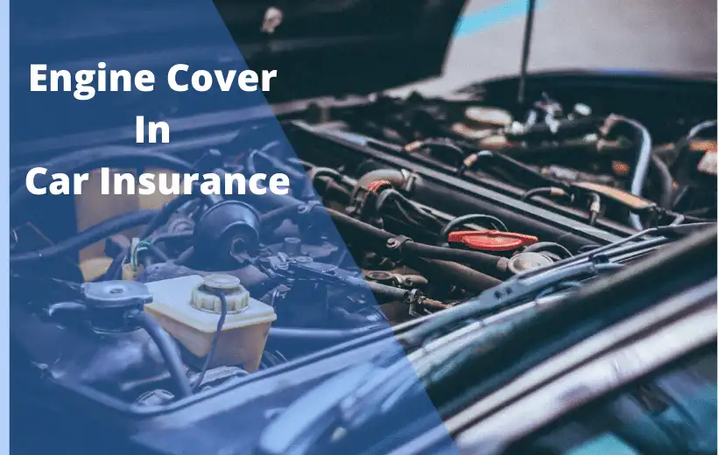

|  |  |
| --- | --- |
| **Engine Secure** | 2% of the current market price of the car |
| exclusions | force start the car |
|  | consequential damages |
|  | only 2 claims per year |
|  | car age - not more than 5 yrs |

1. **Zero Depreciation**- It is a popular add-on option among car owners. When you file a claim for your car damage, insurers do not pay the entire amount for they deduct the depreciation value of the car before settlement. A zero depreciation add-on will ensure that you get the entire claim amount on the value of any parts that have been replaced.

# **Daily Allowance** - This add-on cover offers reimbursement or repayment for the expenses involved in hiring an alternate vehicle when the insured automobile is undergoing repairs at a garage.

|  |  |  |
| --- | --- | --- |
| **daily allowance**  **(in Rs per day)** | **class of cars** | **price (in Rs per year)** |
| 600 | mini/compact | 2000 |
| 800 | mid size cars | 2200 |
| 1200 | mpv/ suv | 2800 |
| 2000 | high end cars | 3339 |
|  |  |  |
| this benefit is for a maximum of 5 days in a one year policy | | |
| payable If time required for repair of motor vehicle is up to 3 days | | |

1. **Consumables Cover**-There are certain consumable parts or substances used in the repairs of any car. To name a few - nuts, bolts, pipes, engine oil, grease to AC gas, etc. These are not covered under any insurance policy. With consumables cover add-on, you’re passing on that liability on your insurance company.

|  |  |
| --- | --- |
| **consumable cover** | **covered** |
| price- 799 | lubricants and oil (engine oil,radiator coolant,etc) |
|  | nuts,bolts,screws,washers,grease,etc |

# **NCB Protection**- An NCB protection cover in car insurance is a discount offered to you when you do not lodge a claim throughout the policy period. In simple words, as a policyholder of a car insurance policy, you get a discount on the premium for the next year, provided you do not lodge a claim during your policy tenure. For instance, if you do not lodge a claim in the first year of your policy, you will get a 20% discount on the premium of the second-year policy. It’s a sure shot way to save money on the car insurance policy premiums. You earn discounts for every claim-free year. The percentage of discount increases with the number of consecutive claim-free years, which can go up to a 50% discount on the premium.

|  |  |
| --- | --- |
| **NCB Protection** | |
| **No. of claim-free years** | **discount** |
| one claim-free year | 20% |
| two consecutive claim-free years | 25% |
| three consecutive claim-free years | 35% |
| four consecutive claim-free years | 45% |
| five consecutive claim-free years | 50% |

# 

# **Roadside assistance** is the attempt by a service professional to make minor mechanical repairs and adjustments in an effort to make a vehicle drivable again. There is a seemingly infinite list of things that can go wrong with a car, which can make it a worthwhile addition to any car insurance policy. If you cannot drive it for any reason and the service professional cannot restore your vehicle to a state in which it can be safely driven, then you’ll be in need of one of the following services.

|  |  |  |
| --- | --- | --- |
| **Roadside assistance** | price-1999 Rs per annum | price-3299 Rs per annum |
| **Services offered** | standard cars | elite cars |
| **Coverage Radius** | anywhere in india | anywhere in india |
| **Number of Services** | 3 times per year | 5 times per year |
| **Free Towing** | upto 50 kms | unlimited kms |
| **Battery Jumpstart** | yes | yes |
| **Flat-Tyre Assistance** | yes | yes |
| **Locked/Lost Key** | yes | yes |
| **Fuel Delivery** | 5 ltrs-free | 5 ltrs-free |
| **On-site Minor Repairs** | yes | yes |
| **Assistance over phone** | yes | yes |
| **Medical Coordination** | yes | yes |
| **Taxi Benefit** | on actuals | upto 50 kms |
| **Car age** | not more than 6 yrs | not more than 6 yrs |

1. **DEPRECIATION REIMBURSEMENT-** As the name suggests, the zero depreciation/nil depreciation/depreciation reimbursement cover reimburses or compensates you for the amount of claim that gets deducted due to depreciation. Depreciation reimbursement cover can only be used for the first two claims in the policy period, so be prudent with your claims. But rest assured, in a claim where no parts are replaced and thus, therefore, no depreciation has been deducted, it won’t be counted as a claim under the cover. This depreciation is directly related to the age of the car. So, when you make a claim, the insurer calculates the value of your car or its part after factoring in depreciation, and only then do you get the settlement amount.

This means, if you make a claim of Rs 10000 for your 4-year-old car, the insurer will not pay more than Rs 5000. This is why every car should have depreciation reimbursement cover or add-on.

|  |  |
| --- | --- |
| **Depreciation Reimbursement** | |
| **Vehicle's age** | **rate of depreciation** |
| Not Exceeding 6 months | 0% |
| Exceeding 6 months but not exceeding 1 year | 10% |
| Exceeding 1 year but not exceeding 2 years | 20% |
| Exceeding 2 years but not exceeding 3 years | 30% |
| Exceeding 3 years but not exceeding 4 years | 40% |
| Exceeding 4 years but not exceeding 5 years | 50% |
| Exceeding 5 years but not exceeding 7 years | 55% |
| Exceeding 7 years | 65% |

ADD-ONS FOR COMMERCIAL VEHICLE

1. **Engine Protection Cover:** Vehicle engines are at risk of damage sometimes especially during monsoon season. Engine protection is an added cover under commercial vehicle insurance policy. An engine protection cover for vehicle insurance keeps the insured financially protected against any repair cost in case there is damage to the engine and/or its parts. Usually, a comprehensive insurance policy doesn’t cover the damages incurred on the engine or other vehicle parts like gearbox, cylinder, etc. A separate add-on is therefore necessary.

It is particularly recommended for customers going for taxi insurance cover in Indian metros cities. This feature can be purchased with an additional payment which will be above the premium.

|  |  |
| --- | --- |
| **Engine protection** | |
| **Cost of the vehicle** | **Engine Protect** |
| Up to Rs. 5 lakh | Rs 750 (Annually) |
| Rs 5 - 10 lacs | Rs 1,500 (Annually) |
| Rs 10 - 15 lacs | Rs 2,250 (Annually) |

1. **NCB PROTECTOR**: The NCB protector is an add-on cover that protects an insured’s accrued no claim bonus. An NCB protector makes sure that if the insured is not at fault and it was another party who caused the accident, maybe someone else was driving the car, the discount should remain in place. For this, the insured will have to pay an additional amount over and above the insurance coverage to protect the bonus. The add-on will ensure that the insured’s no claim bonus stays intact for the first two claims made during the year. This will be in addition to the claim amount reimbursed.

|  |  |
| --- | --- |
| **No Claim Bonus**, wherever applicable, will be as per the following table. | |
| **ALL TYPES OF VEHICLES** | **% discount on own damage premium** |
| No claim made or pending during the preceding full year of insurance | 20% |
| No claim made or pending during the preceding 2 consecutive years of insurance | 25% |
| No claim made or pending during the preceding 3 consecutive years of insurance | 35% |
| No claim made or pending during the preceding 4 consecutive years of insurance | 45% |
| No claim made or pending during the preceding 5 consecutive years of insurance | 50% |

1. **Invoice Protection:** The invoice protection cover will ensure that the insured’s claim is settled in a way that he recovers the entire amount of loss (the on-road price of the car at the time of purchase) that he incurred from losing his vehicle.The invoice protection add-on bridges the gap between the invoice value of the vehicle and its Insured Declared Value. The IDV represents the cost of the car after depreciation has been deducted from the original sale price of the vehicle. However, it is important to note that invoice protection cover is not available for cars older than three years.

|  |  |
| --- | --- |
| invoice protection | |
| **covered** | **uncovered** |
| theft of car | small dents & repairs |
| complete loss in fire | coverage if stolen vehicle is recovered within 90 days |
| premium : 10% of the actual premium | cost of accessories |

1. **Roadside Assistance Cover:** This is an add-on cover for situations where the insured is stranded in the middle of a highway with no help in hand. If a customer buys road assistance cover, all he needs to do is make a phone call. The cover will ensure that he gets emergency services.

|  |  |  |  |
| --- | --- | --- | --- |
| Roadside assistance | | | |
| **Scope of Service** | **Call Coordination/ Access** | **Cost to customer** | **Additional Chargeable to the customer if applicable** |
| Pick up of Vehicle in case of Driver Disability | Included | Free upto 50 Km of Distance | Additional will be charged @ Rs.100/- per hour of use |
| The insured gets critical services like emptying the fuel tank or jumpstarting the battery. | Included | Included | Free within distance covered in our scope of services across India |
| Emergency Fuel delivery | Included | Up to 5 litres | NIL |
| Flat tire support and assistance if the key is jammed. | Included | Included | Free within distance covered in our scope of services across India |
| Emergency Towing Assistance (Break-down) | Included | Towing Free up to 50 KMs . | Included Towing Free up to 50 KMs . Additional will be charged @ Rs.25 per KM. |

1. **Consumable Cover:** Consumables refer to those materials of the vehicle that serve a specific purpose – like a nut, a bolt, or even grease – that once used, are consumed completely. Consumables are things that therefore have to be replaced or refilled frequently because of continuous wear and tear or usage. Regular bus insurance or taxi insurance or any other commercial vehicle insurance cover might not cover consumable parts. This type of cover is only used by high-end luxury vehicles. Moreover, the cover is available for vehicles upto 60 months

|  |  |
| --- | --- |
| **Consumable Cover** | |
| **Cover** | **Exclusions** |
| All kinds of lubricants and oils like engine oil, brake oil, radiator coolants, power steering oil, and AC gas. | driving a private vehicle for commercial purposes make you ineligible for lodging this claim. |
| -Vital items like nuts, bolts, screws, washers, grease | -Electrical and mechanical breakdown is not eligible under this policy. |
| -Filters, etc. | -Normal replenishment of engine oil and other consumables are not admissible under this policy cover. |

1. **Zero depreciation:** If an insured buys this cover, depreciation will be waived off on plastic or metal parts in case of partial loss or claim. We can make only 2 claims in a year. add-on insurance cover, during the settlement of a claim, the insurance company pays the entire claim amount without accounting for the vehicle’s depreciation.

|  |  |
| --- | --- |
| zero depreciation cover | |
| **covered** | **uncovered** |
| repairing costs of fiber, glass, rubber parts and plastic. | not applicable for cars above the age of 5 yrs |
| 100% of the cost of spare parts replaced | only covers cost during claims and not compulsory deductibles |
| premium: actual premium + 20% of the actual premium | |

1. **Personal Accident Insurance for Passenger**: This covers monetary pay-outs towards injuries sustained to passengers in a commercial vehicle in an accident. The add-on covers:

* Capital Sum Insured for which the maximum amount is Rs. 2 lakhs per person.
* Permanent total disablement.
* Permanent partial disablement.
* Accidental Death.

|  |  |
| --- | --- |
| **Personal Accident Cover for Passengers** | |
| **Nature of injury** | **Scale of compensation** |
| (i) Death | 1 |
| (ii) Loss of two limbs or sight of two eyes or one limb  and sight of one eye. | 1 |
| (iii) Loss of one limb or sight of one eye | 0.5 |
| (iv) Permanent total disablement from any costs or expenses whatsoever incurred by the insured or any claimant or  other person after injuries other than named above | 1 |
|

PRODUCT PRICING

**Loss cost**, also known as a pure premium or pure cost, is the amount of money an insurer must pay to cover claims, including the **costs** to administer and investigate such claims. Loss cost, along with other factors, is used to calculate premiums. We have a target loss ratio of 50%.

**Loss cost** = probability of claim(frequency)/avg amt to be paid per claim(severity)

**Target loss ratio(50%)** = premium(100%)-expense(50%)

Therefore, the premium is twice the loss cost. (assuming the expense to be the loss cost)

**Insured Declared Value** (IDV) is the maximum Sum Assured fixed by the insurer which is provided on theft or total loss of vehicle. Basically, IDV is the current market value of the vehicle. If the vehicle suffers total loss, IDV is the compensation that the insurer will provide to the policyholder.

**IDV** = Showroom price of your car + cost of accessories (if any) – depreciation value as per (IRDAI)

|  |  |
| --- | --- |
| AGE OF THE VEHICLE | **% OF DEPRECIATION** |
| Not exceeding 6 months | Nil |
| Exceeding 6 months but not exceeding 1 year | 5% |
| Exceeding 1 year but not exceeding 2 years | 10% |
| Exceeding 2 years but not exceeding 3 years | 15% |
| Exceeding 3 years but not exceeding 4 years | 25% |
| Exceeding 4 years but not exceeding 5 years | 35% |
| Exceeding 5 years but not exceeding 10 years | 40% |
| Exceeding 10 years | 50% |

To see the calculation of loss coat, premium and IDV click here:- [**car_insurclaim**](https://docs.google.com/spreadsheets/d/1HE9-uSsqp3fuby3f_0a4d8Fgw4P13GRSRX00CWEGQ3c/edit#gid=397171419) and [**Motor_insurance_Pricing**](https://docs.google.com/spreadsheets/d/1GO_QHUlt3yHNwjT2UO1Ew1V_rT_qlj5c_MFiCJ9XRLE/edit#gid=1531189604)

PANDEMIC PROTECTION COVER ( NEW PRODUCT)

**What is a pandemic protection cover?**

In regard to our current situation of Covid-19, we have thought of having a “Pandemic Protection Cover”. In this add-on cover, the insured will pay an extra premium to insure himself/herself during Crisis. If a situation similar to covid-19 or any major natural disaster happens again.

The insurance company would waive the premium for one month when a pandemic is declared and pays 15% of premium for next month ONLY. This cover is applicable after the policy is in force for at least 2 years.

1. **COVERAGE-** All kinds of natural calamities like earthquakes (magnitude less than 5), virus outbreak, flood, and world war.
2. **Not covered**- If earthquake magnitude is more than 5 then this policy isn’t eligible to give the benefit. Also if there is an accident during a pandemic or lockdown the insurance company will not pay for the claim as it's against the law to go out during lockdown/pandemic.
3. **Benefits**- Free car service after the pandemic is over, Emergency ambulance services can also be availed.
4. Cost of this cover will be R**s 3599 per quarter** taking into account all risk and rating parameters.

UNDERWRITING

Underwriting occurs when an insurer and an insured conclude a contract of insurance, whereby the insurer undertakes to indemnify the insured against losses due to specific future risks, while the insured has the obligation to pay periodic premiums to the insurer in return. The underwriting process is of prime importance to any insurer as it represents the starting point of the legal and financial relationship between an insurer and a particular proposer.

The main factors influencing underwriting are:

1. **Age of the proposer.**

Age of the proposer can be taken into consideration as the younger drivers are commonly viewed as higher risks. At the same time, people do not have direct control over their age. So, When used as a guideline rather than a central underwriting variable, the age of a proposer should be of big value to an insurer.

2. **Gender of the proposer.**

Using gender as an underwriting factor may be regarded as discriminatory, because people cannot choose their sex. Gender of the proposer may be employed as an underwriting factor when it can be proved that men cover more mileage than women, and are therefore exposed to more risks.

3. **Marital status of the proposer.**

The use of marital status as a risk variable in motor vehicle insurance may also lead to the conclusion that single persons are more irresponsible compared to married people who are seen to be more settled down and responsible. These views discriminate against homosexual and single people, as marriage is a personal choice or belief.

4. **Address of the proposer/Location** (Urban or Rural).

Studies showed that territory is often a very valuable rating factor when underwriting motor insurance. It should however be taken into consideration that problems may arise when two adjacent territories are classified as a high and a low risk area. The classification of high and low risk areas should therefore have an intermediate area with a moderate risk to accommodate low risk proposers living in higher risk areas, and vice versa.

5. **Travel time** (how much you use your car).

The description of use is an indication of the level of risk associated with the employment of the motor vehicle and is also an indication of the mileage to be covered within a year. To employ the distance to be covered by the motor vehicle in a year as an underwriting factor, is not very feasible as it is mostly based on an estimate by the proposer of the insurance. It is only human to underestimate the mileage, as the proposer stands to benefit from under forecasting the mileage by paying a lower premium.

6. **Particulars of the motor vehicle** (Year of Manufacture of vehicle, type of motor vehicle and associated value, safety features).

The older your car, the lesser is its Insured Declared Value (IDV) and the lesser the IDV, the lesser is the premium. The type and the associated value of the motor vehicle are two underwriting factors which can be easily determined. For obvious reasons, sports cars are insured at a higher price than ordinary cars. On similar grounds SUVs are insured at a higher premium than a family car. While underwriting a motor vehicle, an insurer should also take the safety features into consideration when deciding whether to underwrite, and under which conditions and at what premium should be charged.

7. **Old claim** (Driving record).

The better your record, the lower your premium. If you've had accidents or serious traffic violations, it's likely you'll pay more than if you have a clean driving record. You may also pay more if you're a new driver without an insurance track record.

8. **Occupation.**

Certain professionals such as defence personnel, doctors and govt. employees are entitled to get an additional discount on their premium.

9. **Use of motor vehicles** (private/commercial).

Description of use of the motor vehicle has also been shown to have a great influence as a rating factor in the underwriting process. The use of the motor vehicle allows an insurer to forecast risks associated with the motor vehicle as they are made aware of who will operate the motor vehicle and when it will be used.

10. **Driving history of the proposer** (Motor vehicle record points)

The driving history of a proposer may help an insurer to determine the level of associated risk. The reasoning of considering the previous driving history is that driving habits may be indicated by past traffic offences and convictions. So, it should therefore be carefully evaluated by an insurer whenever it is considered as an underwriting factor in motor vehicle insurance.

11. **Ownership of or financial interest in the motor vehicle**.

When underwriting motor vehicle insurance, one of the factors to be considered has to be whether an insurable interest exists between the proposer and the subject matter, otherwise the contract of insurance will be null and void.

The most important underwriting factors of motor vehicle insurance (in a declining order of importance) are as follows:

* The age of the owner of the motor vehicle, or any person who (to the owner’s knowledge) will drive the motor vehicle.
* Particulars of previous motor accidents involving the owner of the motor vehicle, or any person who (to the owner’s knowledge) will drive the motor vehicle.
* The name and address of the owner of the motor vehicle.
* Particulars of the motor vehicle.
* The description of use of the motor vehicle for the professions and/or business of the various drivers.

**Suggestions:**

In order to improve profitability an analysis of the risk and claims data is required and then underwriting terms can be amended accordingly.

**For examples**:

Commercial vehicles are rated according to their carrying capacity or gross vehicle weight. Restrictions can be placed on drivers such as the weight limit of the vehicle they are allowed to drive.

Additional premiums can be charged and/or an increased excess applied when a particular driver uses the vehicle.

Young drivers that have a claim free record can be rewarded with a discount in premium and reduced terms.

Drivers considered the highest risk are the most likely to have driving endorsements. Restrictions to the use of a vehicle, increased premium or excess, or a combination of both, can bring to the attention of the driver that they are more likely to be involved in an incident that gives rise to a claim.

Using the proposer’s history relating to insurance in general could be included as one underwriting factor. Insurers should rather focus on specific aspects, like previous refusals of cover to the owner of the motor vehicle or previously detected fraudulent claims, in order to assess the proposer’s attitude to insurance in general.

By conducting a detailed analysis of the driver data and the vehicle they are using, appropriate terms and premiums can be applied. This will improve the profitability of the business.

FRAUD CONTROL

Insurance Fraud is a criminal act, provable beyond a reasonable doubt that violates laws, making the willful act of obtaining money or value from an insurer under false pretenses or material misrepresentations a crime. Duffield and Grabosky (2001) proposed that fraud means obtaining something of value or avoiding an obligation by means of deception. According to the International Association of Insurance Supervisors (IAIS), fraud in insurance is defined as “an act or omission intended to gain a dishonest advantage for the fraudster or for the purpose of other parties”. This includes many and varied forms of conduct, ranging from false claims against an insurance policy to some corporate frauds that are well planned and executed.

Underwriting and claim fraud

Underwriting fraud, which includes fraudulent acts perpetrated at renewal of the insurance contract, covers, for example, the dissemination of information during application (application fraud) to obtain coverage or a lower premium (premium fraud), the deliberate concealment of existing insurance contracts and underwriting coverage for made-up risks. Since the principle of utmost good faith obliges the policyholder to report any new information that comes to his attention during the course of the contract and is likely to affect the insured risk. Claim fraud is the most prevalent fraud in India which refers to deliberately inflated, false, or fictitious claims.

Approaches to Detect Fraud Claims in Motor Insurance

Following are the important approaches which can help in detecting potential fraud:

(a). Predictive Modelling to Detect Fraud and Control Claim Cost

In this technique, we can use analytics to detect fraudulent patterns in large volumes of data residing in databases, claims management systems and third party data sources. The predictive analytics when applied to insurance can considerably reduce the number and amount of claims paid out each year and hence can save millions of rupees. Therefore, this technique can prove very useful in motor insurance to detect identifiable and unidentifiable frauds. Hence preventing loss in a much faster and easier way.

(b) Preliminary Investigation by Experienced and Efficient Front Office Claims Handlers

The process of investigation generally involves seeking further information, either from the claimant or from third party sources, and building up a clear account of irregularities and inconsistencies in the claim along with potential motives of the claimant. The responsibility for detecting fraudulent claims in motor insurance companies rests heavily with the people handling claims process.

(c) Sophisticated Databases to Detect Fraud

Our Industry should develop and improve several databases to assist in the detection of anomalous information at the claim stage. For example a database should be developed which can verify information provided by claimants or assess if claimants have a history of suspicious or similar claims. It should provide repositories for sharing information about claim histories across companies and with other parties. These databases could be restricted for use of specialist investigators.

(d) Using Technology to Detect and Control Fraud

The recent technologies and processes have tried to address some of the problems inherent in inexperienced staff and error in databases by using advanced intelligent software along with understanding the nature of fraud and fraudsters. One approach is to use Data mining techniques, it can detect anomalies between client-supplied data and existing datasets while being sensitive to minor mismatches that are likely to generate false positives, and allow the detection of patterns of fraudulent activity (e.g. patterns of repeated claim activity) among complex data sets. Other new technologies draw upon profiling approaches used in criminology and forensic investigations. The fraud detection process relies heavily on accurate and comprehensive communication of claims information and suspicions. The technological approaches show promise but are mostly unproven. One concern is that the current wave of technological and process fixes seems to have been developed without a full understanding of their users, that is, the claims handling and investigation staff within the insurance industry.

HOW WE CONTROL FRAUDS

* Implement a foundational framework.

Implementing a foundational framework enables management to make better decisions about priorities, resource deployment and investments. A foundational framework can range from automation of the institutional knowledge of your claims professionals and enabling workflow management to full social networking analysis of the parties involved in a claim. Using that, the insurers can add a multitude of scoring engines, third-party data captures, criminal history lookups and many other tools. An important aspect of fraud detection is having a culture in the claims staff that emphasizes the importance of recognizing, identifying and investigating suspicious claims efficiently.

* Know the relative level of fraud potential.

Knowing the relative level of fraud potential for every type of claim allows the best, and quickest, action to be taken to maximize special investigative unit (SIU) efficiency and savings. With limited resources to give to fraud, it is important to make sure the investigations can be focused on the items that have the greatest potential for cost avoidance and successful identifications. Examples of common false claim schemes include deliberately destroying property and misreporting the cost of auto repairs.

* Use data analytics to detect fraud.

Insurance fraud can be divided into two categories:

Criminal fraud, which is perpetrated by professionals habitually trying to milk the system;

Cultural fraud, which is a genuine claimant being opportunistic or exaggerating a claim.

Data analytics can be applied to detect fraud. By analyzing past fraud, insurers can use predictive modeling to produce what is called a “Suspicion Score,” a value for the propensity of fraud. The process works like this: Adjusters simply enter data, and claims are automatically given a Suspicion Score to indicate the likelihood that fraud has occurred. The technology behind this involves utilizing data-mining tools and applying quantitative analysis.

Even with technology and data analytics, the weakest link in fighting fraud can be the employees/staff. The importance of checks and balances cannot be stressed enough.

* Continually review and rescore claims.

Success in combating insurance fraud comes from persistence and good timing. After applying all the tools including data analytics and predictive modeling, Claims should be continuously monitored for fraud potential. As an insurance company, it is compulsory that the right claims are targeted, at the right time, with the right tools. Luckily, predictive modeling and advanced analytics are coming into play as essential tools for fighting insurance fraud. These tools can be automated, preventing the need for hands-on manual analysis.

Monitoring Suspicion Scores has been shown to be more accurate and more effective than traditional fraud-detection methods. Some claims score high immediately at first notice of loss, prompting your SIU to get involved immediately. For others, high scores do not show up until after the claim has been collected. But, the key is to not rely solely on technology to do all of the heavy lifting — human analysts are required to initiate action after the suspected fraud has been flagged, and staff must follow through with appropriate measures. This is where training employees to identify fraud becomes an important piece of the overall fraud-detection puzzle.

CLAIM SETTLEMENT PROCEDURE

The insurance claim process typically involves five main stages, from the moment the loss is reported to the resolution of the claim.

Steps to Claim Settlement:

• Intimation by Insured for accidental loss to subject matter of Insurance.

• Registration of Claim by Insurer.

• Deputation of Surveyor / Investigator for assessment of liability of Insurer-After the claim has been reported, it will need to be investigated by an adjuster to determine the amount of loss or damages covered by your insurance policy. The adjuster will also identify any liable parties, and also check for any possibility of fraud that can help the process by providing any witness information.

• Assessment and submission of Survey report by Surveyor-Once the investigation is complete, the adjuster will go through your policy carefully to determine what is and isn’t covered under your policy, and inform you of any applicable deductibles that may apply to your case.

• Scrutiny of Claim file

• Letter to Insured regarding assessment of loss and to submit required information / papers- In order to accurately evaluate the extent of the damage, your insurance adjuster may hire appraisers, engineers, or contractors to lend their expert advice. Once the evaluation is complete, your adjuster will provide you with a list of preferred vendors to help with repairs. You’re not obligated to hire these vendors, but it can save you a good deal of time and research.

• Approval of Claim by the Competent Authority, after receiving the complete information / papers.

• Settlement of Claim-After repairs have been completed and lost or damaged items have been replaced, your adjuster will contact you regarding settlement of your claim and payment. The amount of time it takes to receive payment will depend on the complexity and severity of your situation.

To find your settlement amount fill in the data in :- <https://docs.google.com/spreadsheets/d/1GO_QHUlt3yHNwjT2UO1Ew1V_rT_qlj5c_MFiCJ9XRLE/edit#gid=1531189604>

Claim Documents

Apart from claim form and Survey report the other documents required for processing the claim are:

• Driving Licence

• Registration Certificate Book

• Fitness Certificate (Commercial Vehicles)

• Permit (Commercial Vehicles)

• Police Report (Taxis, commercial Vehicle need F.I.R./ spot survey if loss is heavy or T.P. loss occurs)

• Final Bill from repairers

• Satisfaction Note from the insured

• Receipted bill from the repairer, if paid by insured.

• Discharge voucher (full and final payment)

**WORK DONE BY EACH MEMBER IN THE GROUP**

**(ALPHABETICAL ORDER)**

**R PROGRAMMING-**

i.Data cleaning , Data analysis, Data exploration and Modelling data- Saloni Bera.

ii. Ggplot - Drishti Chulani and Jill Morakhiya.

**Excel & Pricing**

i. Calculation of basic premium, IDV and claim settlement - Drishti Chulani, Jill Morakiya and Saloni Bera.

ii. Coverages and add-ons - Drishti Chulani, Jill Morakhiya and Saloni Bera.

**New Add-on (Pandemic Protection Cover)-** Drishti Chulani and Saloni Bera.

**Research work(overall) -** Drishti Chulani,Khushwant Tripathi, Jill Morakhiya, Saloni Bera & Sandowen Ramasawmy.

**Underwriting -**Sandowen Ramasawmy.

**Fraud control -** Khushwant Tripathi.

**PPT-** Jill Morakhiya.

**Report-** Drishti Chulani, Jill Morakhiya, Khushwant Tripathi, Saloni Bera,and Sandowen Ramasawmy.

**Editing and review-** Drishti Chulani.