**Chi square test**

**Test1**

**H0 : Occupation is not associated with a person being married or not.**

**Ha : Occupation is associated with a person being married or not.**

Chi square = 178.68318794607453

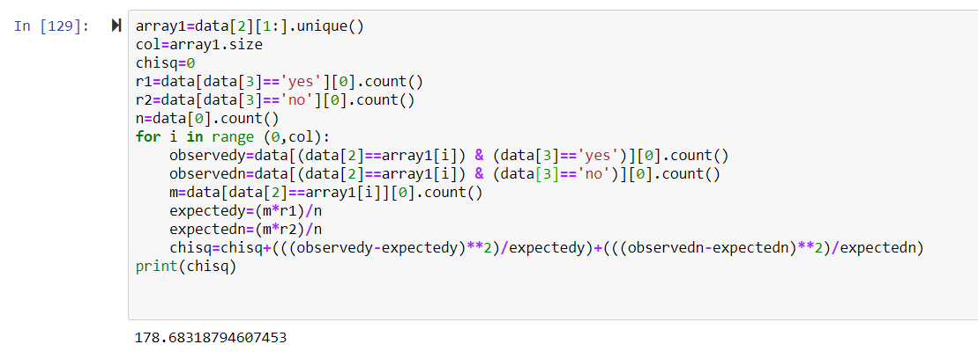

Number of occupations=24

DOF=23

Chi square alpha=35.172

Chi square>Chi square alpha

So H0 rejected

**Occupation is associated with a person being married or not.**

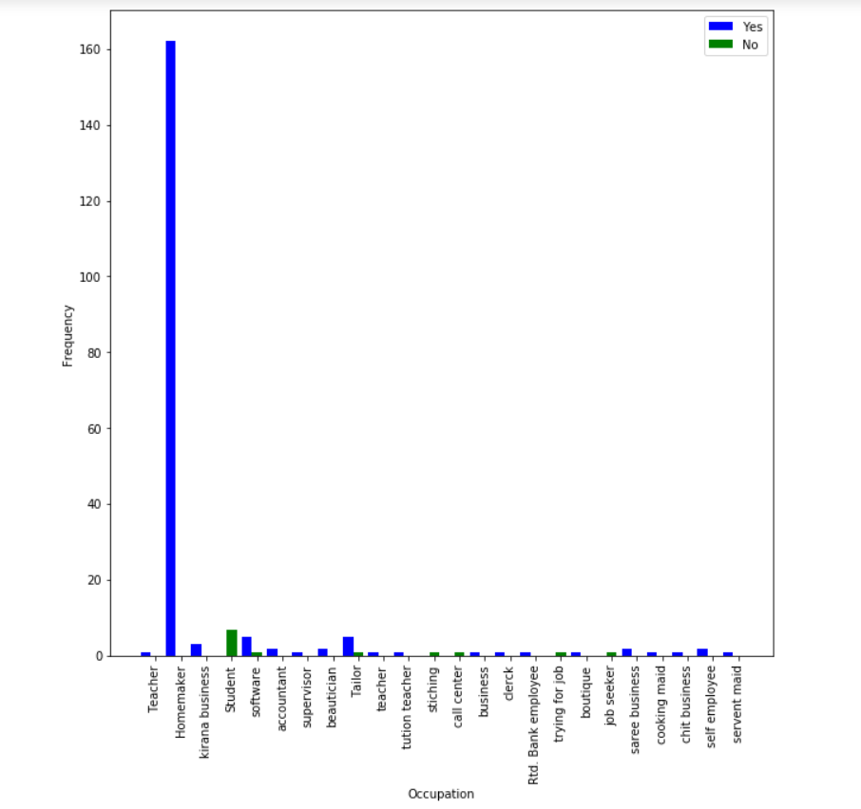

**Test 2**

**H0 : Occupation is not associated with a person having a family history of Heart Problem**

**Ha : Occupation is associated with a person having a family history of Heart Problem**

Chi square = 34.70467489321308

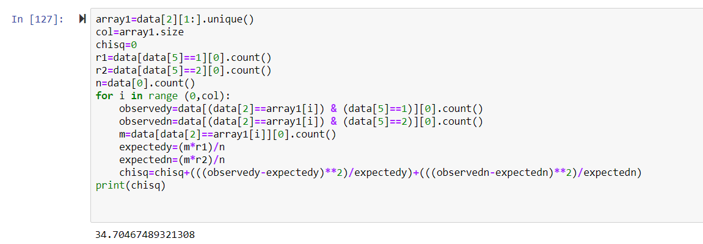

Number of occupations=24

DOF=23

Chi square alpha=35.172

Chi square<Chi square alpha

So H0 not rejected

**Occupation is not associated with a person having a family history of Heart Problem**

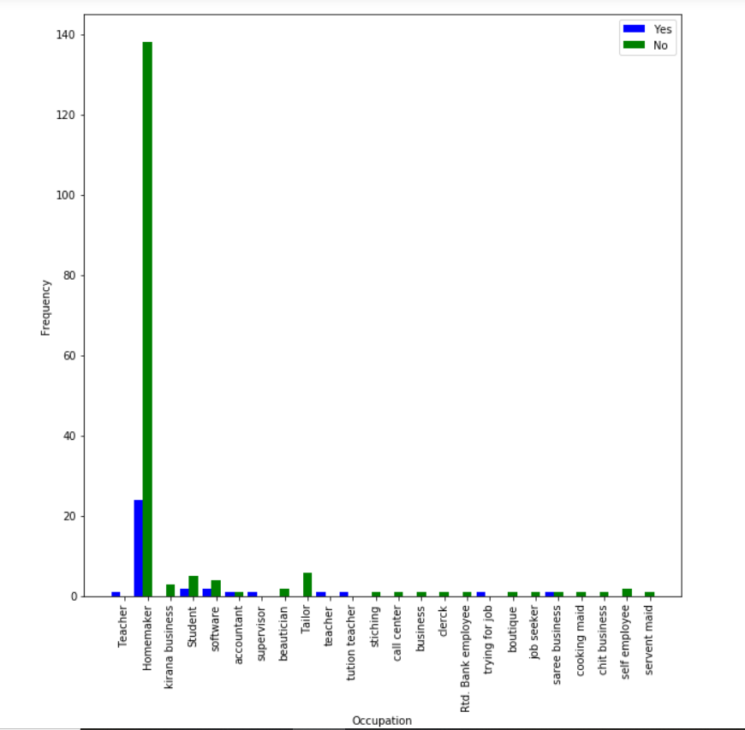

**Test 3**

**H0 : Occupation is not associated with a person having a family history of Hyper Tension**

**Ha : Occupation is associated with a person having a family history of Hyper Tension**

Chi square = 14.798395001225197

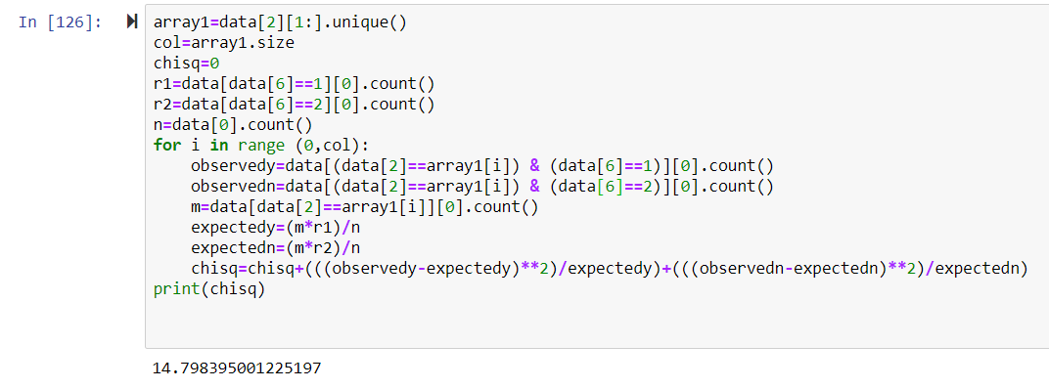

Number of occupations=24

DOF=23

Chi square alpha=35.172

Chi square<Chi square alpha

So H0 not rejected

**Occupation is not associated with a person having a family history of Hyper Tension**

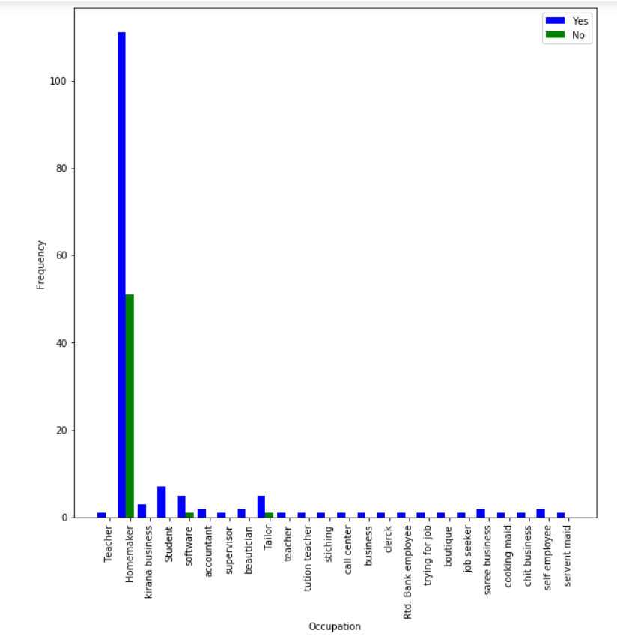

**Test 4**

**H0 : Occupation is not associated with a person having a family history of Diabetes**

**Ha : Occupation is associated with a person having a family history of Diabetes**

Chi square = 25.552684999729333

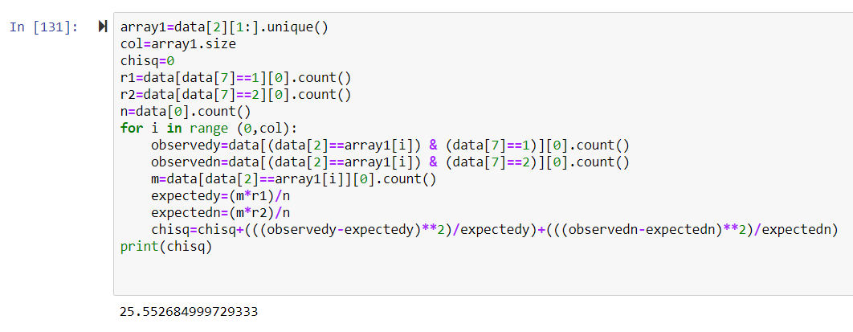

Number of occupations=24

DOF=23

Chi square alpha=35.172

Chi square<Chi square alpha

So H0 not rejected

**Occupation is not associated with a person having a family history of Diabetes**

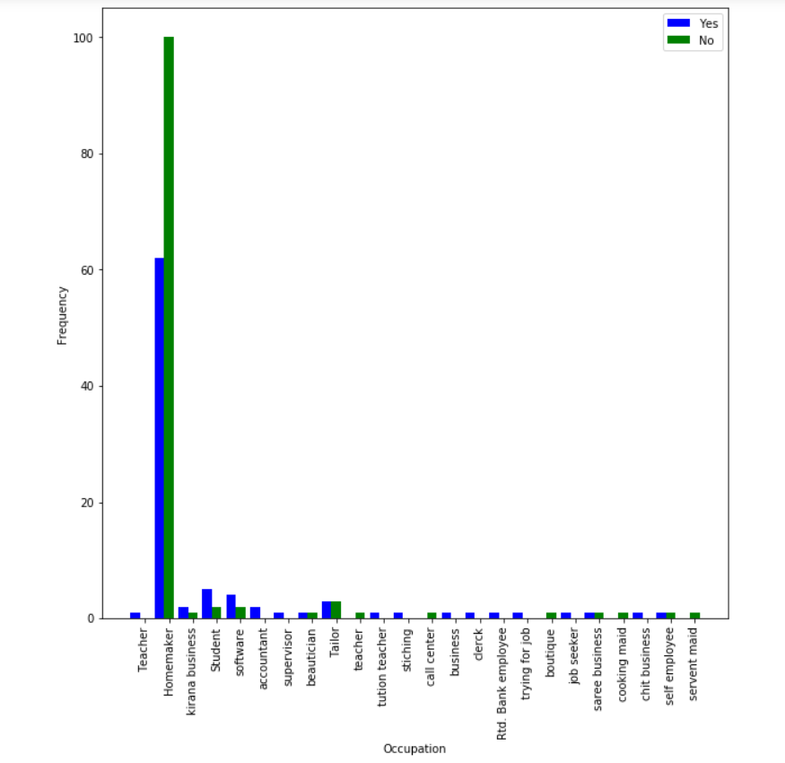

**Test 5**

**H0 : Occupation is not associated with a person having a family history of Obesity**

**Ha : Occupation is associated with a person having a family history of Obesity**

Chi square = 32.55148431665423

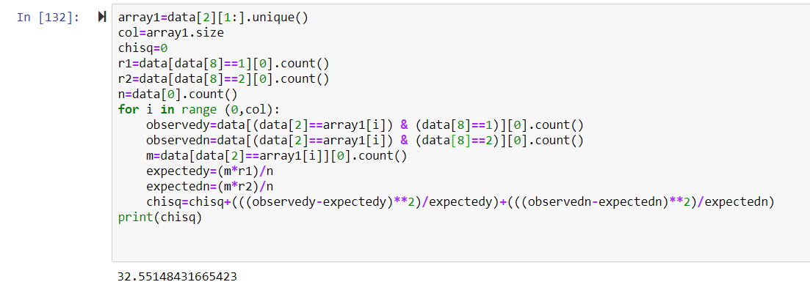

Number of occupations=24

DOF=23

Chi square alpha=35.172

Chi square<Chi square alpha

So H0 not rejected

**Occupation is not associated with a person having a family history of Obesity**

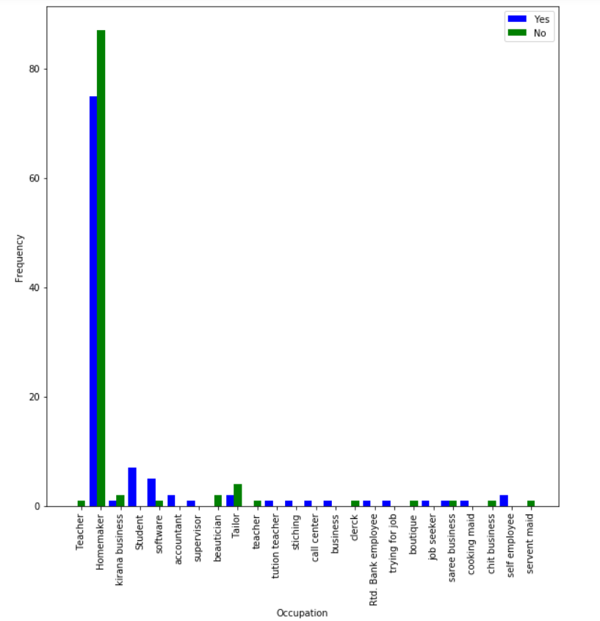

**Test 6**

**H0 : Occupation is not associated with a person having a family history of Pcos**

**Ha : Occupation is associated with a person having a family history of Pcos**

Chi square = 55.310858163928344

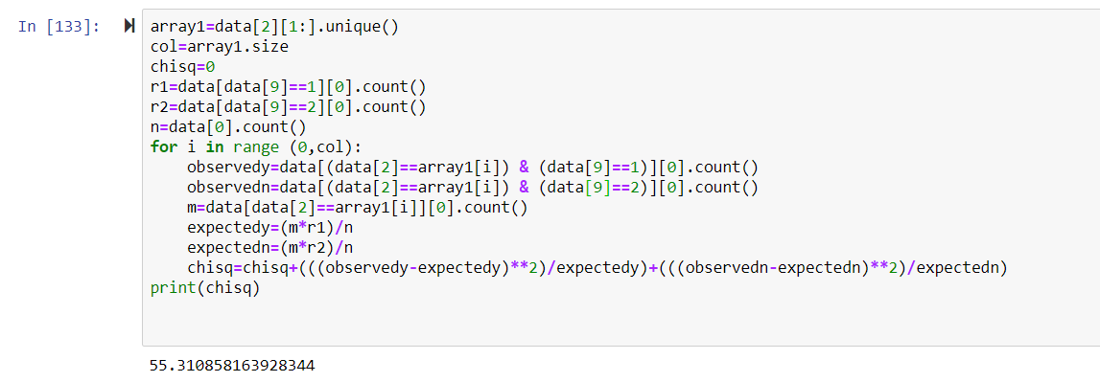

Number of occupations=24

DOF=23

Chi square alpha=35.172

Chi square>Chi square alpha

So H0 rejected

**Occupation is associated with a person having a family history of Pcos**

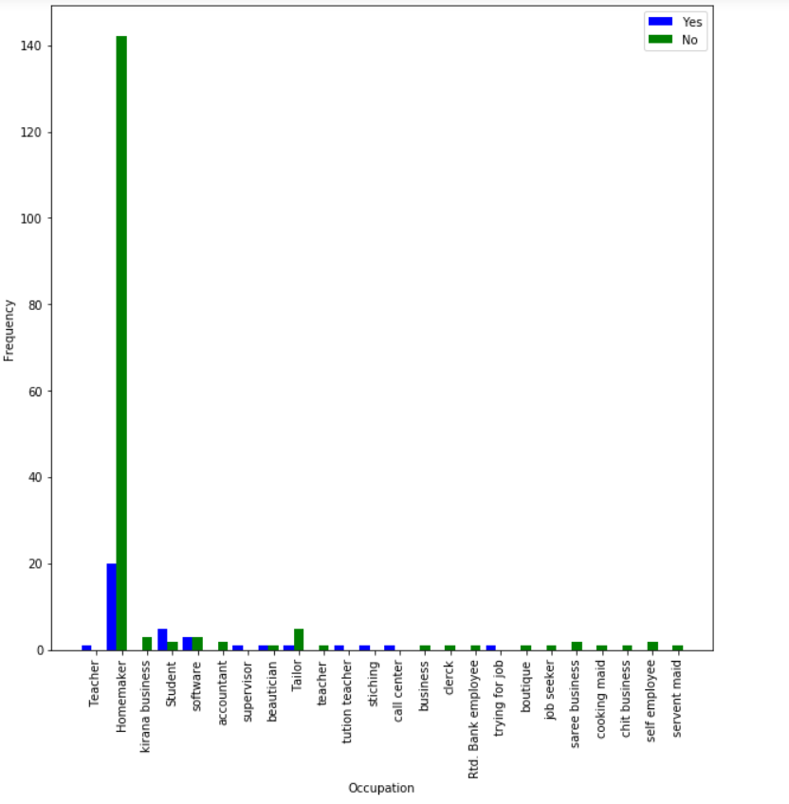

**Test 7**

**H0 : Occupation is not associated with a person having a family history of Hypothyroid**

**Ha : Occupation is associated with a person having a family history of Hypothyroid**

Chi square = 34.58416653335468

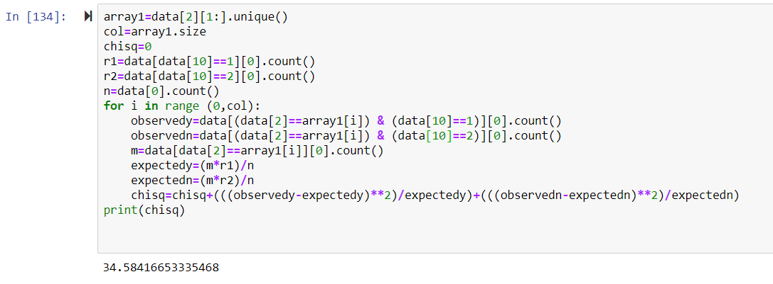

Number of occupations=24

DOF=23

Chi square alpha=35.172

Chi square<Chi square alpha

So H0 not rejected

**Occupation is not associated with a person having a family history of Hypothyroid**

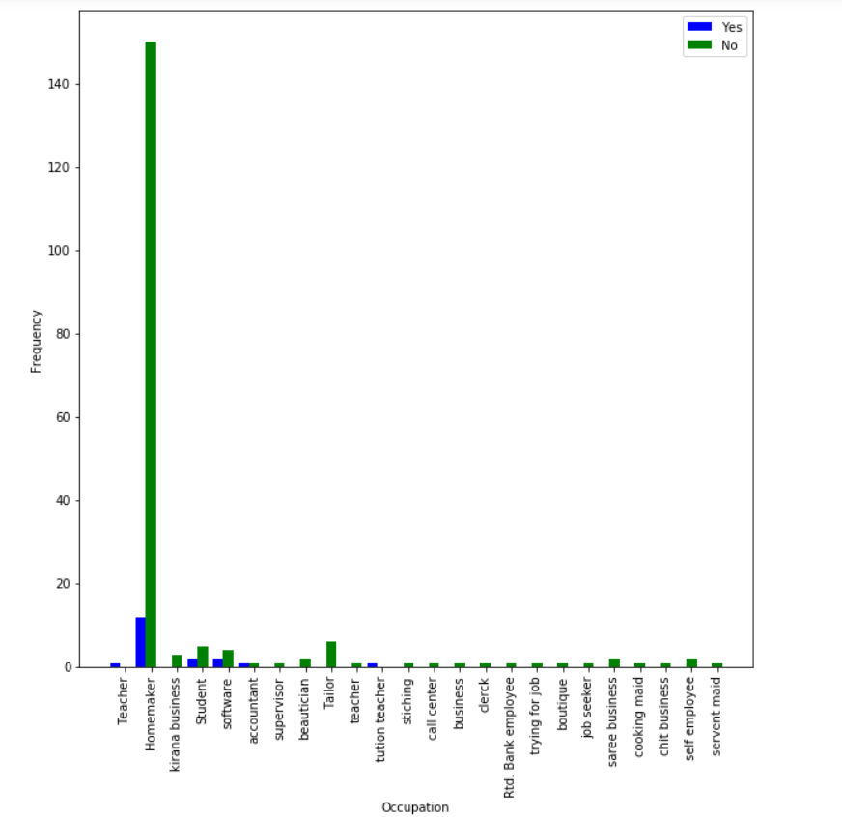

**Test 8**

**H0 : Occupation is not associated with a person having a family history of Cancer**

**Ha : Occupation is associated with a person having a family history of Cancer**

Chi square = 49.31251309174697

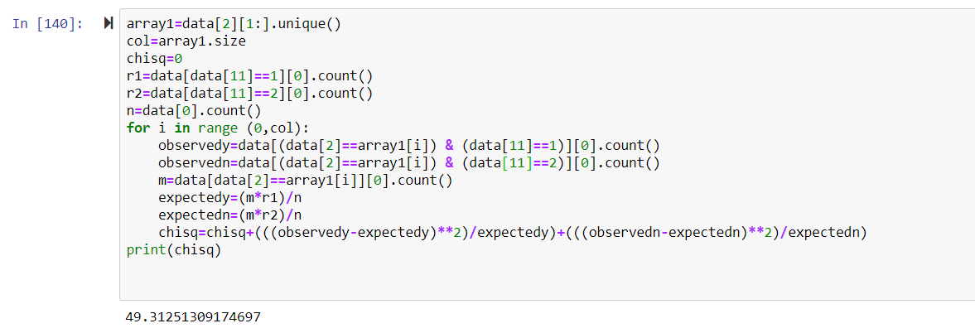

Number of occupations=24

DOF=23

Chi square alpha=35.172

Chi square>Chi square alpha

So H0 rejected

**Occupation is associated with a person having a family history of Cancer**

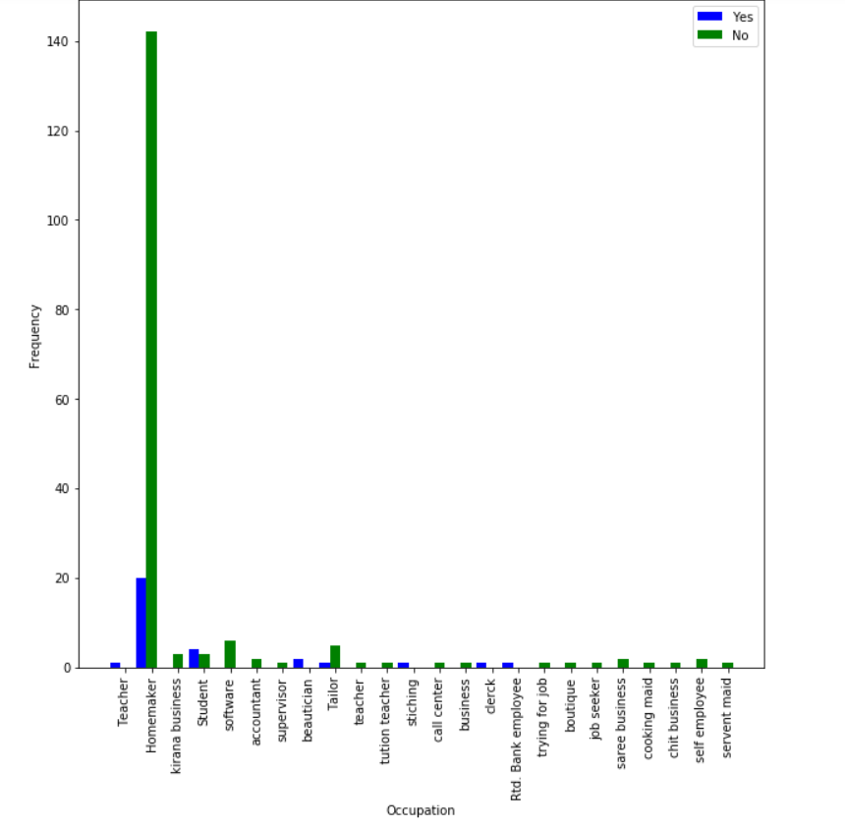

**Test 9**

**H0 : Occupation is not associated with a person having a family history of any other disease**

**Ha : Occupation is associated with a person having a family history of any other disease**

Chi square = 27.827373151095298

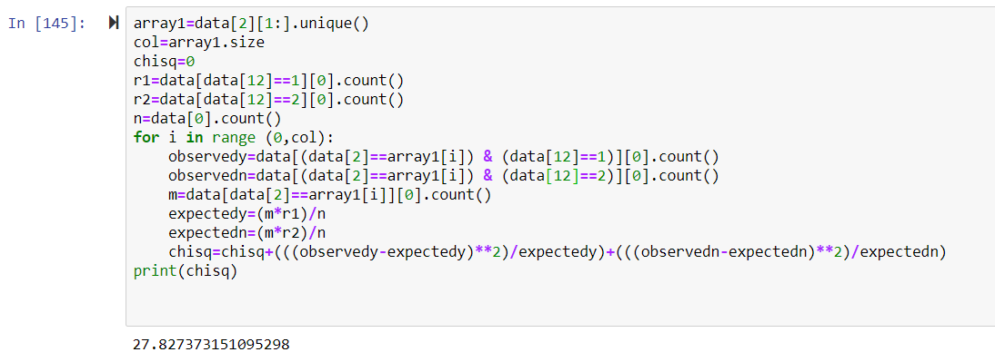

Number of occupations=24

DOF=23

Chi square alpha=35.172

Chi square<Chi square alpha

So H0 not rejected

**Occupation is not associated with a person having a family history of any other disease**

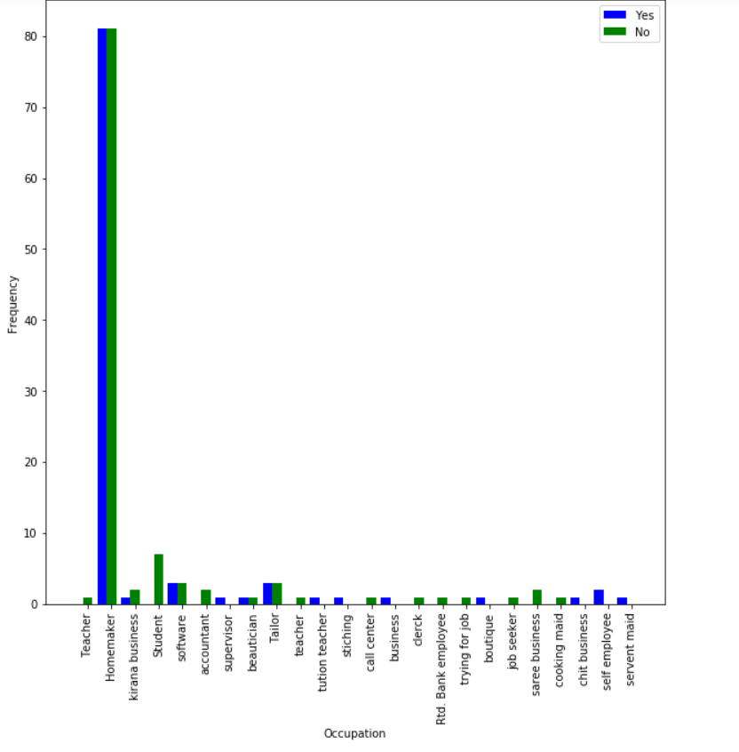

**Test 10**

**H0 : Occupation is not associated with a person having Diabetes**

**Ha : Occupation is associated with a person having Diabetes**

Chi square = 21.451506591337097

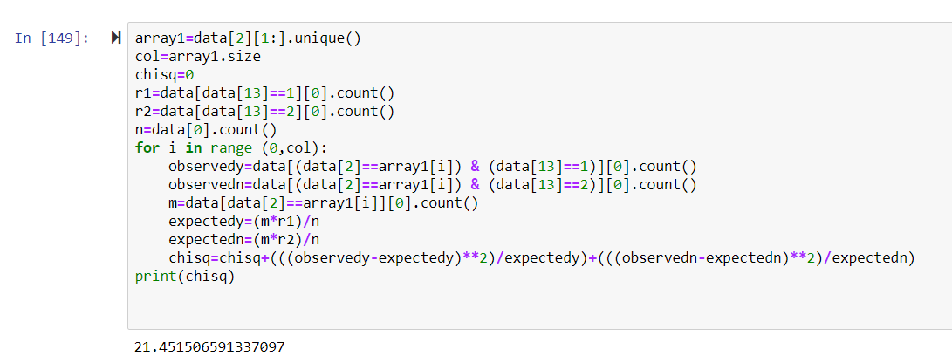

Number of occupations=24

DOF=23

Chi square alpha=35.172

Chi square<Chi square alpha

So H0 is not rejected

**Occupation is not associated with a person having Diabetes**

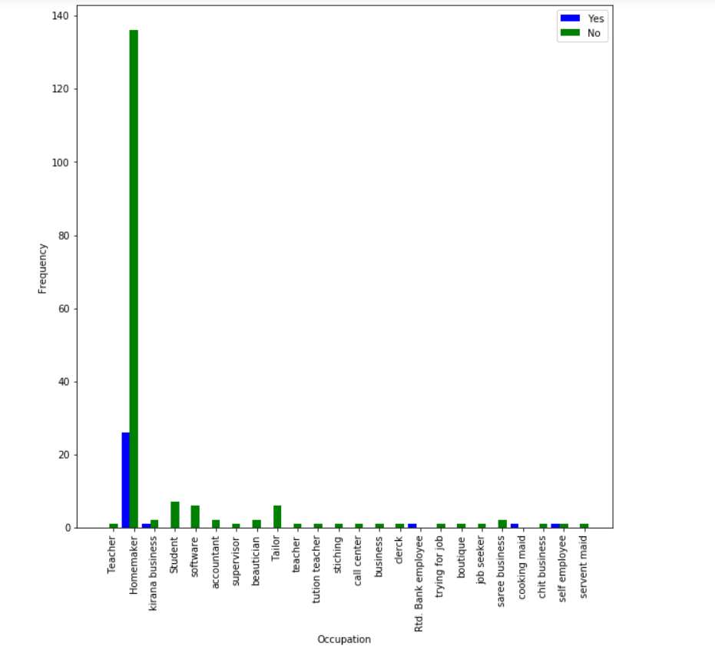

**Test 11**

**H0 : Occupation is not associated with a person having HTN**

**Ha : Occupation is associated with a person having HTN**

Chi square = 25.836483253588508

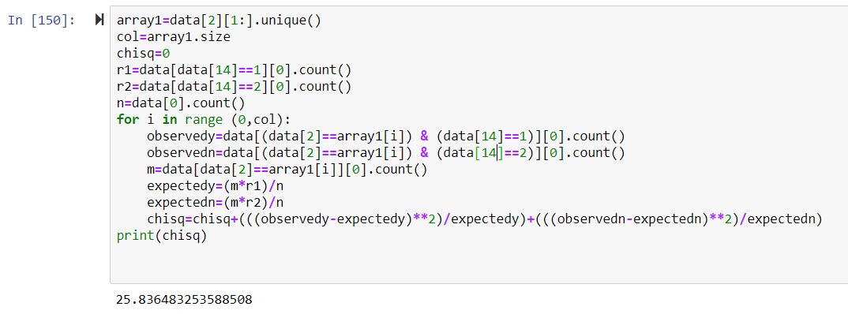

Number of occupations=24

DOF=23

Chi square alpha=35.172

Chi square<Chi square alpha

So H0 is not rejected

**Occupation is not associated with a person having HTN**

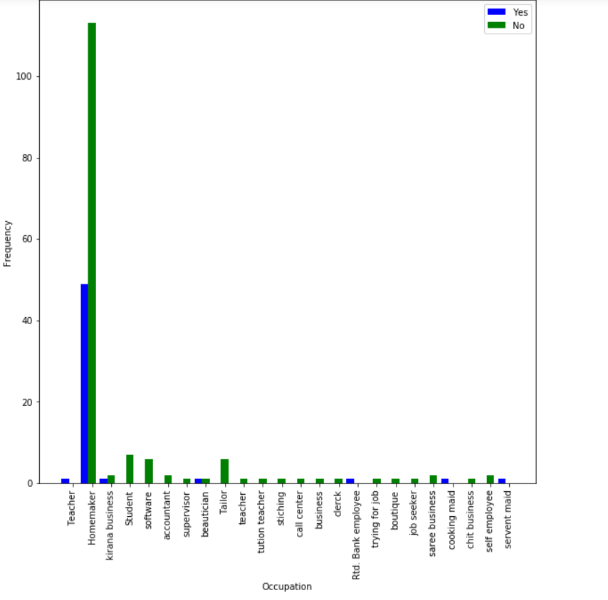

**Test 12**

**H0 : Occupation is not associated with a person having Pcos**

**Ha : Occupation is associated with a person having Pcos**

Chi square = 26.557522543901282

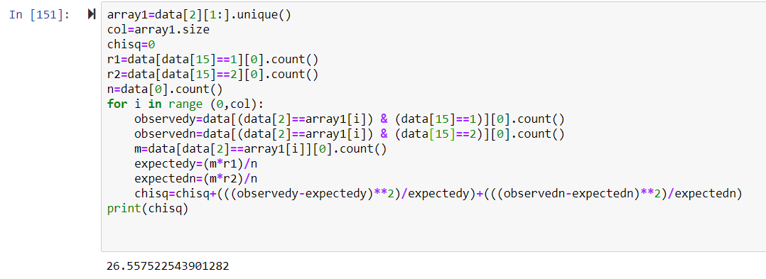

Number of occupations=24

DOF=23

Chi square alpha=35.172

Chi square<Chi square alpha

So H0 is not rejected

**Occupation is not associated with a person having Pcos**

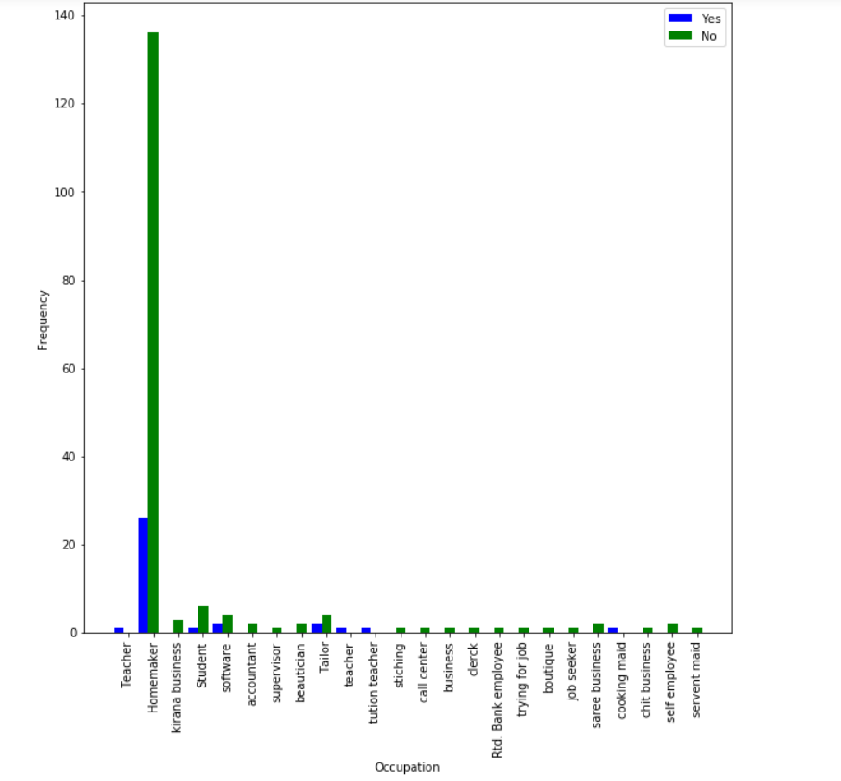

**Test 13**

**H0 : Occupation is not associated with a person having CVD**

**Ha : Occupation is associated with a person having CVD**

Chi square = 206.99999999999994

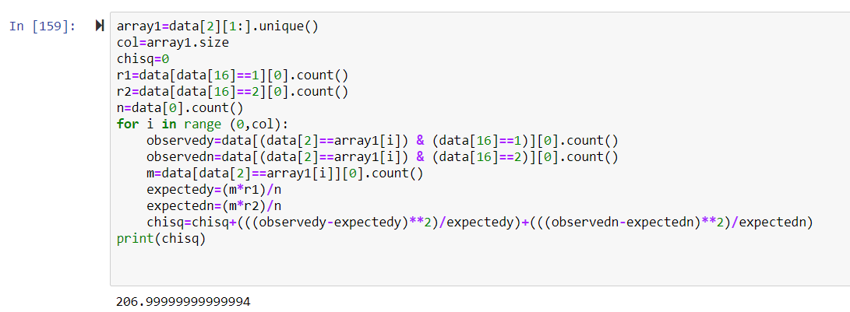

Number of occupations=24

DOF=23

Chi square alpha=35.172

Chi square>Chi square alpha

So H0 is rejected

**Occupation is associated with a person having CVD**

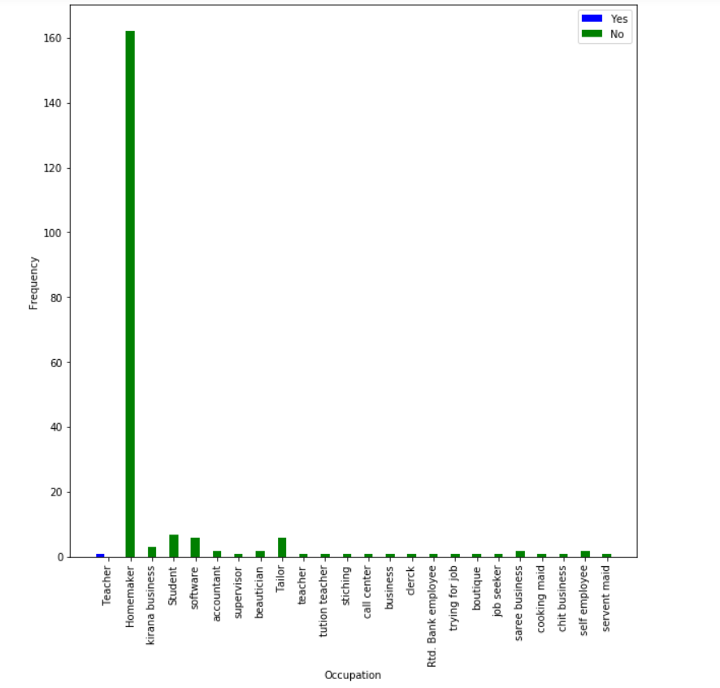

**Test 14**

**H0 : Occupation is not associated with a person having Hypothyroid**

**Ha : Occupation is associated with a person having Hypothyroid**

Chi square = 26.499659979598782

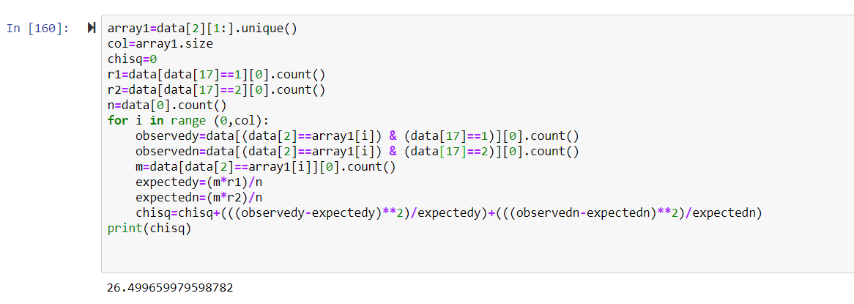

Number of occupations=24

DOF=23

Chi square alpha=35.172

Chi square<Chi square alpha

So H0 is not rejected

**Occupation is not associated with a person having Hypothyroid**

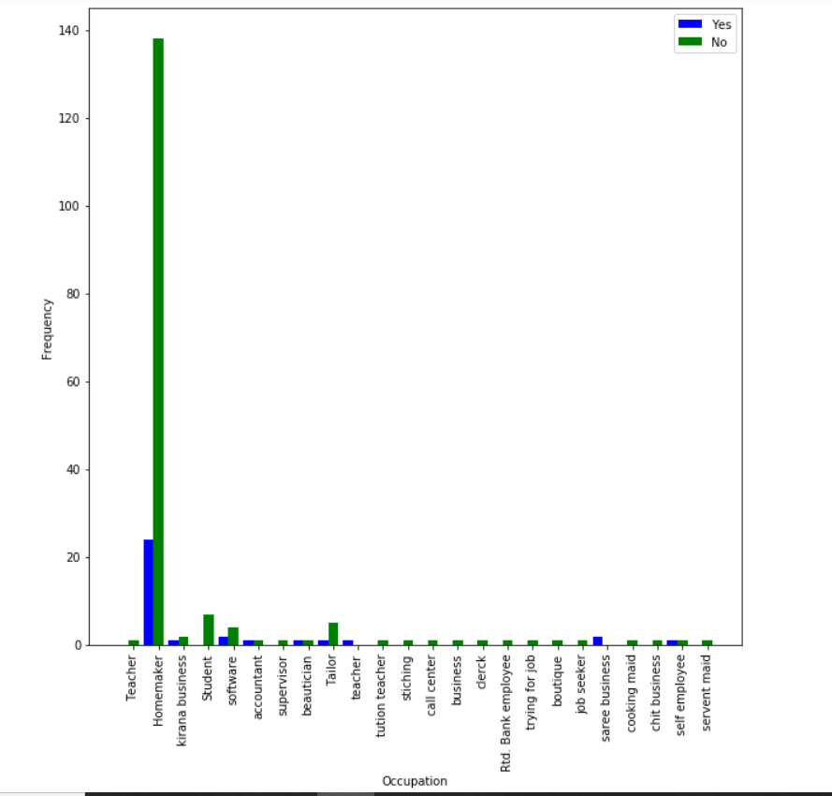

**Test 15**

**H0 : Occupation is not associated with a person having s**

**Ha : Occupation is associated with a person having s**

Chi square = 48.75510204081631

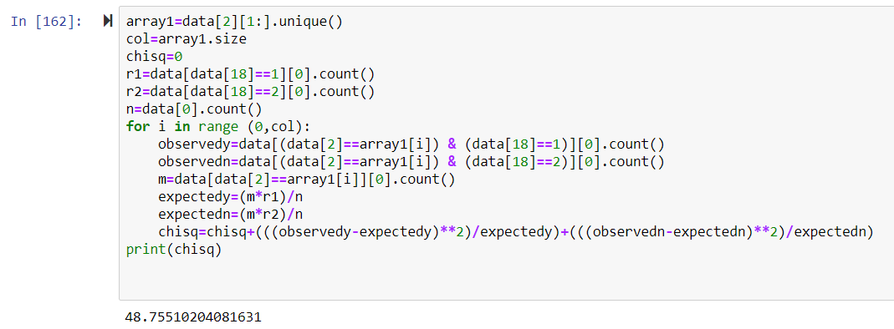

Number of occupations=24

DOF=23

Chi square alpha=35.172

Chi square>Chi square alpha

So H0 is rejected

**Occupation is associated with a person having s**

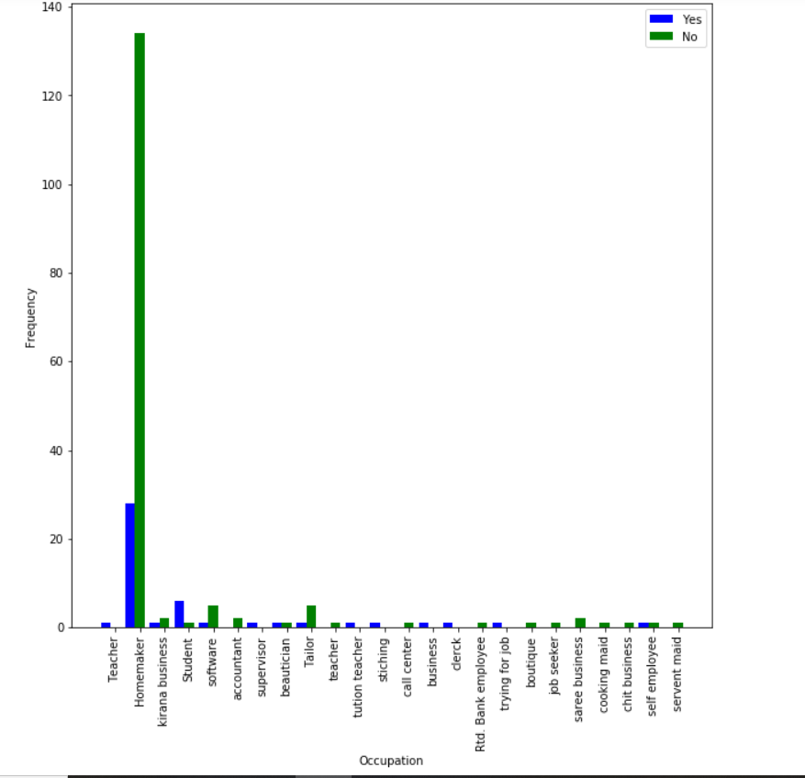

**Test 16**

**H0 : Occupation is not associated with a person having Arthritis**

**Ha : Occupation is associated with a person having Arthritis**

Chi square = 17.066834109286944

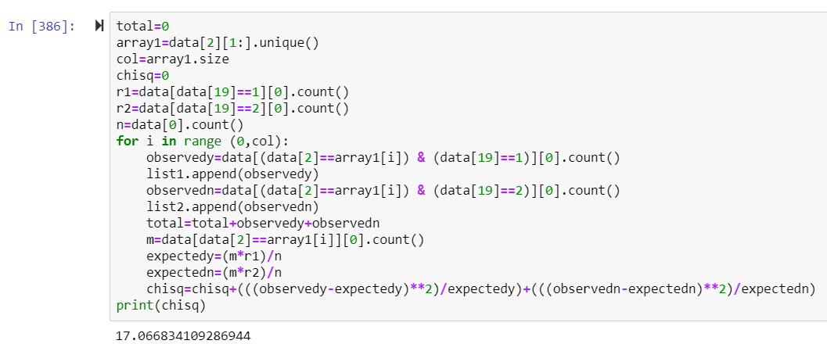

Number of occupations=24

DOF=23

Chi square alpha=35.172

Chi square<Chi square alpha

So H0 is not rejected

**Occupation is not associated with a person having Arthritis**

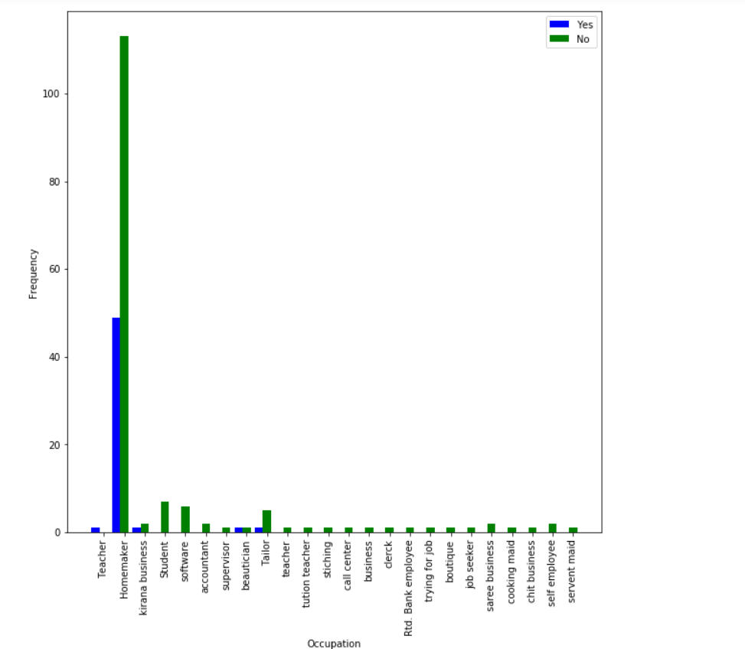

**Test 17**

**H0 : Occupation is not associated with a person having Vertigo**

**Ha : Occupation is associated with a person having Vertigo**

Chi square = 24.117332830568124

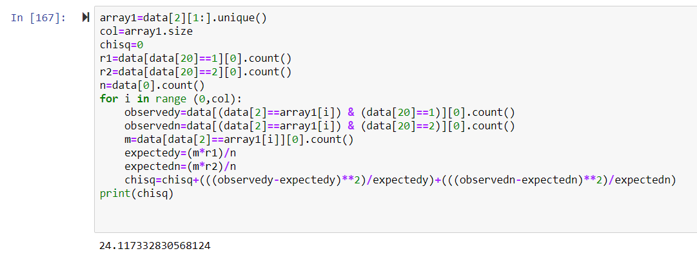

Number of occupations=24

DOF=23

Chi square alpha=35.172

Chi square<Chi square alpha

So H0 is not rejected

**Occupation is not associated with a person having Vertigo**

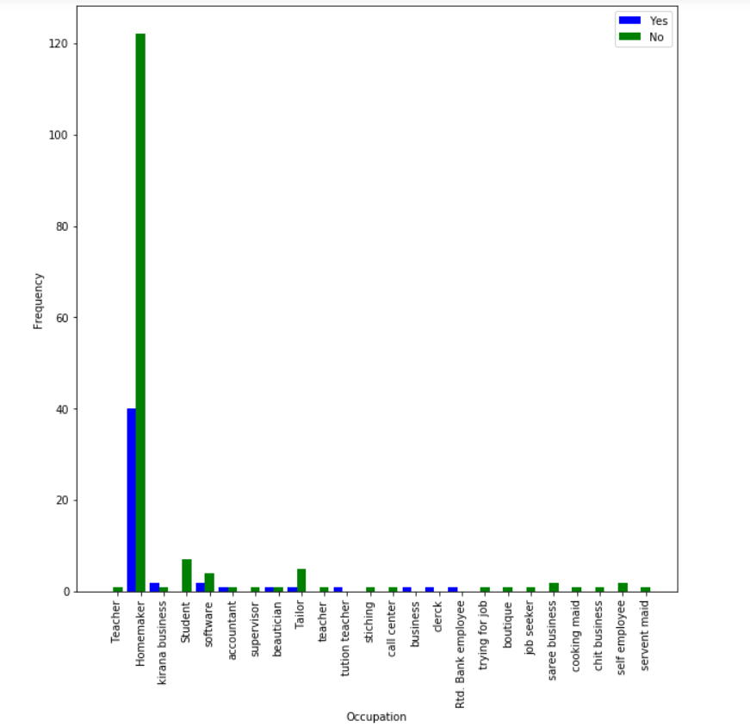

**Test 18**

**H0 : Occupation is not associated with a person having any other medical problem**

**Ha : Occupation is associated with a person having any other medical problem**

Chi square = 27.701626048848272

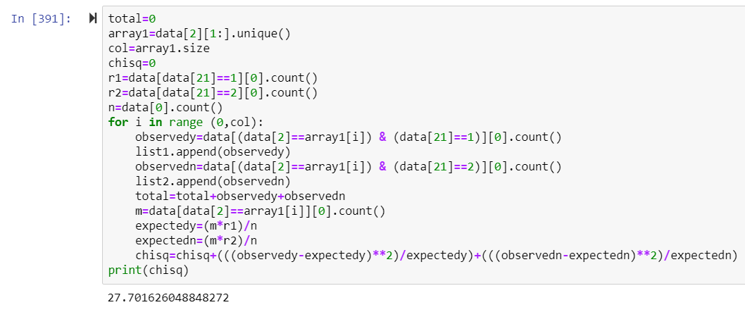

Number of occupations=24

DOF=23

Chi square alpha=35.172

Chi square<Chi square alpha

So H0 is not rejected

**Occupation is not associated with a person having any other medical problem**

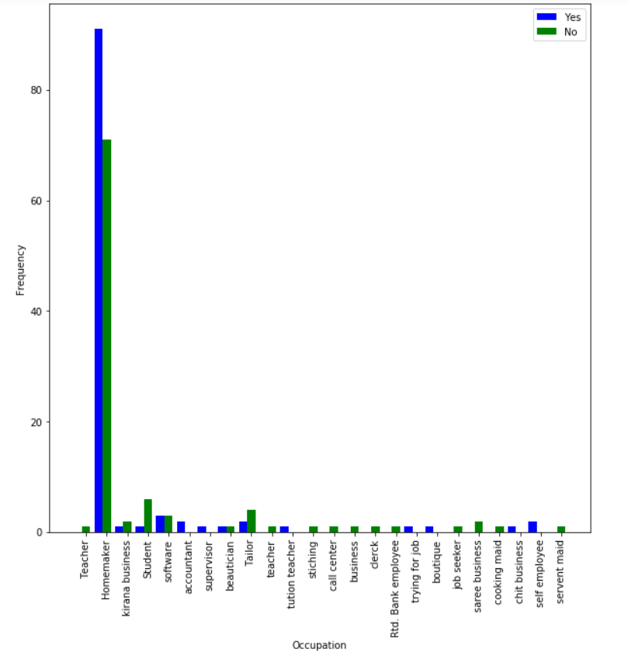

**Test 19**

**H0 : Occupation is not associated with medication/supplement**

**Ha : Occupation is associated with medication/supplement**

Chi square = 26.14911786786786

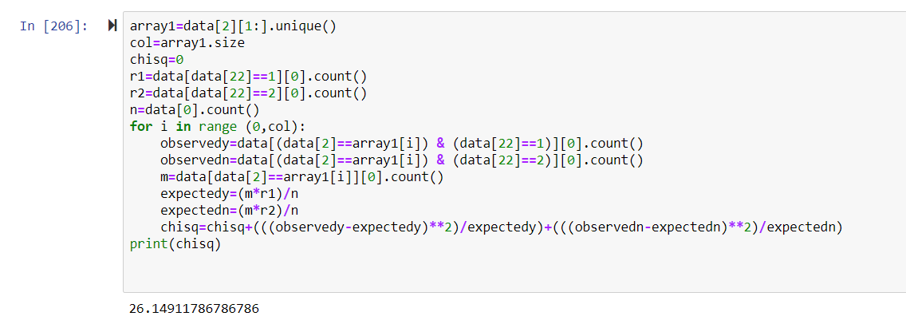

Number of occupations=24

DOF=23

Chi square alpha=35.172

Chi square<Chi square alpha

So H0 is not rejected

**Occupation is not associated with medication/supplement**

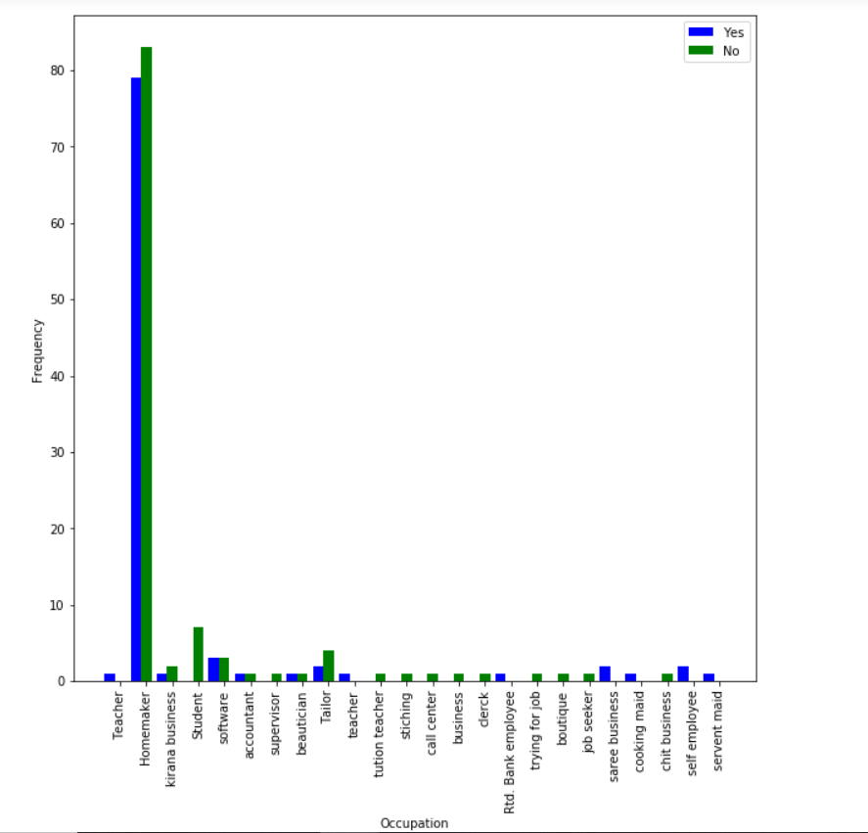

**Test 20**

**H0 : Occupation is not associated with Weight Management**

**Ha : Occupation is associated with Weight Management**

Chi square = NaN

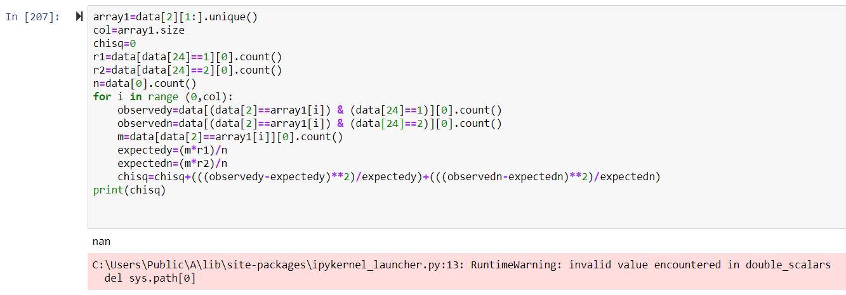

Number of occupations=24

DOF=23

Chi square alpha=35.172

**Weight Management is always a yes and hence**

**Occupation is not associated with Weight Management**

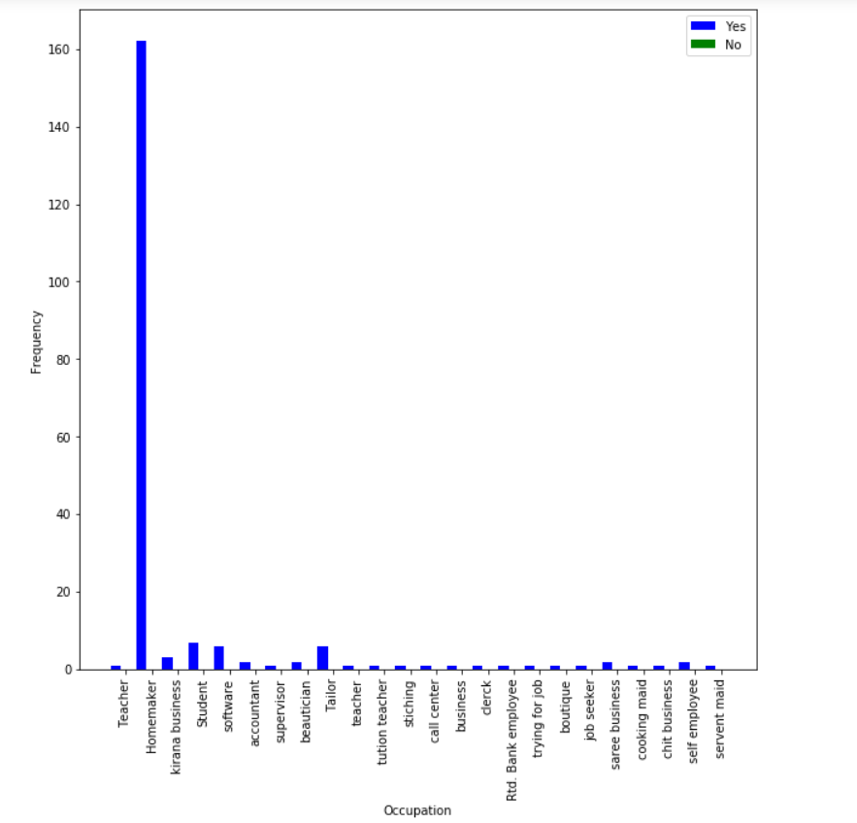

**Test 21**

**H0 : Occupation is not associated with Improved Fitness**

**Ha : Occupation is associated with Improved Fitness**

Chi square = 16.57763596556701

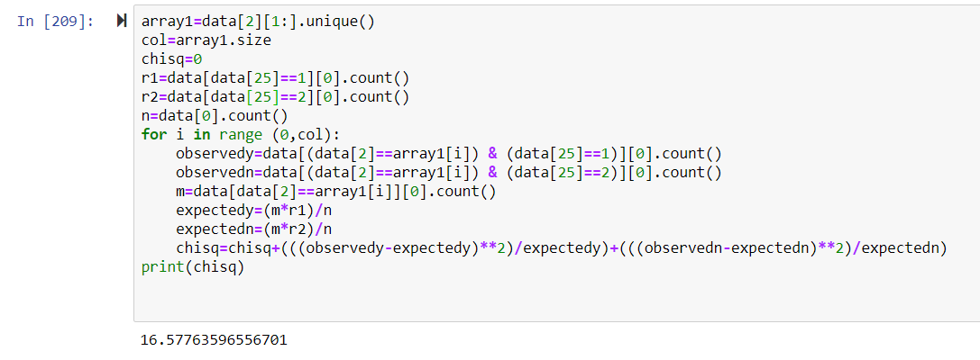

Number of occupations=24

DOF=23

Chi square alpha=35.172

Chi square<Chi square alpha

So H0 is not rejected

**Occupation is not associated with Improved Fitness**

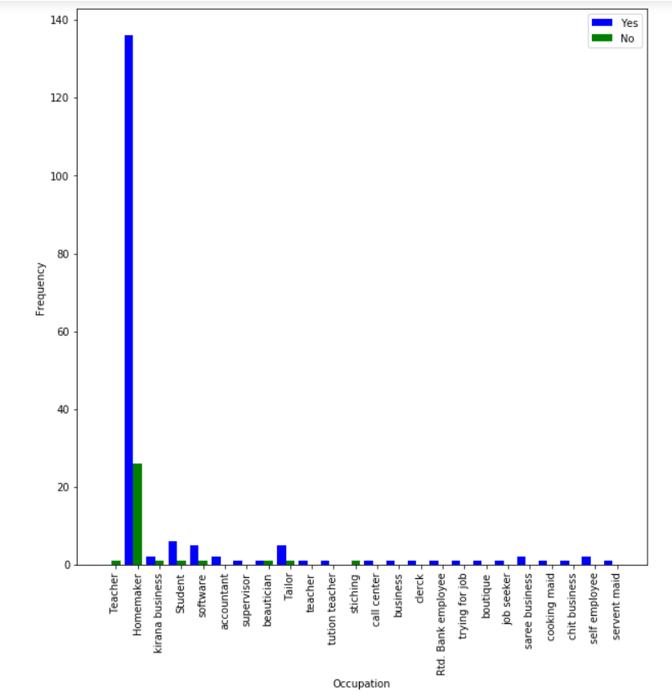

**Test 22**

**H0 : Occupation is not associated with Back Strengthening**

**Ha : Occupation is associated with Back Strengthening**

Chi square = 17.426531323083054

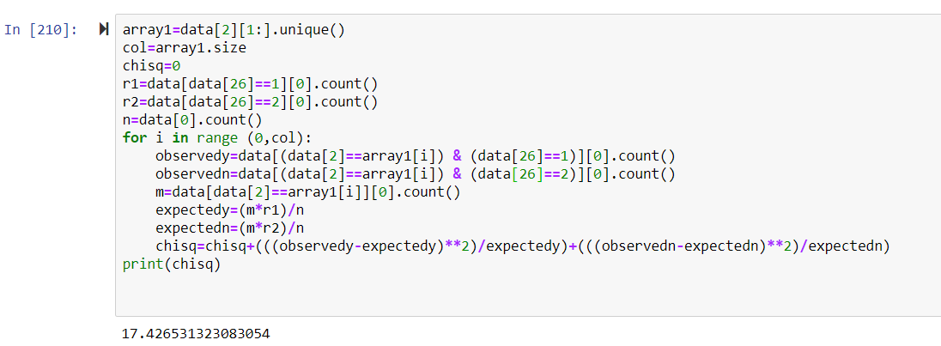

Number of occupations=24

DOF=23

Chi square alpha=35.172

Chi square<Chi square alpha

So H0 is not rejected

**Occupation is not associated with Back Strengthening**

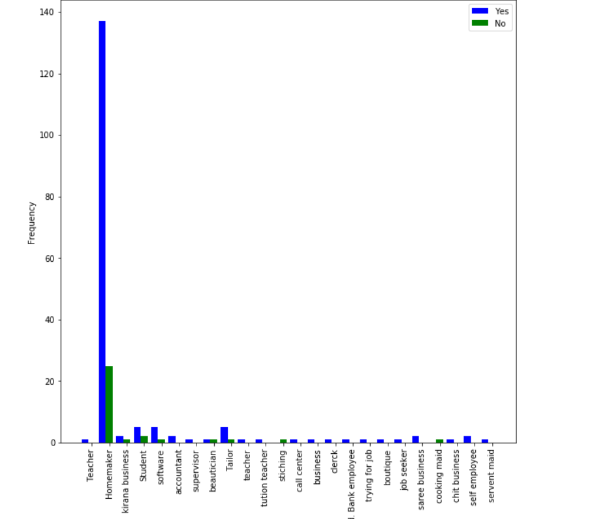

**Test 24**

**H0 : Occupation is not associated with Nutrition and Diseases prevention**

**Ha : Occupation is associated with Nutrition and Diseases prevention**

Chi square = 22.414161706349205

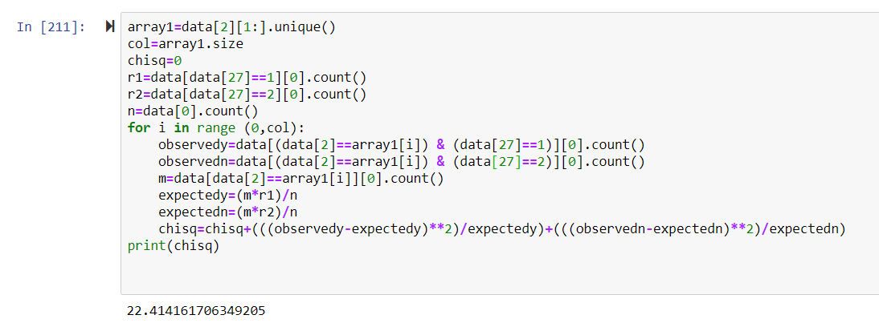

Number of occupations=24

DOF=23

Chi square alpha=35.172

Chi square<Chi square alpha

So H0 is not rejected

**Occupation is not associated with Nutrition and Diseases prevention**

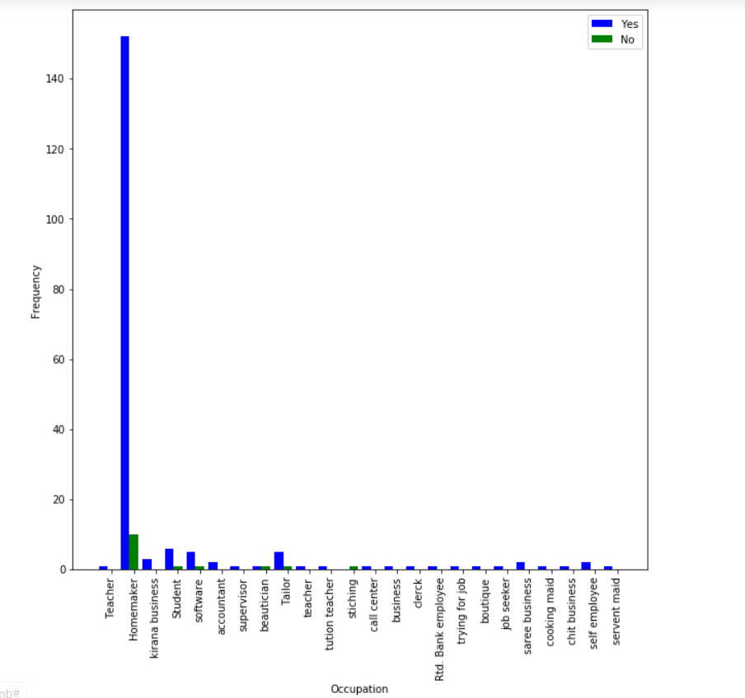

**Test 25**

**H0 : Occupation is not associated with a person being Vegetarian**

**Ha : Occupation is associated with a person being Vegetarian**

Chi square = 90.74101307189542

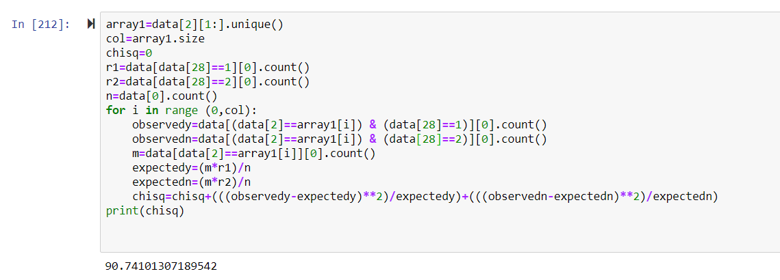

Number of occupations=24

DOF=23

Chi square alpha=35.172

Chi square>Chi square alpha

So H0 is rejected

**Occupation is associated with a person being Vegetarian**

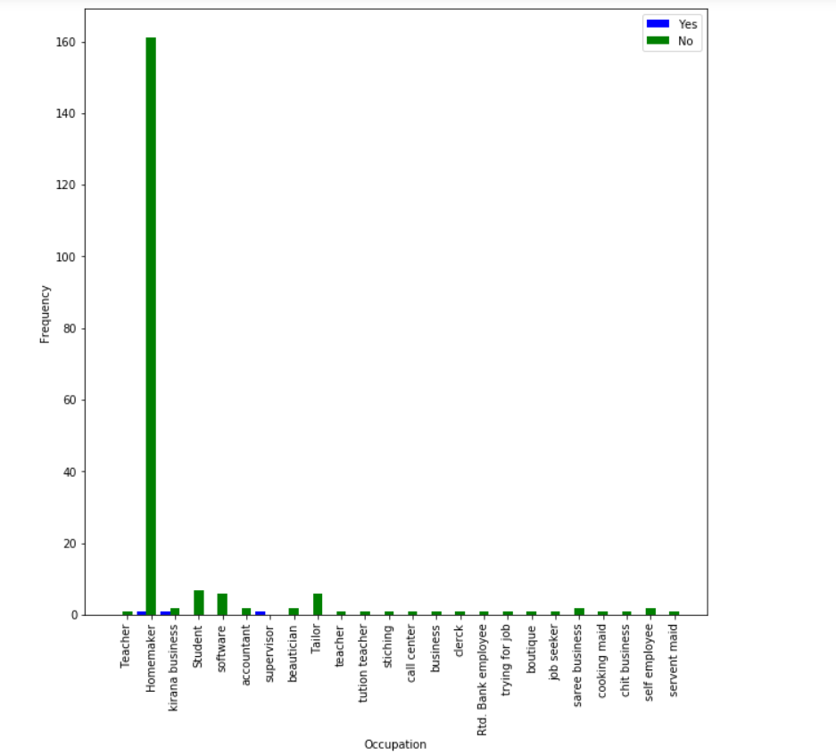

**Test 26**

**H0 : Occupation is not associated with a person being Lacto Vegetarian**

**Ha : Occupation is associated with a person being Lacto Vegetarian**

Chi square = 35.81439743527469

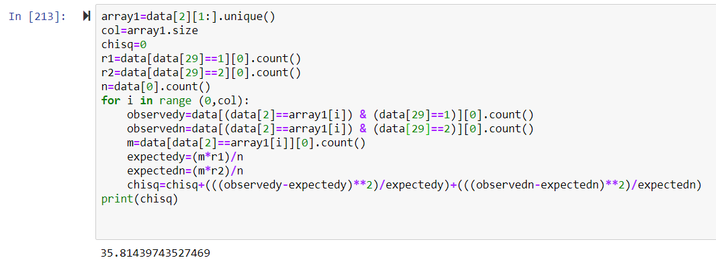

Number of occupations=24

DOF=23

Chi square alpha=35.172

Chi square>Chi square alpha

So H0 is rejected

**Occupation is associated with a person being Lacto Vegetarian**

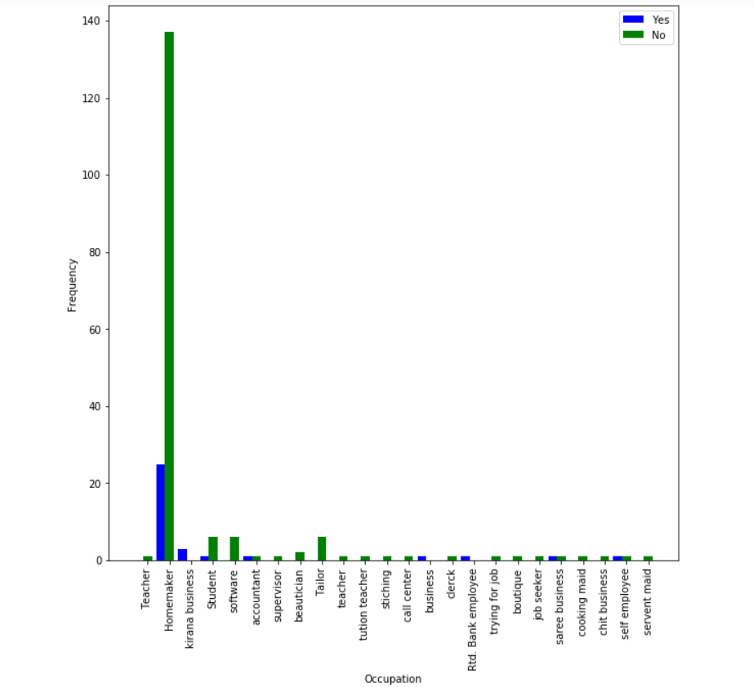

**Test 26**

**H0 : Occupation is not associated with a person being Ovo Vegetarian**

**Ha : Occupation is associated with a person being Ovo Vegetarian**

Chi square = 13.555574912891988

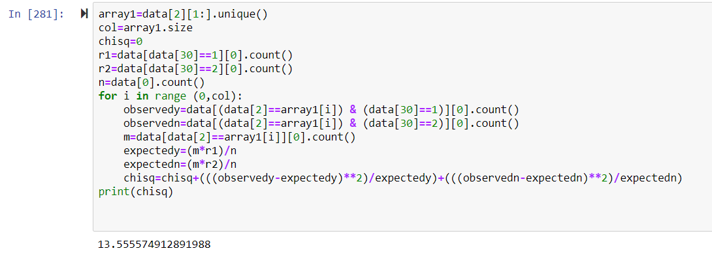

Number of occupations=24

DOF=23

Chi square alpha=35.172

Chi square<Chi square alpha

So H0 is not rejected

**Occupation is not associated with a person being Ovo Vegetarian**

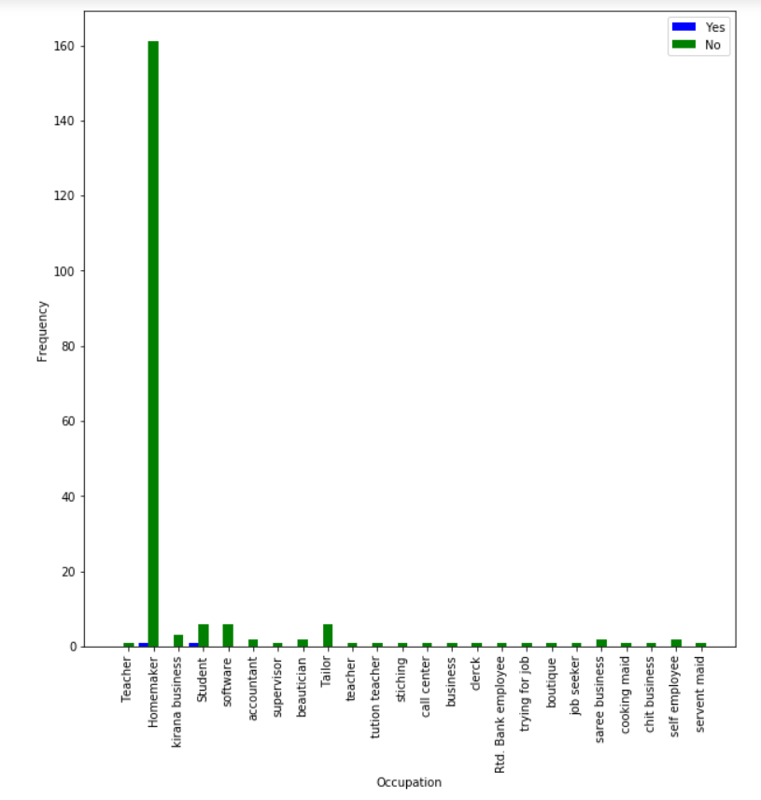

**Test 27**

**H0 : Occupation is not associated with a person being Lacto-Ovo Vegetarian**

**Ha : Occupation is associated with a person being Lacto-Ovo Vegetarian**

Chi square = 26.573508475330346

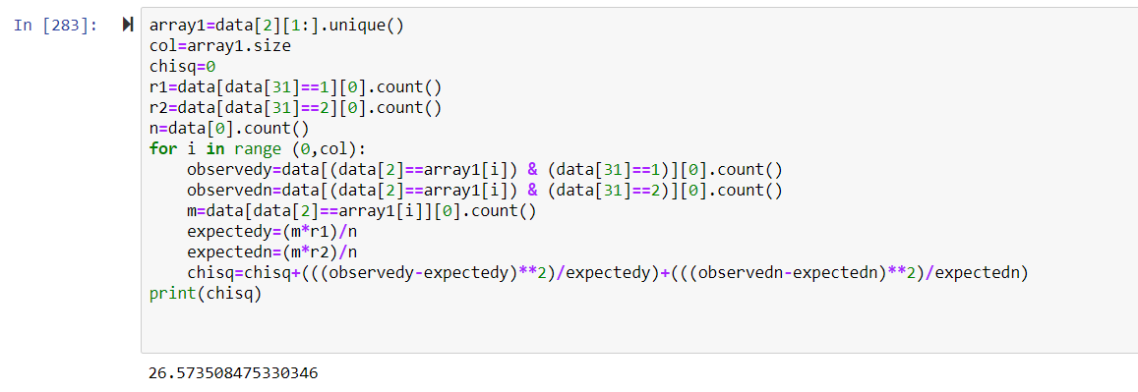

Number of occupations=24

DOF=23

Chi square alpha=35.172

Chi square<Chi square alpha

So H0 is not rejected

**Occupation is not associated with a person being Lacto-Ovo Vegetarian**

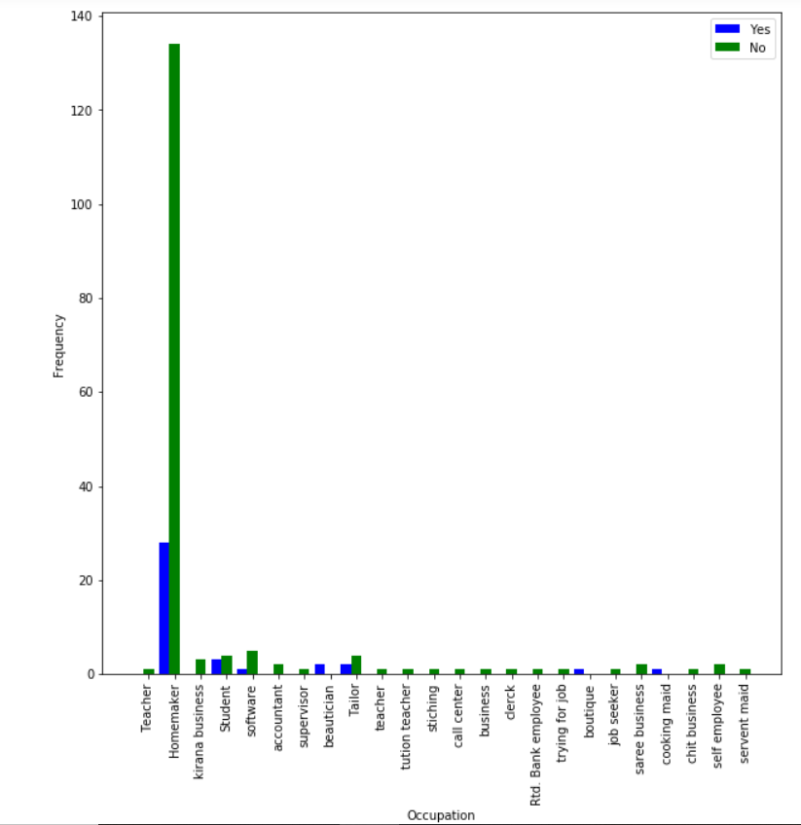

**Test 28**

**H0 : Occupation is not associated with a person being Non-Vegetarian**

**Ha : Occupation is associated with a person being Non-Vegetarian**

Chi square = 29.132337662337676

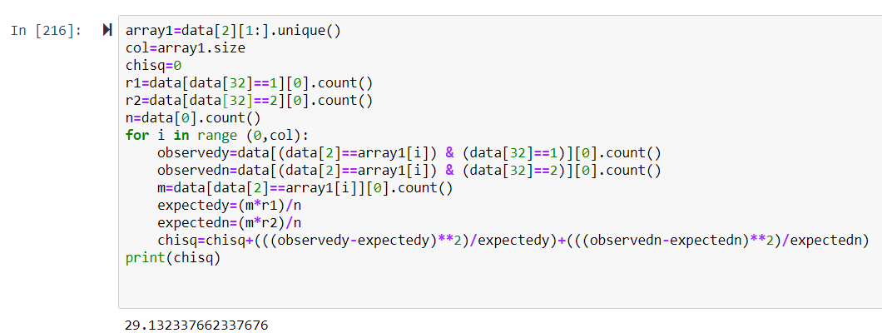

Number of occupations=24

DOF=23

Chi square alpha=35.172

Chi square<Chi square alpha

So H0 is not rejected

**Occupation is not associated with a person being Non-Vegetarian**

