**Chi square test**

**Test 1**

**H0 : No. of children a person has is not associated with a person having a family history of Heart Problem**

**Ha : No. of children a person has is associated with a person having a family history of Heart Problem**

Chi square = 6.223336089605234

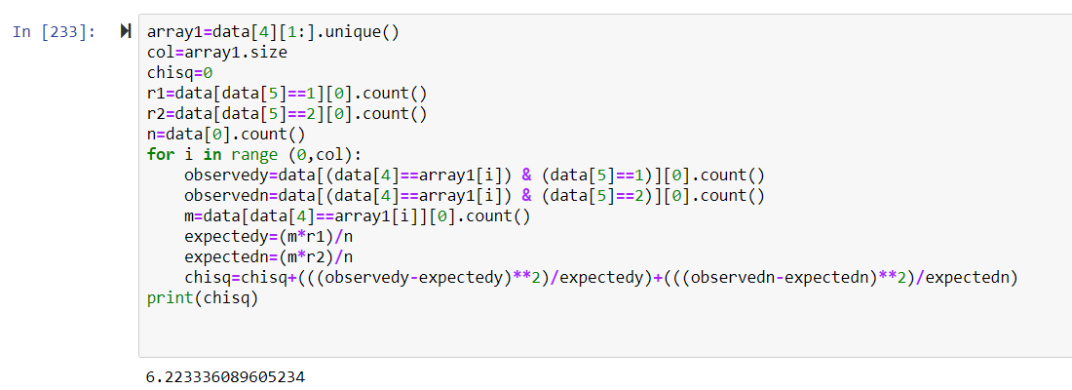

DOF=7

Chi square alpha=14.067

Chi square<Chi square alpha

So H0 is not rejected

**No. of children a person has is not associated with a person having a family history of Heart Problem**

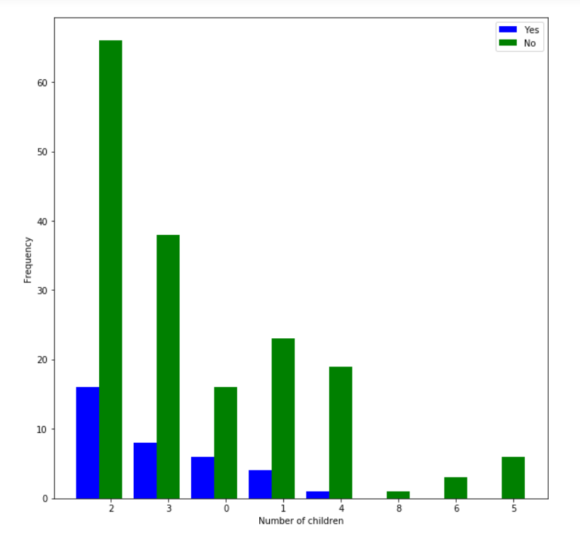

**Test 2**

**H0 : No. of children a person has, is not associated with a person having a family history of Hyper Tension**

**Ha : No. of children a person has, is associated with a person having a family history of Hyper Tension**

Chi square = 20.867461360335685

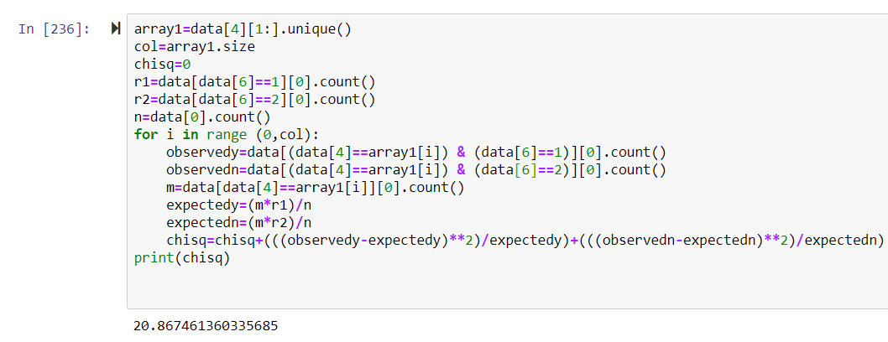

DOF=7

Chi square alpha=14.067

Chi square>Chi square alpha

So H0 is rejected

**No. of children a person has is associated with a person having a family history of Hyper Tension**

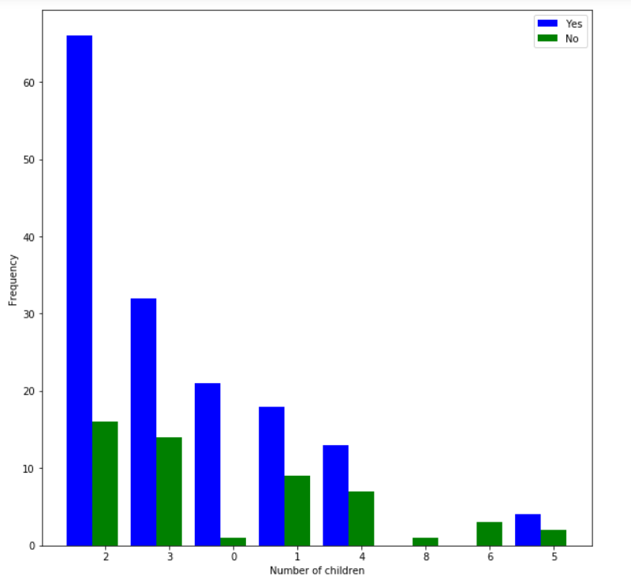

**Test 3**

**H0 : No. of children a person has is not associated with a person having a family history of Diabetes**

**Ha : No. of children a person has is associated with a person having a family history of Diabetes**

Chi square = 22.529418394893582

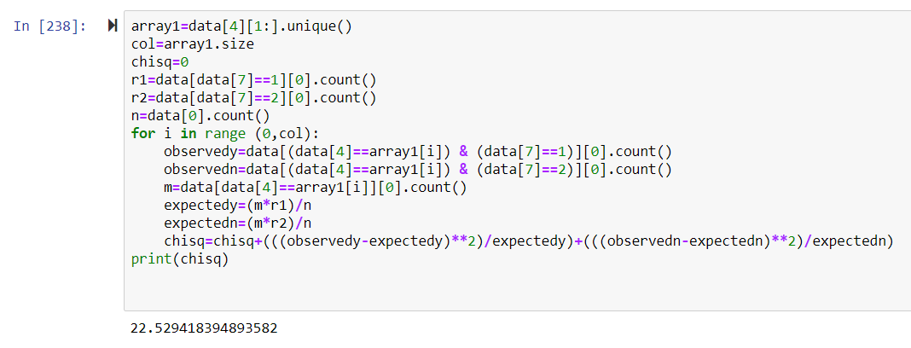

DOF=7

Chi square alpha=14.067

Chi square>Chi square alpha

So H0 is rejected

**No. of children a person has is associated with a person having a family history of Diabetes**

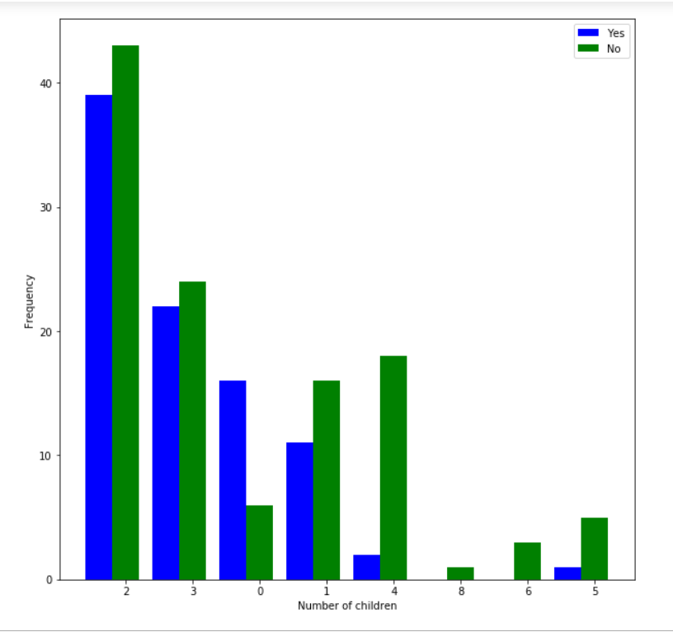

**Test 4**

**H0 : No. of children a person has is not associated with a person having a family history of Obesity**

**Ha : No. of children a person has is associated with a person having a family history of Obesity**

Chi square = 15.80446780161586

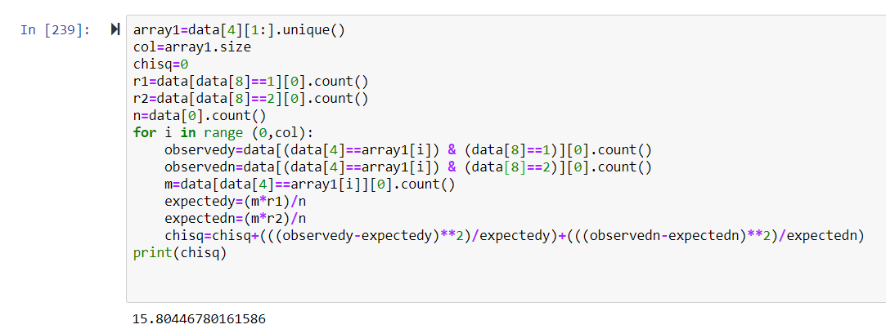

DOF=7

Chi square alpha=14.067

Chi square>Chi square alpha

So H0 is rejected

**No. of children a person has is associated with a person having a family history of Obesity**

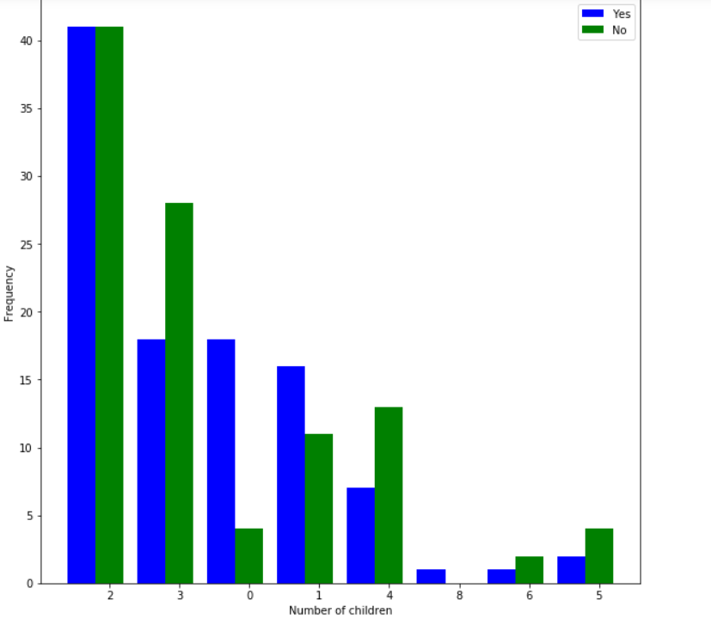

**Test 5**

**H0 : No. of children a person has is not associated with a person having a family history of Pcos**

**Ha : No. of children a person has is associated with a person having a family history of Pcos**

Chi square = 32.68976635200962

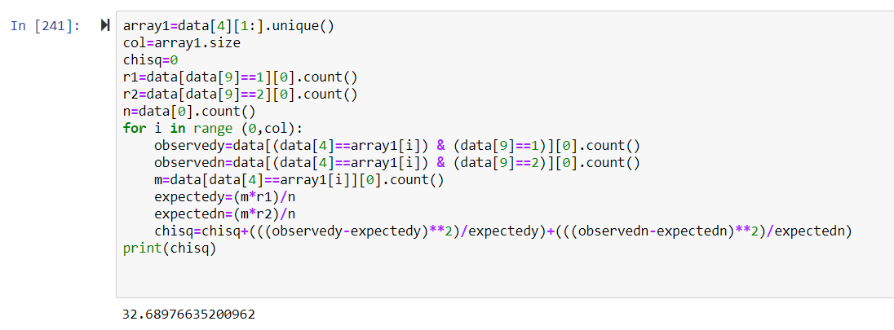

DOF=7

Chi square alpha=14.067

Chi square>Chi square alpha

So H0 is rejected

**No. of children a person has is associated with a person having a family history of Pcos**

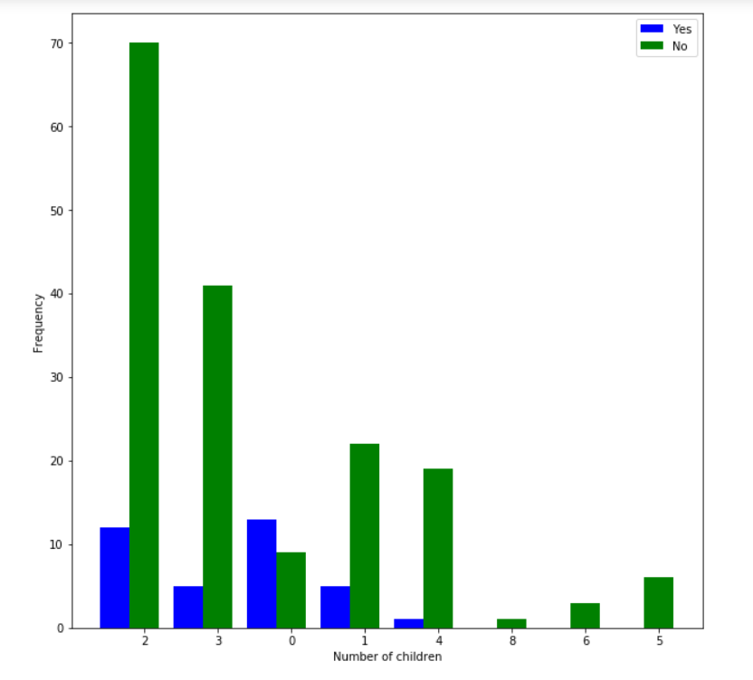

**Test 6**

**H0 : No. of children a person has is not associated with a person having a family history of Hypothyroid**

**Ha : No. of children a person has is associated with a person having a family history of Hypothyroid**

Chi square = 8.631127015242972

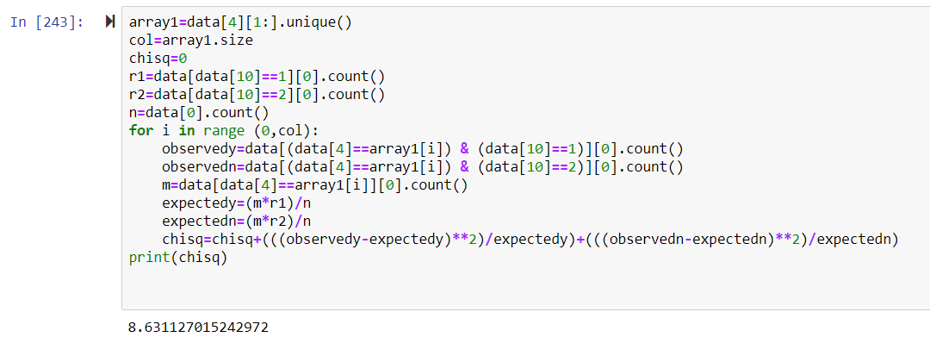

DOF=7

Chi square alpha=14.067

Chi square<Chi square alpha

So H0 is not rejected

**No. of children a person has is not associated with a person having a family history of Hypothyroid**

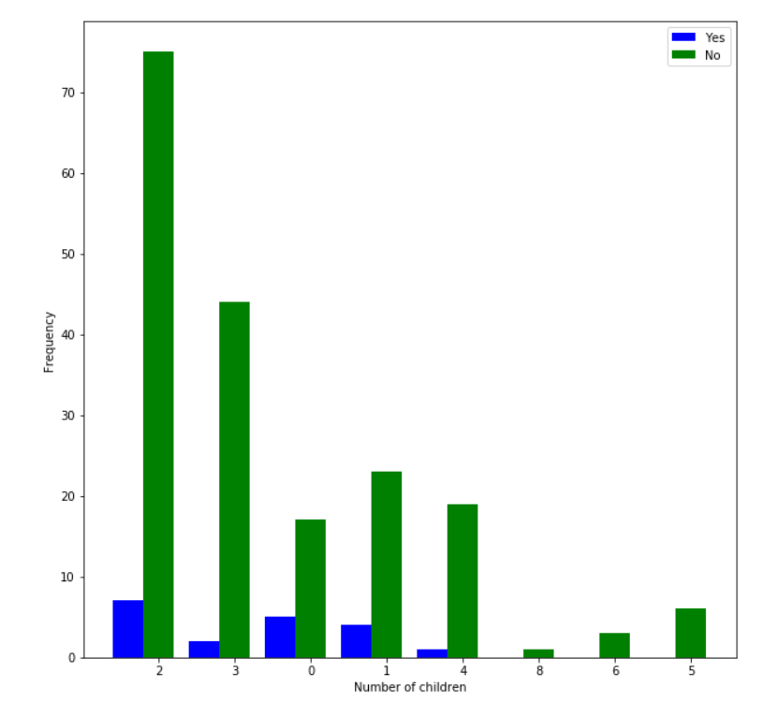

**Test 7**

**H0 : No. of children a person has is not associated with a person having a family history of Cancer**

**Ha : No. of children a person has is associated with a person having a family history of Cancer**

Chi square = 8.410667704059405

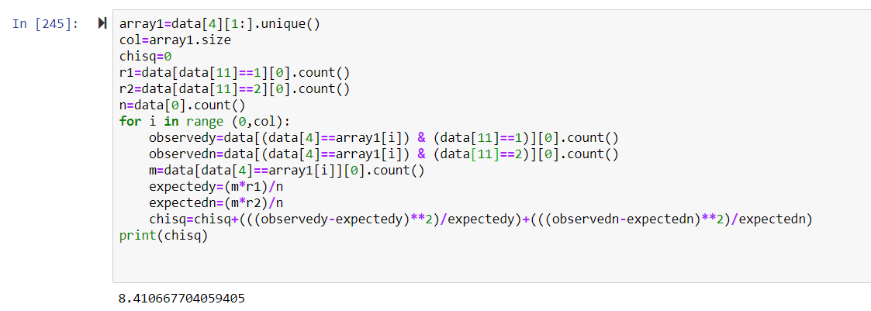

DOF=7

Chi square alpha=14.067

Chi square<Chi square alpha

So H0 is not rejected

**No. of children a person has is not associated with a person having a family history of Cancer**

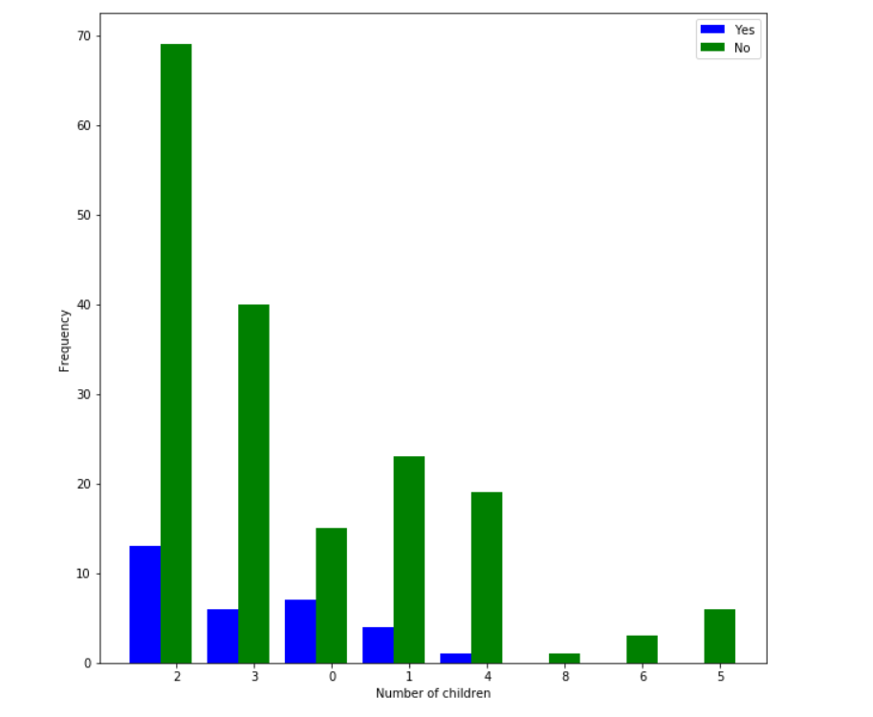

**Test 8**

**H0 : No. of children a person has is not associated with a person having a family history of any other disease**

**Ha : No. of children a person has is associated with a person having a family history of any other disease**

Chi square = 7.012875919911691

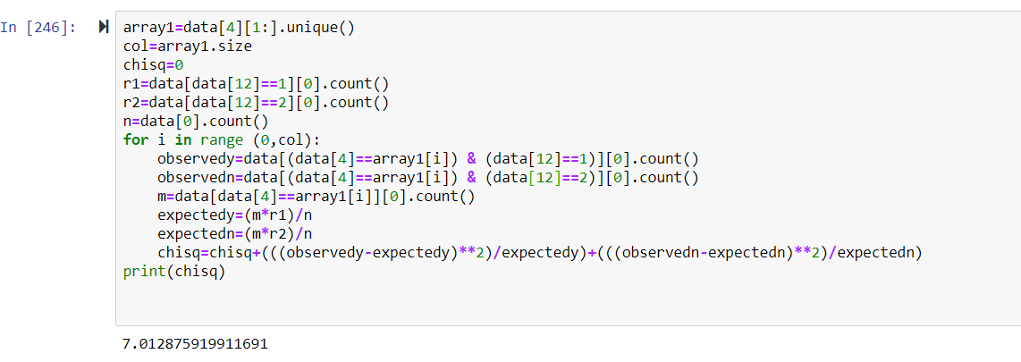

DOF=7

Chi square alpha=14.067

Chi square<Chi square alpha

So H0 is not rejected

**No. of children a person has is not associated with a person having a family history of any other disease**

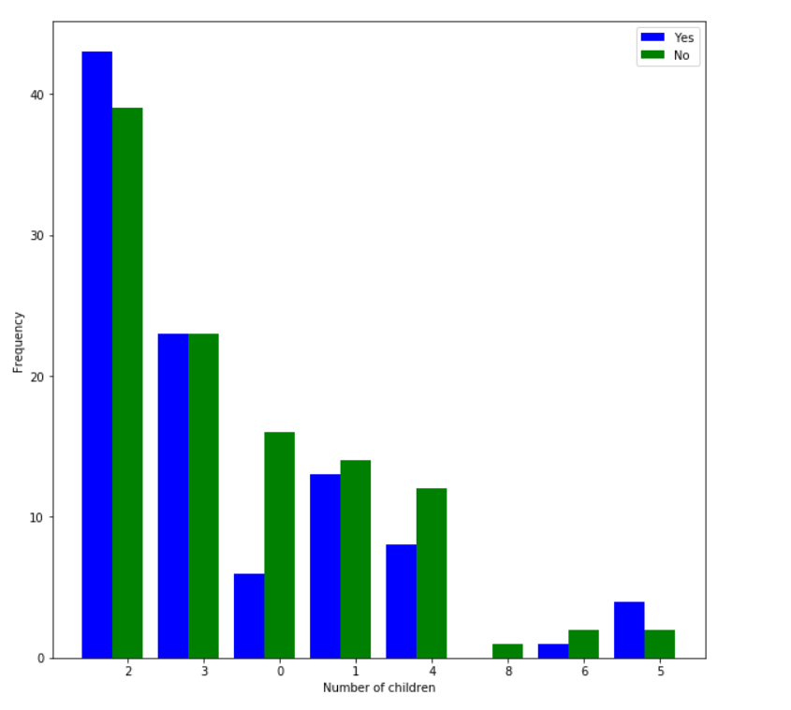

**Test 9**

**H0 : No. of children a person has is not associated with a person having Diabetes**

**Ha : No. of children a person has is associated with a person having Diabetes**

Chi square = 15.806137522392177

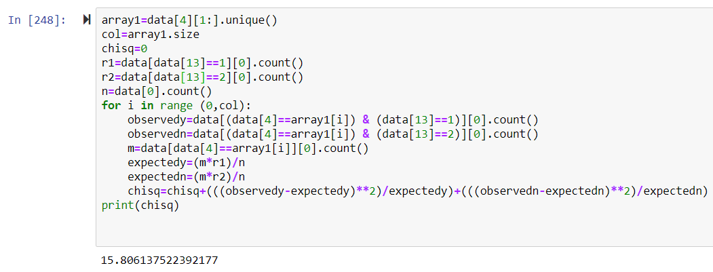

DOF=7

Chi square alpha=14.067

Chi square>Chi square alpha

So H0 is rejected

**No. of children a person has is associated with a person having Diabetes**

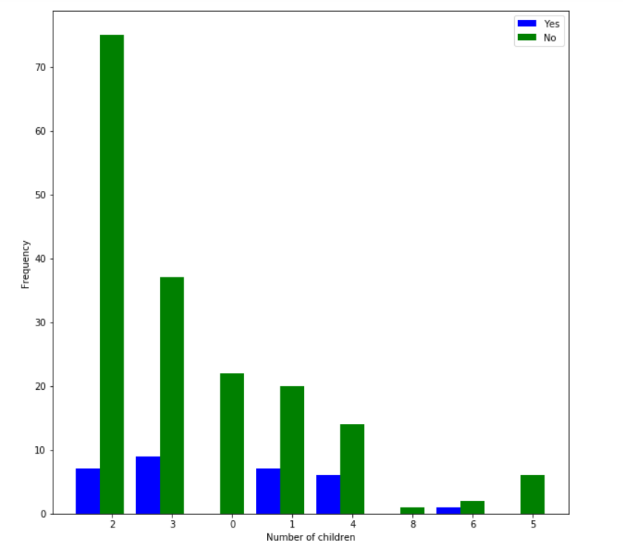

**Test 10**

**H0 : No. of children a person has is not associated with a person having HTN**

**Ha : No. of children a person has is associated with a person having HTN**

Chi square = 26.003004739600467

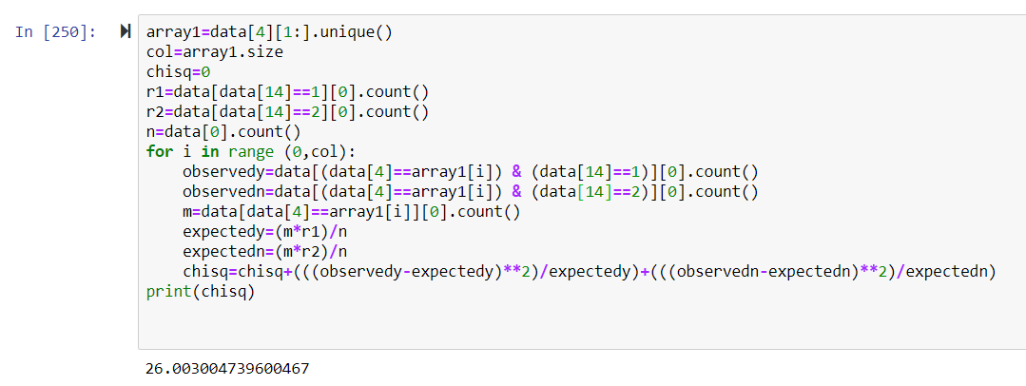

DOF=7

Chi square alpha=14.067

Chi square>Chi square alpha

So H0 is rejected

**No. of children a person has is associated with a person having HTN**

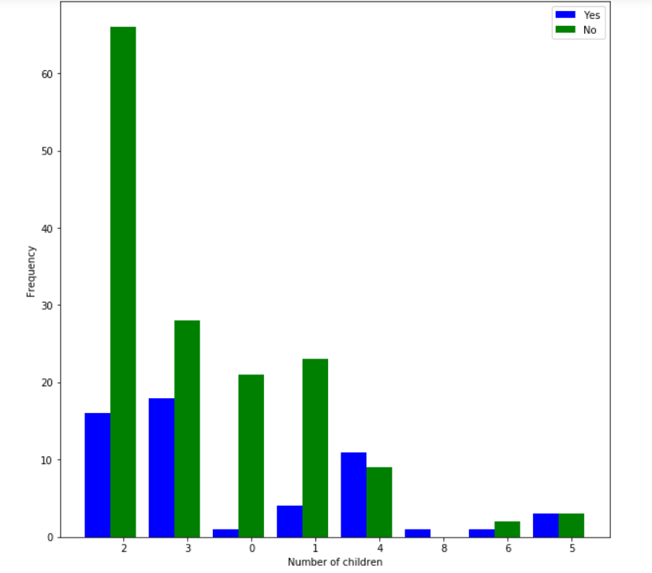

**Test 11**

**H0 : No. of children a person has is not associated with a person having Pcos**

**Ha : No. of children a person has is associated with a person having Pcos**

Chi square = 17.562239854586704

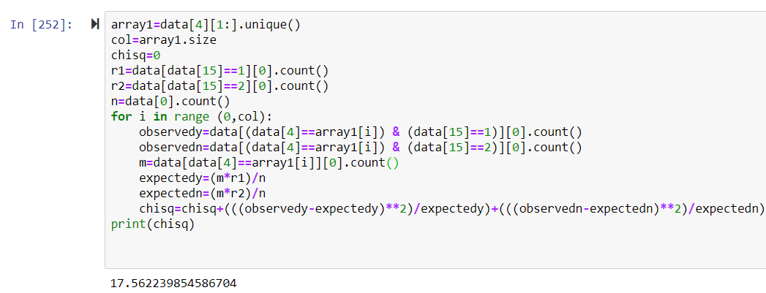

DOF=7

Chi square alpha=14.067

Chi square>Chi square alpha

So H0 is rejected

**No. of children a person has is associated with a person having Pcos**

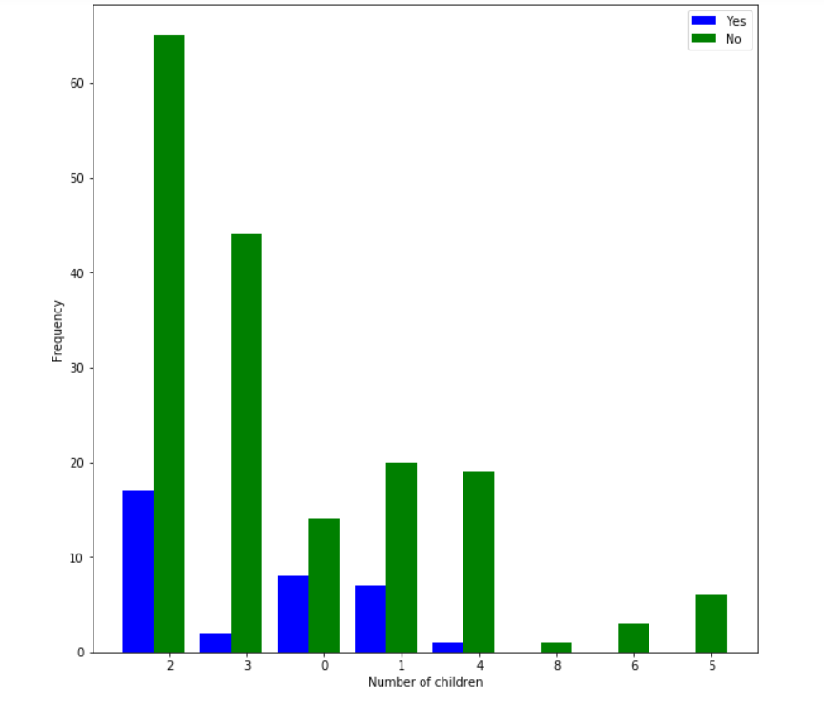

**Test 12**

**H0 : No. of children a person has is not associated with a person having CVD**

**Ha : No. of children a person has is associated with a person having CVD**

Chi square = 1.531790196542742

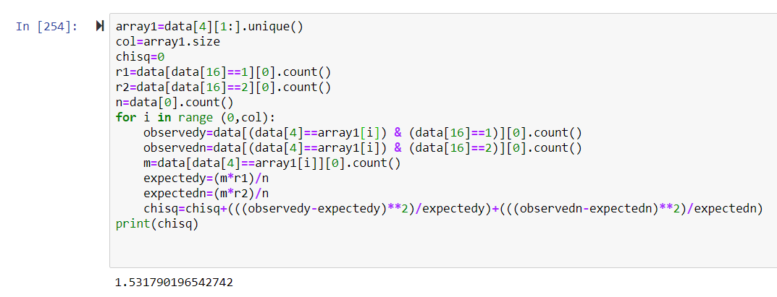

DOF=7

Chi square alpha=14.067

Chi square<Chi square alpha

So H0 is not rejected

**No. of children a person has is not associated with a person having CVD**

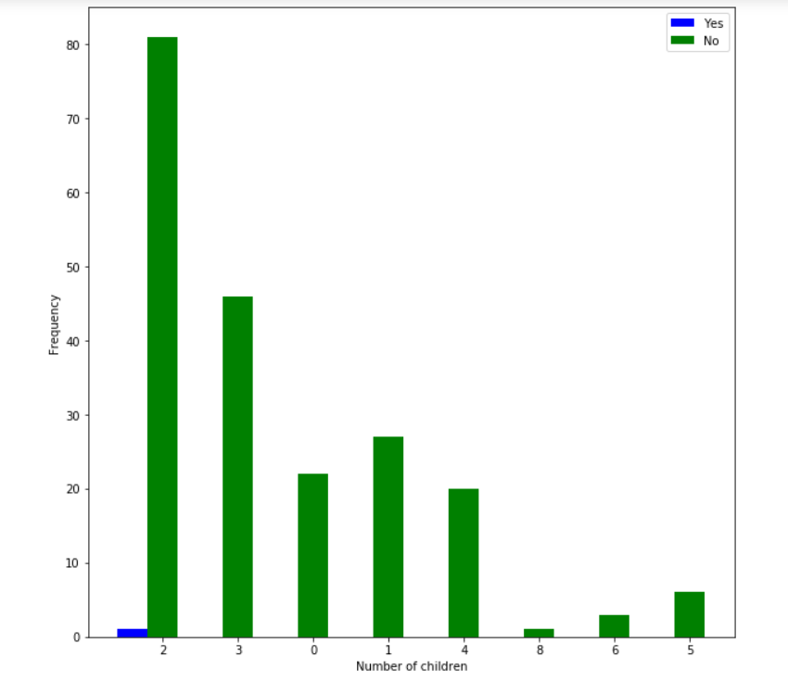

**Test 13**

**H0 : No. of children a person has is not associated with a person having Hypothyroid**

**Ha : No. of children a person has is associated with a person having Hypothyroid**

Chi square = 6.754857900121457

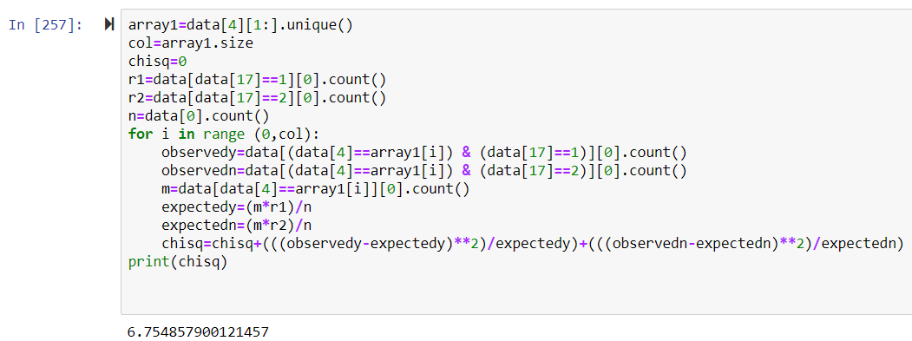

DOF=7

Chi square alpha=14.067

Chi square<Chi square alpha

So H0 is not rejected

**No. of children a person has is not associated with a person having Hypothyroid**

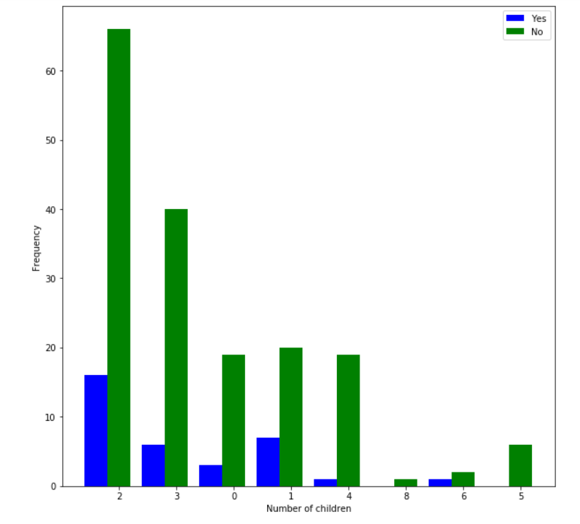

**Test 14**

**H0 : No. of children a person has is not associated with a person having s**

**Ha : No. of children a person has is associated with a person having s**

Chi square = 31.671978074947315

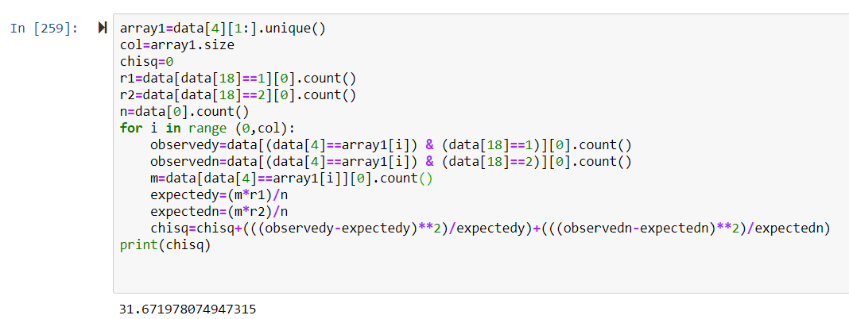

DOF=7

Chi square alpha=14.067

Chi square>Chi square alpha

So H0 is rejected

**No. of children a person has is associated with a person having s**

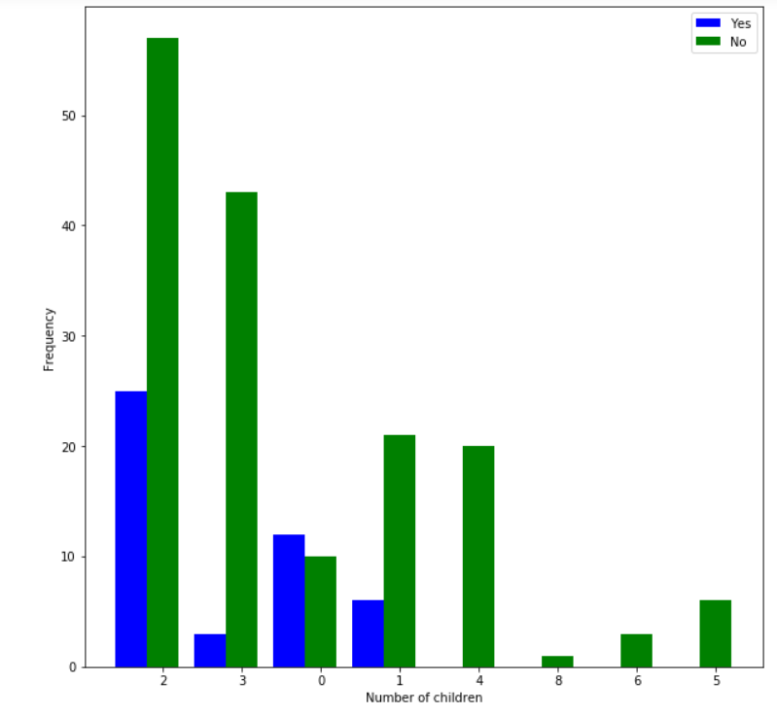

**Test 15**

**H0 : No. of children a person has is not associated with a person having Arthritis**

**Ha : No. of children a person has is associated with a person having Arthritis**

Chi square = 13.32063146450671

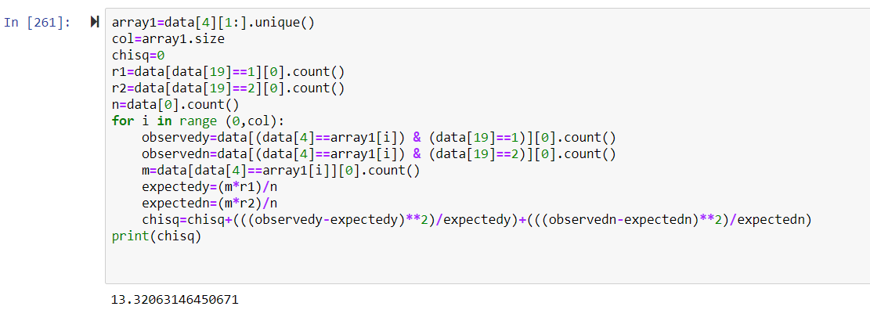

DOF=7

Chi square alpha=14.067

Chi square<Chi square alpha

So H0 is not rejected

**No. of children a person has is not associated with a person having Arthritis**

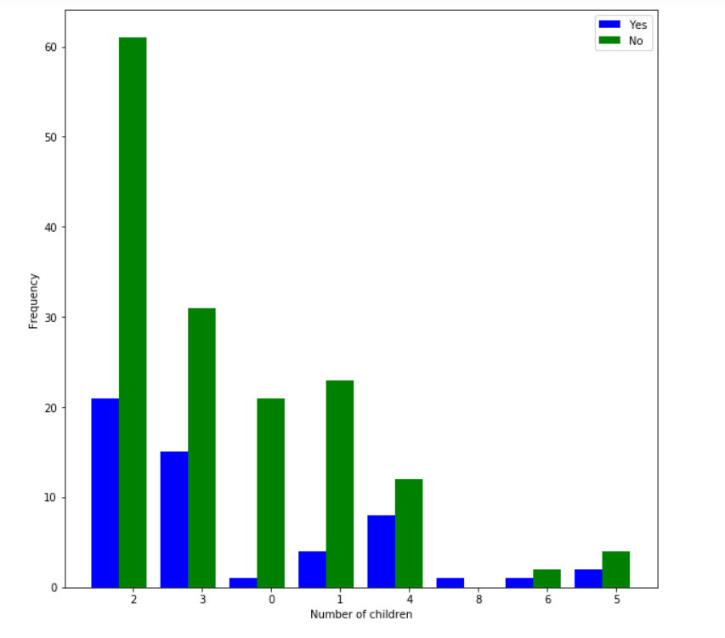

**Test 16**

**H0 : No. of children a person has is not associated with a person having Vertigo**

**Ha : No. of children a person has is associated with a person having any other medical problem**

Chi square = 12.133564761398334

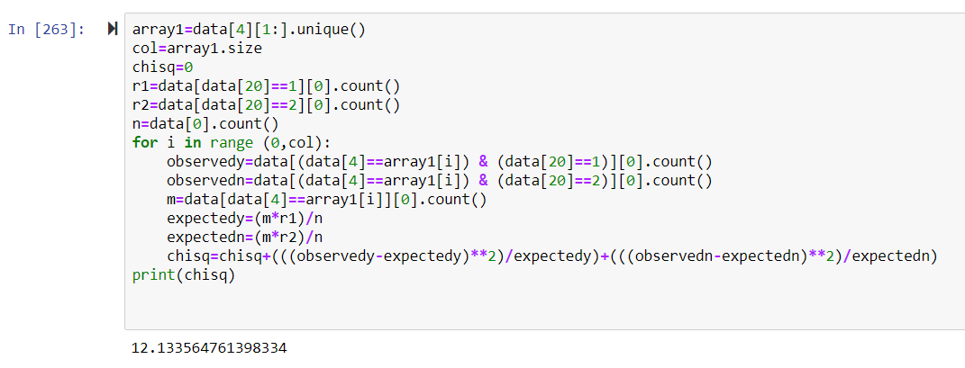

DOF=7

Chi square alpha=14.067

Chi square<Chi square alpha

So H0 is not rejected

**No. of children a person has is not associated with a person having Vertigo**

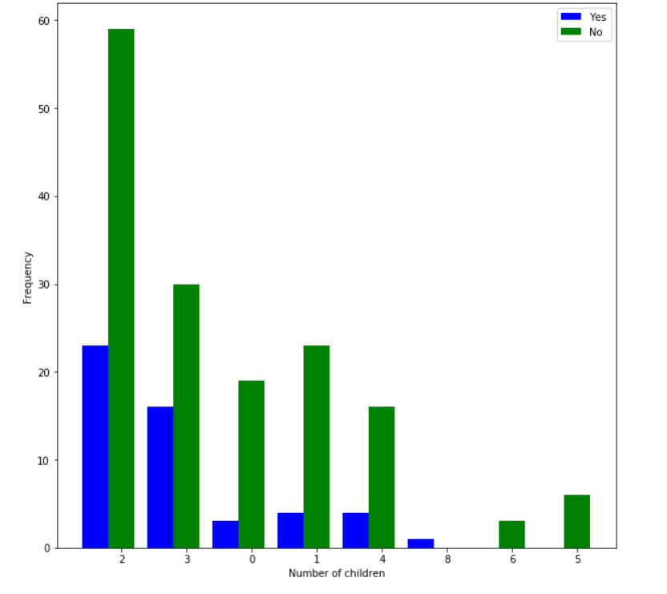

**Test 17**

**H0 : No. of children a person has is not associated with a person having any other medical problem**

**Ha : No. of children a person has is associated with a person having any other medical problem**

Chi square = 27.701626048848272

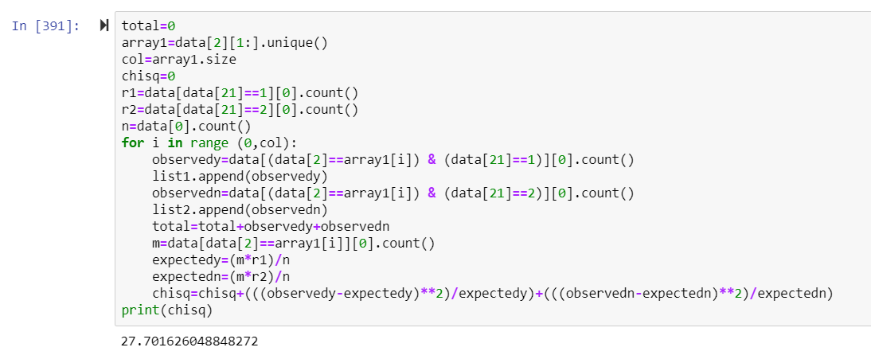

DOF=7

Chi square alpha=14.067

Chi square>Chi square alpha

So H0 is rejected

**No. of children a person has is associated with a person having any other medical problem**

**Test 18**

**H0 : No. of children a person has is not associated with medication/supplement**

**Ha : No. of children a person has is associated with medication/supplement**

Chi square = 28.641684270190368

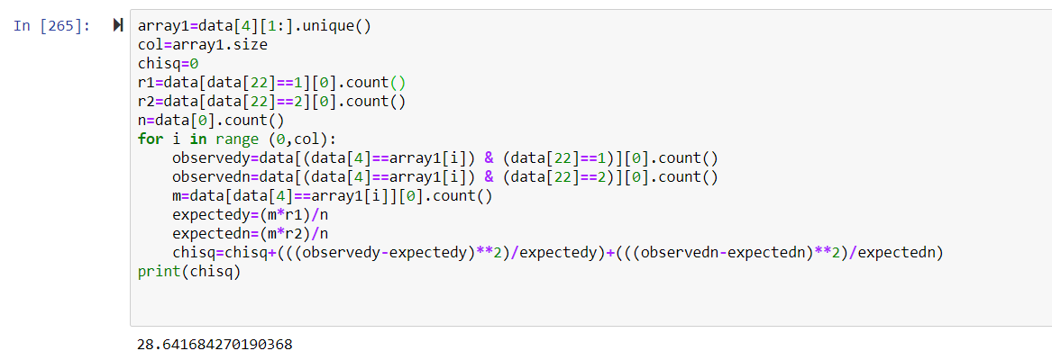

DOF=7

Chi square alpha=14.067

Chi square>Chi square alpha

So H0 is rejected

**No. of children a person has is associated with medication/supplement**

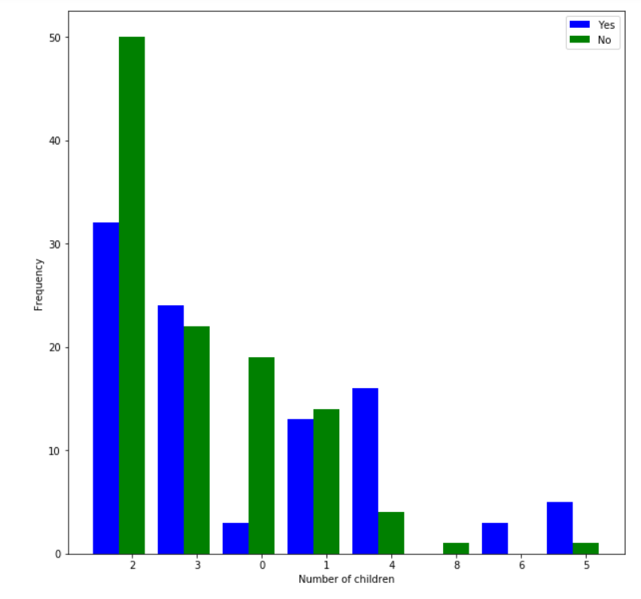

**Test 19**

**H0 : No. of children a person has is not associated with Weight Management**

**Ha : No. of children a person has is associated with Weight Management**

Chi square = NaN

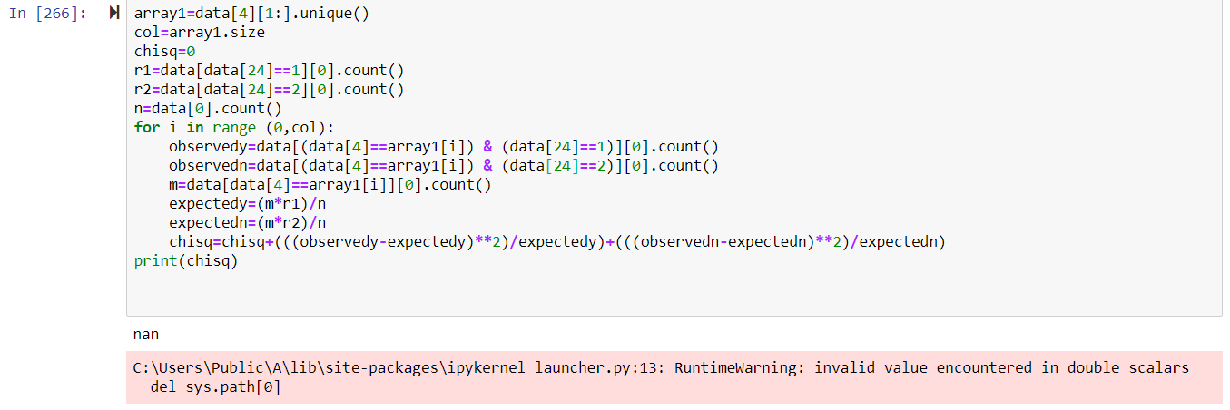

DOF=7

Chi square alpha=14.067

**Weight Management is always a yes and hence**

**No. of children a person has is not associated with Weight Management**

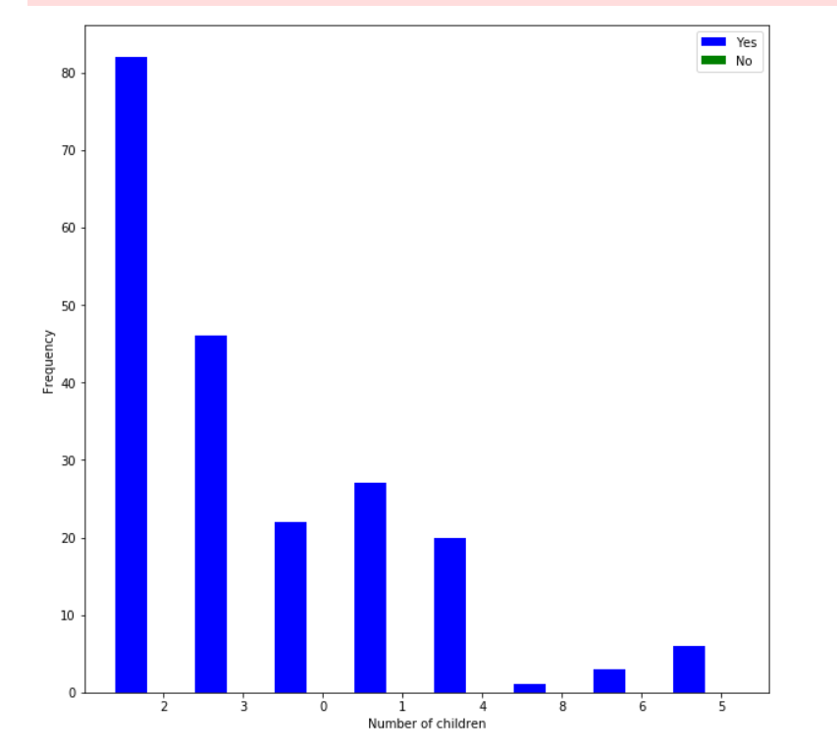

**Test 20**

**H0 : No. of children a person has is not associated with Improved Fitness**

**Ha : No. of children a person has is associated with Improved Fitness**

Chi square = 11.948210293160212

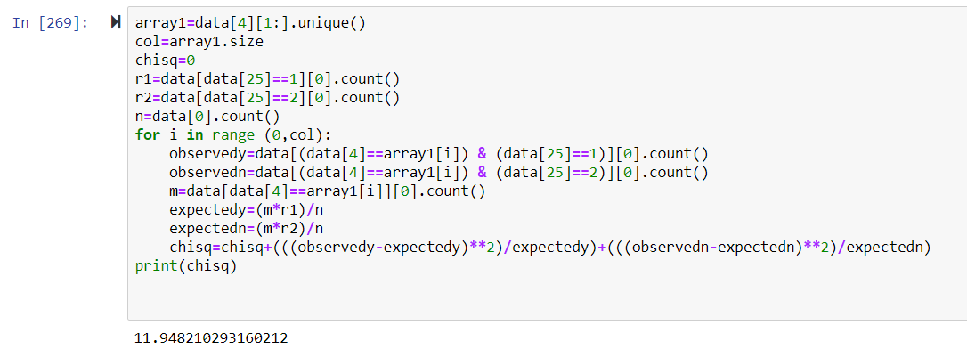

DOF=7

Chi square alpha=14.067

Chi square<Chi square alpha

So H0 is not rejected

**No. of children a person has is not associated with Improved Fitness**

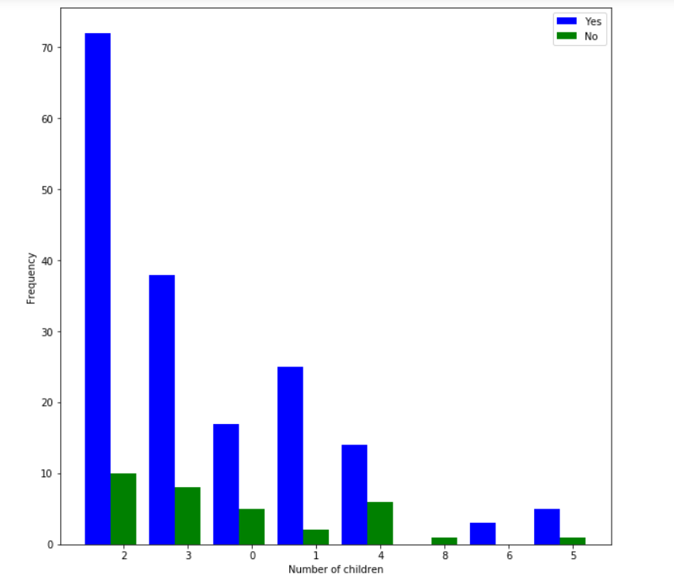

**Test 21**

**H0 : No. of children a person has is not associated with Back Strengthening**

**Ha : No. of children a person has is associated with Back Strengthening**

Chi square = 15.761360334748971

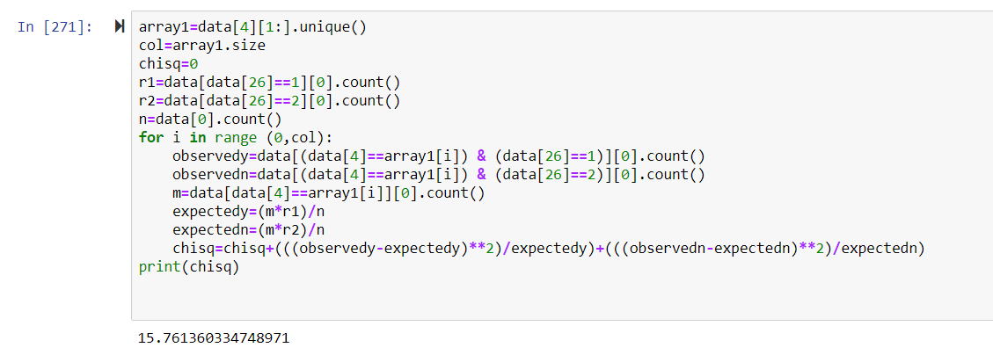DOF=7

Chi square alpha=14.067

Chi square>Chi square alpha

So H0 is rejected

**No. of children a person has is associated with Back Strengthening**

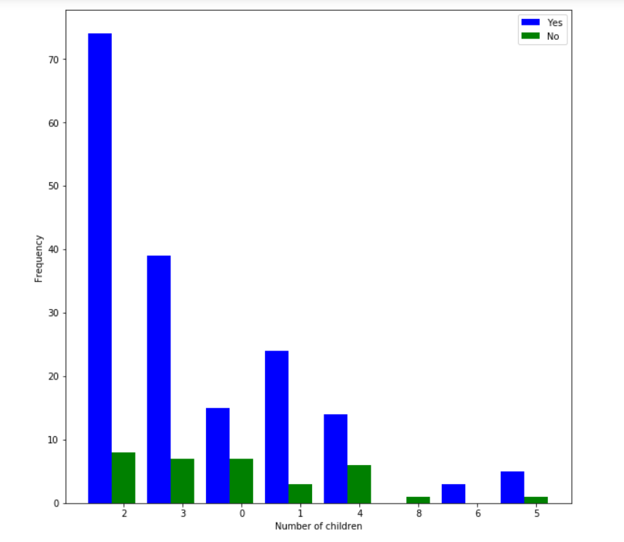

**Test 22**

**H0 : No. of children a person has is not associated with Nutrition and Diseases prevention**

**Ha : No. of children a person has is associated with Nutrition and Diseases prevention**

Chi square = 25.62600332594235

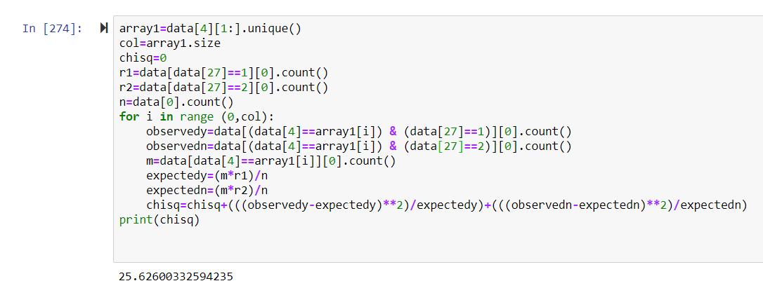DOF=7

Chi square alpha=14.067

Chi square>Chi square alpha

So H0 is rejected

**No. of children a person has is associated with Nutrition and Diseases prevention**

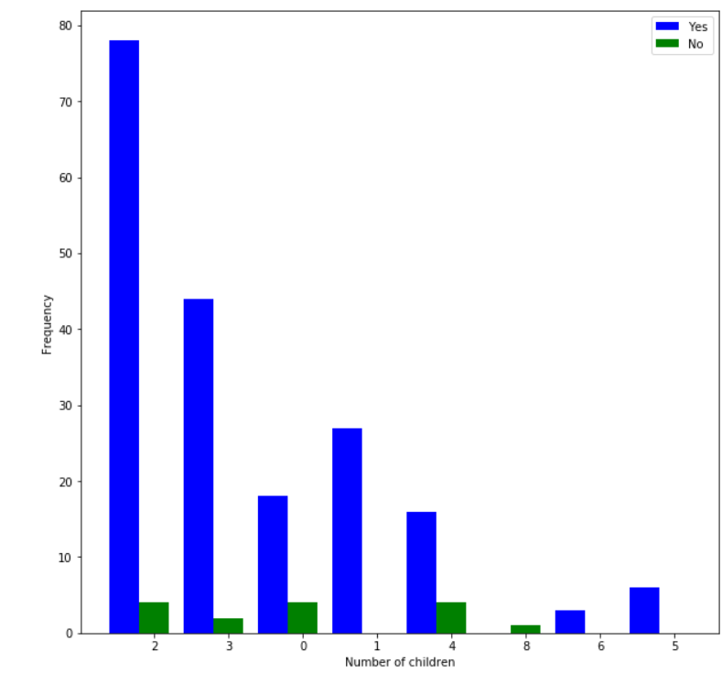

**Test 23**

**H0 : No. of children a person has is not associated with a person being Vegetarian**

**Ha : No. of children a person has is associated with a person being Vegetarian**

Chi square = 3.903592778574845

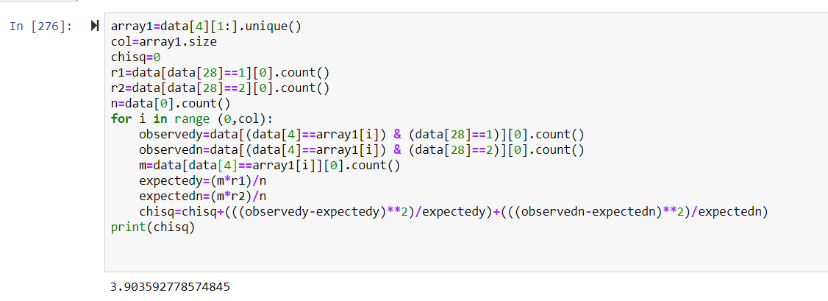

DOF=7

Chi square alpha=14.067

Chi square<Chi square alpha

So H0 is not rejected

**No. of children a person has is not associated with a person being Vegetarian**

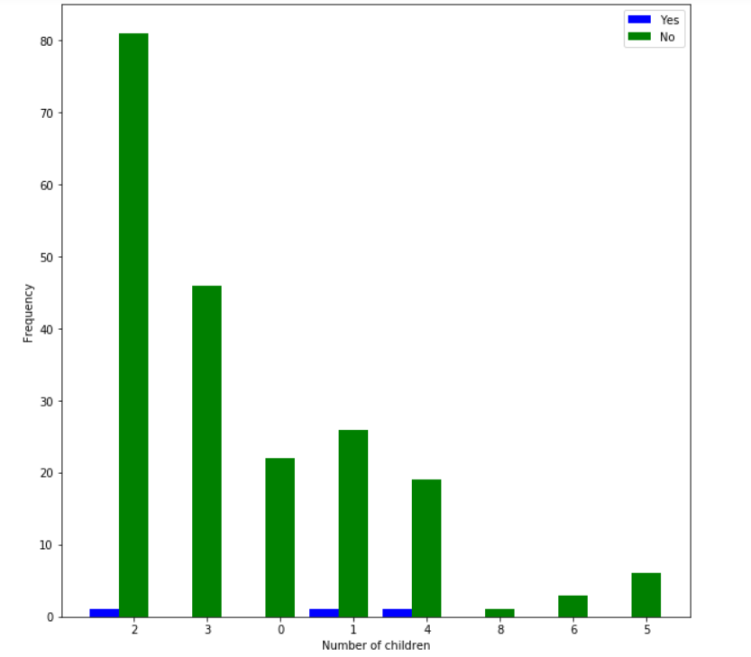

**Test 24**

**H0 : No. of children a person has is not associated with a person being Lacto Vegetarian**

**Ha : No. of children a person has is associated with a person being Lacto Vegetarian**

Chi square = 2.2556973019268076

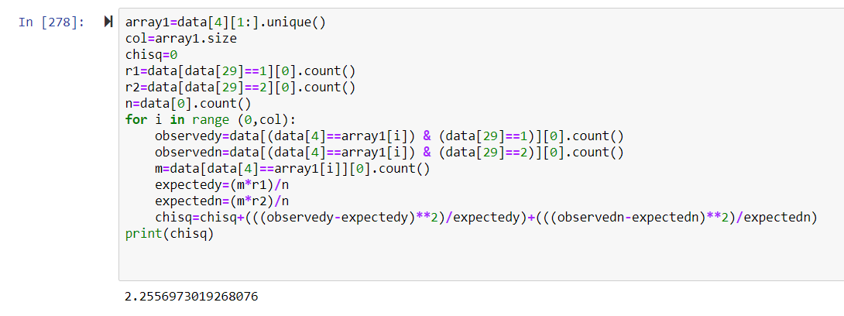

DOF=7

Chi square alpha=14.067

Chi square<Chi square alpha

So H0 is not rejected

**No. of children a person has is not associated with a person being Lacto Vegetarian**

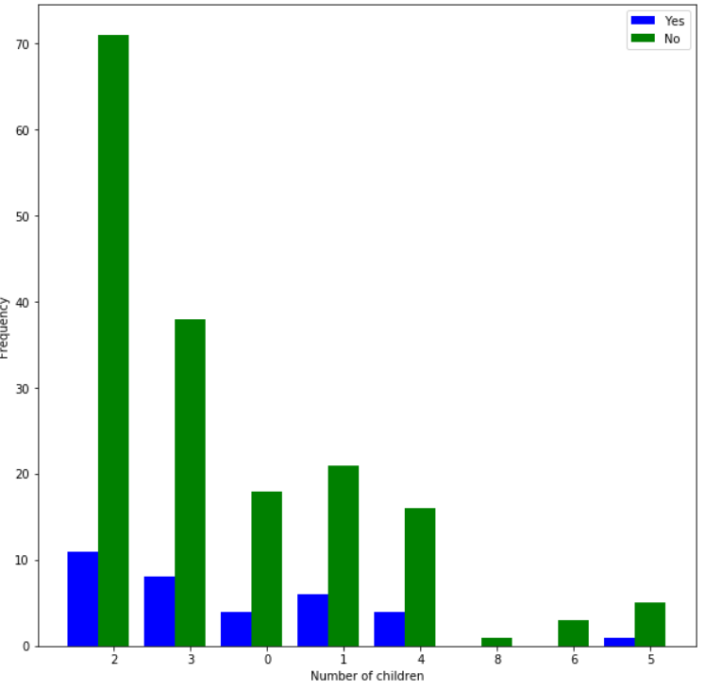

**Test 25**

**H0 : No. of children a person has is not associated with a person being Ovo Vegetarian**

**Ha : No. of children a person has is associated with a person being Ovo Vegetarian**

Chi square = 4.005440484560055

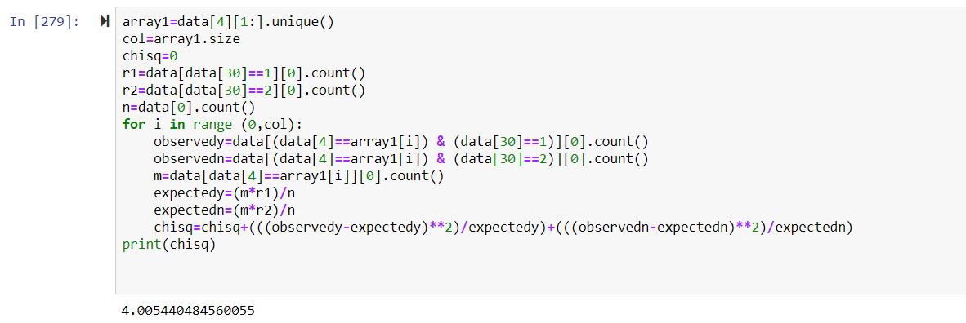

DOF=7

Chi square alpha=14.067

Chi square<Chi square alpha

So H0 is not rejected

**No. of children a person has is not associated with a person being Ovo Vegetarian**

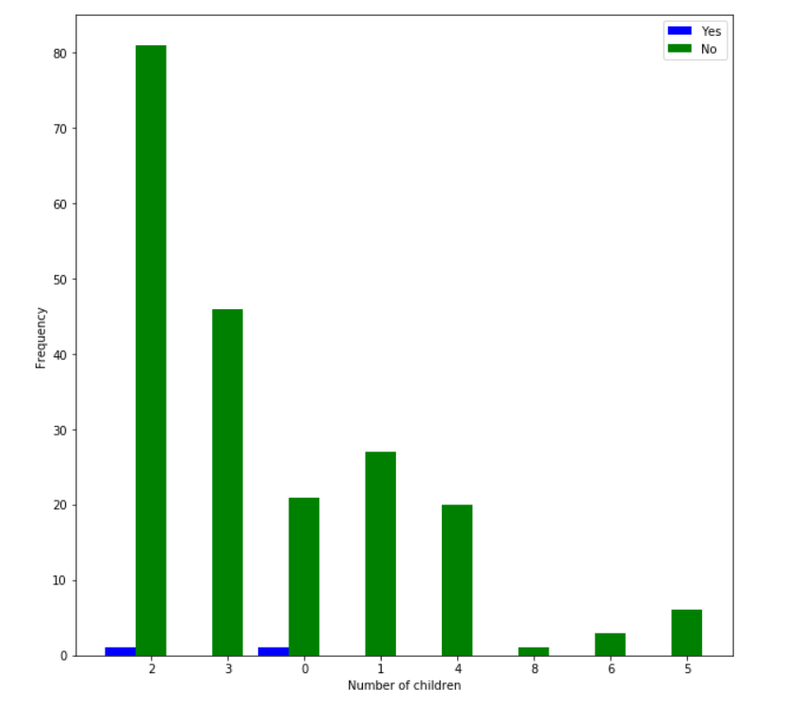

**Test 26**

**H0 : No. of children a person has is not associated with a person being Lacto Ovo Vegetarian**

**Ha : No. of children a person has is associated with a person being Lacto Ovo Vegetarian**

Chi square = 4.182333559597309

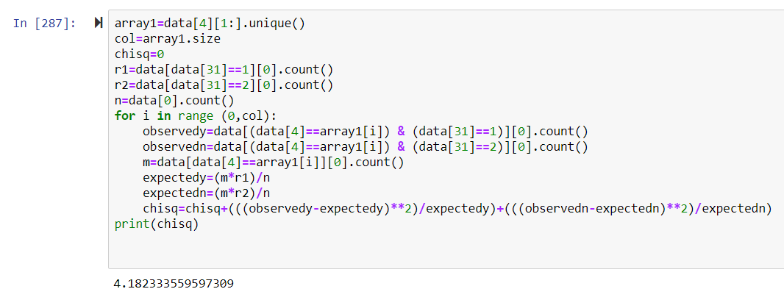

DOF=7

Chi square alpha=14.067

Chi square<Chi square alpha

So H0 is not rejected

**No. of children a person has is not associated with a person being Lacto Ovo Vegetarian**

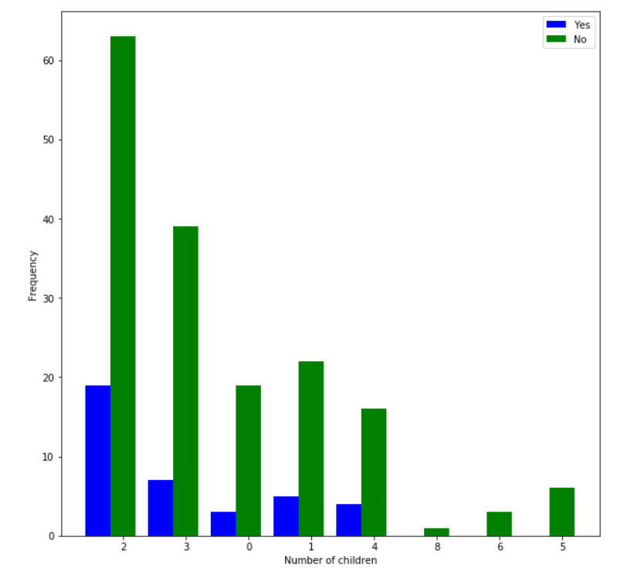

**Test 27**

**H0 : No. of children a person has is not associated with a person being Non Vegetarian**

**Ha : No. of children a person has is associated with a person being Non Vegetarian**

Chi square = 4.527253981052207

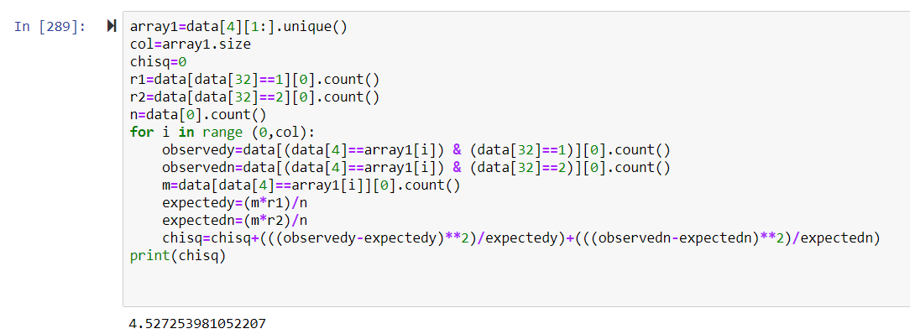

DOF=7

Chi square alpha=14.067

Chi square<Chi square alpha

So H0 is not rejected

**No. of children a person has is not associated with a person being Non Vegetarian**

