**DRISHTI**

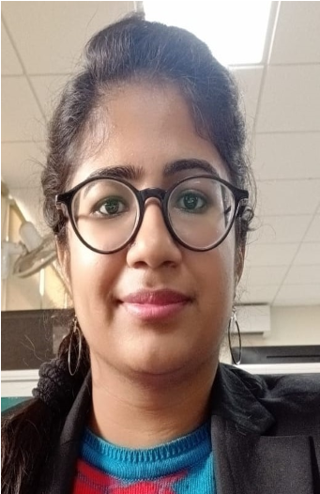

**Address :** 136/8/1 Gali No. 22, Sant Nagar, Burari , Delhi-110084

**Mobile No. :** 9354574304

**Email Id :** dchakarvarty70@gmail.com@gmail.com

# Career Objective

To secure a challenging career where I can effectively contribute my skill in technical industry, possessing component managerial and communication skill.

# Work Experience

**Fresher**

**Academic Qualifications**

**Degree**

**School/College**

**Board/University**

**Year of Passing**

**ADIT**

**NSTI-Noida**

**D.G.T**

**Pursuing**

**MA(English)**

**I.G.N.O.U**

**Ignou University**

**Pursuing**

**BA(Programme**

**)**

**D.U**

**Delhi University**

**2021**

**C.I.T.S**

**NSTI-Hyderabad**

**D.G.T**

**2020**

**I.T.I**

**I.T.I Dheerpur**

**D.G.T**

**2019**

**12**

**th**

**Patrachar Vidyalaya**

**C.B.S.E**

**2018**

**10**

**th**

**Dr. MKK School**

**C.B.S.E**

**2016**

**Computer Proficiency**

•

Basic Software knowledge.

* MS Office
* Typing Speed:-50-55wpm

# Personal Strengths

* Good Communication Skills.
* Capacity of Working for long hours to achieve the organisational goal.
* Self Motivated and dedicated person with a positive attitude.
* Believe in team works and always ready to help others in team.

# Hobbies

* Surfing Internet
* Typing
* Teaching

## Personal Details

**Father’s Name :** Shalinder

**Date of Birth :** 24/09/2000

**Languages Known :** English, Hindi, Punjabi

**Nationality :** Indian

**Gender :** Female

**Marital Status** : Unmarried

## Preferences

1. Punctual and reliable with the ability to work independently or as part of a team.
2. Excellent Communication Skills, both oral and written.
3. Time Management.

## Declaration

I hereby declare that all the information given above is true and correct to the best of my knowledge.

**Date:**

**Place**: **(Drishti)**