FINAL OUTPUT INTERFACE:

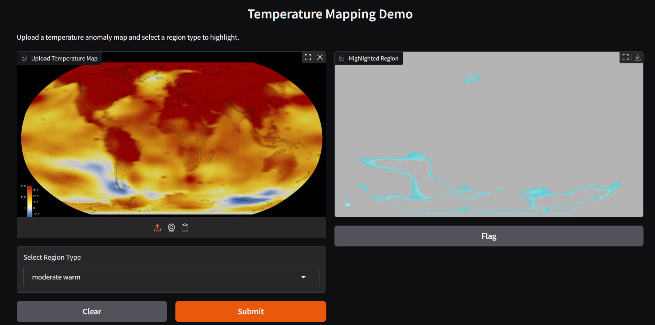

INTERFACE HOST ID:
https://ddb1ee46ae460b0f43.gradio.live

