SCHOOL OF COMPUTER SCIENCE AND ARTIFICIAL INTELLIGENCE |  |  |  |  | DEPARTMENT OF COMPUTER SCIENCE ENGINEERING
ProgramName:B. Tech |  |  |  | Assignment Type: Lab |  |  | AcademicYear:2025-2026
CourseCoordinatorName |  |  |  | Venkataramana Veeramsetty
Instructor(s)Name |  |  |  | 1. Dr. Mohammed Ali Shaik  2. Dr. T Sampath Kumar  3. Mr. S Naresh Kumar  4. Dr. V. Rajesh  5. Dr. Brij Kishore  6. Dr Pramoda Patro  7. Dr. Venkataramana  8. Dr. Ravi Chander  9. Dr. Jagjeeth Singh
CourseCode |  |  | 24CS002PC215 | CourseTitle |  | AI Assisted Coding
Year/Sem |  |  | II/I | Regulation |  | R24
Date and Day  of Assignment |  |  |  | Time(s)
Duration |  |  | 2 Hours | Applicableto  Batches
AssignmentNumber:3.3(Present assignment number)/24(Total number of assignments)
 | Q.No. | Question |  |  |  |  |  | ExpectedTime  to complete
 | 1 | Lab 3: Prompt Engineering – Improving Prompts and Context Management  Lab Objectives:  - To understand how prompt structure and wording influence AI-generated code.  - To explore how context (like comments and function names) helps AI generate relevant output.  - To evaluate the quality and accuracy of code based on prompt clarity.  - To develop effective prompting strategies for AI-assisted programming.  Lab Outcomes (LOs):  After completing this lab, students will be able to:  - Generate Python code using Google Gemini in Google Colab.  - Analyze the effectiveness of code explanations and suggestions by Gemini.  - Set up and use Cursor AI for AI-powered coding assistance.  - Evaluate and refactor code using Cursor AI features.  - Compare AI tool behavior and code quality across different platforms.  Task Description#1  - Try 3 different prompts to generate a factorial function.  - Prompt 1: write a python code to generate a factorial function .  - 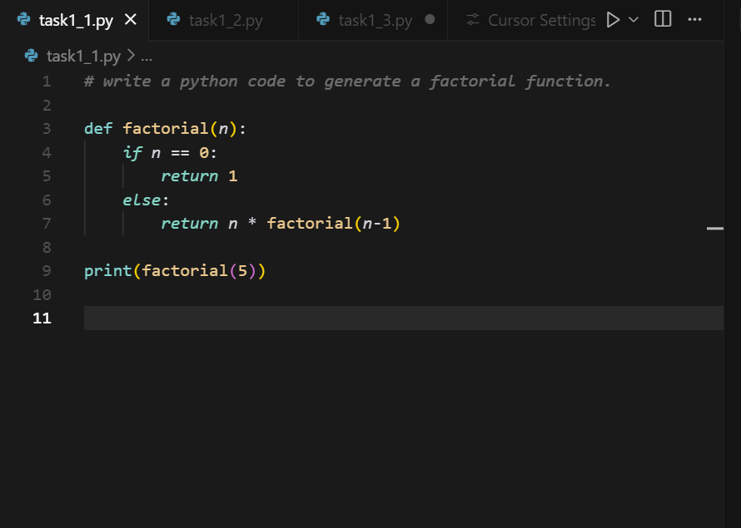  - Prompt 2: write a python code to generate a factorial function for a number given by user  - 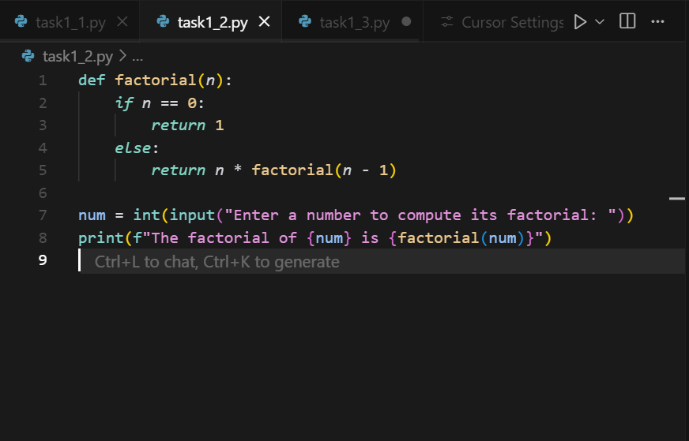  - Prompt 3:Create a Python program to compute the factorial of a number using recursion with proper function docstring.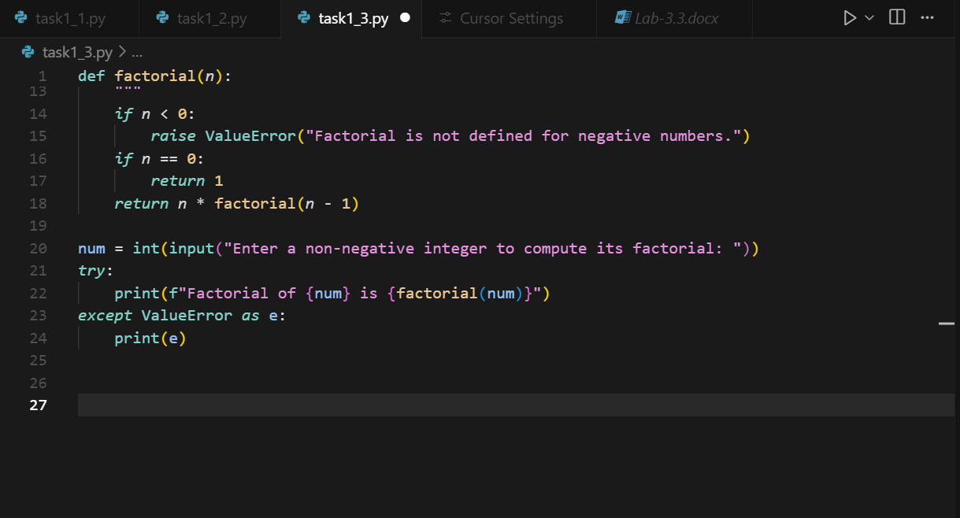  Expected Output#1  - Comparison of AI-generated code styles  - Output1:  - 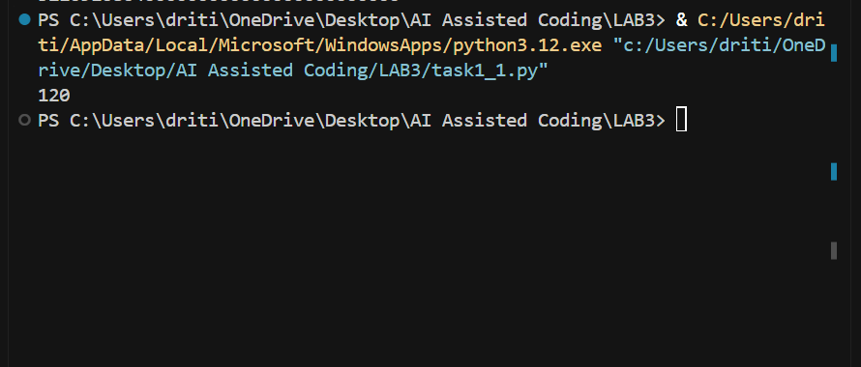  - Output2:  - 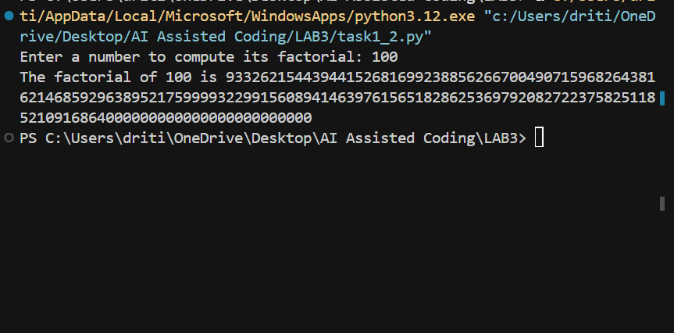  - Output3: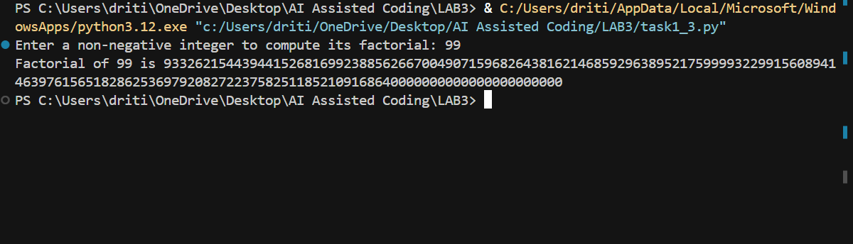  Report  Task Description#2  - Provide a clear example input-output prompt to generate a sorting function.  - Prompt : write a python code to generate a sorting function.  - 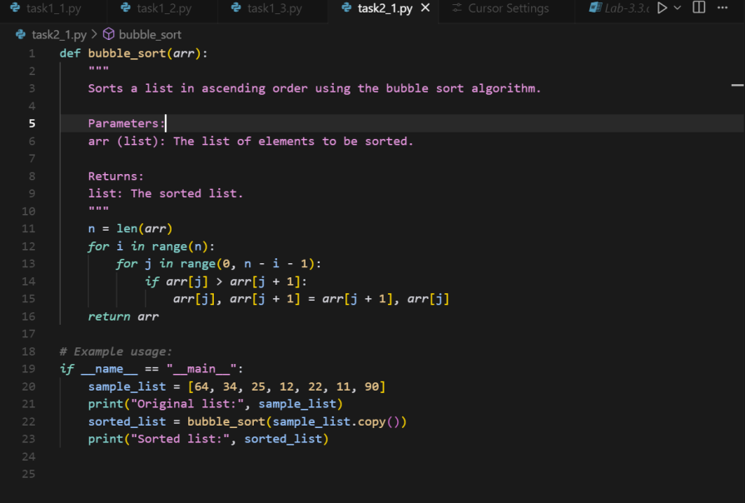  Expected Output#2  - Functional sorting code from AI  - 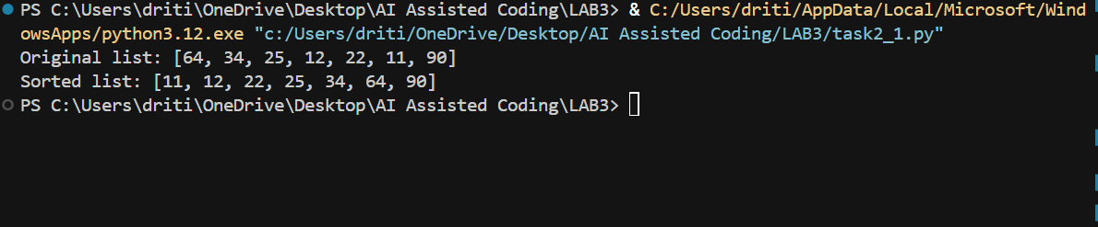  Task Description#3  - Start with the vague prompt “Generate python code to calculate power bill” and improve it step-by-step  - Prompt 1: develop a python code to calculate power bill  - 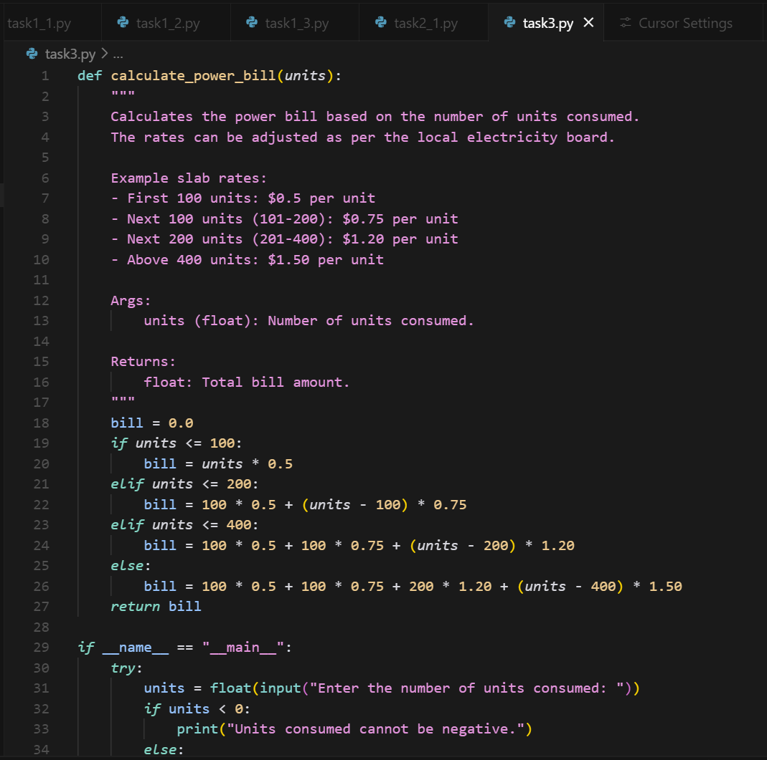  - 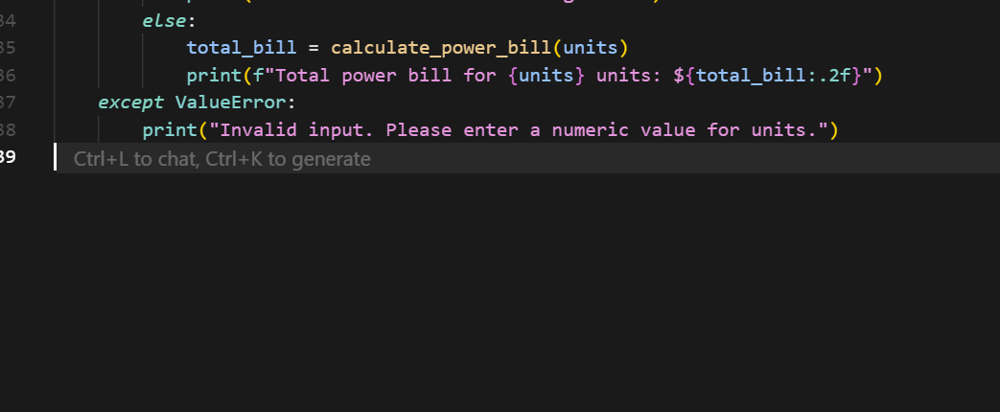  - Prompt 2:create a Python function to calculate an electricity bill with tiered rates and tax, and include input validation for usage values  - 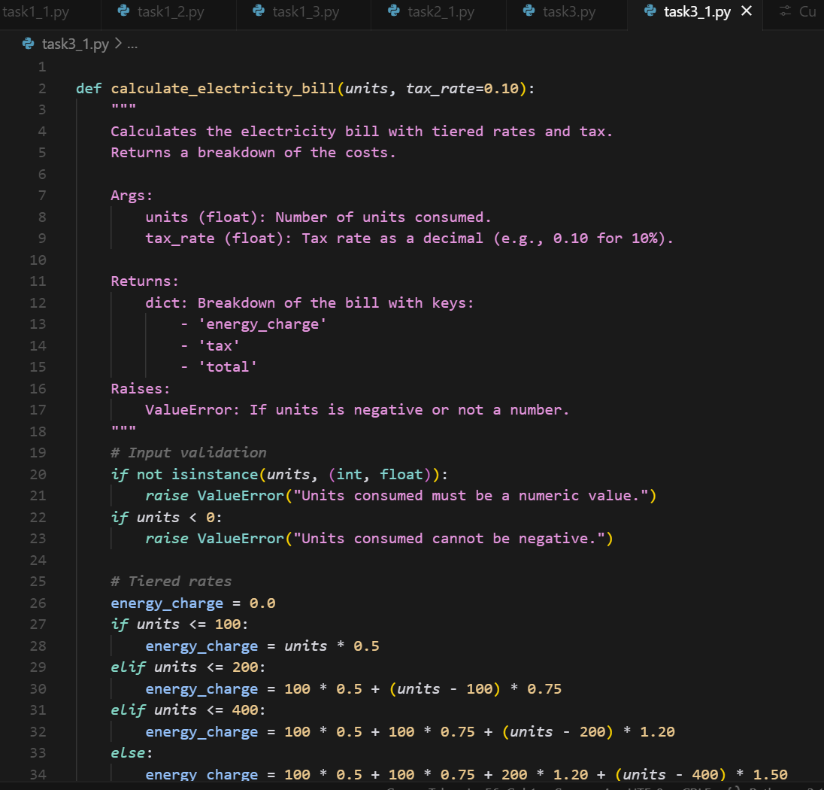  - 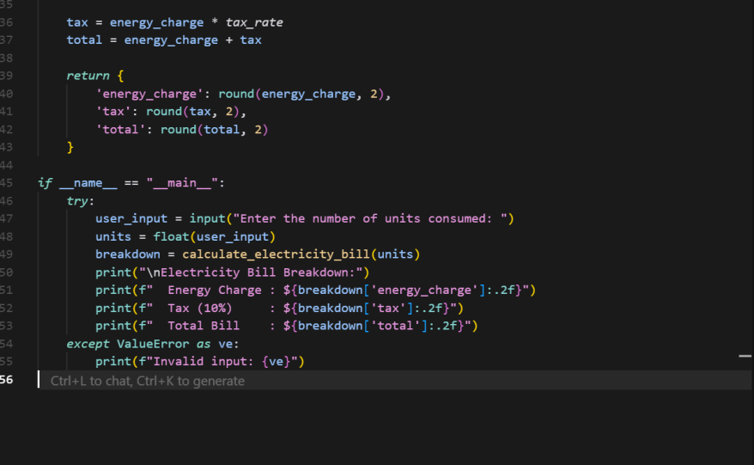  Expected Output#3  - Enhanced AI output with clearer prompts  - Output 1:  - 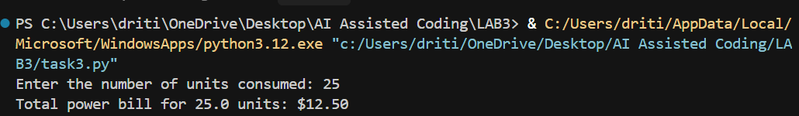  - Output 2:  - 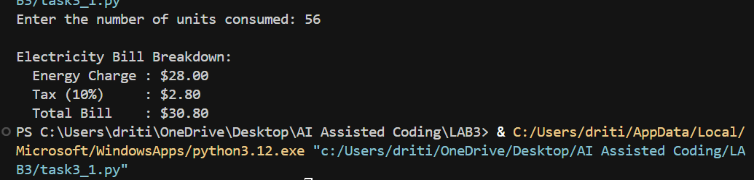  - Report on the difference between the codes:  Code in task1_1.py only defines a factorial function and calls it with the fixed number 5  Code in task1_2.py takes user input instead of using a fixed number and then calls the factorial function with that input  Code in task1_3.py improves task1_2 by adding input validation for negative numbers and handles errors using try and except  Main differences are task1_1 is hardcoded, task1_2 adds user input, and task1_3 adds error handling and input validation  This shows progressive improvement from basic function to a more user-friendly and safe version  Task Description#4  - Write structured comments to help AI generate two linked functions (e.g., login_user() and register_user()).  - Prompt: generate a two linked functions in python (Celsius,fahrenheit)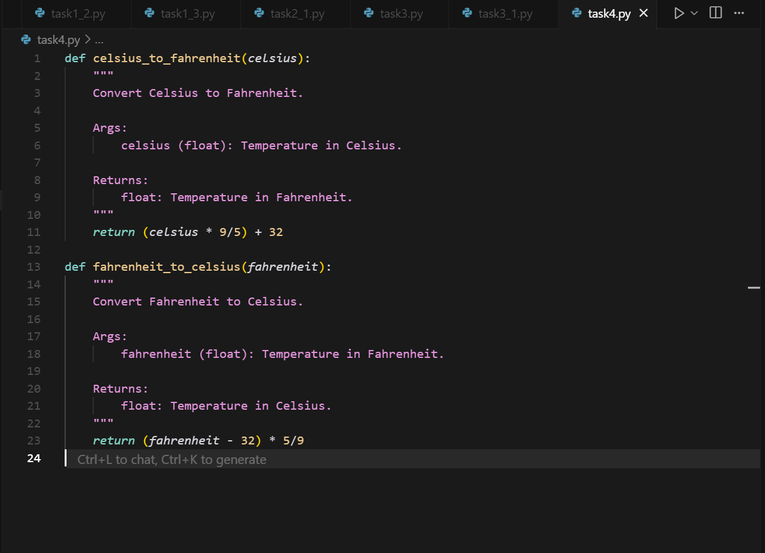  Expected Output#4  - Consistent functions with shared logic  Task Description#5  - Analyzing Prompt Specificity: Improving Temperature Conversion Function with Clear Instructions  - Prompt 1: Write a Python function to convert Celsius to Fahrenheit and Kelvin.  - 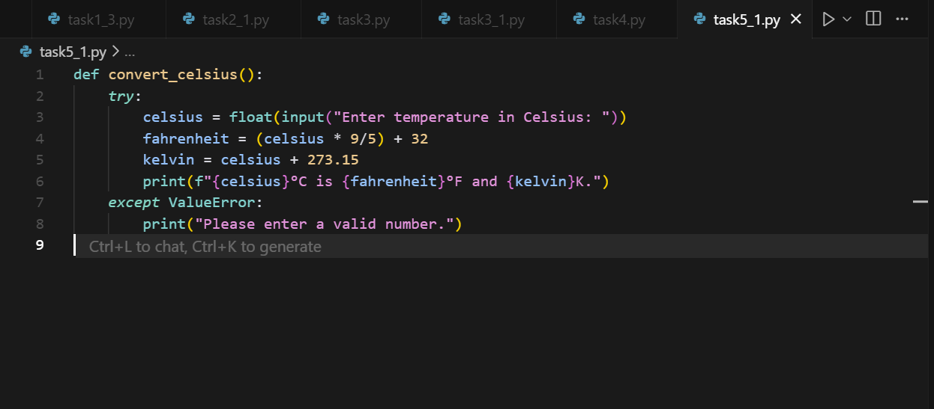  - Prompt 2:  - 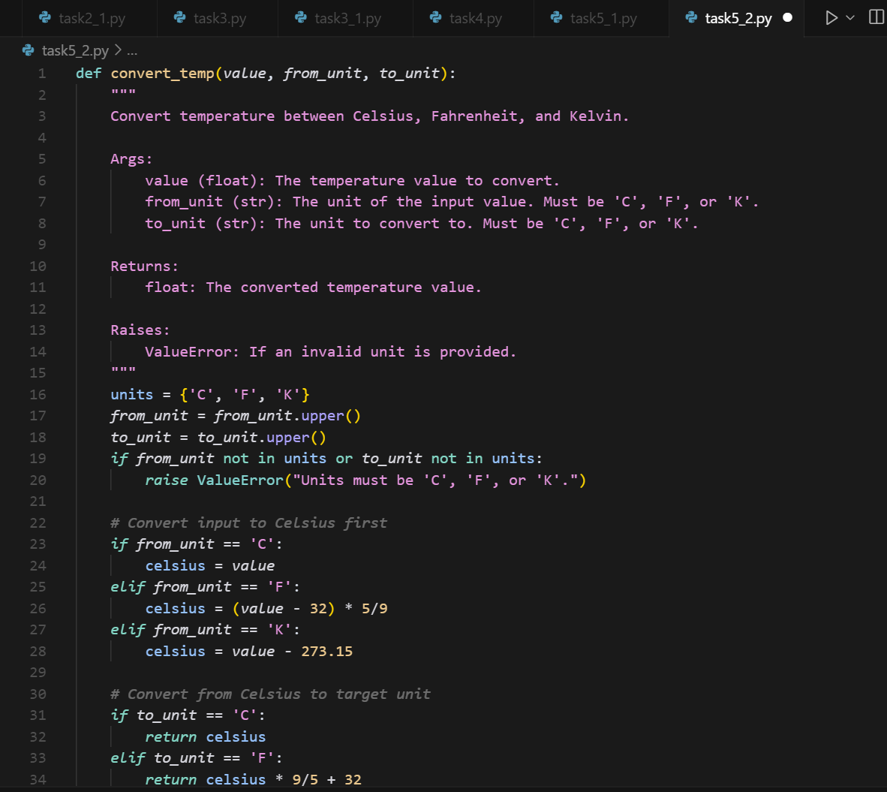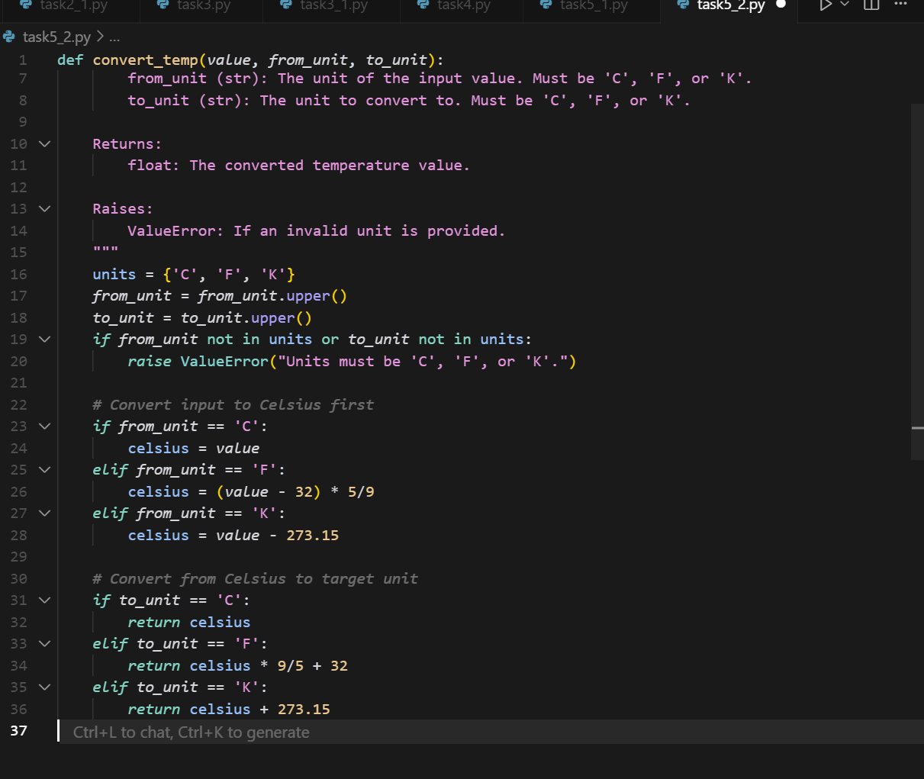  Expected Output#5  - Code quality difference analysis for various prompts  - Output 1:  - 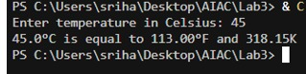  - Output 2:  - 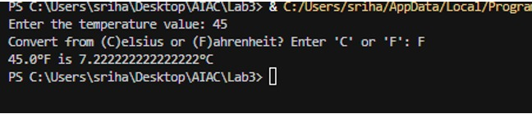  Report: for your temperature conversion prompts:  1.The first prompt requires a Python function to convert Celsius into Fahrenheit and Kelvin.  2.The second prompt extends functionality by allowing user choice between Celsius and Fahrenheit.  3.These tasks enhance knowledge of formulas, functions, and user interaction in Python.  4.Such conversions show practical applications of coding in science and daily life.  Note: Report should be submitted a word document for all tasks in a single document with prompts, comments & code explanation, and output and if required, screenshots  Evaluation Criteria:  Criteria Max Marks  Factorial Function (Task#1) 0.5  Sorting Function (Task#2) 0.5  Vogue Vs. Specific Prompting (Task #3) 0.5  Linked Functions (Task #4) 0.5  Temperature Conversion Function (Task #5) 0.5  Total 2.5 Marks |  |  |  |  |  | 03.08.2025 EOD

