

**编译原理实验报告**

学生姓名 ：林天岳

学 号 ：2017217893

班 级 ：计算机科学与技术2017-5

完成日期 ：2019 年 10 月 22 日

**实验1：词法分析设计**

1.数据结构及算法描述

1. String alphabet = "ABCDEFGHIGKLMNOPQRSTUVWXYZabcdefghijklmnopqrstuvwxyz";//字母
2. String number = "0123456789";//数字
3. String keyword[] = {"auto","break","case","char","const ","continue","default","do ",
4. "double ","else ","enum ","extern","float","for","goto","if","int",
5. "long","register","return","short","signed","sizeof","static","struct","switch",
6. "typedef","unsigned","union","void","volatile","while"};//关键字
7. String operator[] ={"<<=",">>=","&&","||","<=","|=","*=","^=","==","++","--","/=","-=","+=","%=","!=",">=","[","]","!","%","(",")","*","+",",","-","/",";","<","=",">"};//运算符
8. String arithmeticOperator[] = {"++","--","+","-","*","/","%"};//算术运算符
9. String relationalOperator[] = {"<=","<",">=",">","==","!="};//关系运算符
10. String logicalOperator[] = {"&&","||","!"};//逻辑运算符
11. String delimiter[] = {";",",","(",")","[","]"};//分界符
12. String assignmentOperator[] ={"=","+=","-=","*=","/=","%=","<<=",">>=","%=","^=","|="};//赋值运算符
14. Map<String,String> opS;//<单个运算符,种类名>
15. Map<String,String[]> KindtoArrary;//<种类名,对应的运算符数组>
17. List<Result> result = **new** ArrayList<>();//结果 保存后显示为表格
18. GUI包含一个Solution
19. 分析时 在textArea中输入需要的分析的代码
20. 或者直接打开文件读取到textArea
22. 分析 则使用Solution.Solve 返回分析结果
23. 显示在界面上
24. Solution 包含一个 Analyzer分析器
25. 调用Solve方法  传入String数组 返回分析结果
26. **for**(String line:传入的String数组){
27. result.addAll(Analyzer.LineAnalyse(line));Analyzer.LineAnalyse(line)
28. }
29. **return** result
30. LineAnalyse方法
31. **if**(当前分析的是 null,//,\n,或者Length == 0){
32. 则直接结束
33. }
34. **else** {
35. **if**(字母表含有当前头部的string){
36. **while**(是字母或者是数字){
37. 继续取出之后的部分
38. }
39. 得到了一个String
40. **if**(单词是关键字){
41. 标记为 关键字
42. }
43. **else**{
44. 标记为 标识符
45. }
46. }
47. **else** **if**(数字表含有当前头部的的string){
48. **while**(是数字或者小数点){
49. 继续取出之后的部分
50. }
51. **if**(数字之后直接追加字母){
52. 标记错误
53. brerak
54. }
55. 标记为 常数//常数的标记使用一个静态方法调用方法返回当前的数目+1 ERROR使用同样的方法编号
56. }
57. **else**{
58. **if**(匹配到了符号){//运算符经过按照长度排序 确保长度较长的先匹配到 比如 ++ 会优先于+匹配
59. 标记 运算符
60. }
61. **else**{
62. 标记 错误
63. }
64. }
65. 递归处理之后的String
66. resturn  result.addAll(递归的结果);
67. }

2.算法流程图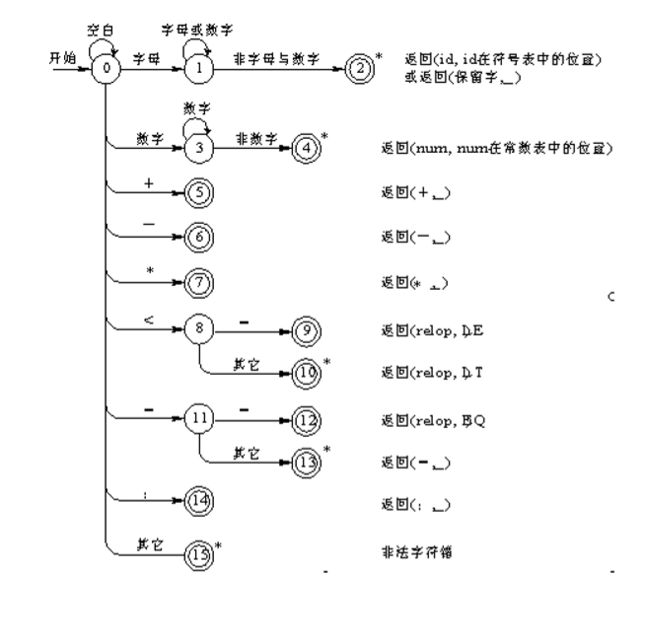 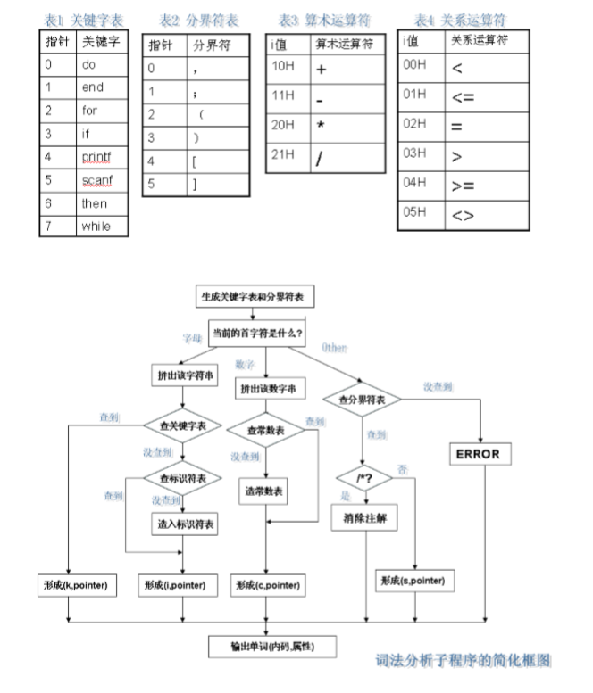

3.源码及测试结果

Main.java：

1. package 实验一___词法分析设计;

4. **public** **class** Main{
5. **public** **static** **void** main(String[] args) {
6. Windows windows = **new** Windows();
7. }
8. }

Solution.java

1. package 实验一___词法分析设计;
3. import java.util.*;
5. **class** Solution{
6. Analyzer ana = **new** Analyzer();
7. **public** List<Result> Solve(String[] lines) {
8. List<Result> res = **new** ArrayList<>();
9. **if**(lines==null|| lines.length==0)
10. **return** res;
11. List<String> text = **new** ArrayList<>();
12. **for**(String line:lines){
13. line = line.replaceAll("\t"," ");
14. **if**(line.length()>0)
15. text.add(line);
16. }
17. **int** l = 1;
18. **for**(String str:text){
19. **if**(str.length()>2 && str.substring(0,2).equals("//"))
20. **continue**;
21. ana.result.clear();
22. res.addAll(ana.LineAnalyse(str+"\n",l,1));
23. l++;
24. }
25. **return** res;
26. }
27. **public** **void** manullySetKP(String k[] , String p[] ){
28. ana.setKP(k,p);
29. }
30. }
31. **class** Analyzer{//在这里是用C的标准了
32. String alphabet = "ABCDEFGHIGKLMNOPQRSTUVWXYZabcdefghijklmnopqrstuvwxyz";//字母
33. String number = "0123456789";//数字
35. String keyword[] = {"auto","break","case","char","const ","continue","default","do ",
36. "double ","else ","enum ","extern","float","for","goto","if","int",
37. "long","register","return","short","signed","sizeof","static","struct","switch",
38. "typedef","unsigned","union","void","volatile","while"};//关键字
39. String operator[] ={"<<=",">>=","&&","||","<=","|=","*=","^=","==","++","--","/=","-=","+=","%=","!=",">=","[","]","!","%","(",")","*","+",",","-","/",";","<","=",">"};//运算符
40. String arithmeticOperator[] = {"++","--","+","-","*","/","%"};//算术运算符
41. String relationalOperator[] = {"<=","<",">=",">","==","!="};//关系运算符
42. String logicalOperator[] = {"&&","||","!"};//逻辑运算符
43. String delimiter[] = {";",",","(",")","[","]"};//分界符
44. String assignmentOperator[] ={"=","+=","-=","*=","/=","%=","<<=",">>=","%=","^=","|="};//赋值运算符
46. Map<String,String> opS;//<单个运算符,种类名>
47. Map<String,String[]> KindtoArrary;//<种类名,对应的运算符数组>
49. List<Result> result = **new** ArrayList<>();
51. **public** Analyzer(){
52. KindtoArrary = **new** HashMap<>();
53. KindtoArrary.put("算术运算符",arithmeticOperator);
54. KindtoArrary.put("关系运算符",relationalOperator);
55. KindtoArrary.put("逻辑运算符",logicalOperator);
56. KindtoArrary.put("分界符",delimiter);
57. KindtoArrary.put("赋值运算符",assignmentOperator);
58. opS = **new** HashMap<>();
59. KindtoArrary.keySet().forEach(KindStr->Arrays.asList(KindtoArrary.get(KindStr)).forEach(str->opS.put(str,KindStr)));
60. }
62. **public** **void** setKP(String k[] , String p[] ){
63. **this**.keyword = k;
64. **this**.operator = p;
65. }
66. **public** List<Result> LineAnalyse(String line,**int** L,**int** C){//当前行 行数 列数
67. //System.out.print("当前分析 :"+line+" ");
68. **if**(line == null || line.length()==0 || line.equals("\n") || (line.length()>=2 && line.substring(0,2).equals("//"))){
69. **return** null;//行空 长度为0 回车 注释 行结束
70. }
71. **if**(line.substring(0,1).equals(" ")){//是空格 跳过当前单词
72. LineAnalyse(line.substring(1),L,C);
73. **return** result;
74. }
75. Result res = **new** Result();
76. String head = line.substring(0,1);
77. **int** i = 0;
78. **if**(alphabet.contains(head)){//匹配到字母
79. **while**(i!=line.length() &&  (alphabet+number).contains(line.substring(i,i+1))){
80. i++;
81. }
82. String wordGet = line.substring(0,i);
83. Boolean ketWordMatch = **false**;
84. **int** count = 0;
85. **for**(String str:keyword){
86. **if**(wordGet.equals(str)){//是关键字
87. ketWordMatch = **true**;
88. res.setKind("关键字");
89. res.setSequence("("+count+","+wordGet+")");
90. **break**;
91. }
92. count++;
93. }
94. **if**(!ketWordMatch){//是标识符
95. res.setKind("标识符");
96. res.setSequence("("+DataList.getID(wordGet)+","+ wordGet+")");
97. }
98. res.setWord(wordGet);
99. }
100. **else** **if**(number.contains(head)){//匹配到数字考虑小数，但小数不会以"."开头
101. **while** (i!=line.length() && (number+".").contains(line.substring(i,i+1))){
102. i++;
103. }
104. **if**(alphabet.contains(line.substring(i,i+1))){//数字之后直接追加字母  非法输入
105. **while**(i!=line.length() &&  (alphabet+number).contains(line.substring(i,i+1))){
106. i++;
107. }
108. res.setWord(line.substring(0,i+1));
109. res.setKind("ERROR");
110. res.setSequence("ERROR"+DataList.getERROR(line.substring(0,i+1)));
111. }
112. **else**{
113. String number = line.substring(0,i);
114. res.setWord(number);
115. res.setKind("常数");
116. res.setSequence("("+DataList.getCI(line.substring(0,i))+","+ line.substring(0,i)+")");
117. }
119. }
120. **else**{
121. Boolean match = **false**;
122. **for**(String str:operator){//用运算符来匹配而不是去匹配运算符号  避免 ++ 匹配出 +*2
123. **if**(str.length() > line.length())
124. **continue**;//符号是在尾部 且不会匹配成功 则直接跳过
125. //System.out.println(str+"匹配"+line.substring(0,str.length()));
126. **if**(str.equals( line.substring(0,str.length()) )){//是运算符
127. res.setWord(str);
128. res.setKind(opS.get(str));
129. **int** count = Arrays.asList(KindtoArrary.get(opS.get(str))).indexOf(str);
130. res.setSequence("("+count+","+str+")");
131. match = **true**;
132. i+=str.length();
133. **break**;
134. }
135. }
136. **if**(!match){//没有匹配到
137. res.setWord(line.substring(0,1));
138. res.setKind("ERROR");
139. res.setSequence("ERROR"+DataList.getERROR(line.substring(0,1)));
140. i++;
141. }
142. }
143. line = line.substring(i);
144. res.setLocation("("+L+","+C+")");
145. result.add(res);
146. LineAnalyse(line,L,++C);
147. **return** result;
148. }
149. }
150. **class** Result{
151. **private** String word;//单词
152. **private** String binarySequence;//二原序列
153. **private** String kind;//类型
154. **private** String location;//位置
155. **public** Result(){
156. **this**.word = "Null";
157. **this**.binarySequence = "Null";
158. **this**.kind = "Null";
159. **this**.location = "Null";
160. }
161. **public** **void** setWord(String word){
162. **this**.word = word;
163. }
164. **public** **void** setSequence(String Sequence){
165. **this**.binarySequence = Sequence;
166. }
167. **public** **void** setKind(String kind){
168. **this**.kind = kind;
169. }
170. **public** **void** setLocation(String location){
171. **this**.location = location;
172. }
173. **public** String[] toStringArrary(){
174. String stringS[] = {"  "+word,"  "+binarySequence,"  "+kind,"  "+location};
175. **return** stringS;
176. }
177. @Override
178. **public** String toString(){
179. String strs[] = {word,binarySequence,kind,location};
180. StringBuffer toString = **new** StringBuffer();
181. **for**(String str:strs){
182. str =  String.format("%-20s", str);
183. toString.append(str);
184. }
185. **return** toString.toString();
186. }
187. }
188. **class** DataList{
189. **static** List<String> id = **new** ArrayList<>(),ci = **new** ArrayList<>(),ERROR = **new** ArrayList<>();//标识符 常数
190. **public** **static** **int** getID(String str){//获取标识符位置  存在则返回地址 不存在则存入 返回最后位置
191. **if**(id.contains(str)){
192. **return** id.indexOf(str);
193. }
194. **else**{
195. id.add(str);
196. **return** id.size()-1;
197. }
198. }
199. **public** **static** **int** getCI(String str){//获取常数位置
200. **if**(ci.contains(str)){
201. **return** ci.indexOf(str);
202. }
203. **else**{
204. ci.add(str);
205. **return** ci.size()-1;
206. }
207. }
208. **public** **static** **int** getERROR(String str){//获取错误代码
209. **if**(ERROR.contains(str)){
210. **return** ERROR.indexOf(str);
211. }
212. **else**{
213. ERROR.add(str);
214. **return** ERROR.size()-1;
215. }
216. }
217. }

GUI.java

1. **package** 实验一___词法分析设计;
3. **import** javax.swing.*;
4. **import** javax.swing.table.AbstractTableModel;
5. **import** java.awt.*;
6. **import** java.io.BufferedReader;
7. **import** java.io.File;
8. **import** java.io.FileReader;
9. **import** java.io.IOException;
10. **import** java.awt.event.ActionEvent;
11. **import** java.awt.event.ActionListener;
12. **import** java.util.List;
13. **import** java.util.Vector;
15. **class** Windows **extends** JFrame{
16. JMenuBar bar;
17. JMenu menu;
18. JMenuItem file;
19. JMenuItem manuallySet;
20. JMenuItem exit;
21. JTextArea TA;
22. JButton clear;
23. JButton analyse;
24. String[] text;
25. JTable table;
26. Vector<String[]> vecRes = **new** Vector<>();
27. TableDataModel tableDataModel;
28. JScrollPane restablescrollPane;
29. Solution sl = **new** Solution();
30. **public** Windows(){
31. **try**{
32. setIconImage(**new** ImageIcon("bilibili.PNG").getImage());
33. Font f = **new** Font("Yahei Consolas Hybrid",Font.PLAIN,16);
34. String   names[]={ "MenuBar","Menu","MenuItem", "TextArea", "Button", "ScrollPane", "Table"};
35. **for** (String item : names) {
36. UIManager.put(item+ ".font",f);
37. }
38. UIManager.setLookAndFeel("com.sun.java.swing.plaf.windows.WindowsLookAndFeel");
39. }**catch**(Exception e){}
40. init();
42. setSize(600,800);//初始大小
43. setLocation(640,100);//初始位置
44. setVisible(**true**);//是否可视
45. setDefaultCloseOperation(WindowConstants.EXIT_ON_CLOSE);//X退出
46. }
47. **public** **void** init(){
48. setTitle("词法分析器");
49. setDefaultCloseOperation(JFrame.EXIT_ON_CLOSE);
50. setVisible(**true**);
51. setResizable(**false**);
52. setLayout(**null**);
53. setBounds(10, 10, 300, 400);
54. initMenu();//初始化菜单
55. initTextArea();//初始化输入文本
56. initButton();//初始化按钮
57. initResultTable();//初始化结果区域
58. }
59. **private** **void** initMenu(){
60. **class** fileListen **implements** ActionListener{
61. @Override
62. **public** **void** actionPerformed(ActionEvent e){
63. JFileChooser fileChooser = **new** JFileChooser("D:\\工作\\programs");
64. fileChooser.setFileSelectionMode(JFileChooser.FILES_ONLY);
65. fileChooser.showOpenDialog(**null**);
66. File file = fileChooser.getSelectedFile();
67. **if**(file!=**null**){
68. **try**{
69. BufferedReader read = **new** BufferedReader(**new** FileReader( file ));
70. Object[] lines = read.lines().toArray();
71. StringBuffer bufferTA = **new** StringBuffer();
72. **for**(Object line:lines){
73. bufferTA.append(line.toString()+"\n");
74. }
75. TA.setText(bufferTA.toString());
76. }
77. **catch** (IOException err){
78. }
79. }
80. }
81. }
82. **class** manuallySet **implements** ActionListener {
83. @Override
84. **public** **void** actionPerformed(ActionEvent e) {
85. String [] k ={};
86. String [] p ={};
87. String kString,pString;
88. Boolean changed = **true**;
89. **do**{
90. kString = JOptionPane.showInputDialog(**null**,"请输入K[ ]：\n","自定义K,P",JOptionPane.PLAIN_MESSAGE);
91. **if**(kString==**null**){
92. changed = **false**;
93. **break**;
94. }
95. }**while** (kString.length()<2);
96. **if**(changed){
97. **boolean** allchanged = **true**;
98. **do**{
99. pString = JOptionPane.showInputDialog(**null**,"请输入P[ ]：\n","自定义K,P",JOptionPane.PLAIN_MESSAGE);
100. **if**(pString == **null**){
101. allchanged = **false**;
102. **break**;
103. }
104. }**while** (pString.length()<2);
105. **if**(allchanged){
106. kString = kString.substring(1,kString.length()-1);
107. pString = pString.substring(1,pString.length()-1);
108. k = kString.split(" ");
109. p = pString.split(" ");
110. **if**(k.length<2 || p.length<2){//如果输入不规范 警告 不修改kp
111. JOptionPane.showMessageDialog(**null**, "格式输入错误", "Error !", JOptionPane.ERROR_MESSAGE);
112. }
113. **else**
114. sl.manullySetKP(k,p);
115. }
116. }
117. }
118. }
119. **class** exitListen **implements** ActionListener {
120. @Override
121. **public** **void** actionPerformed(ActionEvent e) {
122. dispose();
123. }
124. }
126. bar = **new** JMenuBar();
127. setJMenuBar(bar);
129. menu = **new** JMenu("选项");
130. bar.add(menu);
132. file = **new** JMenuItem("选择文件");
133. file.addActionListener(**new** fileListen());//读取文件到TA里
135. manuallySet = **new** JMenuItem("手动设定");
136. manuallySet.addActionListener(**new** manuallySet());
138. exit = **new** JMenuItem("退出");
139. exit.addActionListener(**new** exitListen());
141. menu.add(file);
142. menu.add(manuallySet);
143. menu.add(exit);
144. }
145. **private** **void** initTextArea(){
146. TA = **new** JTextArea();
147. JScrollPane SP = **new** JScrollPane(TA);
148. TA.setLineWrap(**true**); // 设置自动换行
149. SP.setBounds(10, 10, 565, 300);
150. add(SP);
151. }
152. **private** **void** initButton(){
153. **class** clearListen **implements** ActionListener{
154. @Override
155. **public** **void** actionPerformed(ActionEvent e){
156. TA.setText("");
157. vecRes.clear();
158. table.validate();
159. table.updateUI();
160. restablescrollPane.updateUI();
161. }
162. }
163. **class** analyseListen **implements** ActionListener{
164. @Override
165. **public** **void** actionPerformed(ActionEvent e){
166. text = TA.getText().split("\n");//这样分割后的String没有\n
167. //for(String str:text) System.out.println(str);
168. vecRes.clear();
169. List<Result> resS = sl.Solve(text);
170. **for**(Result result:resS){
171. vecRes.add(result.toStringArrary());
172. }
173. //vecRes.forEach(Strings -> {for(String str:Strings) System.out.print(str+" ");System.out.println();});
174. table.validate();
175. table.updateUI();
176. restablescrollPane.updateUI();
177. }
178. }
179. clear = **new** JButton("清空");
180. clear.addActionListener(**new** clearListen());
182. analyse = **new** JButton("分析");
183. analyse.addActionListener(**new** analyseListen());
185. clear.setBounds(400,320,70,35);
186. analyse.setBounds(500,320,70,35);
187. add(clear);
188. add(analyse);
189. }
190. **private** **void** initResultTable(){
191. tableDataModel = **new** TableDataModel(vecRes);
192. table = **new** JTable(tableDataModel);
193. table.setVisible(**true**);
194. table.setPreferredScrollableViewportSize(**new** Dimension(550, 100));
195. table.setRowHeight(24);
196. restablescrollPane = **new** JScrollPane(table);
197. restablescrollPane.setBounds(10, 367, 565, 363);
198. add(restablescrollPane);
199. pack();
200. }
201. }
203. **class** TableDataModel **extends** AbstractTableModel{
204. **private** Vector<String[]> TableData;//用来存放表格数据的线性表
205. **private** Vector<String> TableTitle;//表格的 列标题
206. **public** TableDataModel(Vector data){
207. String Names[] = {"单词","二元序列","类 型","位置（行，列）"};
208. Vector Namessss = **new** Vector();
209. **for**(String str:Names){
210. Namessss.add(str);
211. }
212. TableTitle = Namessss;
213. TableData = data;
214. }
216. @Override
217. **public** **int** getRowCount(){
218. **return** TableData.size();
219. }
220. **public** **int** getColumnCount(){
221. **return** TableTitle.size();
222. }
223. @Override
224. **public** String getColumnName(**int** colum){
225. **return** TableTitle.get(colum);
226. }
227. **public** Object getValueAt(**int** rowIndex, **int** columnIndex){
228. String LineTemp[] = **this**.TableData.get(rowIndex);
229. **return** LineTemp[columnIndex];
230. }
231. @Override
232. **public** **boolean** isCellEditable(**int** rowIndex, **int** columnIndex){//不允许编辑
233. **return** **false**;
234. }
235. }

运行结果：

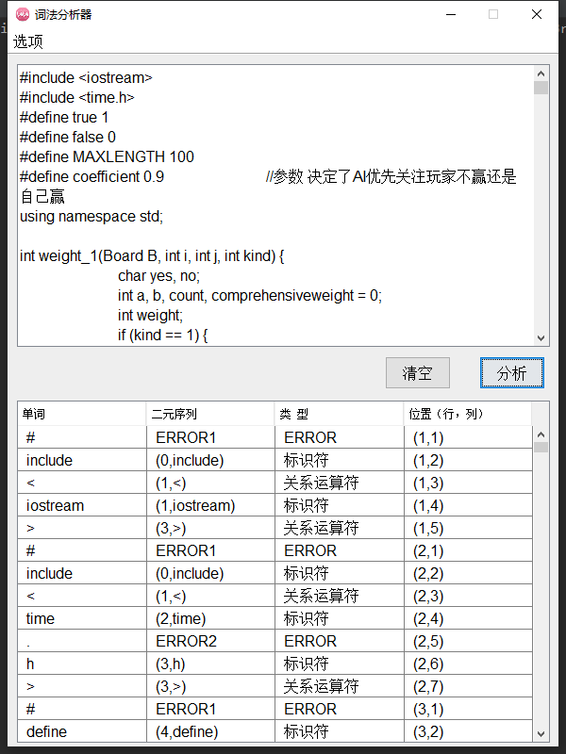

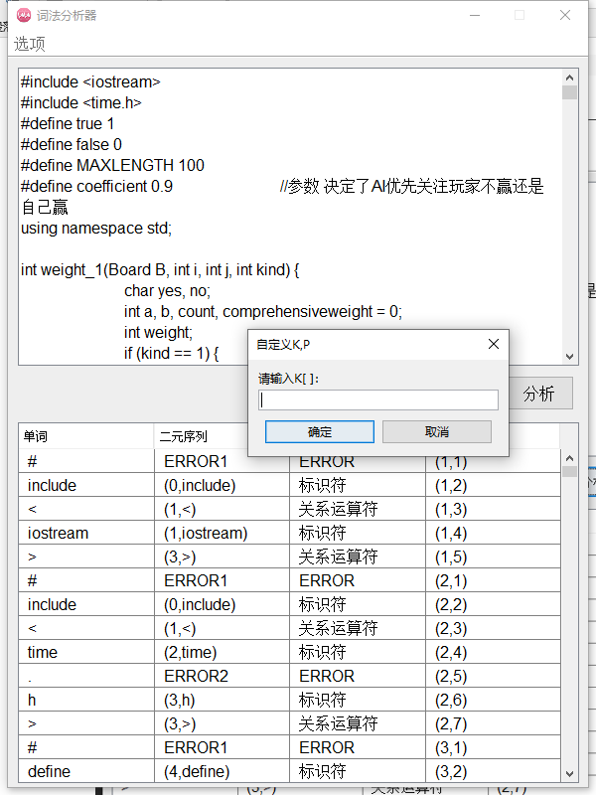

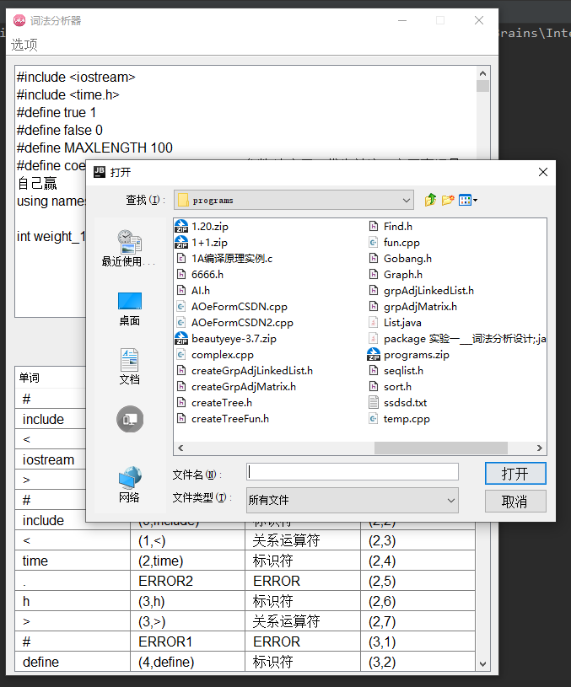

4.实验收获

本次试验算法部分较为简单，核心部分为递归行分析中的使用每个符号去匹配字符串的头部，根据匹配结果得出分析结果，然后将剩余的部分递归处理。大部分时间都用于学习设计界面UI，初步掌握了UI的设计方法，有了一套自己的设计思路。