MumaxViewer Manual

# **User Interface**

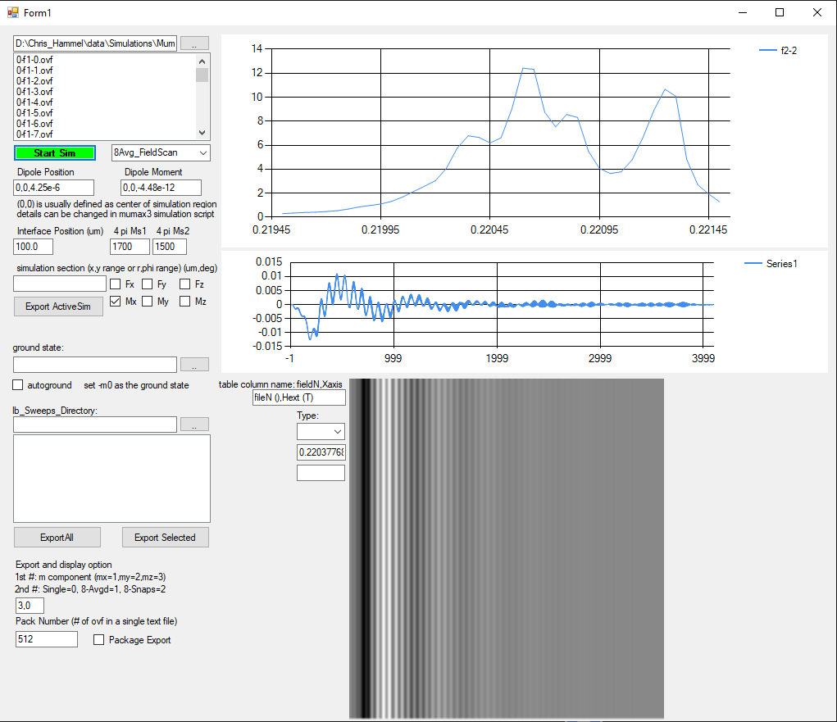

# **Routine for convert .ovf file to .txt file**

# Step1: Load .ovf files into MuMax3 Viewer

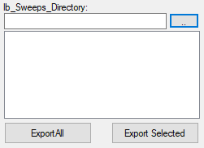

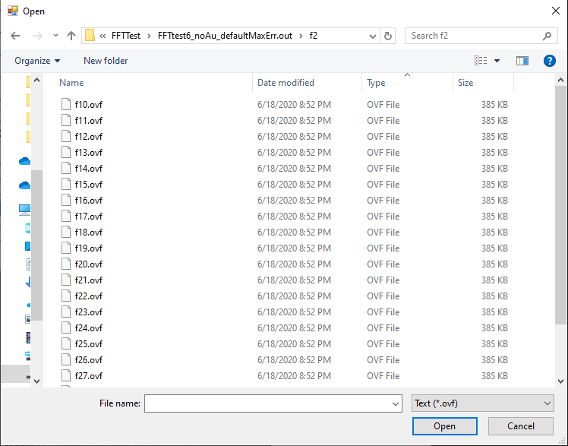

# Step2: Select magnetization component for exportation

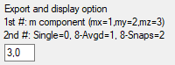

In Export and display option, put in *a,b* in the textbox to set up the magnetization component to look at (mx->1, my->2, mz->3) and average or not (yes->1, no->0). The second parameter does not matter here.

# Step3: Export single .ovf file

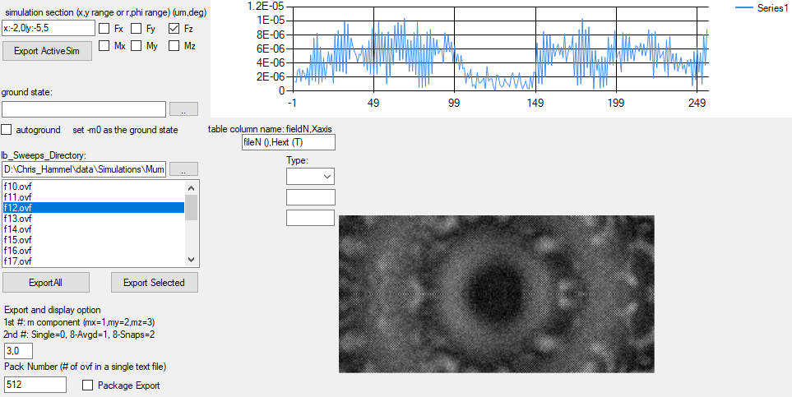

Select the file for exportation, you should see an updated 2D picture and 1D line cut on the right.

Click Export Selected, you should get a .txt file saved in your folder

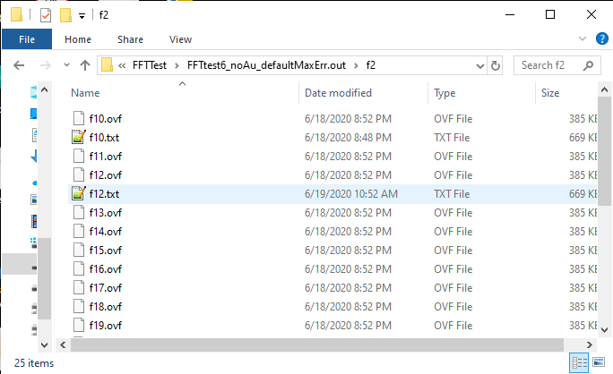

# Step3: Export all files loaded



Click Export All button, you can covert all .ovf files loaded in MumaxViewer into .txt files.

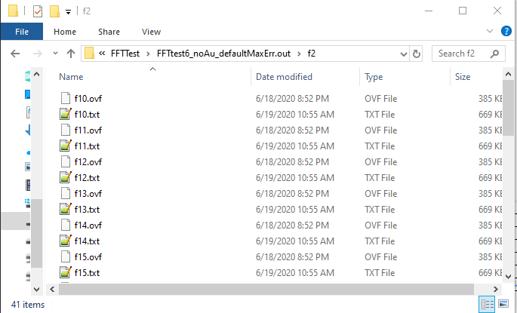

# **Routine for Field Sweep simulation analysis**

# Step1: Select simulation result

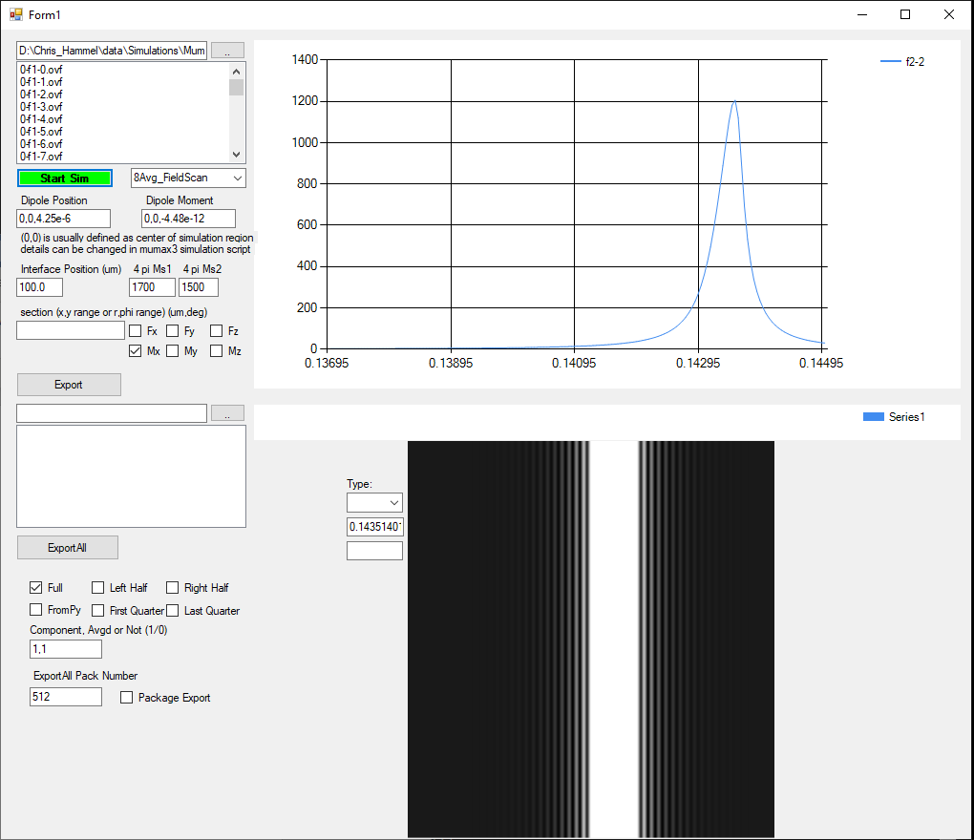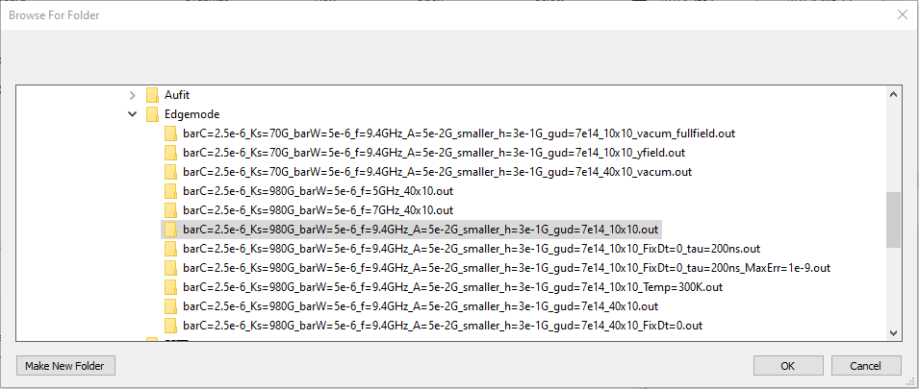

Click the browse button, and select the .out folder that contains the simulation result you want to analyze

# Step2: Select simulation type

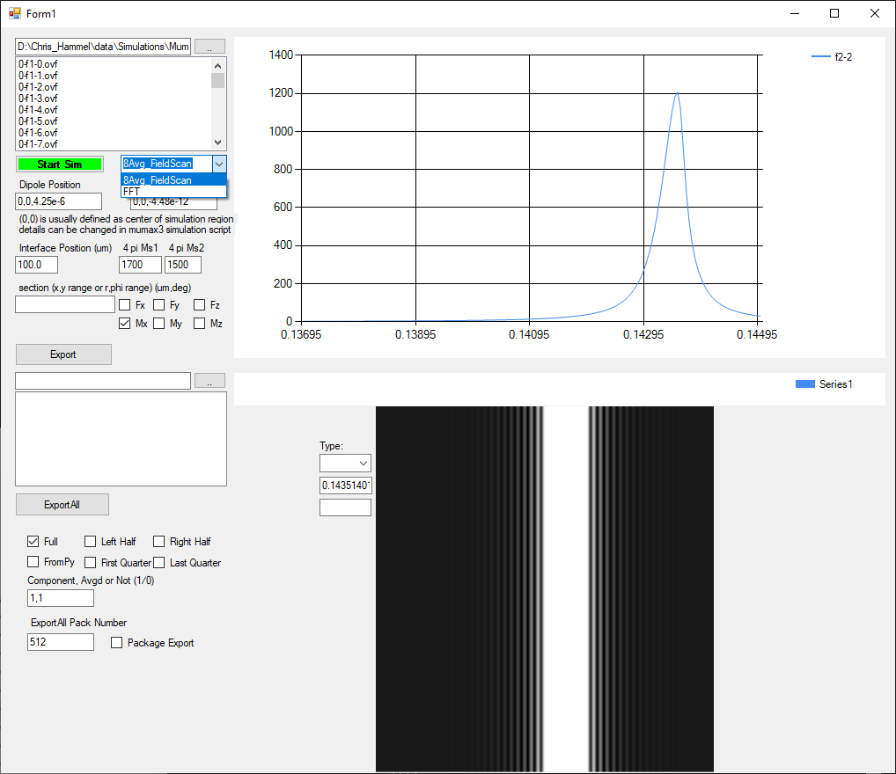

Select the 8Avg_FieldScan as the simulation type

# Step3: Set up calculation parameters

## Dipole force calculation

For the output spectrum, you can select it to be the force applied by the ferromagnet on a point dipole. To do this, you need to set up the parameters of the dipole

1. dipole position (x,y,z)
2. dipole moment (mx,my,mz)
3. force direction Fx, Fy or Fz

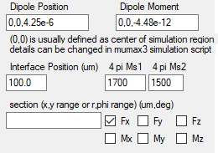

## Magnetization reduction calculation

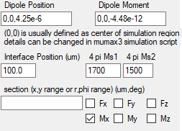

Select the magnetization direction Mx, My or Mz

# Step4: Start Calculation

Click button 

After a while, you will get a spectrum

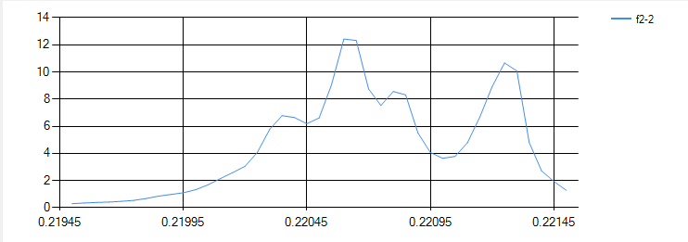

# Step5: look at mode profile



In Export and display option, put in *a,b* in the textbox to set up the magnetization component to look at (mx->1, my->2, mz->3) and average or not (yes->1, no->0)

Click on the spectrum, you will see an updated gray scale 2D picture in the picturebox beneath it and its line cut across the center of the image, showing the selected component of the magnetization. The text box besides shows the value of the field

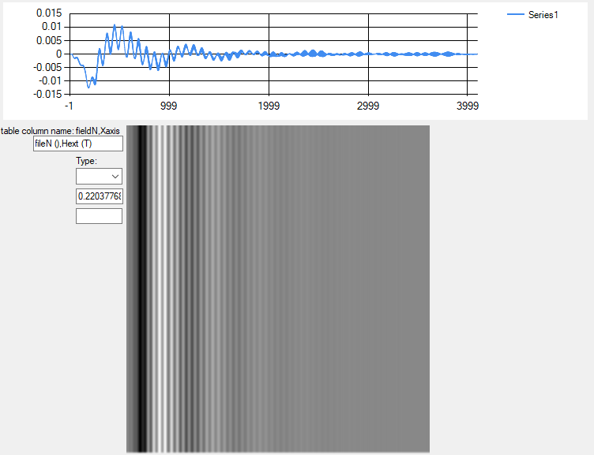

**Line cut**

# Step6: Export the mode profile



Click Export ActiveSim button, you can save the spatial profile in a text file

If you set *b*=2, you will be able to export 8 files representing a revolution cycle of the precession

# **Routine for Pulse Excitation FFT simulation analysis**

# Step1: load simulation result

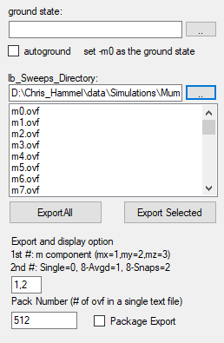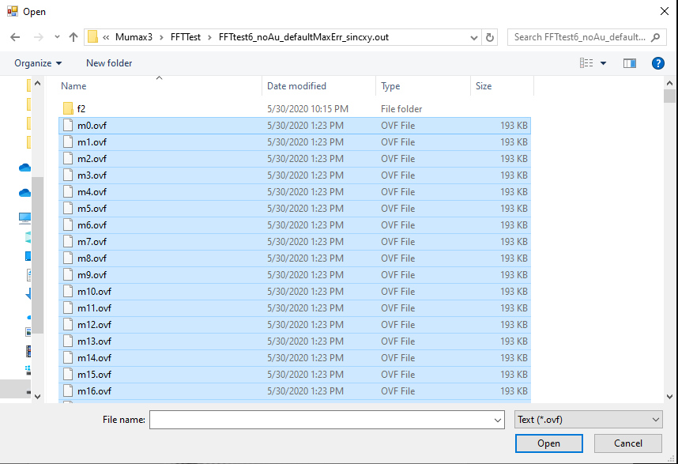

Load all the .ovf file generated from simulation in to the mumaxviewer



Select the initial magnetization profile as ground state

# Step2: Export to text files in package

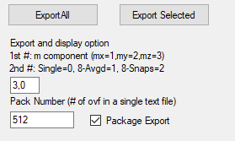

Select the component of magnetization you want to analyze. The second number doen’t matter here. For FFT simulation, you should choose the transverse component of the dynamic magnetization.

Select the number of .ovf files in a single package, check package export.

Click Export All

# Step3: Fourier transform using python

Load the 3d matrix m_i(x,y,t) into python and do Fourier transform to get magnetization in frequency domain m_i(x,y,f) and save the transformed result into folder ./f2

# Step4: Load FFT ovf files into MumaxViewer

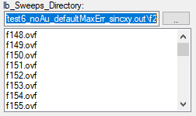

Go to ./f2 folder and load the frequency domain .ovf files into MuMaxViewer

# Step5: Start FFT simulation analysis



Select FFT as the simulation type, and click Start Sim button