MumaxViewer Manual

# User Interface

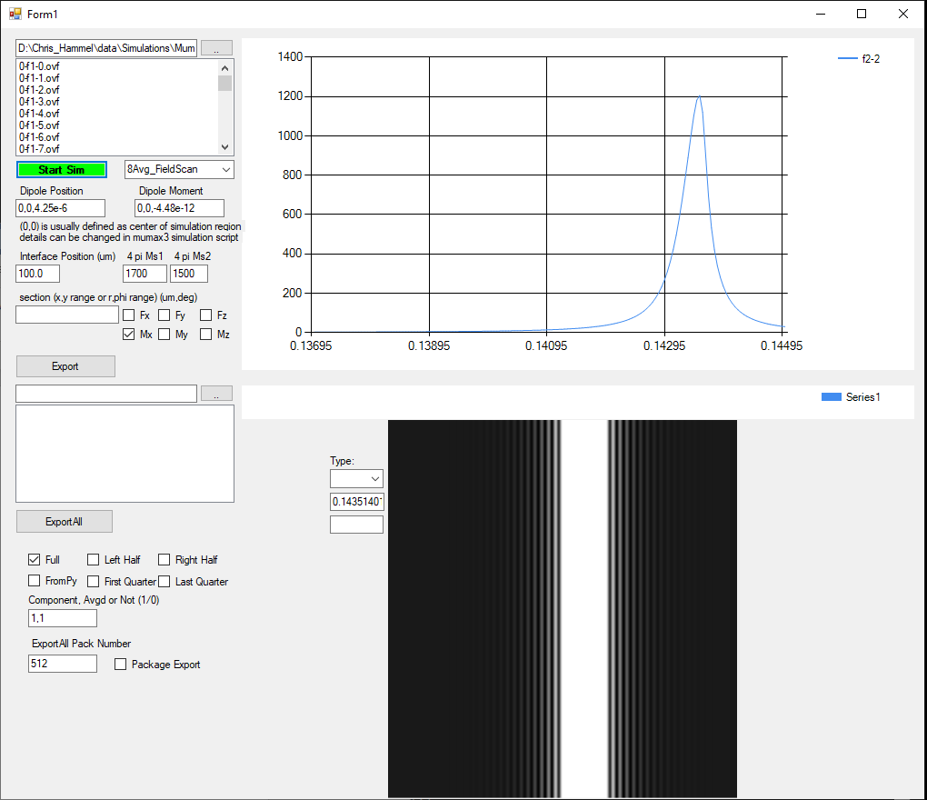

# Step1: Select simulation result

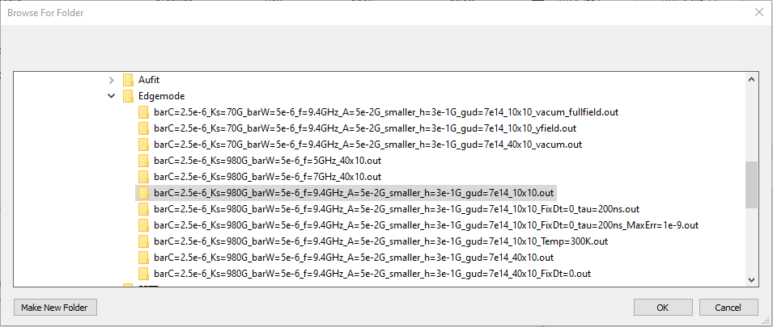

Select the .out folder that contains the simulation result

# Step2: Select simulation type

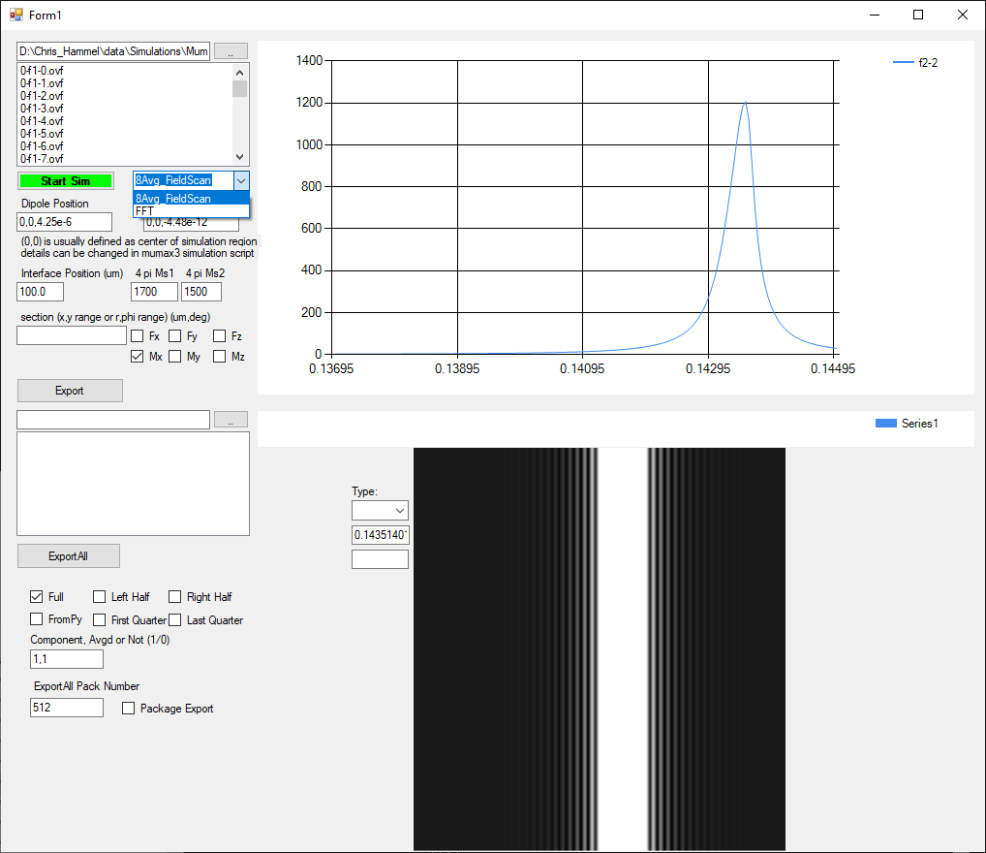

Select the 8Avg_FieldScan as the simulation type

# Step3: Set up calculation parameters

## Dipole force calculation

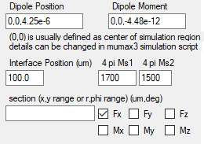

Set up dipole position (x,y,z), dipole moment (x,y,z)

Select the force direction Fx, Fy or Fz

## Magnetization reduction calculation

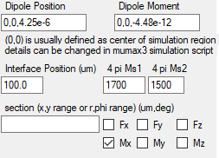

Select the magnetization direction Mx, My or Mz

# Step4: Start Calculation

Click button 

After a while, you will get the calculation result in the chart

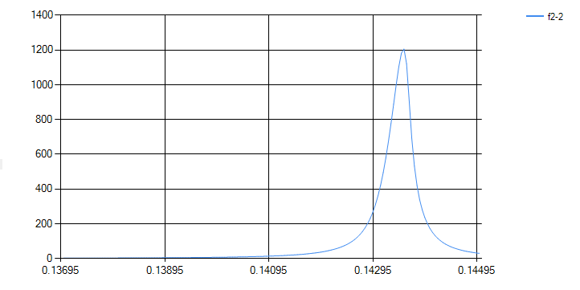

# Step5: look at mode profile

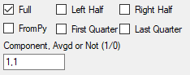

Select Full

Put in *a,b* in the textbox to set up the magnetization component to look at (mx->1, my->2, mz->3) and average or not (yes->1, no->0)

Click on the chart, you will see an updated gray scale 2D picture in the picturebox beneath it

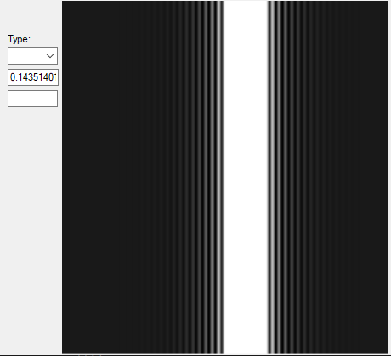

# Step6: Export the mode profile



Click export button, you can save the profile in a text file

If you set *b*=2, you will be able to export 8 files representing a revolution cycle of the precession