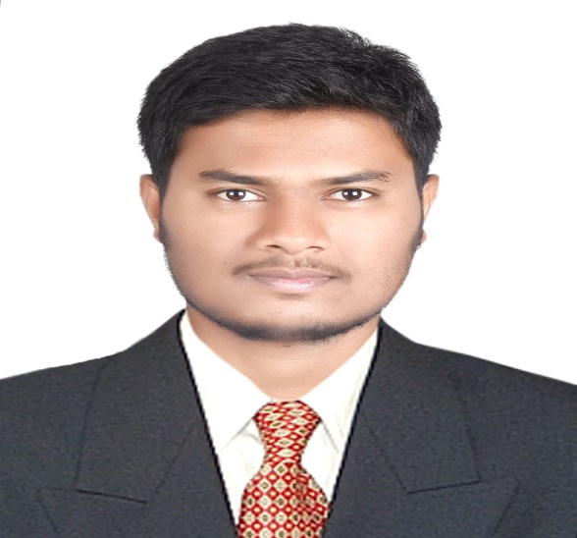

Marketing Specialist

**VARUNKUMAR K M**

With extensive experience, I have developed and implemented effective marketing strategies that drive company objectives and significantly enhance revenue growth. Proficient in managing marketing budgets and analysing regional market trends, I ensure maximum ROI and heightened customer engagement.



**EDUCATION**

Bachelor of Engineering (BE) in Mechanical Engineering  
Mysuru royal institute of technology (MRIT) Mysore, Karnataka, 2016 - 2019

**Ezy Colour customer Associate | Aug 01 2020 to Feb 15 2022**Asianpaints

* Assisted customers in selecting suitable paint colors and finishes through Ezy colour service, ensuring personalized recommendations based on their preferences and requirements.
* Collaborated closely with customers to understand their specific needs, addressing queries and concerns promptly to enhance satisfaction and loyalty.
* Utilized Asian Paints proprietary tools and technologies to demonstrate colour simulations and visualizations, enabling customers to make informed decisions.
* Achieved high customer satisfaction scores through effective communication, product knowledge, and attentive service delivery.
* Contributed to achieving sales targets by promoting additional products and services aligned with customers’ preferences and project requirements.

**Key Achievements:**

* Successfully resolved customer complaints, leading to a 20% improvement in customer retention.
* Recognized for consistently exceeding monthly sales targets, averaging a 30% increase in revenue.

**Software engineer | Aug 08 2022 to Present**Capgemini India private limited

* Provided technical support and assistance to clients/customers regarding [specific software product/service], ensuring timely resolution of issues and inquiries.
* Diagnosed and troubleshooted software problems related to installation, configuration, and usage, utilizing [tools or platforms] to effectively identify root causes and implement solutions.
* Conducted training sessions and created documentation for clients/customers to facilitate self-service support and promote best practices in software usage.
* Recognized for exceptional customer feedback and received [award or recognition] for outstanding customer support.

**WORK EXPERIENCE**

* English: Fluent
* Kannada: Native
* Telegu: Proficient (Manage)
* Hindi: Proficient (Manage)

**LANGUAGES**

* Market research and Analysis
* Competitive Analysis
* Customer Segmentation
* Pricing Strategy
* Go-to-Market Planning
* Team management
* Technology solutions
* Quality Control & Standards
* Troubleshooting
* System Administration
* Analytical Thinking
* Time management
* Problem-solving skills
* Projects and contribution
* Technology Solutions
* Campaign Execution
* Customer Focus
* Learning Agility

**SKILLS**

Bangalore

drizzlevarun@gmail.com

**CONTACT**

9108677907