Please find below a COE/refund recommendation for approval:

476374346 Georgie Vella

1. Course Code and Name: 11240NAT - Certificate IV in Adult Tertiary Preparation
2. Liability Category: ENH
3. Citizenship: Australian
4. Application date: 19/11/2025
5. CESD: 07/10/2025
6. Census Date: NA
7. Reason for COE:

Employment related reasons
The student’s employer has increased their working hours unexpectedly due to staff shortages, which has impacted the student’s ability to balance work and study commitments.

Special Circumstances eligibility:

Beyond control: MET – The increase in working hours was due to an unexpected staff shortage and is outside the student’s control.

After start of study/census: MET – The increased hours and resulting impact occurred after the course commencement date of 07/10/2025.

Unreasonable to complete: MET – The increased workload (25–38 hours per week) makes it unreasonable for the student to continue their studies during the current timeframe.

Documentation assessment:

Independence of documentation: The supporting letter is from the student’s employer (Practice Manager), an independent and appropriate source.

Adequacy of detail: The letter includes dates (employment since March 2025, letter dated 05/12/2025), describes the change in hours, and explains the impact on the student’s ability to balance work and study.

Noted gaps/limitations: The letter does not explicitly state when the student first realized they could not continue study, but the timing implies recent impact. Otherwise, no significant gaps.

Timeline of events:

07/10/2025 – Course / financially relevant units commence (EASD)

Approx. late 2025 (after 07/10/2025) – Employer increases student’s working hours from 15–20
hrs/week to 25–38 hrs/week due to staff shortage

19/11/2025 – Student lodges withdrawal/refund application with TAFE Queensland

05/12/2025 – Employer provides supporting letter confirming increased hours and impact on study

Impact on study (summary):

• The increased hours and resulting impact occurred after the course commencement date.
• Increased work hours significantly reduced the student’s available time to attend classes.
• The heavier workload limited the student’s capacity to engage effectively with learning activities.
• The student likely faced difficulties submitting assessments on time due to work commitments.
• The overall increased employment demands made it unreasonable to meet study timelines for the course period.
8. Has evidence been supplied: Yes
9. AHPRA Verified?: NA
10. Account Balance: $0.00
11. Financial Impact: $181.00 refund to student

NAT11240002 [ENG: 27.27] Fee Waiver $281.00

Total Fee Waiver: $281.00 (1 unit(s))

12. Recommendation:

Post EASD WID FREF 1 unit and apply fee waiver of $281.00 - $100.00 Administration fee = $181.00 refund to student.
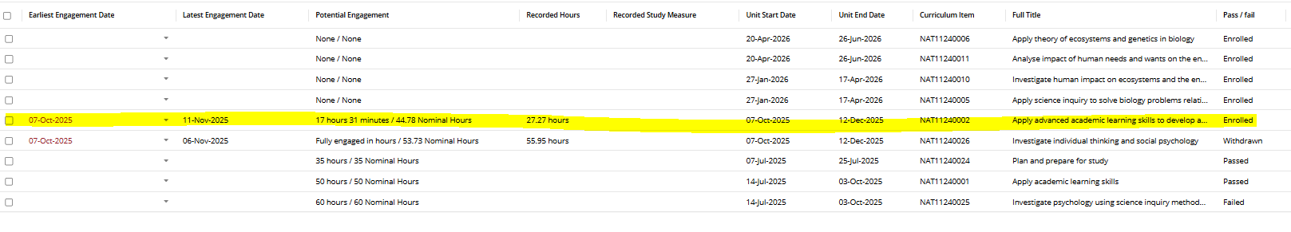

By sending through this request, I acknowledge that I am aware of TAFE Queensland Procedure 650 Student Fees, the TAFE Queensland Financial Management Delegations and will be processing the above transaction in SMS as per the FACT SHEET - Fee Waivers, Reversals and Overrides

Kind regards,
Sien

