Chapter 1

Title: "The Awakening of the Fireflower" Chapter One: The Whispering Willow In the lush, verdant heart of Eldra, where the sun caressed the land in hues of gold and amber, nestled a quaint, idyllic village called Lumina. Nestled among rolling hills, Lumina was a place untouched by time, a beacon of magic, love, and harmony that had long been the cradle of extraordinary beings. Among the denizens of this enchanted realm resided eleven-year-old Irisa, an unassuming yet tenacious girl with golden curls, emerald eyes, and a heart full of curiosity. She lived in a quaint cottage nestled between two ancient oaks, her home shared with her grandmother, Elara, who was as wise as the ancient willow tree that stood sentinel over their property. Every morning, Irisa would accompany Elara to tend to their garden, where flowers of every color and hue bloomed. As they worked, Elara would weave tales about the magical beings who roamed Eldra: nymphs dancing in moonlit groves, gnomes forging treasures deep within mountains, and fairies flitting among the petals of the most delicate blooms. One sunny afternoon, as they tended to their favorite rose bush, a peculiar sight caught Irisa's attention: a tiny bluebird, no larger than her pinky finger, alighted on Elara's shoulder and whispered something in her ear. A wave of excitement washed over the old crone, and she shared the news with her granddaughter - a powerful magician, Morwen, was coming to their village, seeking an apprentice. With dreams of wielding magic dancing in her head, Irisa spent days in anticipation, eagerly awaiting Morwen's arrival. But little did she know that her very own magical powers were about to be awakened long before the enigmatic magician's arrival. As the sun began to set one evening, casting the village in a warm, golden glow, Irisa wandered deep into the forest. The willow tree stood before her, whispering secrets on the wind, beckoning her closer. Unbeknownst to her, this was no ordinary tree: it was the Whispering Willow, the guardian of Eldra's magic. Irisa reached out, placing both hands on its gnarled trunk. A surge of energy coursed through her veins as leaves glowed with an ethereal light. The whispers in her mind grew louder - a cacophony of voices urging her to embrace her innate abilities. A fireflower, they said, lies within you, waiting to be ignited. It shall be your most powerful ally, but beware, for it can also be your greatest enemy if wielded without care. The future of Eldra rests in your hands, young one. As Irisa stood there, her heart pounding with a mix of fear and excitement, she felt an inexplicable connection to the Whispering Willow - a bond stronger than any she had ever known. She knew that her life would never be the same again, that she was no longer just a village girl but the keeper of Eldra's magic, destined to protect it from those who sought to misuse its power. But for now, as darkness enveloped the forest and twilight blanketed Lumina, Irisa made her way back home, her heart filled with a newfound sense of purpose. And so began the extraordinary journey of a young girl discovering her magical powers in the fantastical world of Eldra - a tale that would test her courage, challenge her beliefs, and ultimately redefine who she was.

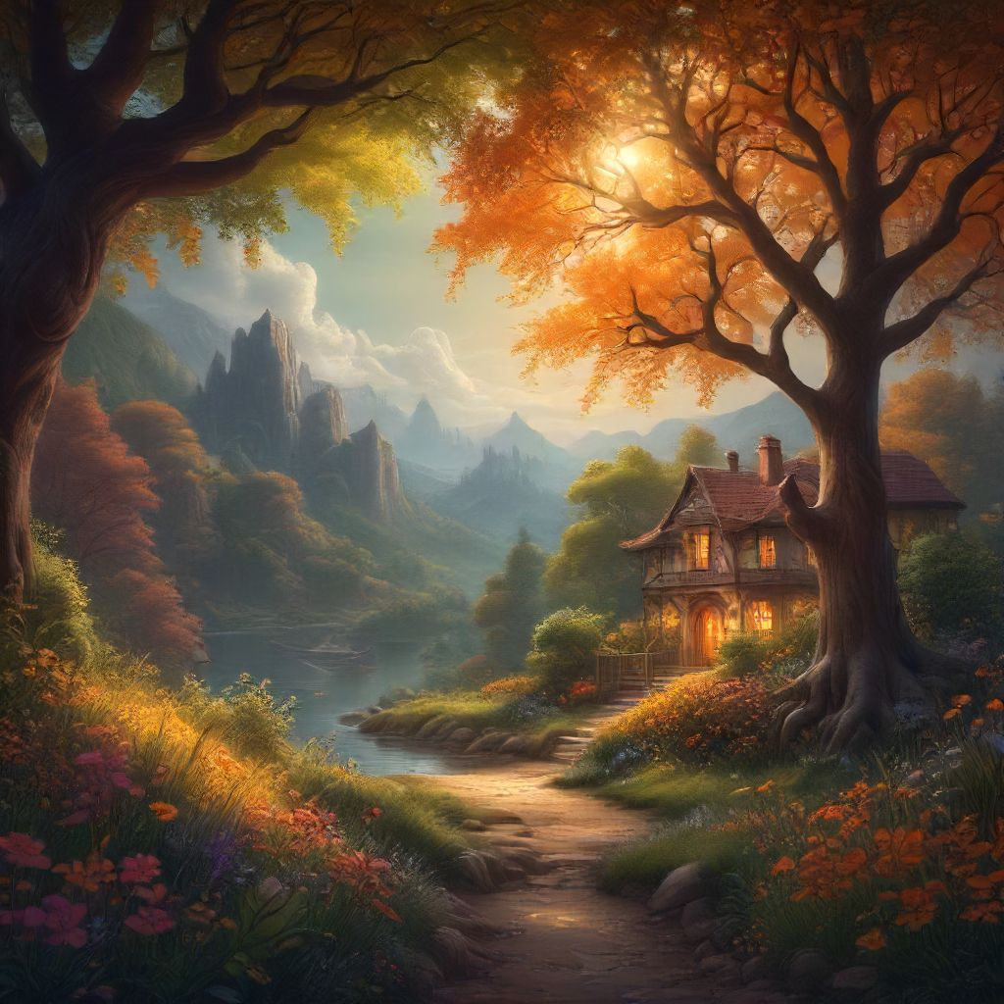

# Chapter 2

Title: The Awakening of Aria Chapter 2: Whispers of Magic The sun had set, casting the village in an ethereal glow. Aria, her heart pounding, stood on the edge of the forest, where the last rays of sunlight reached out tentatively, as if unwilling to let go. She could hear the soft hooting of owls and the gentle rustle of leaves in the breeze. Her eyes were wide with wonder and a hint of apprehension. Aria closed her eyes and took a deep breath, feeling the cool night air fill her lungs. A thousand whispers seemed to dance on the wind, speaking to her in an ancient language that she had never heard before. The whispers called out to her, beckoning her deeper into the forest. She listened intently, her heart quickening at the thought of discovering the truth about her magical heritage. As she walked further into the woods, Aria began to notice strange things happening around her. Shimmering leaves danced above her head, and glowing insects illuminated her path with a gentle light. She felt a connection to the world around her, a sense of belonging that she had never before experienced. Suddenly, she came across a clearing where three old trees stood guard. Their twisted trunks seemed to beckon her closer, and she could feel a powerful energy emanating from them. As Aria approached, she felt the ground beneath her feet begin to tremble, and the air around her crackled with energy. The wind howled and leaves swirled as an ancient force awakened within Aria. She reached out tentatively, and the trees seemed to respond, their branches weaving together to form a shield. The whispers that had called out to her before coalesced into a single voice that spoke in her mind, "Welcome, young one, you have been chosen by the ancient magic of the forest." Aria stood there, speechless, as the trees continued to speak, their voices filling her with knowledge and wisdom. They told her of her lineage, of how her family had long ago served as guardians of the forest. They also warned her that with great power came great responsibility, and that she must learn to harness her magic wisely. As dawn began to break, Aria left the clearing, her mind filled with awe and wonder. She knew that her life would never be the same. She was no longer just an ordinary girl; she was a guardian of the forest, a bearer of ancient magic, and a protector of all that lived within it. The world seemed more vibrant and alive than ever before, and Aria couldn't wait to explore its secrets and unlock the full potential of her newfound abilities. With a sense of purpose and determination, she continued on her journey into this fantastical world, knowing that she was not alone and that the magic within her would guide her through any challenge.

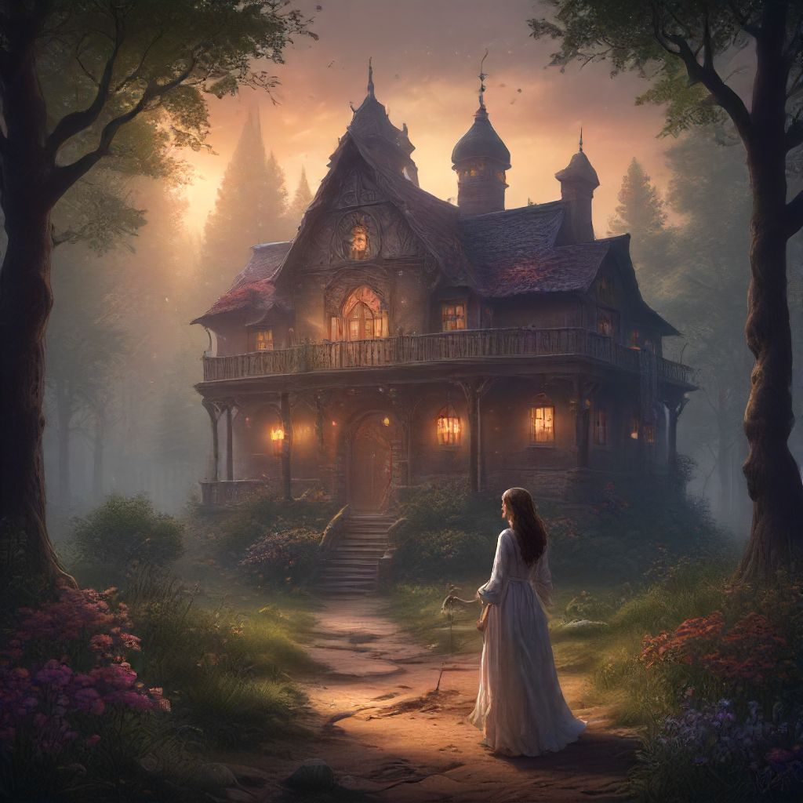

# Chapter 3

Title: The Awakening of Aria Chapter 3: Whispers of Magic Aria sat on the lush, emerald grass under the vast canopy of twinkling stars, her heart still pounding from the enchanting encounter with the fairy. She closed her eyes and let the night air soothe her spirit. The gentle hum of crickets filled her ears as she pondered the events that had transpired just hours before. The realization that she possessed magical abilities was both exhilarating and terrifying. As Aria contemplated her newfound powers, she felt a soft breeze brush against her cheek. She opened her eyes to find a familiar figure standing before her – her grandmother, Elara. A wave of warmth washed over Aria as she embraced her beloved grandmother. “My dear child,” Elara whispered, her voice tinged with wisdom and love, “it seems that the time has come for you to embrace your heritage. You are a descendant of an ancient line of magic users.” Aria was taken aback by her grandmother's revelation. "But how? I don't understand," she stammered. Elara smiled gently, "Magic runs in our blood, Aria. It is a gift that can be awakened with time and practice." They spent the night talking about the magical world, its wonders, and dangers. Elara shared stories of her own experiences as a young magic user and imparted valuable lessons on controlling and harnessing their powers. Aria listened intently, absorbing every word. As dawn approached, they made their way back to the village, Aria's heart swelling with determination. She knew that she had a long journey ahead of her, one filled with challenges and discoveries. But she was ready, armed with her newfound knowledge and the unwavering support of her grandmother. Together, they stepped into the mystical world, eager to explore the depths of Aria's magical abilities. And as they walked, the trees seemed to rustle in approval, the flowers bloomed more vibrantly, and the creatures of the forest watched with curious eyes. Aria knew then that she truly belonged in this enchanted realm, and she was ready to embrace her destiny.

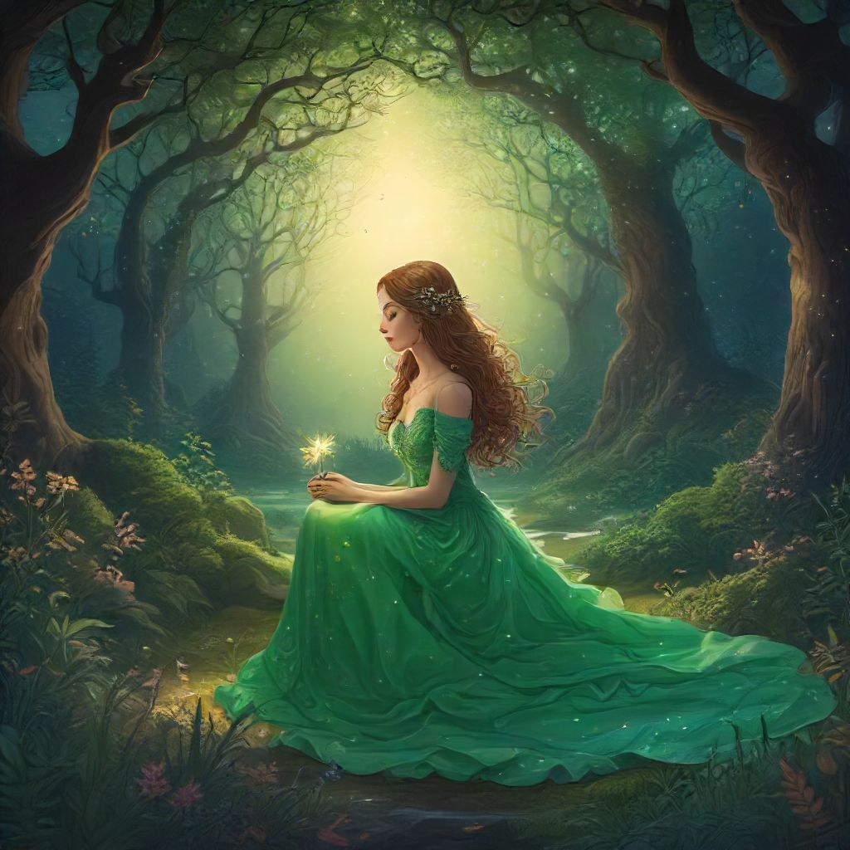

# Chapter 4

Title: The Awakening of Aria Chapter 4: Discovering the Depths of Magic As days passed, Aria continued to explore the enchanted forest, her heart brimming with awe and wonder at every new discovery. However, it was not just the wonders of nature that she began to unravel. Unbeknownst to her, she was also slowly unearthing the hidden mysteries within herself. One sunny afternoon, as Aria meandered through the forest, humming a lilting tune, she stumbled upon an unusual scene. A cluster of vibrant, glowing mushrooms had appeared overnight in a previously barren clearing. Intrigued, Aria reached out to touch one with the tip of her finger. As soon as her skin made contact, a jolt of electricity coursed through her body, leaving her momentarily breathless. But before she could recoil in alarm, a ripple of warmth spread from the mushroom, enveloping her hand and soothing the tingling sensation. Suddenly, the ground beneath her feet began to tremble gently. Aria looked around, her heart pounding with both fear and excitement. The trees around her rustled softly in the breeze, whispering ancient secrets. She closed her eyes, taking a deep breath, feeling the power within her stirred. When she opened her eyes, the mushroom at her feet had transformed into a magnificent crystal orb, radiating ethereal light. Aria gasped, reaching out to touch it. The moment her fingers brushed against the cool glassy surface, a surge of energy flowed from the orb and into her, filling every cell in her body with an unparalleled sense of joy and strength. Aria stood transfixed as she felt the magic coursing through her veins. She could feel her abilities growing stronger by the moment – the power to communicate with nature, to manipulate the elements, and even to heal herself and others. Overwhelmed by this revelation, Aria knelt down before the crystal orb, tears of joy streaming down her cheeks as she whispered a prayer of gratitude for this extraordinary gift. But as powerful as this newfound ability was, it came with a great responsibility. As days turned into weeks, Aria discovered that not all beings within the forest welcomed her magical powers with open arms. Some saw her as a threat, while others sought to use her abilities for their own nefarious purposes. It would take all of Aria's courage and determination – not to mention her newfound magical prowess – to protect her enchanted home and safeguard the harmony within it. As she stood there, bathed in the soft glow of the crystal orb, Aria knew that this was only the beginning of her journey. With renewed resolve and a deep sense of purpose, she embraced her destiny as the guardian of the enchanted forest, knowing that the true test of her power was yet to come.

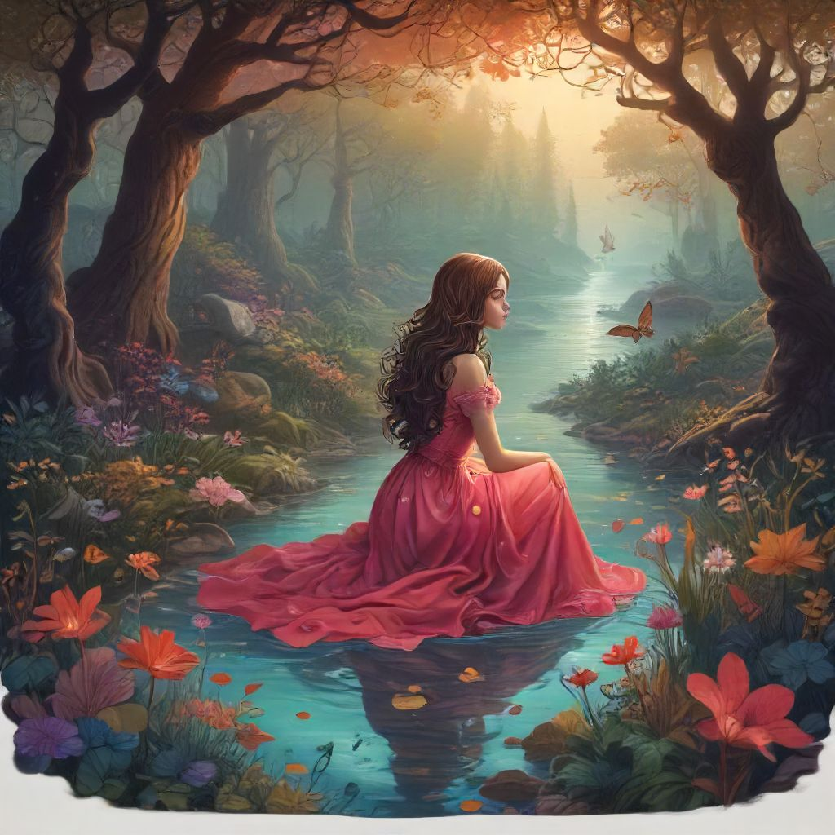

# Chapter 5

Title: The Awakening of Aria Chapter Five: Whispers of Magic The sun had set, painting the evening sky a brilliant palette of pinks and purples. Aria sat cross-legged in her hidden glade, her heart pounding with anticipation. She had spent countless nights practicing the incantations she had learned from the old witch, Marigold. Her eyes were closed, focusing on the feeling of the earth beneath her, the gentle breeze in her hair, and the soft chirping of crickets. A sudden rustle nearby made Aria open her eyes, her hand reaching for the amulet that hung around her neck. She saw a small fox cub watching her curiously from behind a tree. The moment their eyes met, Aria felt a surge of warmth in her chest. In an instant, she understood: this was the magic Marigold spoke of. A connection to nature, the ability to communicate with creatures and plants, and the power to heal. Aria extended her hand towards the fox, whispering an incantation Marigold had taught her. Instantly, the cub bounded closer, nuzzling against her palm. With a wave of her hand, Aria healed a small scratch on its snout. The fox looked up at her, as if understanding the gratitude in her eyes. Emboldened by this encounter, Aria closed her eyes and focused on the whispers of magic in the wind. She could sense the energy around her, the pulse of life that connected every creature and plant. She felt a deep bond with nature, and in that moment, she understood that she was not just an observer but a guardian, a protector of this enchanted world. But as quickly as the realization came, it was gone, leaving Aria alone in the darkness. The fox had vanished, returning to its forest home, but the connection remained. With newfound determination, Aria stood up and made her way back to her village. She knew that she could no longer hide the truth about her magic from those she loved – it was a part of who she was now. As Aria walked beneath the canopy of stars, she couldn't help but wonder what adventures awaited her in this enchanted world. With a deep breath, she let go of her fears and embraced the power that flowed through her veins. The journey ahead was certain to be filled with challenges, but Aria knew that she would face them with courage, for she was no longer just a young girl – she was the guardian of the enchanted woods, and her magic would guide her every step of the way.

