Chapter 1

Title: "The Awakening: A Journey into Artificial Intelligence and Machine Learning" **Chapter 1: The Foundations of Intelligent Machines** Once upon a time in the land of innovation, there lived two curious explorers named Leo and Ana. They had heard tales of intelligent machines that could learn from data and make decisions on their own. Intrigued by these stories, they embarked on a thrilling journey to understand the world of Artificial Intelligence (AI) and Machine Learning (ML). First, our intrepid duo set out to grasp the fundamental concept of AI. Leo explained that AI refers to a machine or computer system designed to mimic intelligent human behavior. He emphasized three types: Reactive Machines which respond based on current data; Limited Memory Systems capable of recalling past experiences for better decisions; and Self-aware Machines having consciousness and emotion. Ana then took the lead, expounding on Machine Learning - a subset of AI where systems learn from experience without being explicitly programmed. She illustrated three primary learning styles: Supervised Learning (training with labeled data), Unsupervised Learning (discovering patterns in unlabeled data), and Reinforcement Learning (learning through interaction with the environment). To make these abstract concepts more tangible, Leo proposed an analogy using a toddler learning to identify objects. "Imagine a toddler," he began. "It learns to recognize a cat by observing numerous instances of cats and associating them with the label 'cat'. This is similar to Supervised Learning." Next, Ana added, "Now consider how the toddler might discover patterns in its own room without explicit instruction. For instance, noticing that books are typically found on shelves, or that toys belong in the play area. This aligns with Unsupervised Learning." Finally, Leo introduced Reinforcement Learning: "Just like a puppy learning to sit for a treat or avoiding hot stovetops, Machine Learning models learn from rewards and penalties in their environment." As evening approached, Leo and Ana marveled at how far they had come on their enlightening journey. But the sun had only just set, leaving many more wondrous discoveries waiting to be explored in the vast landscape of AI and ML. Stay tuned for our next adventure!

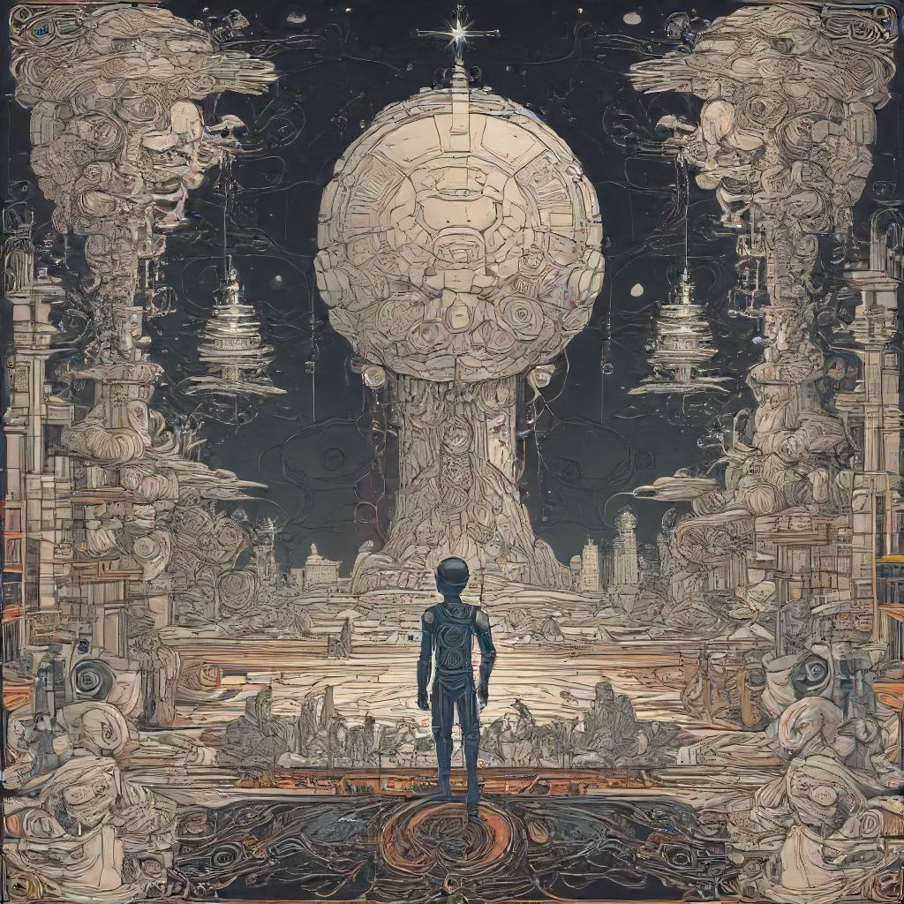

# Chapter 2

Title: "The Intelligent Journey: Unraveling the Mysteries of Artificial Intelligence and Machine Learning" Chapter 2: Diving Deeper into Artificial Intelligence and Machine Learning As we embarked on our intellectual adventure, we had a cursory understanding of Artificial Intelligence (AI) and Machine Learning (ML), two essential branches of computer science that have captured the collective imagination of tech enthusiasts and scientists alike. Let's now delve deeper into their concepts, practical applications, and real-world use cases. First, allow us to clarify the relationship between AI and ML: While AI is a broader concept referring to machines or software capable of performing tasks that typically require human intelligence, ML is a subset of AI. It enables systems to improve automatically through experience without being explicitly programmed. In simpler terms, ML algorithms learn from data to identify hidden patterns and make decisions. Now, let's elucidate some essential AI and ML concepts: 1. Neural Networks: Inspired by the human brain's structure, neural networks consist of interconnected processing nodes called neurons. They can analyze complex patterns, learn from experience, and adapt to new inputs. 2. Deep Learning: A subset of ML, deep learning employs multi-layered neural networks with automatic feature extraction to enable more accurate predictions and better performance on large datasets. 3. Natural Language Processing (NLP): This is an application of AI that focuses on the interaction between computers and human languages, allowing machines to understand, interpret, and manipulate natural language data. 4. Re Reinforcement Learning: An ML technique where an agent learns from its environment by performing actions and receiving rewards or penalties, enabling it to optimize its behavior for maximum reward. 5. Computer Vision: Another AI application, computer vision enables machines to interpret and understand visual information from the world, including object recognition, facial detection, and motion analysis. Now that we've touched upon some fundamental concepts let's explore real-world applications of AI and ML: 1. Predictive Analytics: Companies like Netflix and Amazon use ML algorithms to recommend products or movies based on user behavior and preferences. 2. Healthcare Diagnostics: AI algorithms help diagnose diseases like cancer, identifying patterns in medical images that might escape the human eye. 3. Speech Recognition: Siri, Alexa, and Google Assistant all use deep learning models to understand and respond to spoken commands. 4. Self-Driving Cars: Companies like Tesla, Waymo, and Uber employ AI for image recognition and decision-making in self-driving cars. 5. Fraud Detection: ML algorithms analyze financial transactions to detect anomalies and potential fraudulent activities. As our journey into the world of AI and ML continues, stay tuned for more insights and practical applications in Chapter 3!

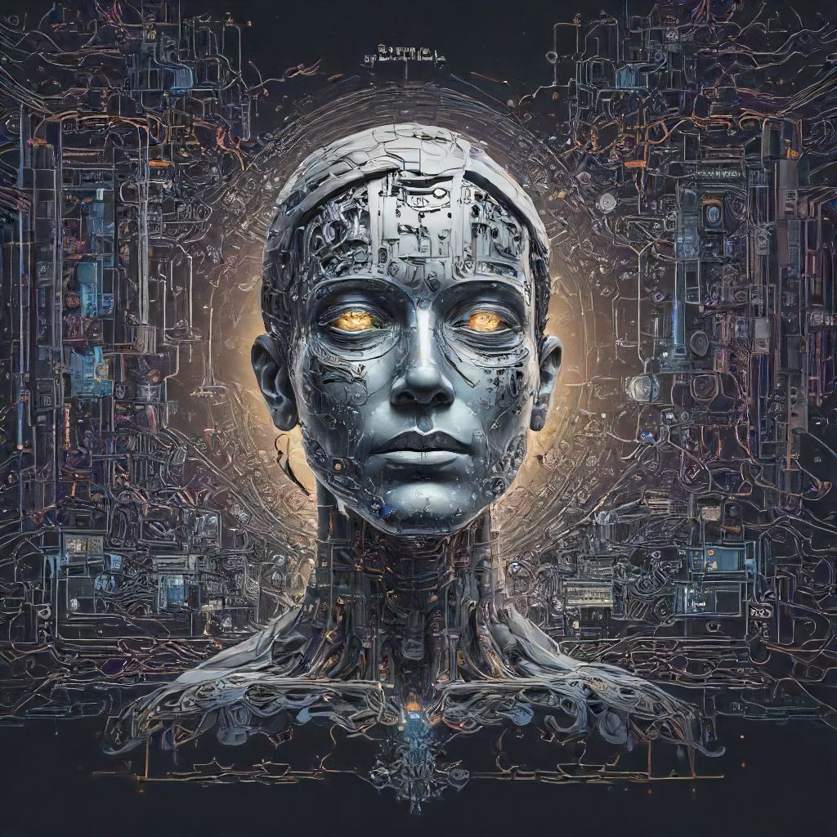

# Chapter 3

Chapter 3: Diving Deeper into Artificial Intelligence and Machine Learning As we ventured further into the world of artificial intelligence (AI) and machine learning (ML), our curiosity grew. In chapter one, we've introduced the basics - what AI is, its history, and its potential applications. Chapter two delved into neural networks, the fundamental building blocks of deep learning models. Now, let's dive deeper into these concepts. First, a quick recap: Artificial intelligence (AI) refers to computer systems that mimic human intelligence, performing tasks such as visual perception, speech recognition, decision making, and language translation. Machine learning (ML), on the other hand, is a subset of AI, a method for teaching computers to learn from data without being explicitly programmed. Now, let's explore supervised and unsupervised learning. Supervised learning is when we train our model using labeled data - that is, data with known outcomes or answers. For example, consider an image recognition system designed to identify cats. We provide the system with numerous images of cats and dogs, clearly labeled as "cat" or "dog." The system uses this labeled data to learn the difference between cats and dogs based on features such as shape, color, size, and texture. Once trained, it can then apply this knowledge to new images, identifying cats and dogs in real-life situations. On the other hand, unsupervised learning involves processing unlabelled data - data without any predefined categories or outcomes. In our example above, imagine giving an image recognition system thousands of images without any labels at all. The system would then try to discover patterns or structures within this unlabeled data, grouping similar images together based on their features. This method is often used for clustering similar data points (like customer segmentation) and discovering hidden relationships in large datasets. Real-world applications of AI and ML are abundant. In healthcare, machine learning algorithms analyze medical records and patient outcomes to detect diseases earlier or predict patient risks. In finance, these technologies can analyze market trends and investor behavior to optimize investment portfolios. In the entertainment industry, AI powers recommendation systems like Netflix and Amazon Prime Video, suggesting content based on your viewing history. One practical example of machine learning is implementing a spam filter for emails. The email service collects data about various messages marked as spam or not-spam by users. It then trains an ML model to identify future emails that fit the characteristics of spam emails, such as certain keywords, email addresses, and message structures. In conclusion, artificial intelligence and machine learning offer limitless opportunities for innovation and progress. With various techniques like supervised and unsupervised learning, the potential applications span across numerous industries, enhancing our daily lives and pushing technological boundaries further. Stay tuned for more insights into this fascinating world of AI and ML!

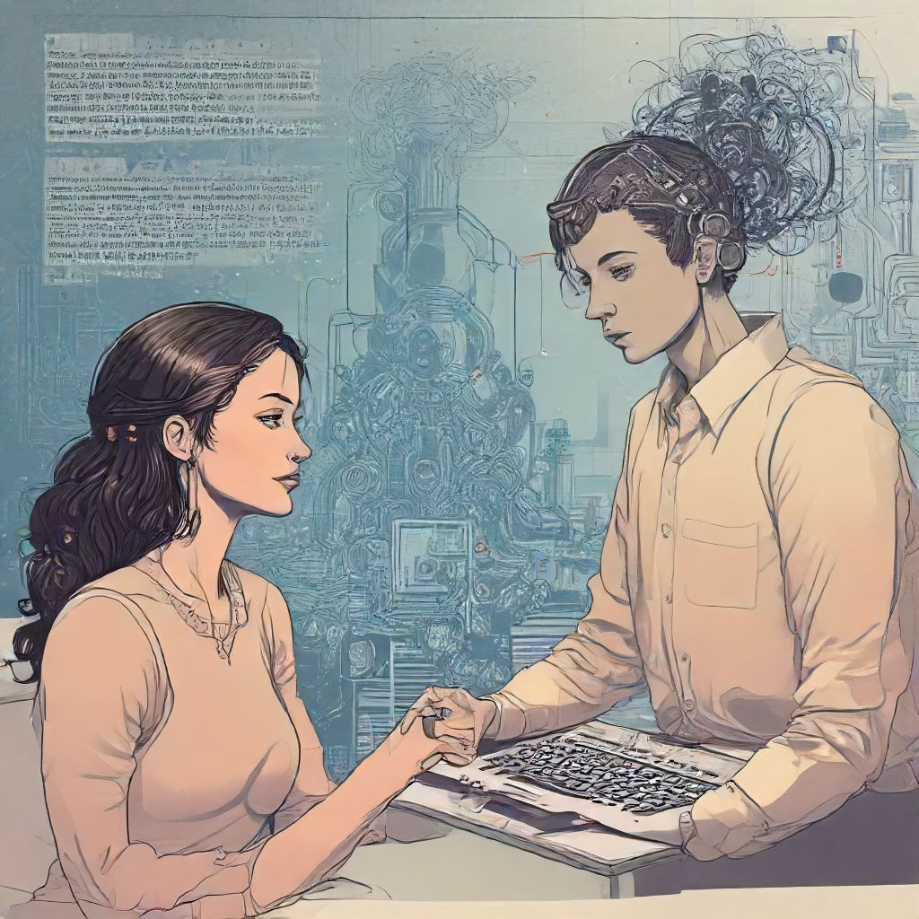

# Chapter 4

Title: "The Awakening Mind: Unraveling the Mysteries of Artificial Intelligence and Machine Learning" Chapter 4: Diving Deeper - Practical Applications of AI and ML As our intrepid protagonist, Alex, delved deeper into the realm of Artificial Intelligence (AI) and Machine Learning (ML), he was beginning to grasp the immense potential that these technologies held. However, Alex knew that theory alone would not suffice in mastering this complex domain. He longed for practical applications to anchor his understanding. One sunny afternoon, as he sat at his favorite coffee shop, a thought crossed his mind: "How about image recognition?" This intrigued him because images were something tangible, and the ability to identify them accurately without human intervention was an enticing prospect. Let's refresh our memory on some crucial concepts before embarking on this new adventure: 1. **Image Recognition**: A process wherein computers are trained to recognize and identify various objects within images or even the entire image itself. It lies at the heart of several applications, such as facial recognition, autonomous vehicles, etc. 2. **Deep Learning** : A subset of ML inspired by the structure and function of the brain's neural networks. Deep learning models can learn and improve from experience, much like humans do. Convolutional Neural Networks (CNNs) are popular deep learning architectures for image recognition tasks. Alex decided to explore image recognition using TensorFlow, an open-source platform developed by Google Brain Team. The first task was data acquisition: gathering a large dataset of labelled images. For this, he employed the CIFAR-10 dataset - consisting of 50,000 32x32 color training images and 10,000 test images in ten different classes. Next, Alex wrote code to preprocess data by splitting it into batches for efficient handling during training. Then he created a neural network model using TensorFlow's Keras API, specifically a CNN architecture. He compiled the model using categorical cross-entropy loss and SGD optimizer. Training this model involved feeding it the dataset and adjusting the internal parameters based on feedback from its performance (i.e., accuracy) on test images. Days turned into weeks as Alex dedicated himself to this project. His computer hummed steadily, churning out countless iterations of the neural network until one glorious morning when the model achieved an astounding 78% accuracy! The coffee shop buzzed around him as he reveled in his success; every misclassified image was now one step closer to being correctly identified. As Alex savored his victory, he realized that the real journey had just begun. He could explore other practical applications of AI and ML like speech recognition using Google's Speech Recognition API or natural language processing with IBM Watson. But for now, he basked in the knowledge that he had successfully dived deeper into understanding AI and ML, making tangible progress towards his goal. Stay tuned as our hero explores more realms of Artificial Intelligence and Machine Learning!

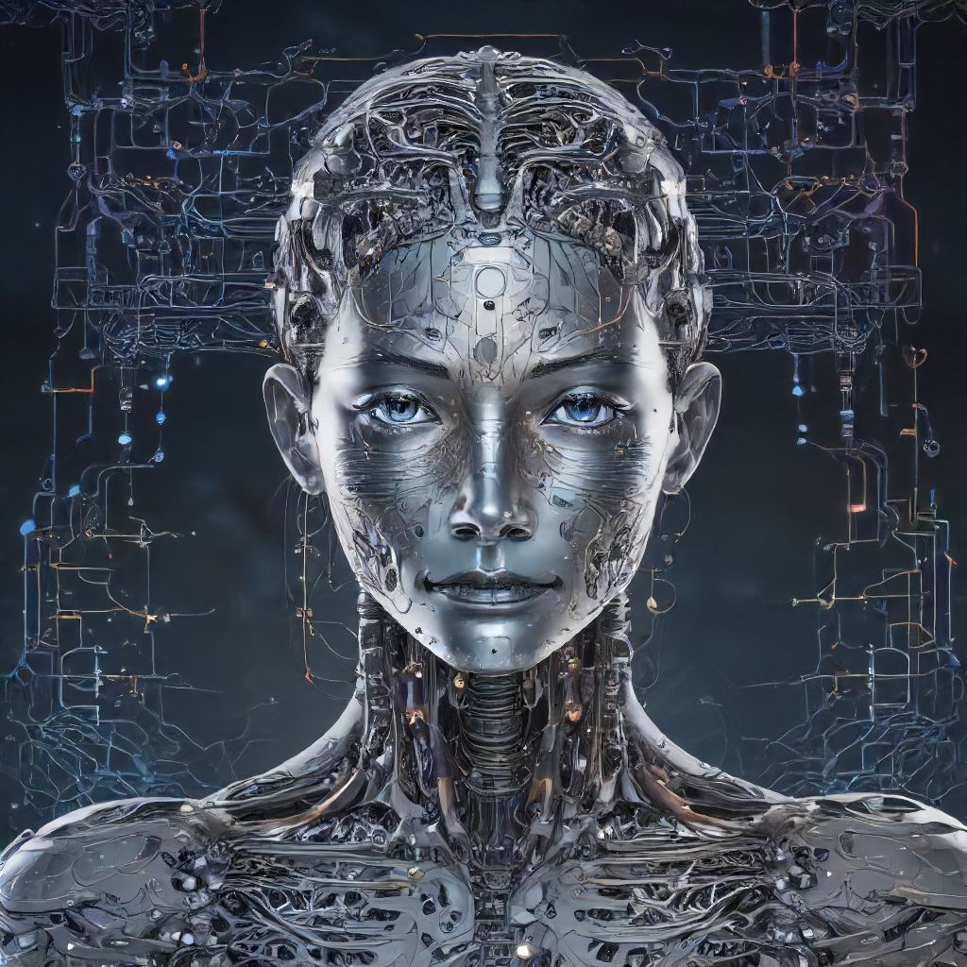

# Chapter 5

Title: "Mastering the Future: A Journey into Artificial Intelligence and Machine Learning" Chapter 5: Diving Deeper into Neural Networks and Deep Learning As the sun rose, the warmth of the morning light crept into Dr. Amelia Hart's lab, casting long shadows across the room. She took another sip of her cooling coffee before diving back into her work, ready to tackle the complex world of neural networks and deep learning. Recap: In our last adventure, we explored the basics of Artificial Intelligence (AI) and Machine Learning (ML), as well as the essential concepts of supervised and unsupervised learning. Now, we'll delve into the fascinating realm of neural networks – a crucial subset of ML, modeled after the human brain. Neural Networks: The Brainchild of AI Neural networks are computational models inspired by the structure, function, and connection patterns in the human brain. They consist of interconnected processing nodes called artificial neurons that simulate information processing occurring naturally. These networks learn to recognize complex patterns from large datasets using a technique called backpropagation – a form of supervised learning. Understanding Deep Learning Deep learning is a subfield of neural networks, characterized by its capacity to learn and improve automatically from experience. Deep learning algorithms can process massive amounts of data, identify hidden patterns, and make decisions with minimal human intervention. Convolutional Neural Networks (CNN) and Recurrent Neural Networks (RNN) are popular deep learning models that have revolutionized various industries. Practical Application: Image Recognition To demonstrate the power of neural networks, imagine an application where machines are tasked with recognizing different types of animals in images. In this case, we can train a CNN to identify and categorize these animals based on input data from labeled image datasets. As the network processes each image, it learns to detect distinct features – such as colors, shapes, or textures – associated with various animal classes. With enough training data, the network becomes proficient in recognizing new images and labeling them accordingly. Real-World Impact: Speech Recognition and Autonomous Vehicles The realms of speech recognition and autonomous vehicles serve as perfect examples of deep learning's transformative potential. Speech recognition systems like Siri or Alexa use deep learning algorithms to process, understand, and respond to human speech commands. These models learn to differentiate between words, phrases, and meanings by analyzing vast datasets of recorded audio samples. Similarly, the advancements in autonomous vehicles depend heavily on deep learning techniques – specifically CNNs and RNNs – for object detection, lane recognition, and path planning. These systems help self-driving cars navigate through real-world environments with an unprecedented level of accuracy. Join us next time as we continue our exploration into the dynamic landscape of artificial intelligence and machine learning! Together, we'll dive deeper into advanced topics like natural language processing, reinforcement learning, and more practical applications. Stay tuned!

