Chapter 1

Title: The Coding Advantages and Advancements in AI and ML: A Comprehensive Guide to the Future of Technology By Anthony Snider Chapter One: Welcome to the Future of Technology The sun was setting over the sprawling campus of Mittech Institute, a bastion of innovation and technological advancement nestled in the heart of Silicon Valley. In this hallowed ground, brilliant minds from around the world gathered to explore the cutting edge of science and technology, pushing the boundaries of knowledge and human potential. Among them was our protagonist, Dr. Anthony Snider, an esteemed computer scientist and artificial intelligence researcher. Anthony walked through the ivy-covered halls of Mittech, lost in thought as he prepared for his groundbreaking lecture on the latest developments in Artificial Intelligence (AI) and Machine Learning (ML). He knew that the world was hungry for a deeper understanding of these transformative technologies and the ways they could change our lives. As he approached the large auditorium where his lecture was to be held, he couldn't help but feel a sense of excitement and trepidation. This was not just another lecture; it was an opportunity to share the fruits of years of research and exploration and to pique the interest of a generation of brilliant minds. As Anthony stepped onto the stage, he greeted his audience with a warm smile. "Ladies and gentlemen, esteemed colleagues, I am thrilled to be here today to discuss an area of science that is not only near and dear to my heart but also poised to change our world in profound ways – Artificial Intelligence and Machine Learning." The auditorium erupted into applause, and Anthony took a deep breath before diving into the depths of this complex subject. "Let us begin by understanding the fundamental difference between these two closely related fields." Anthony went on to explain how AI was a broader concept that encompassed the development of intelligent machines capable of mimicking human intelligence in various forms. ML, on the other hand, was a subset of AI that focused specifically on enabling systems to learn from data and improve their performance without explicit programming. He then delved into the latest advancements in these fields – from deep learning models inspired by the human brain, to natural language processing techniques that could understand and interpret complex human languages, to robotics and automation that were redefining manufacturing and transportation industries. The lecture continued with discussions on the potential applications of these technologies across various sectors, from healthcare to finance to education. Anthony emphasized the need for responsible innovation, stressing the importance of addressing ethical concerns and ensuring that technology was being used in ways that enhanced human lives rather than replacing them. As his lecture drew to a close, Anthony left his audience with a sense of wonder and anticipation for the future. He challenged them to explore these technologies further, to ask questions, to innovate, and above all, to dream. And so, as the sun set on another day at Mittech Institute, the seeds of a technological revolution were sown – a revolution that would change the way we live, work, and interact with each other and the world around us. Join Anthony in this exciting journey as he explores the coding advantages and advancements in AI and ML and uncovers the future of technology.



# Chapter 2

Title: The Coding Advantages and Advancements in AI and ML: A Comprehensive Guide to the Future of Technology by Anthony Snider Chapter 2: The Foundations of Coding for AI and ML In the era of rapid technological advancement, it is essential to understand the fundamentals that form the bedrock of Artificial Intelligence (AI) and Machine Learning (ML). In this chapter, we'll delve deeper into the basics of coding for AI and ML. Anthony Snider sat in his cluttered office, surrounded by textbooks, research papers, and programming manuals. He had spent countless hours immersed in the world of coding, seeking answers to questions that would unlock the true potential of AI and ML. His latest project involved developing an advanced neural network, a complex system inspired by the human brain's intricate structure. Anthony began with Python, the go-to language for data analysis and machine learning. Python offered a simple yet powerful syntax, making it an ideal choice for beginners. He wrote, "import numpy as np," preparing to use NumPy, a powerful library for numerical computations and linear algebra operations crucial in ML algorithms. Next, he installed the TensorFlow library, Google's open-source platform for machine learning and deep learning. Anthony smiled as he recalled the first time he saw the term 'deep learning' - a neural network with three or more hidden layers. These architectures could learn unsupervised from unstructured or unlabeled data, a significant leap in AI capabilities. The initial stages of coding were focused on setting up the environment and installing necessary tools. This was followed by creating a dataset - a collection of data for feeding to ML algorithms to learn patterns and make predictions. Anthony spent hours preprocessing this data, cleaning it, and transforming it into a suitable format for TensorFlow. Once satisfied with his preparations, Anthony started implementing the neural network architecture. He wrote lines upon lines of code, creating layers that could detect features in images, recognize speech, or analyze textual data. The process was meticulous and time-consuming, but with each line of code he wrote, Anthony felt closer to unlocking the true potential of AI and ML. As days passed, Anthony's neural network started to show promising results. It could accurately detect faces in images, classify speech, and analyze text data. He marveled at how these complex systems learned from their environments through trial and error, adapting and evolving with every new input they received. Anthony knew that his work was just the beginning. The world of AI and ML held endless possibilities, from automating mundane tasks to creating sophisticated autonomous systems. With renewed enthusiasm, he continued coding late into the night, excited about the future of technology and the role he would play in shaping it. As dawn approached, Anthony saved his progress and stretched his arms, feeling a deep sense of satisfaction. He had taken another step forward on the journey to understand AI and ML's intricacies - a journey that would undoubtedly lead him to unraveling the secrets of these transformative technologies. The future looked promising indeed. Stay tuned for our next installment, where we'll explore advanced techniques in deep learning and artificial neural networks. Until then, happy coding!

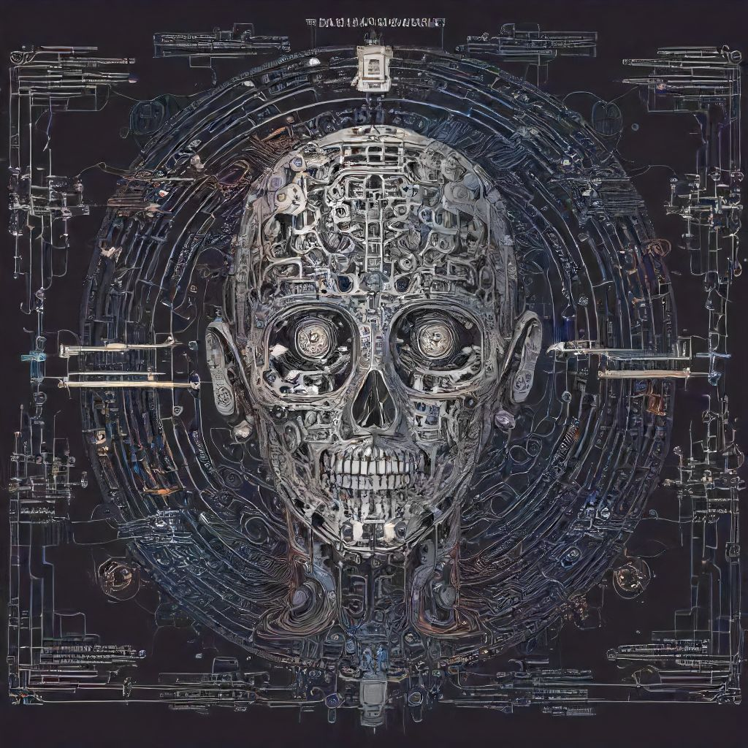

# Chapter 3

Title: The Coding Advantages: A Comprehensive Guide to the Future of Technology by Anthony Snider **Chapter Three: Delving Deep into AI and ML:** Anthony, our intrepid protagonist, sat at his computer, hands poised above the keyboard. The sun was setting, casting long shadows over the quiet room. The gentle hum of the machine filled the silence. His mind raced as he prepared to explore the intricacies of Artificial Intelligence (AI) and Machine Learning (ML), the two technological giants that were shaping the future. The first rays of curiosity led him to AI, the technology designed to create machines or software capable of thinking and learning. He started by understanding the various types - reactive machines, limited memory machines, theory of mind machines, self-aware machines, and superintelligent machines. Each type represented a stepping stone in the evolution of artificial intelligence, but it was the last one that held the most promise and posed the greatest challenge. Anthony then delved deep into ML, a subset of AI that enables systems to learn from data without being explicitly programmed. He explored various ML algorithms - supervised learning (SL), unsupervised learning (UL), semi-supervised learning (SSL), reinforcement learning (RL), and deep learning (DL). Each algorithm provided unique capabilities, enabling machines to perform complex tasks with increasing accuracy and efficiency. As he delved deeper into these concepts, the room began to fill with an electric buzz of ideas and possibilities. He found himself in a world of endless potential where data was the new oil and knowledge was the new gold. But with great power came great responsibility. The consequences of creating intelligent machines could be immense, both good and bad. Anthony's thoughts were interrupted by his computer pinging - a new message had arrived from his colleague, Dr. Jane Williams. She wanted to discuss the latest research on AI ethics and their potential impact on society. As he closed the chapter on ML, Anthony realized that this was just the beginning of an incredible journey. The future of technology held endless opportunities, but it also required a deep understanding of the ethical implications of AI and ML advancements. The room grew quiet once again as Anthony began to ponder over these new insights, ready to embark on the next chapter of his exploration into the fascinating world of coding advantages in AI and ML.

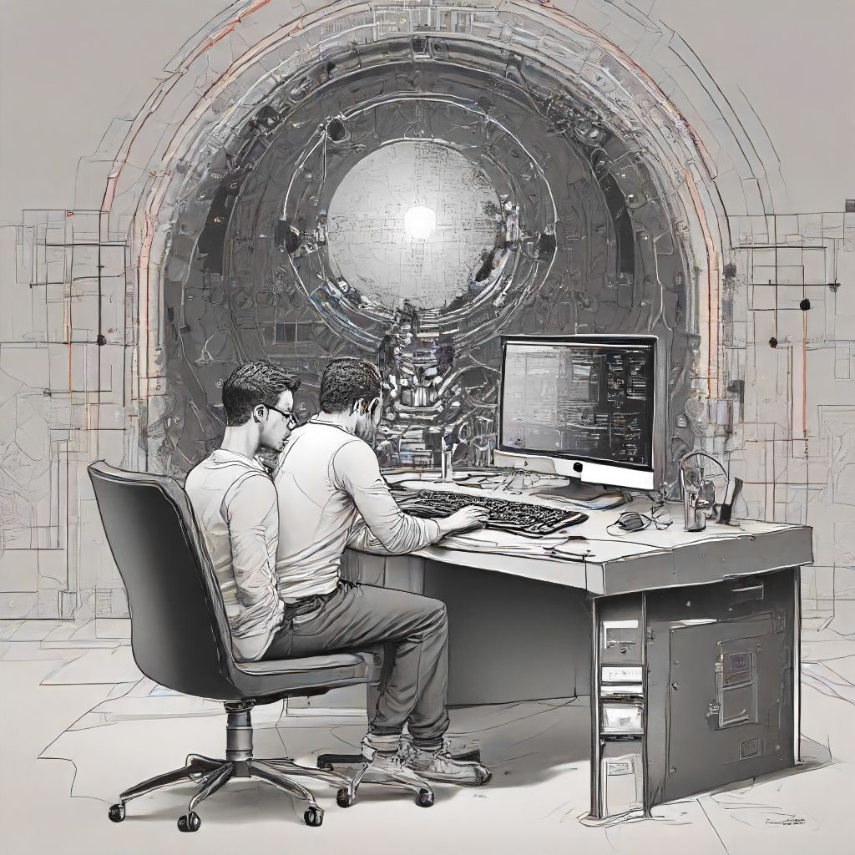

# Chapter 4

Title: The Coding Advantages and Advancements in AI and ML: A Comprehensive Guide to the Future of Technology **Chapter Four: Delving Deeper into Neural Networks** Anthony Snider sat at his workstation, his gaze fixed on the screen as he delved deeper into the intricacies of neural networks. Having spent weeks gaining a solid foundation in artificial intelligence and machine learning, he was now ready to explore one of their most powerful applications: deep learning. "Deep learning is essentially a subset of machine learning that has network architectures composed of three or more hidden layers," he explained to his students in the online course he was teaching. "These neural networks are capable of modeling complex patterns and relationships." Anthony recalled his early days as a computer programmer when neural networks were a subject of fascination for him. He remembered the first time he heard about the Perceptron, a simple single-layer binary classification model, and how it evolved into multilayer perceptrons (MLP) and finally deep neural networks (DNN). "Neural networks learn from data through a process called training," Anthony continued. "They use algorithms to optimize their internal parameters based on the provided input data. One popular optimization algorithm for training deep neural networks is backpropagation." His students watched, rapt, as he demonstrated how backpropagation works. The process involves calculating the error of each neuron in the network and adjusting its weights accordingly to minimize that error. This technique allows deep neural networks to learn increasingly complex patterns and relationships in data. As they explored various deep learning architectures, such as Convolutional Neural Networks (CNN) for image processing and Recurrent Neural Networks (RNN) for sequence-to-sequence data, the students found themselves at the cutting edge of technology. They marveled at how these neural networks could identify objects in images or translate speech into text with incredible accuracy. Anthony guided them through real-world applications of deep learning, including AlphaGo, a computer program that uses deep learning to beat a professional Go player. He explained the concept of Generative Adversarial Networks (GAN), which can generate new data that looks similar to existing data, and how these networks could revolutionize industries like fashion, art, and even video games. The students' minds were racing with ideas as they explored the future possibilities of deep learning. They envisioned a world where self-driving cars became commonplace, where robots could learn to perform tasks autonomously, and where chatbots could understand human emotions. As the course continued, Anthony encouraged his students to explore these advancements further, urging them to dive deeper into the wondrous world of AI and ML. He reminded them that they were part of a revolution in technology, a future where the impossible became possible, and the boundary between man and machine would continue to blur.

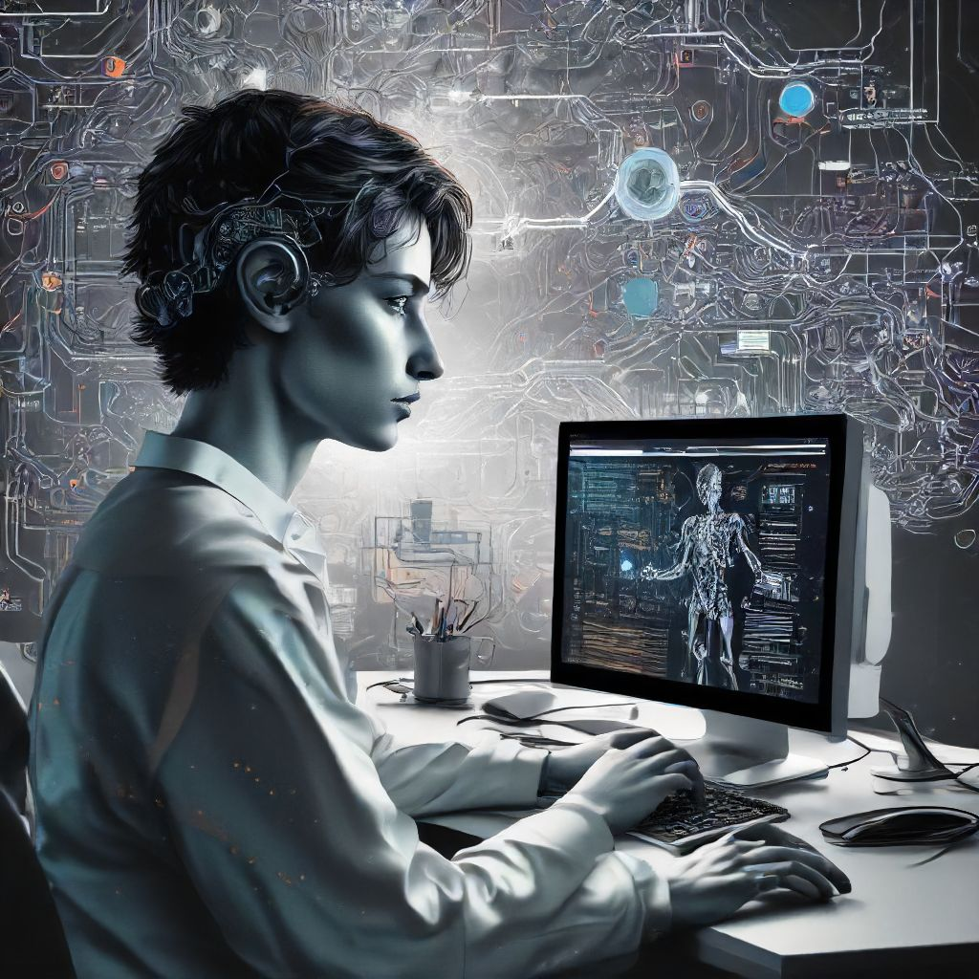

# Chapter 5

Title: The Coding Advantages and Advancements in AI and ML: A Comprehensive Guide to the Future of Technology Author: Anthony Snider Chapter Five: The Evolution of Deep Learning: Unleashing the Power of Neural Networks The sun had set over Silicon Valley, casting an ethereal glow over the sprawling campuses of tech giants. In a secluded corner of one such campus, a team of dedicated researchers huddled around their workstations, their eyes glued to the flickering screens before them. Their fingers danced across keyboards and mice, weaving intricate lines of code that brought their latest creation to life. Anthony Snider, our intrepid author, strode into the room. His arrival was met with a chorus of greetings from his colleagues, who eagerly shared updates on their progress. "So," Anthony began, his voice filled with excitement, "what have we managed to unlock in the world of deep learning this week?" Among them gathered were Dr. Amelia Patel, an expert in neural networks; Dr. Rajesh Gupta, a pioneer in machine perception; and Dr. Maya Rodriguez, who had made significant strides in natural language processing. The air was thick with anticipation as each took turns sharing their latest discoveries. "I've discovered a new way to optimize convolutional neural networks using batch normalization," Amelia shared, her voice brimming with pride. "It significantly reduces internal covariate shift, allowing our models to converge faster and more accurately." Rajesh nodded in approval, sharing his own breakthroughs. "I've been experimenting with recurrent neural networks that incorporate long short-term memory cells," he said. "They have shown remarkable performance in solving complex sequential problems, like speech recognition." Maya added to the conversation, her eyes gleaming with enthusiasm. "My latest work focuses on improving sentiment analysis through deep learning models and advanced text vectorization techniques," she explained. "I've seen impressive results when it comes to accurately gauging the emotional tone of social media posts." Anthony listened intently, his mind racing at the possibilities that could emerge from these discoveries. He knew that deep learning, with its ability to model complex patterns and relationships within data, held immense potential for revolutionizing various industries, from healthcare and finance to education and entertainment. "These are indeed significant advancements," he acknowledged. "But let's not forget about the bigger picture: how do we apply these discoveries in a way that benefits humanity?" The team nodded in agreement, recognizing the importance of their work extending beyond academic curiosity. With renewed vigor, they continued to explore the vast frontier of deep learning, driven by the belief that technology could be used as a catalyst for progress and positive change. As the evening wore on, Anthony captured every detail of their discussions in his notebook. He knew that this was just the beginning – a tantalizing glimpse into the future of AI and ML, brimming with untold opportunities and challenges. And he couldn't wait to see where their collective efforts would lead them next.

