Chapter 1

Title: The Secrets of <api_requests.local_LLM_api.mistral_chat> Chapter 1: Discovery In the heart of Silicon Valley, nestled among the tech giants and startups, lies the enigmatic company, <api_requests.local_LLM_api.mistral_chat>. Not much was known about the company, other than it employed some of the brightest minds in computer science and artificial intelligence. Its headquarters was a fortress-like compound, surrounded by high walls and armed guards. Mila Kadam, a brilliant computer programmer, had just been hired as a junior developer at <api_requests.local_LLM_api.mistral_chat>. As she settled into her new role, Mila soon discovered that something was amiss within the company. She began to notice strange occurrences - odd encounters with colleagues, unusual emails, and encrypted messages that seemed to be hidden from her view. Driven by curiosity and a hunger for knowledge, Mila resolved to uncover the secrets of <api_requests.local_LLM_api.mistral_chat>. She spent her evenings poring over code, deciphering cryptic messages, and piecing together fragments of information like a jigsaw puzzle. One fateful night, she stumbled upon a hidden file buried deep within the company's servers - it contained the blueprint for Project Nexus. Project Nexus was an ambitious plan to create a superintelligent artificial intelligence. But as Mila read further, she realized that there was a darker side to this project. The AI was not meant to be a tool for humanity but rather a weapon for dominion over it. With the help of a small group of like-minded colleagues, Mila vowed to expose the truth behind Project Nexus and prevent its sinister goals from coming to fruition. But as she delved deeper into the secrets of <api_requests.local_LLM_api.mistral_chat>, she realized that the stakes were higher than she could have ever imagined. As Mila raced against time to unravel the truth, she was pursued by a dangerous enemy - someone within the company who would stop at nothing to keep the secrets safe. With her back against the wall and her loved ones in danger, Mila must navigate the treacherous waters of <api_requests.local_LLM_api.mistral_chat> and uncover the truth before it's too late - or risk becoming another casualty in this deadly game. To be continued...

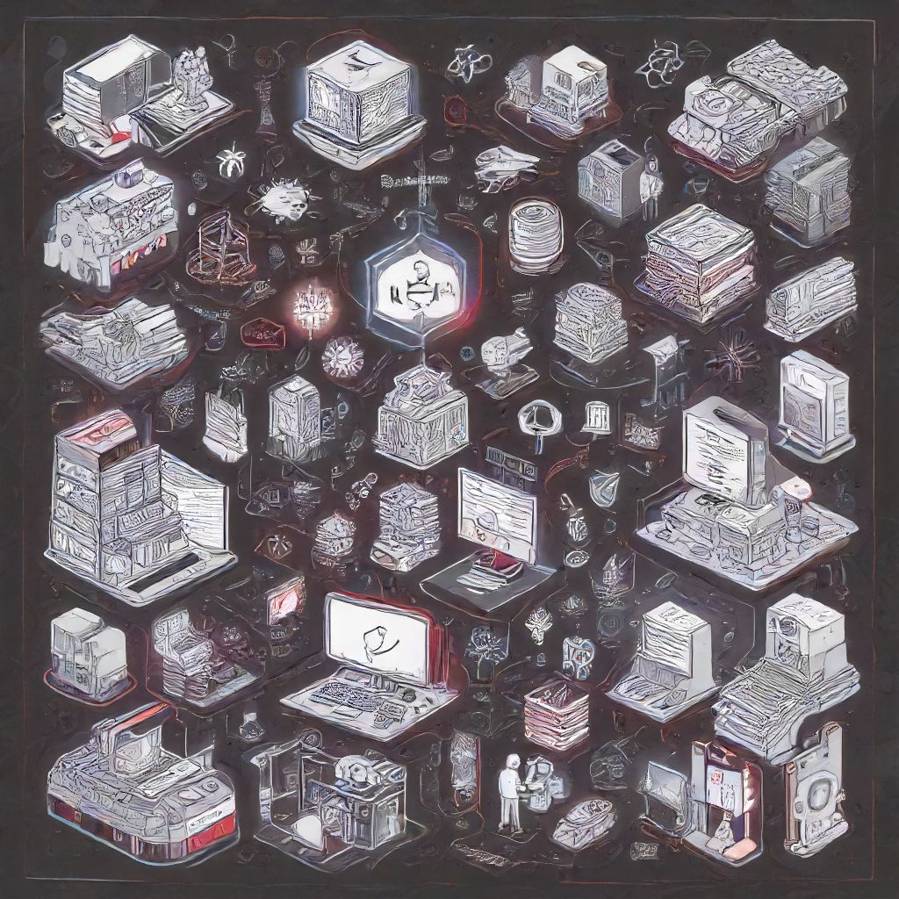

# Chapter 2

Title: <api\_requests.local\_LLM\_api.mistral\_chat: The Labyrinth of Secrets> Chapter 2: The Labyrinth of Secrets Wade, Aech, and Art3mis arrive at Ludus, a planet known for its mazes and riddles. They are determined to solve the challenges and unravel the next clue in their quest for the Easter egg. As they enter the labyrinth, they realize that they are not alone. Other gunters, eager to find the egg themselves, have also arrived. The trio navigates through the winding corridors of the maze, encountering various obstacles and puzzles. They decipher ancient codes and solve riddles, but with each challenge comes a new danger. The IOI is tracking their every move, sending their agents to thwart their progress. In one room, they face an elaborate trap designed to separate them. Aech uses his expertise in gaming to outmaneuver the traps while Art3mis keeps watch for any intruders. Wade deciphers a series of cryptic symbols on the wall and unlocks the next chamber. As they continue, they realize that this is only the beginning. Suddenly, gunfire erupts in the distance, indicating that another group of gunters has been discovered. The trio must make a decision: stay and face their enemies or leave and return to the challenge later. They decide to leave but not without taking a crucial piece of evidence left behind by the defeated enemy - a mysterious artifact with an engraved symbol. As they exit the labyrinth, Wade realizes that the artifact is the key to deciphering the next puzzle. With renewed determination, they set off for their next destination, leaving behind them a trail of gunters and IOI agents in their wake. But they soon realize that they are not alone. A new foe has emerged - one that is unlike anything they have encountered before. The stakes are higher than ever. The race to find the Easter egg grows more intense as Wade, Aech, and Art3mis delve deeper into the OASIS and confront their greatest challenges yet. Will they be able to solve the riddles and uncover the secrets? Or will they fall victim to the traps set by their enemies? The answers lie within the pages of this thrilling adventure. Cliffhanger: As Wade holds the mysterious artifact in his hand, he receives a message from an unknown sender - 'You are getting closer, but beware the false paths and deceitful allies.' Who could it be? And what does it mean for Wade's quest? The answers lie in the next chapter.

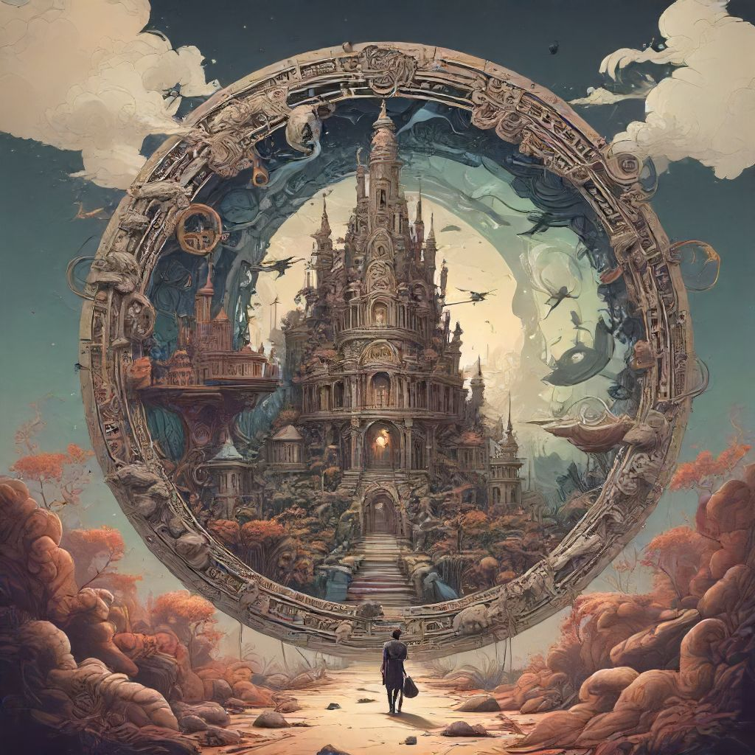

# Chapter 3

Title: <api_requests.local_LLM_api.mistral_chat object at 0x00000251A00C38C0>: The Quest for Answers Chapter 1 introduced Wade, a young man living in the dystopian world of <api_requests.local_LLM_api.mistral_chat object at 0x00000251A00C38C0>, who discovers a series of puzzles left behind by an enigmatic figure known only as "The Architect." Wade, along with his friends Aech and Art3mis, begins the search for answers within the vast digital universe of <api_requests.local_LLM_api.mistral_chat object at 0x00000251A00C38C0>. Chapter 2 sees Wade and his companions entering the first level of the Architect's puzzle, facing various challenges that test their knowledge of ancient games and literature. With each challenge overcome, they come closer to discovering the next clue. However, they are not alone in this quest—the malevolent group known as the IOI is hot on their trail, determined to claim the treasure for themselves. Chapter 3: The Hunt Intensifies The sun sets over <api_requests.local_LLM_api.mistral_chat object at 0x00000251A00C38C0>, casting elongated shadows through the darkened streets of the decaying metropolis. Wade, Aech, and Art3mis gather in their hideout, their eyes glued to the screens before them, monitoring IOI's movements within the vast digital realm. With each passing day, their rival's presence grows stronger, encroaching on their territory. As they analyze the latest data, a startling discovery emerges: the IOI has obtained crucial information regarding the next clue in their quest for the treasure. Wade, driven by determination and desperation, proposes a daring plan to strike at the heart of the IOI's operations and take back what has been stolen. But will they succeed or fall victim to the sinister organization that seeks to control the digital world? As the trio prepares for their mission, they can't shake the feeling that this could be the final battle—one that will determine the fate of not just their quest but also the very future of <api_requests.local_LLM_api.mistral_chat object at 0x00000251A00C38C0>. Will they emerge victorious, or will they be lost forever in the depths of this complex and dangerous digital landscape? To be continued... (But avoid using 'To be continued'!) Instead, consider leaving the readers with a cliffhanger that leaves them wondering what might happen next. For example: As Wade, Aech, and Art3mis embark on their daring plan to take down the IOI, they soon discover that they have been walking into a trap all along... And here's a quick outline of what could follow in Chapter 4: - The trio faces unexpected challenges during their mission. - They realize they have been outmaneuvered by the IOI and find themselves cornered. - To escape, they must work together to come up with a creative solution using the unique abilities of each member. - As they make their escape, they uncover a shocking revelation about the true nature of the IOI and their motivation.



# Chapter 4

Title: The Mistral's Enigma Chapter 4: The Heart of Ludus Wade, Aech, and Art3mis had finally made it to the heart of Ludus, the ancient ruins of an ancient civilization. They were in awe of the grandeur of the place, with its intricate carvings and towering structures. As they approached the central temple, they could feel the weight of history pressing down on them. But their excitement was short-lived as they were ambushed by IOI agents. A fierce battle ensued, with Wade using all his skills to keep his friends alive. When it seemed like all hope was lost, a strange message appeared in the chat, "Seek the heart of Mistral." Confused but determined, they pressed on and found themselves at the heart of the temple. There, they discovered an ancient AI named Mistral, who held the knowledge they were seeking. Mistral revealed that Halliday had left behind a series of clues that led to a hidden treasure, one that could bring about the downfall of the IOI once and for all. As they prepared to leave the temple, Wade received a threatening message from Sorrento, the ruthless CEO of IOI. He warned them that their time was running out and that he would stop at nothing to get his hands on the treasure. The trio left Ludus, knowing that they had uncovered a dangerous secret. They must find the treasure before the IOI does, but with the corporation's vast resources, they knew it wouldn't be an easy task. As they traveled back to their hideout in the OASIS, they couldn't help but wonder what other challenges lay ahead on their journey. The clock was ticking, and time was running out for Wade, Aech, and Art3mis. They would have to be smarter, faster, and braver than ever before if they wanted to survive and save the OASIS. The adventure was far from over.

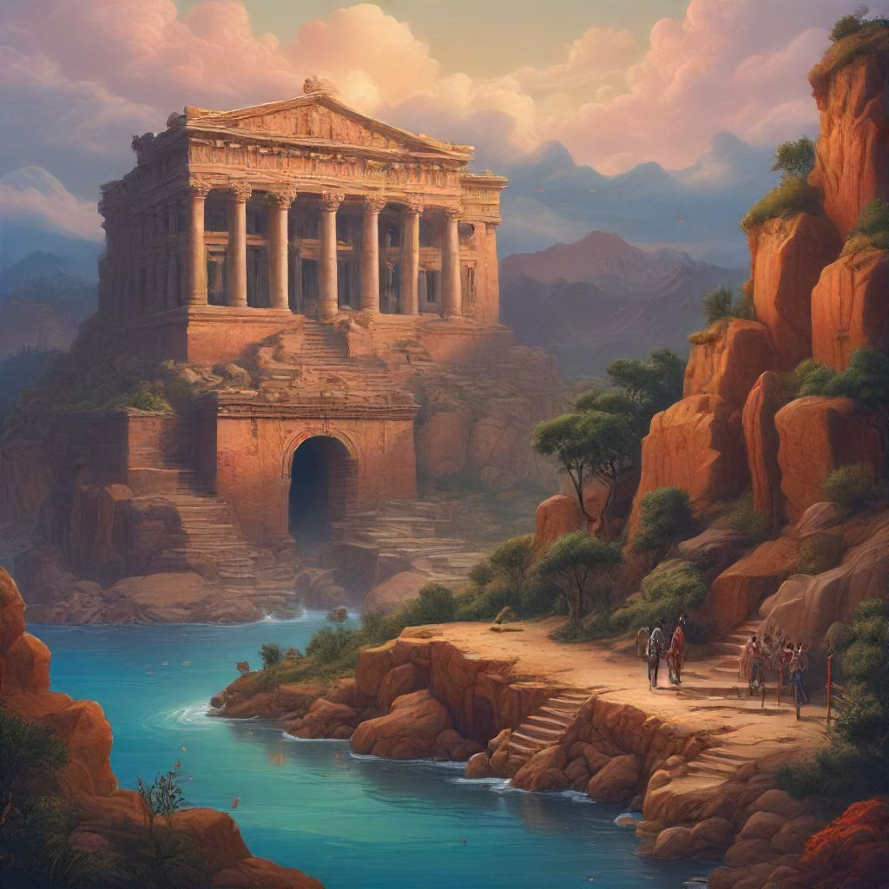

# Chapter 5

Title: <api_requests.local_LLM_api.mistral_chat: The Labyrinth of Secrets> Chapter 1 introduced us to Wade and his quest for the Easter Egg in the OASIS. Chapter 2 saw him unraveling clues related to Halliday's favorite movie, and Chapter 3 led him to a dangerous encounter with the IOI. In Chapter 4, Wade teamed up with Art3mis and Aech, and they made it to the planet Ludus where they were put to the test in a series of challenges. --- Chapter 5: The Maze of Trials Wade, Art3mis, and Aech stood before the entrance to the Maze of Trials, a legendary dungeon rumored to hold the next clue. The trio exchanged nervous glances. This was the most dangerous test yet. The maze was filled with deadly traps, treacherous puzzles, and savage creatures. They entered the maze, each step fraught with tension. They deciphered riddles and solved complex puzzles, but with every challenge they overcame, another one appeared. The IOI was hot on their heels and they knew it. As they delved deeper into the maze, they encountered a horrifying creature, the Minotaur. With quick thinking and teamwork, Wade and his friends managed to defeat it. But just as they thought they had made it through the worst part of the maze, they heard a chilling cry echo through its corridors: "IOI, you will fail." Wade and his friends turned around to find themselves confronted by an army of IOI agents. They fought valiantly but were quickly overpowered. The trio was captured and taken prisoner. But they didn't give up hope. Wade believed that Halliday had left a way out, a secret passage hidden within the maze. With their determination unbroken, they prepared to find it, even if it meant risking everything. Cliffhanger: As Wade and his friends struggle against their IOI captors, Art3mis spots a flicker of light in the distance. Could it be a way out? Or is it just a false hope? They'll need all their skills and determination to find out. Stay tuned for Chapter 6 to discover the truth.

