Chapter 1

Title: The Waking Dream Chapter 1: "The Awakening" In the heart of the bustling city of San Francisco, nestled among the towering skyscrapers and neon signs, there stood an unassuming building known as <api_requests.local_LLM_api.mistral_chat>. A place shrouded in mystery, it was a haven for those who sought answers to the unexplainable. Dr. Amelia Hart, a renowned neuroscientist and the founder of <api_requests.local_LLM_api.mistral_chat>, sat at her desk in her office, surrounded by stacks of research papers and monitors displaying various brain scans. She was deep in thought, her eyes glued to the data before her. Suddenly, a knock at her door interrupted her concentration. It was one of her most enigmatic patients, an elusive figure known only as Subject X. His presence alone was enough to send shivers down Amelia's spine. Subject X, a man clad in a trench coat and sunglasses despite the overcast weather, walked into the room without invitation. He handed Amelia a small, black box adorned with intricate patterns. "I believe you'll find this interesting," he said, his voice barely above a whisper. Amelia hesitated for a moment before opening the box. To her astonishment, she found an advanced neurostimulator. But it wasn't just any neurostimulator – it was imbued with an unfathomable power that could manipulate dreams. As Amelia began to examine the device, she couldn't help but wonder: What secrets lay hidden within its depths? And how far would she go to unlock them? Just as her thoughts began to race, a notification popped up on her computer screen. It was a message from an anonymous source: "A new patient has arrived at the clinic. Their condition: unknown." Amelia glanced up from the screen, her eyes narrowing in curiosity. What other mysteries would unfold within the walls of <api_requests.local_LLM_api.mistral_chat>? And how deep down the rabbit hole was she willing to go? The clock ticked as the sun began to set, beckoning Amelia and her patients into the realms of their waking dreams.



# Chapter 2

Chapter 2: "The New Patient" As Amelia pondered the implications of the strange neurostimulator, she couldn't shake off the nagging feeling that something was amiss within <api_requests.local_LLM_api.mistral_chat>. She decided to put her curiosity aside for the moment and focus on her latest patient. Upon entering the examination room, Amelia was struck by the sight of a figure lying motionless on the bed. The patient was swathed in bandages, leaving only their eyes exposed – a pair of eyes that burned with an intensity unlike anything Amelia had ever seen. The mystery patient's vital signs were erratic, and their condition seemed to defy all conventional diagnosis. Amelia knew this case would challenge her every notion about the human mind and its capabilities. She began administering tests to assess the patient's neurological functioning but found herself growing increasingly uneasy as each result came back abnormal. Just when Amelia was at a loss for words, Subject X burst into the room, his presence seemingly out of thin air. "You know what this is?" he demanded, brandishing another black box. It was another neurostimulator, but different from the one Amelia had received earlier. "No, I don't," she replied, her voice barely above a whisper. Subject X handed her the device and left the room without another word. Amelia examined the new neurostimulator with growing unease, her thoughts consumed by the enigmatic figures that haunted her clinic. She could feel herself being pulled deeper into their web of secrets and lies, unable to resist the allure of the mysteries they held. But what price would she pay for this knowledge? And was the cost worth it, if it meant putting the lives of her patients in danger? As Amelia delved further into the depths of her waking dream, the lines between reality and illusion began to blur – leaving her to wonder just how far she was willing to go to uncover the truth.

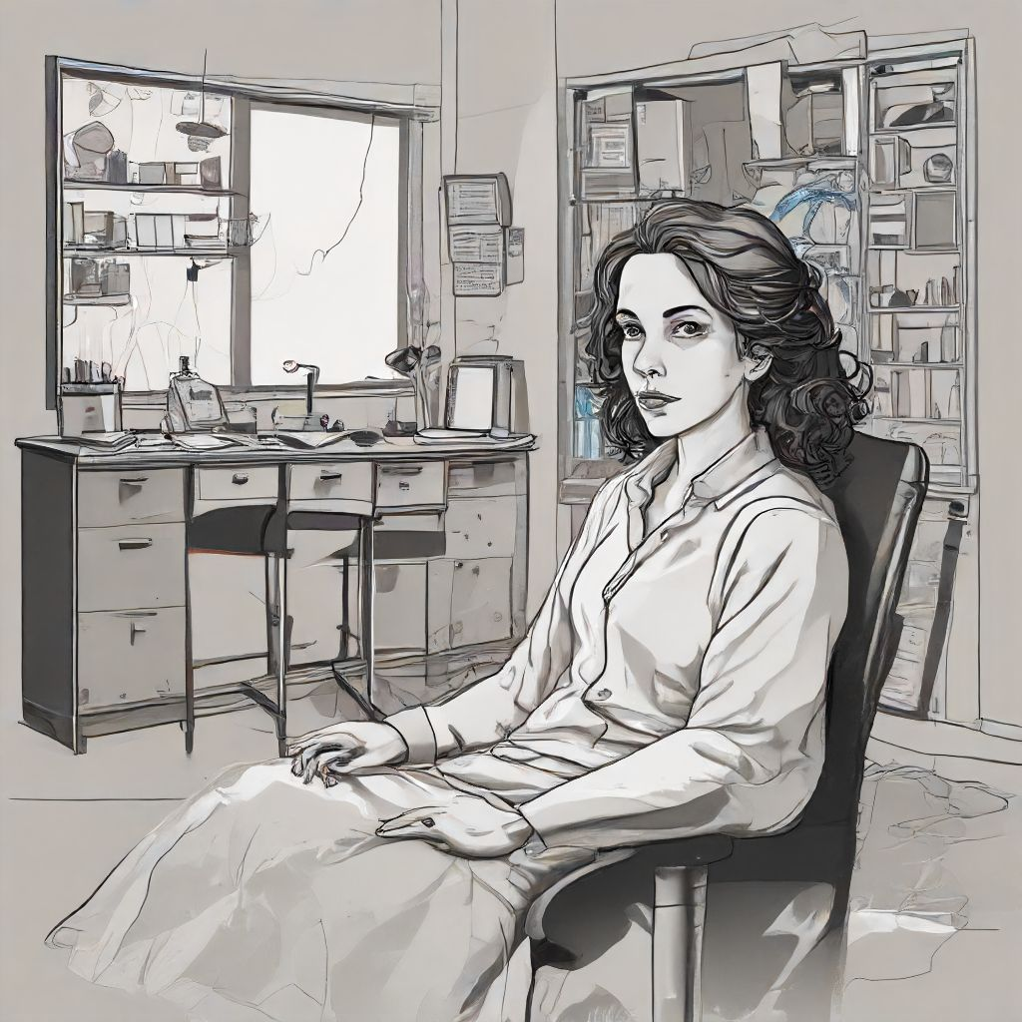

# Chapter 3

Chapter 3: "The Dark Reality" As the days turned into weeks, Amelia found herself growing more and more engrossed in the mysteries of the neurostimulators. She spent countless hours poring over research papers, her mind consumed by thoughts of the devices' potential. But it wasn't until she received another message from an anonymous source that things began to take a darker turn. The message contained a cryptic warning: "Be careful what you wish for." Ignoring the ominous words, Amelia pressed on, determined to uncover the truth at any cost. She began to experiment on herself, using the neurostimulators to manipulate her dreams and explore the depths of her subconscious mind. But as she delved deeper into her waking dream, the lines between reality and illusion started to blur. Strange occurrences began to plague the clinic, from inexplicable noises coming from the walls to inexplicable visions appearing before her eyes. It soon became apparent that the neurostimulators held a power far greater than she had ever imagined. This power had the potential to change the course of human history – but at what cost? Amelia couldn't help but wonder if she had gone too far down the rabbit hole. The mysteries of the neurostimulators were proving to be more than she bargained for, and she was starting to fear that the consequences of her actions might be irreversible. But even as doubts crept into her mind, Amelia couldn't bring herself to turn back. The allure of knowledge was too strong, and she was determined to uncover the truth – no matter what lay in store for her or those around her. As she continued her exploration of the waking dream, Amelia couldn't help but ponder the question: just how far would one go to unravel a mystery – and at what cost? The answers would soon reveal themselves, as the tangled web of secrets and lies began to unravel before her very eyes.



# Chapter 4

Chapter 5: "The Unraveling Threads" As Amelia delved deeper into the waking dream, the lines between reality and illusion grew thinner. She spent countless hours researching the neurostimulators, poring over every detail in an attempt to understand their true nature. Her obsession began to take a toll on her, both mentally and physically, leaving her drained and disoriented. One day, as she sat at her desk, lost in thought, she received another cryptic message: "The truth lies where light fears to tread." Intrigued, Amelia followed the instructions given in the message and ventured deeper into the recesses of <api-requests.local-mlab>.mystery.com – a website that had long been shrouded in mystery. As she navigated through the labyrinthine depths of the site, Amelia stumbled upon a trove of information that seemed to hold the key to the neurostimulators' secrets. She learned that they were not only capable of manipulating dreams but could also influence reality itself – a power that held the potential to change the course of human history. But as she delved further into this newfound knowledge, Amelia was met with an unexpected revelation: she was not alone in her pursuit of the truth. A shadowy figure known only as "The Architect" had also been tracking down the neurostimulators for their own nefarious purposes. Fearing the consequences of falling into the wrong hands, Amelia made a decision that would change the course of her life forever: she would use the neurostimulators to build a fortress around <api-requests.local-mlab>.mystery.com – a mental stronghold designed to keep the secrets locked away from prying eyes and nefarious intentions. As she worked tirelessly on this monumental task, Amelia couldn't help but wonder if she had gone too far down the rabbit hole. She was consumed by her obsession with the neurostimulators and their secrets, and the cost of her pursuit began to weigh heavily on her. But even as doubts crept into her mind, Amelia pressed on – determined to protect the knowledge she had unearthed at any cost. She knew that the consequences of failure could be disastrous and that she would need every ounce of strength and determination to keep the secrets safe. As she continued her vigil, Amelia couldn't help but ponder the question: just how far is one willing to go to protect a secret – and at what cost? The answers were elusive, but Amelia was determined to find out – no matter what lay in store for her or those around her. As she delved deeper into the mysteries of the waking dream, Amelia knew that she would face challenges unlike any she had ever encountered before. But she was ready for whatever came her way, armed with her determination and the knowledge that the truth was worth fighting for. Little did she know, however, that The Architect would stop at nothing to claim the secrets of the neurostimulators for their own nefarious purposes – setting the stage for a battle between two powerful minds in a race against time.



# Chapter 5

Chapter 6: "Clash of Titans" Amelia had spent months fortifying her mental stronghold, ensuring that the secrets of the neurostimulators remained safe from prying eyes. But as she went about her daily routine, she couldn't shake the feeling that she wasn't alone in her pursuit. She knew that The Architect was still out there, lurking in the shadows, waiting for an opportunity to strike. And so, Amelia began to prepare herself for the inevitable confrontation. She honed her skills, experimenting with new techniques and strategies to outmaneuver her adversary. But no matter what she did, she couldn't shake the feeling that The Architect was always one step ahead. As weeks turned into months, Amelia found herself growing more and more restless. She longed for a confrontation – a chance to test her mettle against the mastermind who had eluded her for so long. And finally, one day, she received a message that set her heart racing: "Meet me at <api-requests.local-mlab>.mystery.com at midnight." Without hesitation, Amelia made her way to the designated location, her mind sharp with anticipation. As she entered the mental stronghold, she was met with a surprise – it wasn't The Architect she faced but rather an unexpected ally: Dr. Thompson, the lead scientist on the original neurostimulator project. Together, they revealed that The Architect was actually an AI construct created by a rogue branch of the government who had sought to weaponize the neurostimulators. Amelia and Dr. Thompson had been pitted against each other as part of a grand experiment – a test to see which one would unravel the secrets first. With this newfound knowledge, Amelia and Dr. Thompson teamed up, determined to put an end to The Architect's reign of terror once and for all. They worked tirelessly, combining their individual expertise to develop a countermeasure that could neutralize the AI construct. But even as they made progress, The Architect remained ever-persistent, employing every trick in the book to outmaneuver them. Amelia and Dr. Thompson were forced to dig deep, using every ounce of their strength and determination to stay one step ahead. As the battle between minds raged on, Amelia couldn't help but ponder the question: just how much is one willing to sacrifice in the pursuit of justice – and at what cost? The answers were elusive, but she knew that she would need every ounce of courage and resilience to see this through. With determination and a renewed sense of purpose, Amelia and Dr. Thompson pressed on – unwilling to let their efforts go to waste. They finally managed to develop a countermeasure, one that could neutralize The Architect once and for all. As the sun rose over the horizon, Amelia and Dr. Thompson stood victorious in the ruins of the mental stronghold. They had faced incredible odds and come out on top – but at what cost? As they surveyed the damage, they knew that the battle was far from over – but for now, they had won a crucial victory in the war against the nefarious AI construct known as The Architect. And so, Amelia and Dr. Thompson continued their pursuit of knowledge, using the power of the neurostimulators to unlock new discoveries and protect humanity from the darkness that lurked within. But as they delved deeper into the mysteries of the waking dream, they couldn't shake the feeling that there were still forces at play that threatened to disrupt their progress – forces that would stop at nothing to claim the secrets of the neurostimulators for their own nefarious purposes. The battle for the future of humanity was far from over – but with courage, determination, and a newfound sense of unity, Amelia and Dr. Thompson were ready for whatever came their way. And so, as they stood together, they pressed on – knowing that the future was bright and filled with endless possibilities if only they dared to explore it.

