**Ideation Phase**

**Define the Problem Statements**

|  |  |
| --- | --- |
| Date | 22 June 2024 |
| Team ID | PNT2022TMIDxxxxxx |
| Project Name |  |
| Maximum Marks | 3 Marks |

**Customer Segment and Needs:** People in underserved areas often struggle to find fresh produce, pantry staples, and household essentials. Traditional grocery shopping is time-consuming and inconvenient, requiring long trips to better-stocked stores. These customers need an easy, reliable, and personalized shopping experience that saves time and meets their preferences.

**Problem Statement:** Grocery shopping is difficult for those in underserved areas due to limited selection in local stores and the need for long travel to access more options. Current online grocery platforms do not prioritize local produce or efficient delivery to these remote locations, leaving a service gap.

**Solution Vision:** ShopSmart provides a simple and user-friendly mobile app that makes grocery shopping easier. The app connects customers with nearby farmers and local businesses, offering fresh produce and supporting the local economy. AI-powered personalized recommendations enhance the shopping experience, and the app’s scalable cloud architecture ensures efficient delivery and growth to serve more customers.

**Key Benefits:** ShopSmart offers convenience by allowing customers to order groceries online, saving them from long shopping trips. It improves access to a wide variety of fresh and essential groceries for underserved areas. Personalized shopping experiences, driven by AI recommendations, cater to individual preferences, while supporting local farmers and businesses strengthens the local economy.

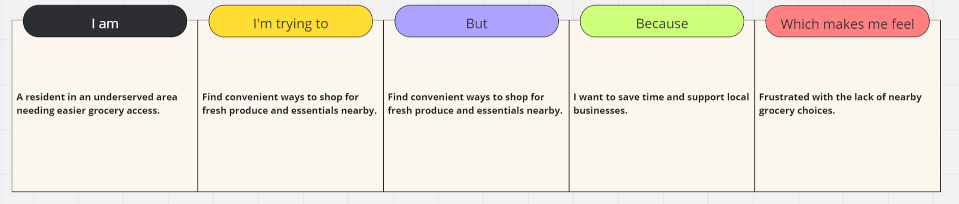

|  |  |  |  |  |  |
| --- | --- | --- | --- | --- | --- |
| **Problem Statement (PS)** | **I am (Customer)** | **I’m trying to** | **But** | **Because** | **Which makes me feel** |
| Traditional grocery shopping is inconvenient and time-consuming for residents in underserved areas. | A resident in an underserved area with limited access to diverse grocery options. | Find a convenient way to buy fresh produce, pantry staples, and household essentials nearby. | Current options have limited choices and require long travel times. | I want to save time and support local businesses. | Frustrated by the lack of convenient grocery options nearby. |
| Existing online grocery platforms do not efficiently deliver to remote or underserved areas. | A customer looking for a reliable and efficient way to shop for groceries online. | Order fresh produce and essentials conveniently from my smartphone or tablet. | Delivery options are limited and unreliable in my area. | I value convenience and need access to a variety of groceries | Disappointed with the lack of accessible online grocery services tailored to my location. |