

SCHOOL OF COMPUTER SCIENCE AND ENGINEERING
REPORT OF THE PROJECT FOR CSE326

TITLE: FITNESS CLUB
SECTION : K19HZ
Roll Number | Name | Registration No
04 | Debojyoti Roy | 11910048
05 | Aryan Sharma | 11910050
06 | Manish Kumar | 11910082

Submitted By

Submitted to
Ms. Manu Bali

PROJECT BREAKUP

Roll No | Reg. No | Name | Work
04 | 11910048 | Debojyoti Roy | Identifying and channelizing the objectives of the project, Checking the system analysis- Economic and Operational Feasibility, Implementation of intrinsic and extrinsic part of web page,  Completion of project report.
05 | 11910050 | Aryan Sharma | Identifying and channelizing the objectives of the project, Checking the system analysis- Technical Feasibility and system functionality, Implementation of landing page, intrinsic and extrinsic part of web page, Completion of project report.
06 | 11910082 | Manish Kumar | Identifying the objective of the project, contribution of images.

TABLE OF CONTENTS

- Introduction.
  - Introduction of the Project.
  - Objectives Of The Project.

- System Analysis
  - Identification Of The Need
  - Preliminary Investigation
  - Feasibility Study
    - Technical Feasibility
    - Economical Feasibility
    - Operational Feasibility
  - Proposed System Functionality

- Data Flow Diagram

- Source Code

- Screen Layouts

- Implementation

- Maintenance

- Conclusion

- Bibliography

SECTION 1

INTRODUCTION

1.1 Introduction to the Project

1.2 Objectives Of The Project

INTRODUCTION TO THE PROJECT

This project is designed to facilitate a gymming and fitness center to automate its operations of keeping records and store them in form of a large and user friendly database further facilitating easy access to the personnel.

OBJECTIVES OF THE PROJECT

What was the Problem?

- Existing system was manual.

- Time consuming as data entry which include calculations took lot of time.

- Searching was very complex as there could be 100’s of entry every year.

- The proposed system is expected to be faster than the existing system.

- The Project was made in order to effectively and efficiently cater to requirements of the fitness center.Very frequently the person who generally holds the tasks to manage the center needs to keep records of all the transactions as well as data mannually . Gennerally, In order to structure these tasks Separate Registers are maintained.This whole process thus becomes quite cumbersome for them to control manually.Moreover,Any wrong data entered mistakenly can brings serious results.

- This Mannually Managed system of the store was also heavily proned to data loss due to certain causes Misplacement of Registers,Destruction of Registers ,Unauthorized access to registers etc. which can bring in disasterous Consquences.

- The cost of maintaince of data and records of occurrence of transactions is very high.

- Searching a particular data specific to particular requirements is also very tedious in such system.In order to retrieve records,The responsible person needs to manually locate the appropriate register and locate the appropriate placement of that particular record which may be very time consuming.

- Data Redundency is also a great issue in such kind of system.”Redundency” means repititon;Thus data modified or updated at a particular place may not be data modified or updated at the other related place which may create inconsistencies in data handling,Destroys Data Integrity and creates confusion for the owner.

SECTION 2

SYSTEM ANALYSIS

2.1 Identification Of The Need

2.2 Preliminary Investigation

2.3 Feasibility Study

2.3.1 Technical Feasibility

2.3.2 Economical Feasibility

2.3.3 Operational Feasibility

2.3.4 Behavioural Feasibility

2.4 Proposed System Functionality
System Analysis refers into the process of examining a situation with the intent of improving it through better procedures and methods. We need to study how it functions currently, what are the problems, and what are the requirements that the proposed system should meet.
System Analysis is conducted with the following objectives in mind:

- Identify the customer’s need.

- Evaluate the system concept for feasibility.

- Perform economic and technical analysis.

- Allocate functions to hardware, software people, database and other system elements.

- Establish cost and schedule constraints.

- Create a system definition that forms the foundation for all the subsequent engineering work.

2.1 Identification of Customer’s Need
Before proceding further ,It becomes very necessary to accumilate the valid and conviencing requirements of the project and communicate the very same to various stakeholders of the project.
This step is initiation of System Analysis. An overview of the client’s requirement has been done. The basic need of the client to opt for such kind of project is analysed. As per current marketing scenario, an entire system was required to track day-to-day transactions.

2.2 Preliminary Investigation
The client set is just a worker(s),who is regularly indulged in manual maintainence transactions,keeping regular records,maintaining the records of fine details of members.
Following manual registers are maintained:

- Member’s Details Register:
This Register is maintained in liu to maintain the records of the various members of the gymming center.The document contains relevant information about the various members such as members’s id, Name,Address,Telephone number.

- Employee’s Details Register:
This Register is maintained in liu to maintain the records of the various employees of the gymming center.The document contains relevant information about the various employees such as employee’s id, Name,Address,Telephone number.

- Inventory Register:
The register is used to record the details of the products(supplements,beverages and apparels supplied and required) such as its ID,Description,Quantity,Price,service date,time period for which it is under maintainence etc.

2.3 Feasibilty Study
Depending on the results of the initial investigation, the survey is expanded to a more detailed feasibility study. The objective of the feasibility study is not to solve the problem but to acquire a sense of its scope . During the study, the problem definition is crystallized and aspects of the problem to be included in the system are determined. Consequently, costs and benefits are described with greater accuracy at this stage.
It consists of the following:

1. Statement of the problem:
A carefully worded statement of the problem that led to analysis.
2. Summary of finding and recommendations:
A list of the major findings and recommendations of the study. It is ideal for the user who requires quick access to the results of the analysis of the system under study. Conclusion are stated , followed by a list of the recommendation and a justification for them .
3. Details of findings :
An outline of the methods and procedures under-taken by the existing system, followed by coverage of the objectives and procedures of the candidate system. Included are also discussions of output reports, file structures, and costs and benefits of the candidate system.

4. Recommendations and conclusions:
Specific recommendations regarding the candidate system, including personnel assignments, costs, project schedules, and target dates.

2.3.1 Technical Feasibility
Technical feasibility centers around the existing computer system (Hardware and Software etc) and to what extend it support the proposed addition. For example, if the current computer is operating at 80 percent capacity - an arbitrary ceiling - then running another application could overload the system or require additional Hardware. This involves financial considerations to accommodate technical enhancements. Using a key the display of text/object is very fast. Also, the tools, operating system and programming language used in this localization process is compatible with the existing one.

2.3.2 Economical Feasibility
Economic analysis is the most frequently used method for evaluating the effectiveness of the candidate system. More commonly known as cost/benefit analysis, the procedure is to be determining the benefits and savings that are expected from a candidate and compare them with costs.

A systems financial benefit must exceed the cost of developing that system. i.e. a new system being developed should be a good investment for the organization. Economic feasibility considers the following:
i. The cost to conduct a full system investigation.
ii. The cost of hardware and software for the class of application.
iii. The benefits in the form of reduced cost or fewer costly errors.
iv. The cost if nothing changes (i.e. The proposed system is not developed).

The proposed SYSTEM is economically feasible because
i. The system requires very less time factors.
ii. The system will provide fast and efficient automated environment instead of slow and error prone manual system, thus reducing both time and man power spent in running the system.
iii. The system will have GUI interface and very less user training is required to learn it.
iv. The system will provide service to view various information if required for some decision making.

2.3.3 Operational Feasability
This Application is very easy to operate as it is made user friendly with the help of very effective GUI tools . Main consideration is user’s easy access to all the functionality of the Application.Another main consideration is here is that whether user organization is trained enough to use the newer application. Here every functionality is As per previous operational strategy which is not expected to be cumbersome to the potential clients.

2.3.4 Behavioural Feasibility

People are inherently resistant to change, and computers have been known to facilitate change. An estimate should be made of how strong a reaction the user staff is likely to have toward the development of a computerized system. Therefore it is understandable that the introduction of a candidate system requires special efforts to educate and train the staff.The software that is being developed is user friendly and easy to learn.In this way, the developed software is truly efficient and can work on any circumstances ,tradition ,locales.
Behavioral study strives on ensuring that the equilibrium of the organization and status quo in the organization are nor disturbed and changes are readily accepted by the users.

2.4 Proposed System Functionality

The proposed system will be designed to support the following features:-

- The proposed system has a user friendly Interface for porting of data to server.

- The proposed system provides the facility to pull the data from the server using a key (such as id) and get the desired report.

- The proposed system provides the no replication of data
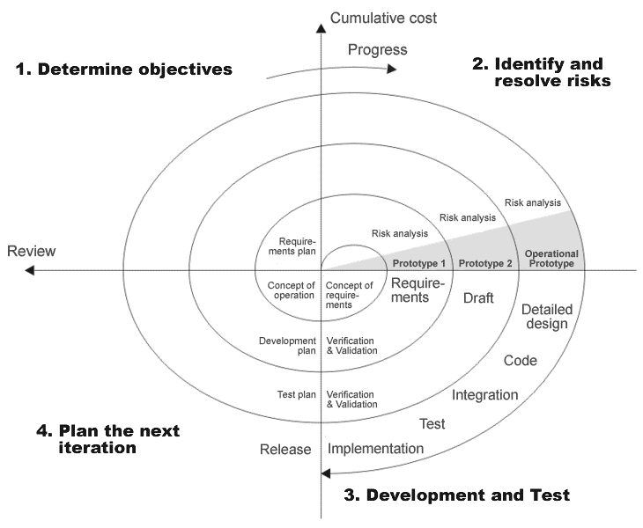

SECTION 3

DATA FLOW DIAGRAM (DFD)

The Context Diagram or the Zero Level DFD.

Member details
Database Operations on MEMBERS record

GYM CENTER’S RECORD MANAGEMEN-T SYSTEM
Member list

Database Operations on EMPLOYEES record
Member’s Record
Reciept

Database Operations on INVENTIRY record

Employee details

Employee schedule

IInventory(orders and products)

SECTION 4

SOURCE CODE

<!DOCTYPE html>
<html lang="en">

<head>
<meta charset="UTF-8">
<meta name="viewport" content="width=device-width, initial-scale=1.0">
<title> OUR Fitness club </title>
<link href="https://fonts.googleapis.com/css2?family=Bree+Serif&display=swap" rel="stylesheet">
<link href="https://fonts.googleapis.com/css2?family=Baloo+Bhai+2:wght@700&display=swap" rel="stylesheet">
<style>
/* CSS reset */
* {
margin: 0;
padding: 0;
}

/* Testing Dropdown */
li a,
.dropbtn {
display: inline-block;
color: white;
text-align: center;
padding: 14px 16px;
text-decoration: none;
}

li a:hover,
.dropdown:hover .dropbtn {
background-color: rgb(15, 9, 105);
}

li.dropdown {
display: inline-block;
}

.dropdown-content {
display: none;
position: absolute;
background-color: #292727;
min-width: 160px;
box-shadow: 18px 15px 16px 16px rgba(244, 244, 245, 0.2);
z-index: 1;
}

.dropdown-content a {
color: black;
padding: 12px 16px;
text-decoration: none;
display: block;
text-align: left;
}

.dropdown-content a:hover {
background-color: #f1f1f1;
}

.dropdown:hover .dropdown-content {
display: block;
}

/* CSS variables */
:root {
--navbar-height: 60px;
}

/* Navigation bar */
#navbar {
display: flex;
align-items: center;
position: fixed;
top: 0px;
}

/*NAVIGATION BAR logo and imag */
#logo {
margin: 34px 35px;
}

#logo img {
width: 150px;
height: 100px;
margin: -30px -16px
}

/* NAVIGATIONS BAR : list styleing */

#navbar ul {
display: flex;
padding: 15px;
font-family: 'Baloo bhai', cursive;
}

#navbar::before {
content: "";
background-color: rgb(8, 8, 8);
position: absolute;
top: 0px;
left: 0px;
height: 100%;
width: 100%;
z-index: -1;
opacity: 0.7;
}

#navbar ul li {
list-style: none;
font-size: 1.4rem;
margin: auto;

}

#navbar ul li a {
color: blanchedalmond;
text-shadow: 2px 2px 5px red;
display: block;
padding: 4px 13.9px;
border-radius: 20px;
text-decoration: none;
cursor: pointer;

}

#navbar ul li a:hover {
color: black;
background-color: rgb(74, 140, 194);
}

/* Home section */
#home {
display: flex;
flex-direction: column;
padding: -60px 200px;
height: 750px;
justify-content: center;
align-items: center;
}

#home::before {
content: "";
background-image: url(https://images.pexels.com/photos/841130/pexels-photo-841130.jpeg?auto=compress&cs=tinysrgb&dpr=2&h=650&w=940);
position: absolute;
top: 0px;
left: 0px;
height: 100%;
width: 100%;
z-index: -1;
opacity: 0.899;
}

#home h1 {
color: rgb(13, 13, 13);
text-align: center;
font-family: 'Baloo bhai', cursive;
}

#home p {
color: rgb(7, 7, 7);
text-align: center;
font-size: 2.3rem;
font-family: 'Bree Serif', serif;
}

#register-now {
text-decoration: none;
color: honeydew;
padding: 40px;

}

#register-now:hover {
text-decoration: none;
color: rgb(0, 0, 0);
font-size: 2.5rem;

}

/* utility classes */
.h-primary {
font-size: 3.1rem;
padding: 14px;
}

.h-secondary {
font-size: 2.9rem;
padding: 14px;
}

.btn {
padding: 6px 20px;
border: 2px solid rgb(41, 40, 40);
border-radius: 25px;
background-color: rgb(74, 140, 194);
color: black;
margin: 18px;
font-size: 2.4rem;
font-family: fantasy;
cursor: pointer;

}

.btn:hover {
padding: 6px 20px;
border: 2px solid rgb(41, 40, 40);
border-radius: 25px;
background-color: rgb(39, 108, 165);
color: black;
margin: 18px;
font-size: 2.2rem;
font-family: fantasy;
cursor: pointer;

}

/* btin */
.btin {
padding: 6px 10px;
border: 2px solid rgb(41, 40, 40);
border-radius: 25px;
background-color: rgb(74, 140, 194);
color: black;
margin: 10px;
font-size: 2.0rem;
font-family: fantasy;
cursor: pointer;

}

.btin:hover {
padding: 6px 10px;
border: 2px solid rgb(41, 40, 40);
border-radius: 10px;
background-color: rgb(39, 108, 165);
color: black;
margin: 10px;
font-size: 1.0rem;
font-family: fantasy;
cursor: pointer;

}

/* services =about section */
.center {
text-align: center;
font-size: 2.1rem;
}

/* for about us */
#about {

margin: 2px;
display: flex;
}

#about .box {
border: 2px solid rgb(39, 39, 39);
border-radius: 25px;
padding: 10px 8px 15px 10px;
margin: 4px;
width: 500px;
background-color: rgb(134, 166, 226);

}

/* for training */
#trainer {

margin: 10px;
display: flex;
}

#trainer .box {
border: 2px solid rgb(83, 80, 80);
border-radius: 25px;
padding: 10px 8px 15px 10px;
margin: 4px;
background-color: rgb(134, 166, 226);
}

/* for nutrition */
#nutrition {

margin: 10px;
display: flex;
}

#nutrition .box {
border: 2px solid brown;
border-radius: 25px;
padding: 10px 8px 15px 10px;
margin: 4px;
background-color: rgb(134, 166, 226);
}

/* for gallery */
#gallery {

margin: 10px;
display: flex;
}

#gallery .box {
border: 2px solid brown;
border-radius: 25px;
padding: 10px 8px 15px 10px;
margin: 4px;
background-color: rgb(134, 166, 226);
}

.about-container {
/* background-color: rgba(182, 9, 9, 0.705); */
background-image: linear-gradient(rgb(15, 15, 15), rgb(53, 52, 52), rgb(73, 71, 71), rgb(29, 28, 28) , rgb(12, 12, 12));

}

.gallery-container {
/* background-color: rgba(182, 9, 9, 0.705); */
background-image: linear-gradient(rgb(15, 15, 15), rgb(53, 52, 52), rgb(73, 71, 71), rgb(29, 28, 28) , rgb(12, 12, 12));
}

/* contat us */
#contact-us {
height: 450px;
color: cornsilk;

width: 97%;
/* margin: 20px; */
padding: 20px 20px;
background-color: rgb(31, 31, 31);
}

#contact {
border: 2px solid rgb(47, 48, 47);
padding: 20px;
padding-top: 2px;
display: block;
width: 38%;
height: 340px;
align-content: center;

margin: 1px auto;
margin-top: 5px;
border-radius: 20px;
background-color: rgb(3, 3, 3)
}

.form-group input {
color: rgb(224, 219, 219);
font-family: 'Baloo bhai', cursive;
font-size: 2.2rem;
font-style: italic;
text-shadow: 2px 2px 5px rgb(85, 123, 228);
text-align: center;
display: block;
width: 500px;
margin: 10px auto;
padding: 6px;
border: 2px solid gray;
border-radius: 20px;
background-color: rgb(5, 5, 5);
}

.form-group option {
color: rgb(224, 219, 219);
font-family: 'Baloo bhai', cursive;
font-size: 2.2rem;
text-shadow: 2px 2px 5px red;
font-style: italic;
text-align: center;
display: block;
width: 500px;
margin: 10px auto;
padding: 6px;
border: 2px solid gray;
border-radius: 20px;
background-color: rgb(5, 5, 5);
}

.form-group select {
color: rgb(224, 219, 219);
font-family: 'Baloo bhai', cursive;
font-size: 2.2rem;
font-style: italic;
text-align: center;
text-shadow: 2px 2px 5px red;
display: block;
width: 500px;
margin: 10px auto;
padding: 6px;
border: 2px solid gray;
border-radius: 20px;
background-color: rgb(5, 5, 5);
}

.form-group button {
margin: 2px auto;
}

#Register-now2 {
font-size: 2.2rem;
text-align: center;
color: honeydew;
background-color: rgb(54, 54, 54);
}

#Register-now2:hover {
font-size: 2.2rem;
text-align: center;
background-color: rgb(26, 26, 26);
}

/* contact us */
#forms {
height: 600px;
width: 97%;
/* margin: 20px; */
padding: 20px;
background-color: black;
}

.container-form {
border: 2px solid rgb(47, 48, 47);
padding: 25px;
padding-top: 25px;
display: block;
width: 38%;
height: 500px;
/* align-content: center; */

margin: 15px auto;
margin-top: 20px;
border-radius: 20px;
background-color: rgb(28, 28, 28)
}

#pn {
color: black;
font-size: 2.2rem;
background-color: gray;
text-shadow: 2px 2px 5px rgb(211, 10, 10);
}

#pn:hover {
background-color: rgb(20, 20, 20);
color: blanchedalmond;
}

/* image setting of about */
.i1st {

width: 450px;
padding: 8px 3px 7px 8px;
}

.i2nd {

width: 390px;
height: 250px;
padding: 8px 3px 7px 8px;
}

.i3rd {
width: 400px;
padding: 8px 3px 7px 8px;
}

.i4th {
width: 430px;
height: 250px;
padding: 7px 5px 9px 5px;
}

.i5th {
width: 420px;
height: 250px;
padding: 8px 3px 7px 8px;
}

.i6th {
width: 410px;
height: 280px;
padding: 8px -5px 7px 18px;
}

.i7th {
width: 420px;
height: 250px;
padding: 7px 5px 9px 5px;
}

.i8th {
width: 420px;
height: 250px;
padding: 8px 3px 7px 8px;
}

.i9th {
width: 420px;
height: 280px;
padding: 8px -5px 7px 18px;
}

/* Gallery */
.i1 {

width: 440px;
padding: 8px 3px 7px 8px;
}

.i2 {
width: 410px;
height: 300px;
padding: 8px 3px 0px 8px;
}

.i3 {
width: 400px;
height: 293px;
padding: 8px 3px 7px 8px;
}

.i4 {
width: 400px;
height: 250px;
padding: 7px 5px 9px 5px;
}

.i5 {
width: 460px;
height: 250px;
padding: 8px 3px 7px 8px;
}

.i6 {
width: 400px;
height: 280px;
padding: 8px -5px 7px 18px;
}

.i7 {
width: 400px;
height: 250px;
padding: 7px 5px 9px 5px;
}

.i8 {
width: 410px;
height: 250px;
padding: 8px 3px 7px 8px;
}

.i9 {
width: 440px;
height: 280px;
padding: 8px -5px 7px 18px;
}

input[type=fext] {
width: 130px;
box-sizing: border-box;
border: 2px solid #ccc;
border-radius: 4px;
font-size: 16px;
background-color: white;
background-image: url('searchicon.png');
background-position: 10px 10px;
background-repeat: no-repeat;
padding: 12px 20px 12px 40px;
transition: width 0.4s ease-in-out;
}

input[type=Fext]:focus {
width: 100%;
}

#any-time:hover {
background-color: rgb(14, 13, 13);
padding: 20px 20px;
font-size: 1.9rem;
text-align: center;
text-shadow: 2px 2px 5px rgb(39, 102, 236);
background-color: black;
}

#any-time:hover {
background-color: rgb(14, 13, 13);
padding: 20px 20px;
font-size: 1.9rem;
text-align: center;
text-shadow: 2px 2px 5px rgb(39, 102, 236);
/* background-color: black; */
}

/* Responsive */

@media only screen and (max-width:800px) {

/* For tablets: */
.dropdown,
.items,
.h-primary,
.btn,
.btin,
.about-container,
.h-primary center,
.box {
width: 80%;
padding: 0;
}

.h-secondary center,
.center,
.gallery-container,
.container-form,
.form-group,
.contact us2 {
width: auto;
height: auto;
}
}

@media only screen and (max-width:500px) {

/* For mobile phones: */
.dropdown,
.items,
.h-primary,
.btn,
.btin,
.about-container,
.h-primary center,
.box,
.h-secondary center,
.center,
.gallery-container,
.container-form,
.form-group,
.contact us2 {
width: auto;
height: auto;
}
}
</style>
</head>

<body style="background-color:cornflowerblue ;">
<nav id="navbar">
<div id="logo">
<a href="http://127.0.0.1:5500/our%20fitness%20club.html#contact"><img
src="https://scontent.fslv1-1.fna.fbcdn.net/v/t1.0-9/18193921_301660363597610_2175187828795659223_n.jpg?_nc_cat=102&_nc_sid=6e5ad9&_nc_ohc=KWuEY4plfgkAX_Q2pf0&_nc_ht=scontent.fslv1-1.fna&oh=ad2c8e4c01cc172cc4a2943d0c221438&oe=5EB1D4C2"
alt="sorry img is not loading"> </a>
</div>
<ul>
<li class="dropdown">
<a href="javascript:void(0)" class="dropbtn">HOME</a>
<div class="dropdown-content">
<a href="#home">Home</a>
<a href="#about">About</a>
<a href="#gallery">Gallery</a>
<a href="#dieting">Diet plan</a>
<a href="#training">Trainings</a>
<a href="#forms">Join Us</a>
<a href="#contact">Call now</a>

</div>
</li>
<li class="item"><a href="#abouth">About Us</a></li>
<li class="item"><a href="#training">Trainings</a></li>
<li class="item"><a href="#dieting">Nutrition</a></li>
<li class="item"><a href="#gallerys">Gallery</a></li>
<li class="item"> <a href="#forms">Register Now </a></li>
<li class="item"><a href="#contact">Contact Us</a></li>
<li class="item"><a href="https://mail.google.com/mail/u/0/?ogbl#inbox" target="blank">Email Us </a></li>
<li class="item">
<form>
<input type="Fext" name="search" placeholder="Search..">
</form>
</li>

</ul>
</nav>
<section id="home">
<h1 class="h-primary">Make yourself stronger than your excuses <br> Welcome to our <strong>"Fitness
Club"</strong>
</h1>
<p>Fitness is not about being better than someone. <br> Fitness is about being better than the person you were
yesterday .</p>
<p>Take care of your body. It’s the only place you have to live .</p>
<button class="btn"><a href="#forms" id="register-now" style="text-shadow: 2px 2px 5px red;">Register-now</a>
</button>
</section>

<section class="about-container ">
<h1 class="h-primary center" id="abouth" style="background-color: lightseagreen;">
We Give First Class training
</h1>
<div id="about">
<div class="box">
<img src="https://encrypted-tbn0.gstatic.com/images?q=tbn%3AANd9GcQzk3OZKYXhCfMK1DYddGNEaMYmvIOhV4WnK8rkGECScjZiW61d&usqp=CAU"
class="i1st" alt="image is not avalaible yet">
<h2 class="h-secendary center"> WE KEEP GETTING STRONGER </h2>
<p class=" center "> physical exercises and activities performed inside, often using equipment,
especially when done as a
subject at school.</p>
</div>
<div class="box">
<img src="https://cdn.wallpaper.com/main/wework-gym-05.jpg?pTKv8SATcytCcZTyzC0ABTePDqZ4r_.Z"
alt="image is not avalaible yet" class="i2nd">
<h2 class="h-secendary center"> MODERN EQUIPMENT </h2>
<p class=" center "> Rugby and Stratford-upon-Avon. Additionally, there are many things to see and do in
and around Coventry itself</p>
</div>
<div class="box">
<img src="https://cdn.shopify.com/s/files/1/0278/7891/products/IDCWP-JB-000987-1_1024x1024.jpg?v=1513510945"
alt="image is not avalaible yet" class="i3rd ">
<h2 class="h-secendary center"> CLASSES DAILY</h2>
<p class=" center "> We would just not have the will in us to go about our daily lives. Its motivation
that helps us get through the most mundane.</p>
</div>
</div>
<br><br>
<h1 class="h-secendary center" id="training " style="background-color:lightskyblue ;">Training Is Mind Blowing
</h1>
<div id="trainer">
<div class="box">
<img src="https://encrypted-tbn0.gstatic.com/images?q=tbn%3AANd9GcTpTpE8KQcFPd4YpGqtlTewsgL1sRl0YcOxIE5Q92ThXUz2M28D&usqp=CAU"
class="i4th" alt="image is not avalaible yet">
<h2 class="h-secendary center"> SUPPORT 24/24 </h2>
<p class=" center "> One of the best ways to make a great vacation quickly horrible is to choose the
wrong accommodations for your trip.</p>

</div>
<div class="box">
<img src="http://atitrainingschool.net/wp-content/uploads/2015/10/ATI_PersonalFitnessTr-870x350.jpg"
alt="image is not avalaible yet" class="i5th">
<h2 class="h-secendary center"> OUR TRAINER </h2>
<p class=" center "> If you are an infrequent traveler you may need some tips to keep the wife happy
while you are jet setting around the globe.</p>
</div>
<div class="box">
<img src="https://content.active.com/Assets/Active.com+Content+Site+Digital+Assets/Fitness/Articles/Personal+Trainer/personal+trainer-carousel.jpg"
class="i6th ">
<h2 class="h-secendary center"> PERSONALIZED SESSIONS</h2>
<p class=" center "> To succeed at any endeavor, you must stay the course…no matter what the cost! Here
are some surefire tips to help you on your journey.</p>
</div>
</div>
<br><br><br>
<h1 class="h-secendary center" id="dieting" style="background-color: lightskyblue;">One must eat to live, not
live to eat.</h1>

<div id="nutrition">
<div class="box">
<img src="https://www.bbcgoodfood.com/sites/default/files/guide/hub-image/2014/04/balanced-diet-vegetarian-hub-image-square.jpg"
class="i7th" alt="image is not avalaible yet">
<h2 class="h-secendary center"> EAT VEG ALSO </h2>
<p class=" center "> Some people have problem to eat non.veg food So we have maintained Veg Diet plans
</p>

</div>
<div class="box">
<img src="https://www.pennysaviour.com/images/blog/the-ultimate-guide-to-protein-powders-for-beginners.jpg"
alt="image is not avalaible yet" class="i8th">
<h2 class="h-secendary center"> PROTIEN </h2>
<p class=" center "> We have Guaranteed and Higly Recomended protien's From our professionals with high
Quality and with Zero Side Effect .</p>
</div>
<div class="box">
<img src="https://www.hindustantimes.com/rf/image_size_960x540/HT/p2/2018/07/05/Pictures/_a021f0b0-8046-11e8-8bd0-affd130bd192.jpg"
class="i9th ">
<h2 class="h-secendary center">DIET PLAN</h2>
<p class=" center "> We Created very efficient Diet Plan From our Proffesionals with help of past
experiences . We creat diet plan according to customer condition also . </p>
</div>
</div>

</section>

<!-- Gallery -->
<section>

<section class="gallery-container ">
<h1 class="g-primary center" id="gallerys"
style="color: blanchedalmond; background-color: rgb(0, 119, 199); text-shadow: 4px 4px 8px red;">
Better Enviroment For Better Fitness
</h1>
<div id="gallery">
<div class="box">
<img src="https://i.pinimg.com/originals/69/f8/a4/69f8a434bb45109225719ab21dde9d74.jpg" class="i1"
alt="image is not avalaible yet">

</div>
<div class="box">
<img src="https://cdn.wallpaper.com/main/wework-gym-05.jpg?pTKv8SATcytCcZTyzC0ABTePDqZ4r_.Z"
alt="image is not avalaible yet" class="i2">

</div>
<div class="box">
<img src="https://encrypted-tbn0.gstatic.com/images?q=tbn%3AANd9GcTzNGHcDkaJWdxX2Xw_rx42x1bt6WtwlSvmcCzMchdtmfM6aPAM&usqp=CAU"
alt="image is not avalaible yet" class="i3 ">

</div>
</div>
<br><br>
<h1 class="h-secendary center" id="training"
style="color: gold; border: 1px solid rgb(53, 51, 51); background-color: grey; padding: 10px; text-shadow: 5px 5px 9px rgb(172, 0, 0); ">
High End
Interior</h1>
<div id="gallery">
<div class="box">
<img src="https://www.pepdeck.com/pepdeck-admin/dbimage/29image6333618.jpg" class="i4"
alt="image is not avalaible yet">

</div>
<div class="box">
<img src="http://atitrainingschool.net/wp-content/uploads/2015/10/ATI_PersonalFitnessTr-870x350.jpg"
alt="image is not avalaible yet" class="i5">

</div>
<div class="box">
<img src="https://www.mensjournal.com/wp-content/uploads/2018/04/bxr_gym.jpg" class="i6 ">

</div>
</div>
<br><br><br>

<div id="gallery">
<div class="box">
<img src="https://www.growfitter.com/backend/uploads/gym/gallary/10137/gf_14957910891.jpg"
class="i7" alt="image is not avalaible yet">

</div>
<div class="box">
<img src="https://www.pennysaviour.com/images/blog/the-ultimate-guide-to-protein-powders-for-beginners.jpg"
alt="image is not avalaible yet" class="i8">

</div>
<div class="box">
<img src="https://content3.jdmagicbox.com/comp/bangalore/x2/080pxx80.xx80.161210133054.i2x2/catalogue/mk-luxury-fitness-club-immadihalli-bangalore-yoga-classes-m9efel.jpg"
alt="chech your connection" class="i9 ">

</div>
</div>
</section>
<section id="forms">
<h1 id="Register-now2" style="text-shadow: 2px 2px 8px rgb(241, 19, 19); ;"> Register-Now</h1>
<div class="container-form">
<h1 style="font-size: 2.2rem; color: cornsilk; text-shadow: 2px 2px 5px red;"> Join The best fitness
club of Jalandhar </h1>
<form action="aryan.php">
<div class="form-group">
<input type="text" name="Aryan Sharma" placeholder="Enter Your Name" id="">
</div>
<div class="form-group">
<input type="email" name="" id="" placeholder="Enter Your Email Address">
</div>
<div class="form-group">
<input type="tel" name="" id="" placeholder="Enter Mobile Number">
</div>
<div class="form-group">
<select name="cars" id="cars" aria-placeholder="your city"
style="text-align: center; cursor: pointer ; ">
<!-- size is use to display no.of option at a time -->

<option value="sl">Select Area</option>
<option value="J">Jalndhar</option>
<option value="A">Amritsar</option>
<option value="C">Chandigarh</option>
<option value="D">Delhi</option>
<option value="K">Kolkata</option>
<option value="UP">UP</option>

</select>
</div>
<div class="form-group"
style="display: flex; padding: 5px; font-size: 2.2rem;text-shadow: 2px 2px 5px rgb(230, 224, 224); color: blanchedalmond; cursor: pointer; ">
<style>
.form-group:hover {
color: black;
}
</style>
<label for="male" style="cursor: pointer ;">Male</label>
<input type="radio" name="your gender" id="male" style="cursor: pointer ;">
<label for="female" style="cursor: pointer ;">Female</label>
<input type="radio" style="cursor: pointer;" name="your gender" id="female">
<label for="Other" style="cursor: pointer;">Other</label>
<input type="radio" style="cursor: pointer ;" name="your gender" id="Other">
</div>
<button type="submit" class="btn"> <a href="#home" id="register-now">Submit Now</a> </button>
</form>
</div>
</section>
<section id=contact-us class="contact us2">
<h1 id="any-time"
style="background-color: rgb(14, 13, 13); padding: 20px 20px; font-size: 1.9rem; text-align: center; text-shadow: 2px 2px 5px rgb(39, 102, 236);">
Contact Us Any Time </h1>
<div id="contact">
<h1 style="font-size: 2.0rem;">
Our Priority is Our Customer
<div>
<h1>
<h2 style="color: rgb(172, 81, 16);">Name -Aryan Sharma </h2>
<h2 style="color: rgb(172, 81, 16);"> -Debojyoti Roy </h2>
<h2 style="color: rgb(172, 81, 16);">-Manish Kumar </h2>
</h1>
<h1 style="font-size: 33px;">Phone Number </h1>
<h1 id="pn">-6284712896 , 7908498178 </h1>
<button type="submit" class="btin"> <a href="#home" id="register-now">Back To The Top</a>
</button>
</div>
</h1>
</div>

</section>
</body>

</html>

SECTION 5

SCREEN LAYOUT

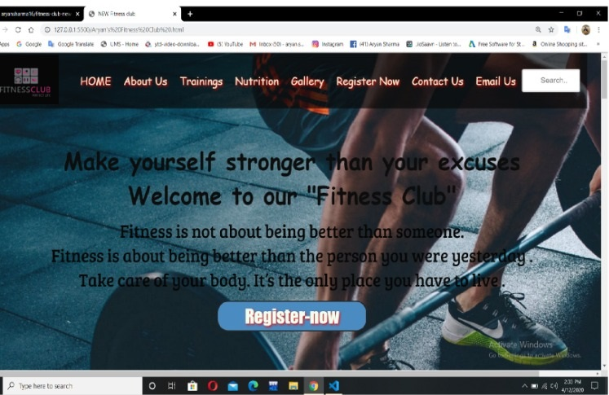

- Landing Page

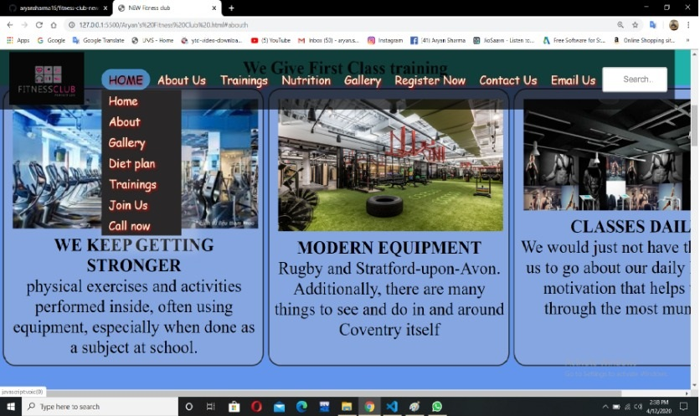
- Home

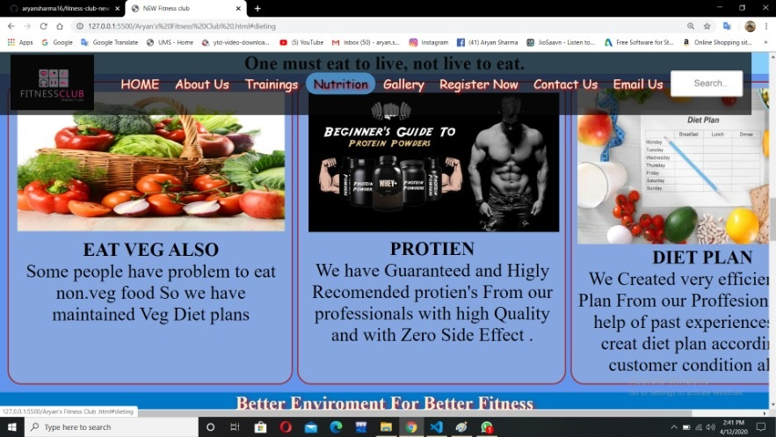

- Nutrition

SECTION 6

IMPLEMENTATION

9.1 Hardware Requirement

9.2 Software Requirement
After completing the packaging process and produced distribution media for the application, The application requires perfectly working Microsoft Visual Studio 6.0 installed on the client system along with Ms Offfice Access. It can run on all applicable operating systems.

8.1 Hardware Requirement
Hardware is the term given to machinery itself and to various individual pieces of equipment. It refers to the physical devices of a computer system. Thus the input, storage, processing control and output devices are hardware.
Minimum Hardware Requirement Of Client Side:
Processor: Any Pentium or Equivalent Machine
RAM: 256 MB
HDD: 1.2 GB
CD-ROM: 32X
14 inches Color Monitor
104 Keys Keyboards
Printer: DeskJet 670 C

8.2 Software Requirement

Software means a collection of program where the objective is to enhance the capabilities of the hardware machine.
Minimum Software Requirement Of Client Side:
Operating System : Windows 9x/NT/2000/Xp
Database : Microsoft Office Access

Front-end : Visual Basic 6.0

IMPLEMENTATION

Once the system was tested, the implementation phase started. A crucial phase in the system development life cycle is successful implementation of new system design. Implementations simply mean converting new system design into operation. This is the moment of truth the first question that strikes in every one’s mind that whether the system will be able to give all the desires results as expected from system. The implementation phase is concerned with user training and file conversion.
The term implementation has different meanings, ranging from the conversion of a basic application to a complete replacement of computer system Implementation is used here to mean the process of converting a new or revised system design into an operational one. Conversion is one aspect of implementation. The other aspects are the post implementation review and software maintainence. There are three types of implementation:

- Implementation of a computer system to replace a manual system
- Implementation of a new computer system to replace an existing one.
- Implementation of a modified application to replace an existing one.

Conversion

Conversion means changing from one system to another. The objective is to put the tested system into operation while holding costs, risks and personnel irritation to a minimum. It involves creating computer compatible files; training the operational staff; installing terminals and hardware. A critical aspect of conversion is not disrupting the functioning of organization.

Direct Implementation

In direct implementation; the previous system is stopped and new system is started up coincidentally. Here there is a direct change over from manual system to computer-based system. In direct change over implementation; employess can face the problems. Suppose our software is not working much efficiently as manual one then we can’t find the defects in our software. It will not be beneficial in finding errors.

The proposed system is fully implemented using Direct Implementation.

SECTION 7

MAINTAINENCE

Once the software is delivered and developed, it enters the maintenance phase. All systems need maintenance. Software needs to be maintained because there are often some residual errors or bugs remaining in the system that must be removed as they are discovered. Many of these surfaces only after the system has been in operation sometimes for a long time. These errors once discovered need to be removed, leading to the software getting changed. Though Maintenance is not a part of software development, it is an extremely important activity in the life of a software product.

Maintenance involves understanding the existing software (code and related documents), understanding the effects of change, making the changes-to both the code and documents-testing the new parts and retesting the old part.
SECTION 8

CONCLUSION

The objective of this project was to build a program for maintaining the details of all the members,employees and inventory .The system developed is able to meet all the basic requirements. The management of the records (both members and employees)will be also benefited by the proposed system, as it will automate the whole procedure, which will reduce the workload. The security of the system is also one of the prime concerns.

There is always a room for improvement in any software, however efficient the system may be. The important thing is that the system should be flexible enough for future modifications. The system has been factored into different modules to make system adapt to the further changes. Every effort has been made to cover all user requirements and make it user friendly.

- Goal achieved: The System is able provide the interface to the owner so that he can replicate his desired data. .

- User friendliness: Though the most part of the system is supposed to act in the background, efforts have been made to make the foreground interaction with user(owner) as smooth as possible. Also the integration of the existing system with the project has been kept in mind throughout the development phase.

SECTION 9

BIBLIOGRAPHY

- www.wikipedia.org
- www.codeproject.com
- Visual Basic 6.0 Resource Center | http://msdn.microsoft.com/hi-in/vbrun/default(en-us).aspx
- Visual Basic 6 Black Book By Steven Holzner

THANK YOU
-----------------------------------------------------------------------

