# NITTE MAHALINGA ADYANTHAYA MEMORIAL INSTITUTE OF TECHNOLOGY

# An Autonomous College Affiliated to VTU Belagavi

# NET LogoNitte -574110, Udupi District

MOBILE APPLICATION DEVELOPMENT

PROJECT REPORT

ON

**PLACES TO VISIT IN PATNA**

SUBMITTED BY:

**GAGAN SHETTY UMESH BHAT**

4NM15CS156 4NM15CS184

VII SEM ‘D’ SEC VII SEM ‘D’ SEC

DEPT. OF CSE DEPT. OF CSE

NMAMIT, NITTE NMAMIT, NITTE

SUBMITTED ON:

November 5th,2018

SUBMITTED TO:

**MR. RAVI B**

ASST. PROF, DEPT OF CSE

NMAMIT, NITTE

**NMAM INSTITUTE OF TECHNOLOGY**

**(An autonomous Institute affiliated to VTU, Belagavi)**

**Nitte-574110, Karkala, Udupi District**

**Department of Computer Science and Engineering**

**CERTIFICATE**

Certified that this project work on Mobile Application Development is a bonafide work carried out by **Gagan Shetty (4NM15CS156)** and **Umesh Bhat (4NM15CS184)** in partial fulfilment for the award of Degree of Bachelor of Engineering in Computer Science and Engineering of the VTU, Belagavi during the year 2018. The project report has been approved as it satisfies the academic requirements in respect of project work prescribed for the Bachelor of Engineering Degree.

**Name of the Guides** **Signature with Date**

*MR. RAVI B ________________________________*

**ACKNOWLEDGEMENT**

This project has provided us with the opportunity of implementing our knowledge of mobile application development on Android Studio. The satisfaction that accompanies the successful completion of any task would be incomplete without the mention of the people who made it possible. We would like to thank the people who helped us in successfully completing this project.

We respect and thank **Mr. Ravi B** for giving us an opportunity to do the project and for all the support and guidance which made us complete the project on time. We also thank our H.O.D **Dr. K R Udayakumar Reddy** and our respected principal **Dr. Niranjan N. Chiplunkar** for their support.

We are grateful to our college and department for providing us proper academic environment to do the project without which our project would still remain on paper. Also, I would like to extend our sincere regards to all the non-teaching staff of department of computer science for their timely support.

**ABSTRACT**

This Project is based on the topic of a Places to visit in patna that allows the user to select and know the different places to visit when going to patna

User can also search about those places on wikipedia and get its coordinates.

The Project is made using Android Studio which allowed us to detect any kind of errors we made. The Android Studio Interface is really very efficient in understanding errors.A After the application was created we tested it out on an Android Phone.

**CONTENTS**

1. INTRODUCTION

2. PROJECT

3. DESIGN & IMPLEMENTATION

* + - Code
    - Screenshots

4. CONCLUSION

5. BIBLIOGRAPHY

**INTRODUCTION**

Android Studio is the official Integrated Development Environment (IDE) for Android app development, based on [IntelliJ IDEA](https://www.jetbrains.com/idea/). On top of IntelliJ's powerful code editor and developer tools, Android Studio offers even more features that enhance your productivity when building Android apps, such as:

* A flexible Gradle-based build system
* A fast and feature-rich emulator
* A unified environment where you can develop for all Android devices
* Instant Run to push changes to your running app without building a new APK

Project Structure

Each project in Android Studio contains one or more modules with source code files and resource files. Types of modules include:

* Android app modules
* Library modules
* Google App Engine modules

All the build files are visible at the top level under **Gradle Scripts** and each app module contains the following folders:

* **manifests**: Contains the AndroidManifest.xml file.
* **java**: Contains the Java source code files, including JUnit test code.
* **res**: Contains all non-code resources, such as XML layouts, UI strings, and bitmap images.

The User Interface

1. The **toolbar** lets you carry out a wide range of actions, including running your app and launching Android tools.
2. The **navigation bar** helps you navigate through your project and open files for editing. It provides a more compact view of the structure visible in the **Project** window.
3. The **editor window** is where you create and modify code. Depending on the current file type, the editor can change. For example, when viewing a layout file, the editor displays the Layout Editor.
4. The **tool window bar** runs around the outside of the IDE window and contains the buttons that allow you to expand or collapse individual tool windows.
5. The **tool windows** give you access to specific tasks like project management, search, version control, and more. You can expand them and collapse them.
6. The **status bar** displays the status of your project and the IDE itself, as well as any warnings or messages.

**Places to visit in Patna**

This Project is based on the topic of a Places to visit in patna that allows the user to select and know the different places to visit when going to patna

User can also search about those places on wikipedia and get its coordinates.

The Project is made using Android Studio which allowed us to detect any kind of errors we made. The Android Studio Interface is really very efficient in understanding errors.A After the application was created we tested it out on an Android Phone.

**DESIGN AND IMPLEMENTATION**

**CODE:**

package ritambhra.com.placestovisitinpatna;

import android.content.Intent;

import android.net.Uri;

import android.os.Bundle;

import android.support.v7.app.AppCompatActivity;

import android.view.View;

import android.widget.AdapterView;

import android.widget.ArrayAdapter;

import android.widget.ListView;

import android.widget.Toast;

public class MainActivity extends AppCompatActivity

{

String[] placeNames={"Sanjay Gandhi Jaivik Udyan","Takht Sri Patna Sahib","Patna Museum","Mahaveer Mandir","Mahatma Gandhi Setu"};

ListView lv;

@Override

protected void onCreate(Bundle savedInstanceState)

{

super.onCreate(savedInstanceState);

setContentView(R.layout.activity_main);

lv= (ListView) findViewById(R.id.listView);

ArrayAdapter<String> adapter=new ArrayAdapter<String>(this,android.R.layout.simple_list_item_1,placeNames);

// ArrayAdapter<String>adapter1=new ArrayAdapter<String>(this,R.layout.list_item_design,R.id.textView,stateNames);

lv.setAdapter(adapter);

lv.setOnItemClickListener(new AdapterView.OnItemClickListener() {

@Override

public void onItemClick(AdapterView<?> adapterView, View view, int i, long l) {

Toast.makeText(MainActivity.this,""+adapterView.getItemAtPosition(i),Toast.LENGTH_LONG).show();

switch(i)

{

case 0:

Intent intent=new Intent(MainActivity.this,Zoo.class);

startActivity(intent);

break;

case 1:

Intent intent1 = new Intent(MainActivity.this,Gurudwara.class);

startActivity(intent1);

break;

case 2:

Intent intent2 = new Intent(MainActivity.this,Measeum.class);

startActivity(intent2);

break;

case 3:

Intent intent3 = new Intent(MainActivity.this,Mandir.class);

startActivity(intent3);

break;

case 4:

Intent intent4 = new Intent(MainActivity.this,Setu.class);

startActivity(intent4);

break;

}

}

});

}

}

#####################################################################################

package ritambhra.com.placestovisitinpatna;

import android.content.Intent;

import android.net.Uri;

import android.support.v7.app.AppCompatActivity;

import android.os.Bundle;

import android.view.View;

import android.widget.AdapterView;

import android.widget.ArrayAdapter;

import android.widget.ImageView;

import android.widget.ListView;

import android.widget.TextView;

import android.widget.Toast;

public class Gurudwara extends AppCompatActivity

{

TextView tv1,tv2,tv3;

ImageView im;

ListView lv;

@Override

protected void onCreate(Bundle savedInstanceState)

{

super.onCreate(savedInstanceState);

setContentView(R.layout.activity_gurudwara);

tv1= (TextView) findViewById(R.id.textView1);

tv2= (TextView) findViewById(R.id.textView2);

tv3= (TextView) findViewById(R.id.textView3);

im= (ImageView) findViewById(R.id.imageView);

lv= (ListView) findViewById(R.id.listView);

String[] details={"For location ,click here!","For more details, click here!"};

ArrayAdapter<String> adapter=new ArrayAdapter<String>(this,android.R.layout.simple_list_item_1,details);

lv.setAdapter(adapter);

lv.setOnItemClickListener(new AdapterView.OnItemClickListener() {

@Override

public void onItemClick(AdapterView<?> adapterView, View view, int i, long l) {

Toast.makeText(Gurudwara.this,""+adapterView.getItemAtPosition(i),Toast.LENGTH_LONG).show();

switch(i)

{

case 0:

Intent intent=new Intent(Intent.ACTION_VIEW, Uri.parse("geo:25.585818 85.23125759999994"));

startActivity(intent);

break;

case 1:

Intent intent1 = new Intent(Intent.ACTION_VIEW, Uri.parse("https://en.wikipedia.org/wiki/Takht_Sri_Patna_Sahib"));

startActivity(intent1);

break;

}

}

});

}

}

################################################################

package ritambhra.com.placestovisitinpatna;

import android.content.Intent;

import android.net.Uri;

import android.support.v7.app.AppCompatActivity;

import android.os.Bundle;

import android.view.View;

import android.widget.AdapterView;

import android.widget.ArrayAdapter;

import android.widget.ImageView;

import android.widget.ListView;

import android.widget.TextView;

import android.widget.Toast;

public class Mandir extends AppCompatActivity

{

TextView tv1,tv2,tv3;

ImageView im;

ListView lv;

@Override

protected void onCreate(Bundle savedInstanceState)

{

super.onCreate(savedInstanceState);

setContentView(R.layout.activity_mandir);

tv1= (TextView) findViewById(R.id.textView1);

tv2= (TextView) findViewById(R.id.textView2);

tv3= (TextView) findViewById(R.id.textView3);

im= (ImageView) findViewById(R.id.imageView);

lv= (ListView) findViewById(R.id.listView);

String[] details={"For location ,click here!","For more details, click here!"};

ArrayAdapter<String> adapter=new ArrayAdapter<String>(this,android.R.layout.simple_list_item_1,details);

lv.setAdapter(adapter);

lv.setOnItemClickListener(new AdapterView.OnItemClickListener() {

@Override

public void onItemClick(AdapterView<?> adapterView, View view, int i, long l) {

Toast.makeText(Mandir.this,""+adapterView.getItemAtPosition(i),Toast.LENGTH_LONG).show();

switch(i)

{

case 0:

Intent intent=new Intent(Intent.ACTION_VIEW, Uri.parse("geo:25.6040 85.1366"));

startActivity(intent);

break;

case 1:

Intent intent1 = new Intent(Intent.ACTION_VIEW, Uri.parse("https://en.wikipedia.org/wiki/Mahavir_Mandir"));

startActivity(intent1);

break;

}

}

});

}

}

##################################################################################################################

package ritambhra.com.placestovisitinpatna;

import android.content.Intent;

import android.net.Uri;

import android.support.v7.app.AppCompatActivity;

import android.os.Bundle;

import android.view.View;

import android.widget.AdapterView;

import android.widget.ArrayAdapter;

import android.widget.ImageView;

import android.widget.ListView;

import android.widget.TextView;

import android.widget.Toast;

public class Measeum extends AppCompatActivity {

TextView tv3, tv4, tv5;

ImageView im2;

ListView lv2;

@Override

protected void onCreate(Bundle savedInstanceState) {

super.onCreate(savedInstanceState);

setContentView(R.layout.activity_measeum);

tv3 = (TextView) findViewById(R.id.textView4);

tv4 = (TextView) findViewById(R.id.textView5);

tv5 = (TextView) findViewById(R.id.textView3);

im2 = (ImageView) findViewById(R.id.imageView2);

lv2 = (ListView) findViewById(R.id.listView);

String[] details = {"For location ,click here!", "For more details, click here!"};

ArrayAdapter<String> adapter = new ArrayAdapter<String>(this, android.R.layout.simple_list_item_1, details);

lv2.setAdapter(adapter);

lv2.setOnItemClickListener(new AdapterView.OnItemClickListener() {

@Override

public void onItemClick(AdapterView<?> adapterView, View view, int i, long l) {

Toast.makeText(Measeum.this, "" + adapterView.getItemAtPosition(i), Toast.LENGTH_LONG).show();

switch (i) {

case 0:

Intent intent = new Intent(Intent.ACTION_VIEW, Uri.parse("geo:25.612677 85.158875"));

startActivity(intent);

break;

case 1:

Intent intent1 = new Intent(Intent.ACTION_VIEW, Uri.parse("https://en.wikipedia.org/wiki/Patna_Museum"));

startActivity(intent1);

break;

}

}

});

}

}

####################################################################################################################

package ritambhra.com.placestovisitinpatna;

import android.content.Intent;

import android.net.Uri;

import android.support.v7.app.AppCompatActivity;

import android.os.Bundle;

import android.view.View;

import android.widget.AdapterView;

import android.widget.ArrayAdapter;

import android.widget.ImageView;

import android.widget.ListView;

import android.widget.TextView;

import android.widget.Toast;

public class Zoo extends AppCompatActivity

{

TextView tv1,tv2,tv3;

ImageView im;

ListView lv;

@Override

protected void onCreate(Bundle savedInstanceState)

{

super.onCreate(savedInstanceState);

setContentView(R.layout.activity_zoo);

tv1= (TextView) findViewById(R.id.textView1);

tv2= (TextView) findViewById(R.id.textView2);

tv3= (TextView) findViewById(R.id.textView3);

im= (ImageView) findViewById(R.id.imageView);

lv= (ListView) findViewById(R.id.listView);

String[] details={"For location ,click here!","For more details, click here!"};

ArrayAdapter<String> adapter=new ArrayAdapter<String>(this,android.R.layout.simple_list_item_1,details);

lv.setAdapter(adapter);

lv.setOnItemClickListener(new AdapterView.OnItemClickListener() {

@Override

public void onItemClick(AdapterView<?> adapterView, View view, int i, long l) {

Toast.makeText(Zoo.this,""+adapterView.getItemAtPosition(i),Toast.LENGTH_LONG).show();

switch(i)

{

case 0:

Intent intent=new Intent(Intent.ACTION_VIEW, Uri.parse("geo:19.229807 72.896254"));

startActivity(intent);

break;

case 1:

Intent intent1 = new Intent(Intent.ACTION_VIEW, Uri.parse("https://en.wikipedia.org/wiki/Sanjay_Gandhi_Jaivik_Udyan"));

startActivity(intent1);

break;

}

}

});

}

}

################################################################################################################

package ritambhra.com.placestovisitinpatna;

import android.content.Intent;

import android.net.Uri;

import android.support.v7.app.AppCompatActivity;

import android.os.Bundle;

import android.view.View;

import android.widget.AdapterView;

import android.widget.ArrayAdapter;

import android.widget.ImageView;

import android.widget.ListView;

import android.widget.TextView;

import android.widget.Toast;

public class Zoo extends AppCompatActivity

{

TextView tv1,tv2,tv3;

ImageView im;

ListView lv;

@Override

protected void onCreate(Bundle savedInstanceState)

{

super.onCreate(savedInstanceState);

setContentView(R.layout.activity_zoo);

tv1= (TextView) findViewById(R.id.textView1);

tv2= (TextView) findViewById(R.id.textView2);

tv3= (TextView) findViewById(R.id.textView3);

im= (ImageView) findViewById(R.id.imageView);

lv= (ListView) findViewById(R.id.listView);

String[] details={"For location ,click here!","For more details, click here!"};

ArrayAdapter<String> adapter=new ArrayAdapter<String>(this,android.R.layout.simple_list_item_1,details);

lv.setAdapter(adapter);

lv.setOnItemClickListener(new AdapterView.OnItemClickListener() {

@Override

public void onItemClick(AdapterView<?> adapterView, View view, int i, long l) {

Toast.makeText(Zoo.this,""+adapterView.getItemAtPosition(i),Toast.LENGTH_LONG).show();

switch(i)

{

case 0:

Intent intent=new Intent(Intent.ACTION_VIEW, Uri.parse("geo:19.229807 72.896254"));

startActivity(intent);

break;

case 1:

Intent intent1 = new Intent(Intent.ACTION_VIEW, Uri.parse("https://en.wikipedia.org/wiki/Sanjay_Gandhi_Jaivik_Udyan"));

startActivity(intent1);

break;

}

}

});

}

}

**SCREENSHOTS**

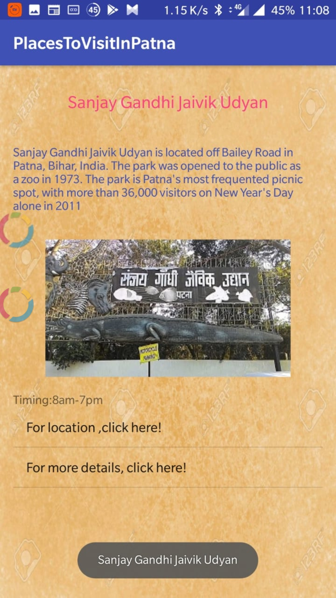

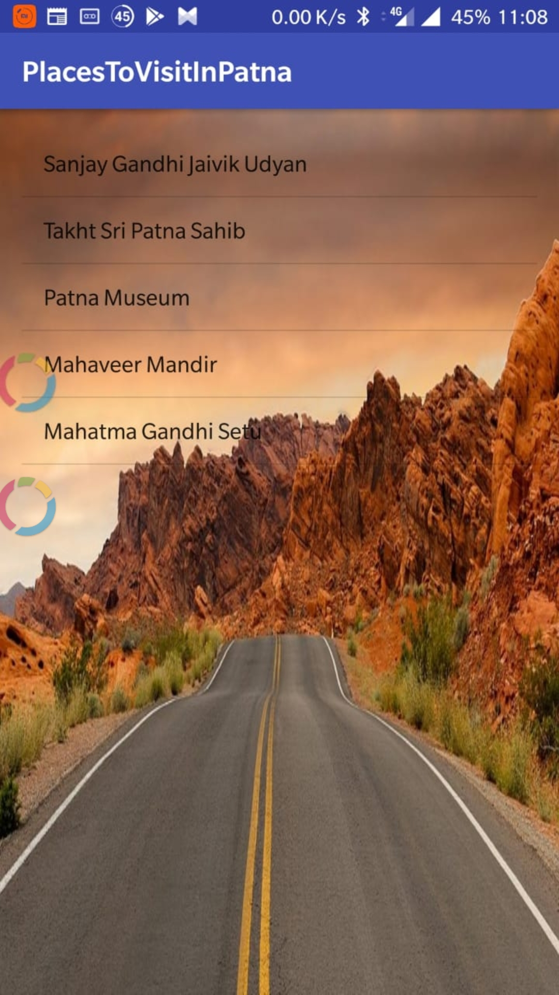

**CONCLUSION**

The development of this application was a rather challenging job which required some knowledge of Android studio and Application Development at the intermediate level. Nevertheless, the project was fun to make and also enhanced our understanding of the subject. New Important could be added to an updated view of this application.

**REFERENCES**

1. [https://en.wikipedia.org/wiki/androviews_(tuts)](https://en.wikipedia.org/wiki/Hangman_(game))
2. <https://www.androidauthority.com/android-studio-tutorial-beginners-637572>
3. https://code.tutsplus.com/tutorials
4. <https://www.javatpoint.com/android-intent-tutorial>
5. https://www.youtube.com/watch?v=QxfZpvdBf3I