1. The central building blocks of application user interfaces.

1. android.app
2. android.database
3. android.opengl
4. android.view
5. None of these

2. Which of the following options can be considered as the advantage of Android operating system?

1. Android has the largest installed base of all operating systems of any kind.
2. A combination of open s and proprietary software.
3. It offers a complete set of software for mobile devices with middleware and key mobile applications.
4. Android is an open-source platform.
5. All of these

3. Raj is new to the app development environment and wanted to develop an Android Apps. Suggest the best suited App development platform he can start with?

1. Eclipse + ADT plugin
2. Android SDK tools
3. Android platform tools
4. ADT Bundle
5. None of these

4. Android provides a method to store user's data through using ______ and ______ are simply sets of data values that are shared steadily.

1. shared Preference and preferences
2. Preference and shared preferences
3. Activity-level preferences and application -level preferences
4. Application-level preferences and activity-level preferences
5. none of these

5. While setting a MediaPlayer, which of the following is/are correct statement/s which best defines the method isPlaying()?

1. This method returns true/false indicating the song is playing or not
2. This method takes an integer, and select the track from the list on that particular index
3. This method sets the data source of audio/video file
4. This method takes an integer and move song to that particular second

choose the best option

1. Option a
2. Option b
3. Option c
4. Option d
5. None of these

6. Which of following is the basis attribute for the URI to be defined in the declaration of the ContentProvider in the AndroidManifest file?

1. android:authorities
2. android:properties
3. android:apps
4. android:system
5. none of these

7. A ______ class is extended in a Broadcast receiver which is further registered as a receiver in an Android Application.

1. BroadcastReceiver
2. Context.registerReceiver ()
3. onReceive
4. import android.content.BroadcastReciever
5. none of these

8. The ______ class provides a general framework to save and retrieve various data types.

1. Parameters
2. Activities
3. sharedpref.edit
4. SharedPreferences
5. None of these

9. Which of the following callback method/s is/are not available in event listenres?

* onClick()
* onLongClick()
* onFocusChange()
* onKey()
* onTouch()
* onCreateContextMenu()
* onRead()
* onOut()

1. onClick() and onLongClick()
2. onFocusChange() and onKey()
3. onTouch()
4. onCreateContextMenu()
5. onRead() and onOut()

10. To create a map layout of the application, specify a fragment referring to the Google Map API i.e ________

1. com.google.android.SupportMapFragment
2. com.google.android.gms.maps.SupportMapFragment
3. android.gms.maps.SupportMapFragment.google
4. None of the these

11. Which of the following is not a type of dialog with Android platform?

1. AlertDialog
2. ProgressDialog
3. IdleDialog
4. TimepickerDialog
5. None of these

12. ______ is an application runtime environment used by the Android operating system.

1. Virtual machine
2. Android runtime
3. Library Manager
4. System Manager
5. None of these

13. Which of the following statement/s is/are correct about the notification messages in Android

statement A: A notification is a message you can show to the user inside of applications normal UI.

statement B: When you notify the system to issue a notification, it first appears as an icon in the notification area.

statement C: To see the details of the notification ,the user opens the notification drawer.

statement D: The viewer can view the notification from the notification area only.

1. Statement A and B
2. Statement A and D
3. Statement B and C
4. Statement B and D
5. All statements are true

14. What is the size of Short integer type in terms of bits?

1. 8
2. 16
3. 32
4. 64
5. 128

15. The _____ method starts the thread in a separate path of execution, then invokes the run() method on this Thread object.

1. public void start()
2. public void run()
3. public final void setDaemon(boolean on)
4. public final void join(long millisec)
5. None of these

16. Which of the following is a lightweight sub-process, a smallest unit of processing?

1. Multicasting
2. Object
3. Class
4. Thread
5. None of these

17. The ______ package defines the buffer classes, which are used throughout the NIO APIs.

1. java.nio
2. java.nio.api
3. nio.java
4. java.nio.char
5. None of these

18. John is working with constructors for Thread in java. He is confused with few thread keywords. Help him to identify valid constructors for Thread from the following list:

1. Thread(Runnable r, String name)
2. Thread()
3. Thread(int priority)
4. Thread(Runnable r, ThreadGroup g)
5. Thread(Runnable r, int priority)
6. option A and C
7. option B and C
8. option C and D
9. option A and B
10. option B and D

19. Which of the following cannot be considered as java.util.Collection interface's basic operation?

1. Can get its number of elements as size
2. Adds a new element to a collection
3. Check if the collection is vacant
4. Checks if an object exists in this collection
5. None of these

20. Following are the central abstractions of the NIO APIs .

1. Buffers, for data of primitive types
2. Character set encoders and decoders
3. Channels, a new primitive I/O abstraction
4. A multiplexed, non blocking I/O facility

which of the following are options are correct about the NIO APIs

1. option A and B
2. option B and C
3. option C and D
4. option A and D
5. All of these

21. The classes that extend Throwable class except the ____ and error are known as checked exceptions.

1. Unchecked exception
2. Runtime exception
3. Error
4. Arithmetic Exception
5. None of these

22. The _____ interface provides the remove operation to remove the last element returned by next from the collections.

1. Iterator
2. List
3. Remove
4. Update
5. Update
6. None of these

23. Which of the following method in List interface returns the index of the first instance of obj in the invoking list obj is not an element of the list -1 is returned?

1. boolean addAll(int index, Collection c)
2. Object get(int index)
3. int indexOf(Object obj)
4. ListIterator listiterator(int index)
5. None of these

24. Which of the following is using which, an object can be represented as a sequence of bytes that consists of the object's data and information regarding the object's type and the types of data stored in the object?

1. Object
2. Serialization
3. Binding
4. Methods
5. None of these

25. While developing java programs, which of the following type of application does Java supports?

1. Standalone Application
2. Web Application
3. Enterprise Application
4. Mobile Application
5. All of these

26. The angle brackets <> are informally called the ____ operator.

1. Diamond
2. Gold
3. instance Creation
4. Silver
5. None of these

27. Which of these methods return a smallest whole number greater than or equal to variable X?

1. double floor(double X)
2. double max(double X)
3. double min(double X)
4. double ciel(double X)
5. None of these

28. Which of the following can be defined as a grouping of related types(classes, interfaces, enumerations and annotations) providing access protection and namespace managemnt.

1. Polymorphism
2. Package
3. Objects
4. Classes
5. None of these

29. ______ in java are a sequence of characters(digits, letters, and other characters) that represent constant values to be stored in variables.

1. Variables
2. Data types
3. Legal and illegal identifiers
4. Literals
5. None of these

30. carefully examine the android code below

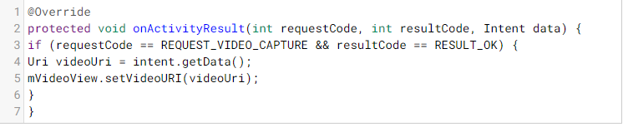

1. This code retrieves video and displays it in a VideoView
2. This code invokes an intent to capture video
3. This code that invokes an intent to capture a photo
4. This code retrieves this image and displays it in an imageView
5. None of these

31. Examine the two different codes below.

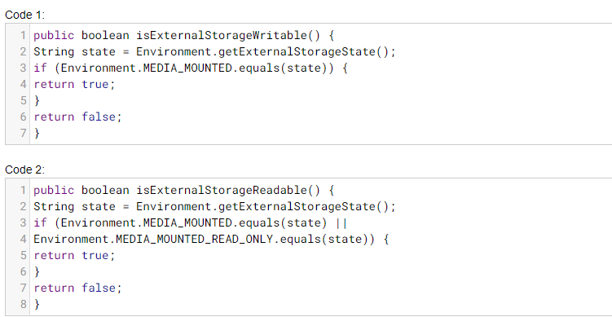

Identify the difference between code 1 and code 2 from the following options

1. Code 1 checks if external storage is available to readwrite and code 2 checks if external storage is available to atleast read
2. Code 1 checks if external storage is available to atleast read and Code 2 checks if external storage is avilable for readwrite
3. Code 1 checks if external storage is active and code2 checks if external storage is available for readwrite
4. code 1 checks if external storage is available and code 2 checks if external storage is ready for write only.
5. None of these

32. Carefully examine the code below

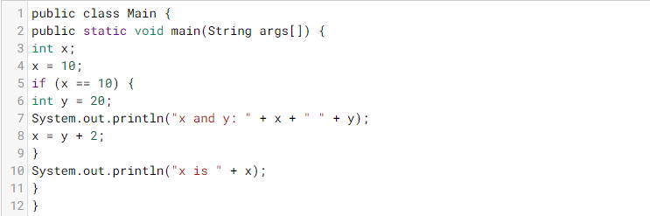

1. x and y: 10 20 x is 22
2. x and y: 20 10 x is 22
3. x and y: 22 22 x is 22
4. y=10;
5. None of these

33. carefully examine the code below

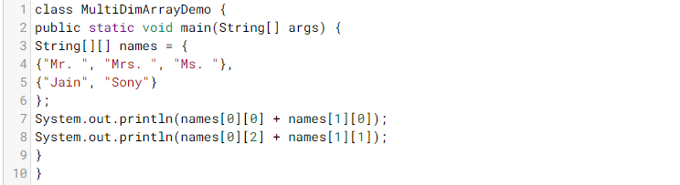

1. Ms.Sony Mr.Jain
2. Mr.Jain Ms.Sony
3. Mr.Jain Mrs.Sony
4. Mrs.Jain Mr.Sony
5. None of these

34. Carefully examine the below code snippet

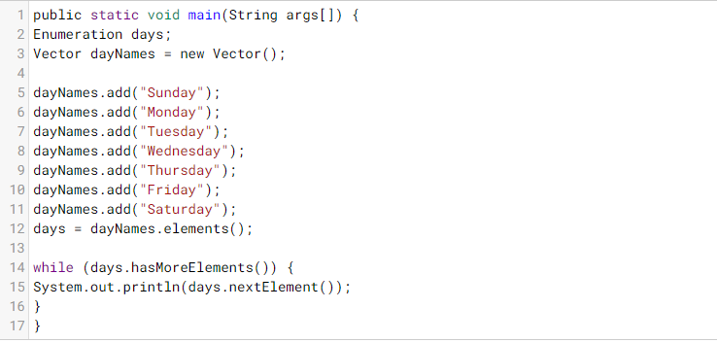

The code is an exampleof:

1. Vector interface
2. Map interface
3. Enumeration interface
4. None of these

35.

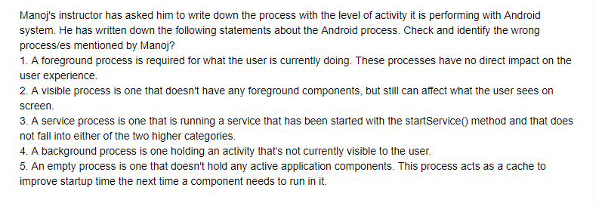

1. Foreground process and background process
2. Visible process and empty process
3. Empty process and empty process
4. visible process and service process
5. One of these

36.

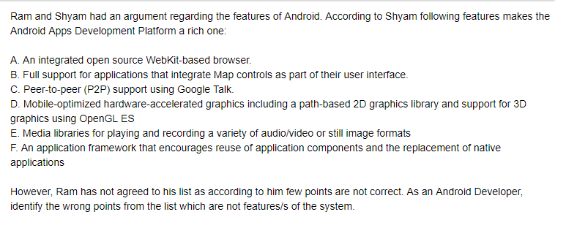

1. A, D AND E
2. A, B AND C
3. B,D AND F
4. A,C,D AND F
5. All mentioned points are features of the android app development platform

37. Which of the following is not a reserved word in java?

1. transient
2. volatile
3. native
4. instane

38.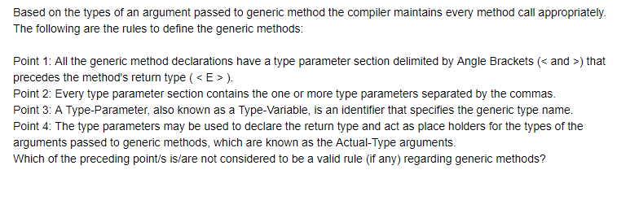

1. Point 1
2. Point 2
3. Point 3
4. Point 4
5. None of these

39. The ___ method declared by the map interface returns the set containing map entries.

1. Map.Entry()
2. entrySet()
3. getKey()
4. getValue()

40. ____________gets a Stream with the group as the resource of elements in java Collection.

1. default Stream<E> stream()
2. default Stream<E> parallelStream()
3. default Stream<E>
4. none of these

41. Android application framework includes following service.

1. Activity Manager
2. Content Providers
3. Resource Manager
4. Notification manager
5. All of these

42. To communicate ________ object is used with the services.

1. bindService
2. IBinder
3. onBind
4. startService

43. Which is not true about the SQLite database

1. SQLite is an open source database embedded in Android
2. Android provides full support for SQLite databases
3. Allows database access outside the application
4. To create a new SQLite database, create a subclass of SQLiteOpenHelper and override the onCreate() method.

45. The following code snippet demonstrates how to build an ImageView that uses an image from drawable resources and adds it to the layout

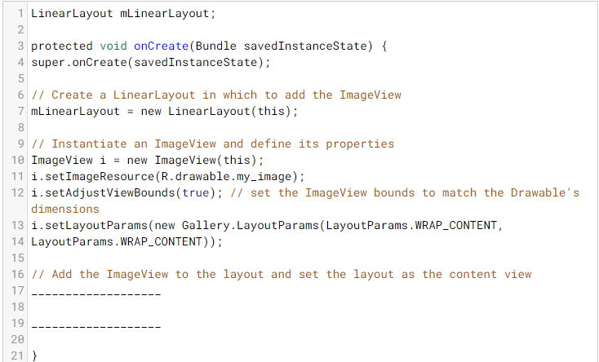

1. mLinearLayout.addView(i); setContentView(mLinearLayout);
2. mLinearLayout.View(i); ContentView(mLinearLayout);
3. ImageView(i); setContentView(mLinearLayout);
4. setContentView(mLinearLayout);